Summary Statistics

Table 1 Summary Statistics of Patient-Provider Communication Data

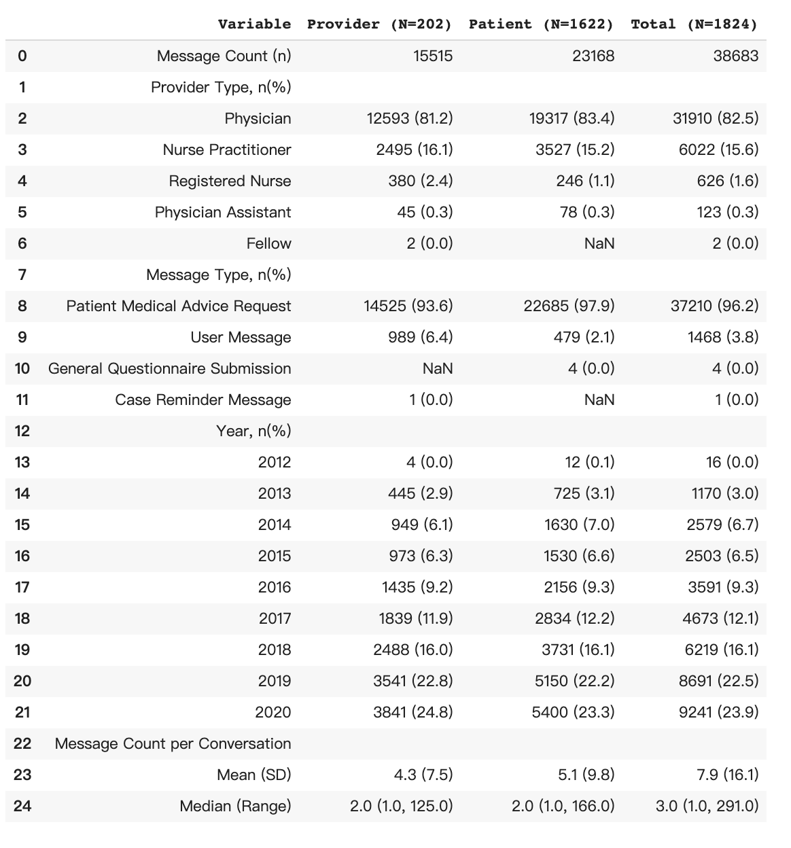

Figure 1 Figure 2

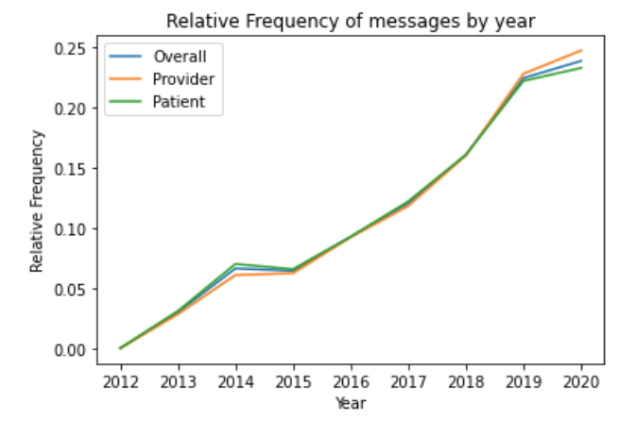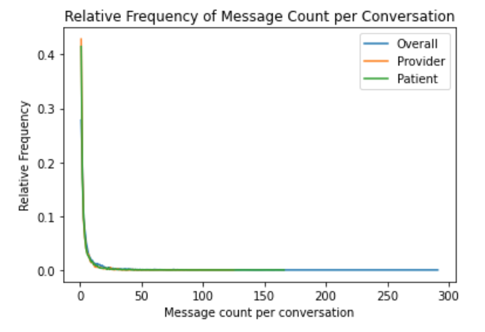

Figure 3

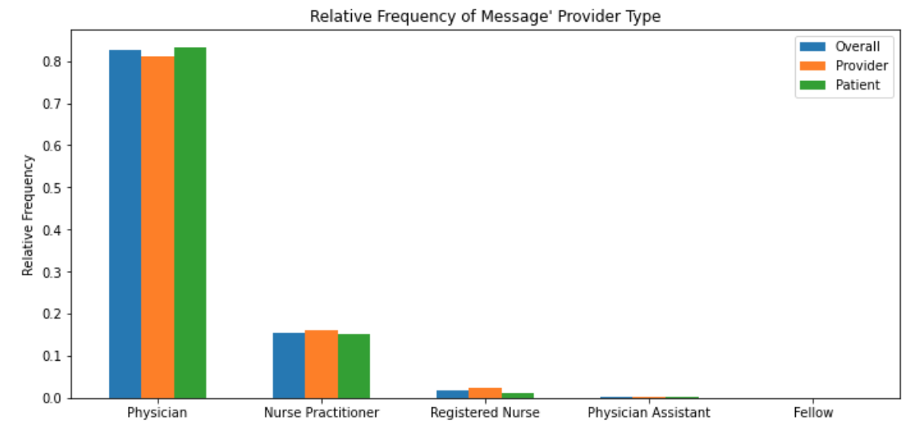

Figure 4

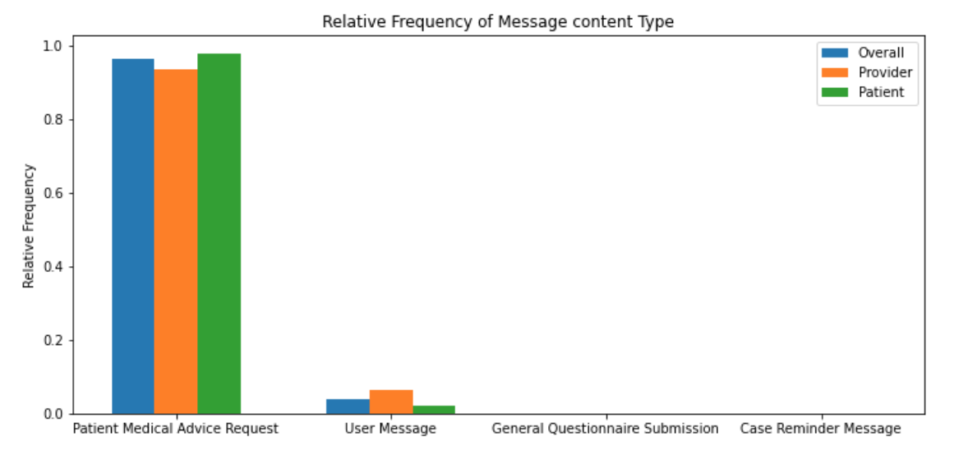

* 202 providers and 1622 patients in total.
* 38683 messages in total, among them, patients sent 23618 messages, providers sent 15515 messages, patients sent more messages than providers (59.9% vs. 40.1%).
* Time (Figure 1)
  + Messages are collected from 2012-05-29 to 2020-09-12. During 2012 to 2020, the overall trend of the frequency of messages is increasing (0.04% vs. 23.9%) except from a slight decrease during 2014-2015 (6.7% vs. 6.5%). 2020: 23.9%, 2019: 22.5%, 2018: 16.1%, 2017: 12.1%, 2016: 9.3%, 2015: 6.5%, 2014: 6.7%, 2013: 3.0%, 2012: 0.04%
* Conversation
  + 4901 conversations in total.
  + Message count per conversation (Figure 2): Average number of messages in a conversation is 8 (range (1, 291)). In average, providers contribute 4 messages in a conversation (range (1, 125)), while patients contribute 5 messages in a conversation (range (1, 166)). The most frequent number of messages in a conversation is only 1 (27.8%), conditions are the same with regards to providers (42.9%) or patients (41.5%), which indicates that a lot of messages sent remained unresponded. Unresponse is also one of the reasons for the duplicate messages.
  + Duration per conversation (days): Average duration of a conversation is 108 days (range(0, 2894)). The most frequent duration of a conversation is within a day (40.9%).
* Messages by provider type (Figure 3)
  + The types of provider are physician, nurse practitioner, registered nurse, physician assistant and fellow.
  + Most communications occur between physicians (82.5%) and patients, secondly is nurse practitioner (15.6%), the rest of providers only account for a very small amount of communications.
  + Similar distribution by providers and patients, but patients do not send any messages to the fellows.
* Type of message content (Figure 4)
  + The contents of the messages range from patient medical advice request, user message, general questionnaire submission, and case reminder message.
  + Most contents are related to the patient medical advice request (96.2%), secondly is user message (3.8%)
  + Similar distributions by provider or by patient are similar, which makes sense since both providers and patients participate in a conversation.
* Duplicate messages
  + 1694 duplicate messages in total, among them, 503 from providers, 1191 from patients.
  + Most of the duplicate messages are different formats of "Thank you", “You are welcome”, or “Refill the drugs”.
  + Only a very small amount of messages (16, 0.9%) are “truly duplicate”, which meet all of the conditions below and were dropped during data cleaning.

1. To/From the same provider (i.e. same conversation ID)
2. Equal or longer than 20 characters
3. Within a month (often on the same date).
4. Not different formats of "Thank you" or "You're welcome"

* We could find several patterns in these truly duplicate messages

1. Providers, often nurses, send duplicate messages to the same patient on the same date might because their patients don't reply to the first message.
2. Patients send duplicate messages to different providers on the same date might because they don't know which providers to ask for help.
3. Patients send duplicate messages to the same provider on the different dates might because their providers don't reply to the first message because providers prefer talking to their patients in person or on the phone to make a more clear conversation.

**Table Data Key**

|  |  |  |
| --- | --- | --- |
| **Variable Name** | **Definition** | **Coding Details/Range** |
| ENC_PROV_ID | Unique identifier for a provider | E.g., 3054 (Physician), S0003293 (NP) |
| DATE_OF_MESSAG | Date of the message sent | 2012-05-29 - 2020-09-12 |
| PROV_TYPE | Type of providers | Fellow  Nurse Practitioner  Physician  Physician Assistant  Registered Nurse |
| ENC_TYPE_DISPLAY | Type of messages | Patient Message |
| MYC_MSG_TYP_DISPLAY | Type of message contents | Case Reminder Message  General Questionnaire Submission  Patient Medical Advice Request  User Message |
| REPLY_YN | Reply of a message | Y=Yes, N=No |
| TO_PAT_YN | Message sent to patient | Y=Yes, N=No |
| MESSAGE_ID | Unique identifier for a message | 10449 - 33081467 |
| MESSAGE_SUB_ID | Sub identifier for a message | 1 |
| INDEX | Unique identifier for a message | 1-44602 |
| MESSAGE_CL | Free text message | E.g., Thank you. |
| PAT_ID_NEW | Unique identifier for a patient | 1-1622 |
| CONVERSATION_ID | Unique identifier for a conversation | 1-4902 |