Project 8: STRATEGY EVALUATION

Zifeng He  
zhe343@gatech.edu

# Indicator Overview

## Bollinger Band percentage (BB%)

According to investopedia.com, a Bollinger Band is a technical analysis tool defined by a set of trendlines plotted two standard deviations (positively and negatively) away from a simple moving average (SMA) of a security's price.

For both Manual Strategy and Strategy Learner, the threshold of BB%, which is monitored to see if we should trade, is optimized.

## Exponential moving average ratio

According to investopedia.com, an exponential moving average (EMA) is a type of moving average (MA) that places a greater weight and significance on the most recent data points.

EMA ratio is stock price divided by its EMA.

For both Manual Strategy and Strategy Learner, the threshold of EMA ratio, which is monitored to see if we should trade, is optimized.

## Moving Average Convergence Divergence

According to investopedia.com, moving average convergence divergence (MACD) is a trend-following momentum indicator that shows the relationship between two moving averages of a security’s price. The MACD is calculated by subtracting the 26-period exponential moving average (EMA) from the 12-period EMA. A nine-day EMA of the MACD called the "signal line," is then plotted on top of the MACD line, which can function as a trigger for buy and sell signals.

I created a variable called “MACD - Signal” by subtracting “signal” from MACD.

For both Manual Strategy and Strategy Learner, the “MACD - Signal” is used to see if we should trade, which is optimized.

# Manual Strategy

## Description

For this strategy, I use 3 indicators, BB%, EMA ratio, “MACD trade” (see above). I set up criteria for each of them and for both LONG entry points and SHORT entry points. If any 2 or 3 of the criteria are satisfied, a trade will be executed (given that it is allowed to trade). Please see below for the criteria.

1. Criteria of Manual Strategy

|  |  |  |
| --- | --- | --- |
|  | Long | Short |
| BB% | <= 0.3 | >= 0.7 |
| EMA ratio | <= 0.8 | >= 1.2 |
| MACD - Signal | > 0 | < 0 |

The reasoning behind the criteria is that I believe the stock should be bought or sold when it reaches below or above its considered “true value”.

It is an effective strategy because it significantly outperforms the benchmark strategy.

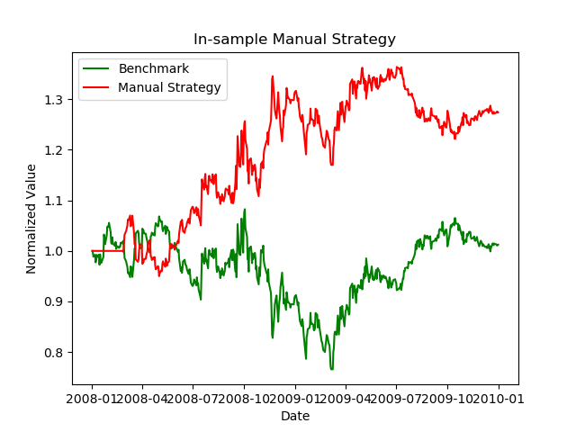

1. In-sample Manual Strategy

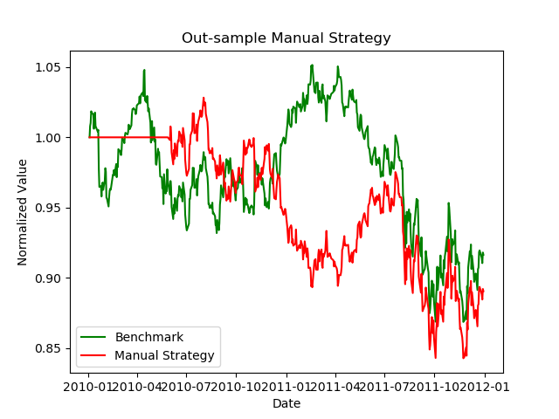

1. Out-sample Manual Strategy
2. Benchmark and Manual Strategy performance metrics out-sample and in-sample

|  |  |  |  |  |
| --- | --- | --- | --- | --- |
|  | MS in-sample | Benchmark in-sample | MS out-sample | Benchmark out-sample |
| cumulative returns | 27.4110% | 1.2325% | -10.9510% | -8.3579% |
| mean of daily returns | 0.0566% | 0.0169% | -0.0200% | -0.0137% |
| standard deviation of daily returns | 1.3089% | 1.7041% | 0.7827% | 0.8500% |

# Experiment 1

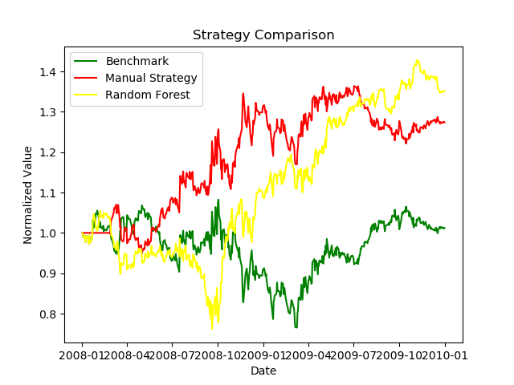

1. Strategy Comparison

# Experiment 2

Here I tested with 0.005, 0.01 and 0.02 impact.

Please see below for a chart of the portfolio performance (normalized) under each impact.

We see that portfolio performs better with less impact. The less impact, the better. We also trades less shares with more impact.

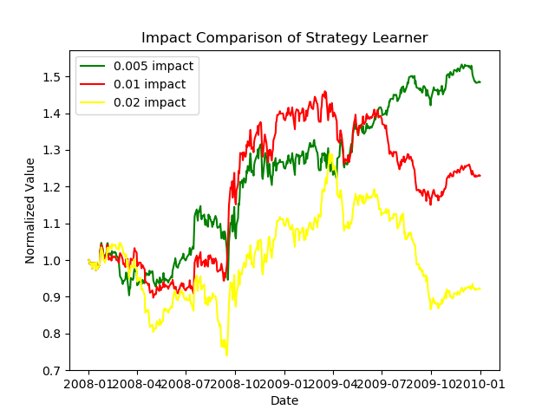

1. Impact Comparison of Strategy Learner
2. Impact Comparison of Strategy Learner

|  |  |
| --- | --- |
| Impact | Traded shares |
| 0.005 | 26700 |
| 0.01 | 25500 |
| 0.02 | 21900 |