S.U.S.S. Handball: A Bluffer’s Guide

# The Game

Handball is a very simple game, with two teams of two players. The objective of handball is to beat the opponent to 11 points, and to win by two points (like ping-pong).

# The Serve

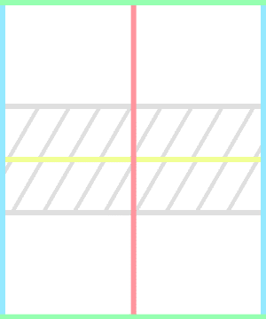

Into this Square

To this Square

Not Through here

From behind this line

A serve consists of one player throwing the ball into their own square, then the square which is diagonal to theirs. The serve must be made from behind the back line, and the server’s arm must not go below their waist whilst they hold the ball. The serve also needs to leave the court outside of the area marked in gray and once the umpire says play, you have ten seconds to throw the ball. If you don’t conform to any of these rules, a fault will be called. Two faults in a row, and the other team wins the point.

# The Point

After the serve, the ball is in play. Like tennis, teams alternate hitting the ball to each other until someone wins the point, which occurs when the other team hits a ball that is “out”. There are many ways for the ball you hit to be out, such as:

## Double Bounce

The ball bounces twice in a row on your side of the court, before or after it is hit.

## Straight

After being hit, the ball does not bounce on your side before bouncing on the opponent’s side.

## Out Of Court

The ball bounces in your square, then lands outside of the court.

## Rolls

After you hit the ball, it rolls so that no one can tell where it bounces.

## Double Touch

The ball is touched twice by your team before the other team touches the ball.

## Grabs

The ball comes to rest inside your hand. For players who have played school-yard handball before, carries are legal, but only within reason.

# Body-Parts

Body-parts in handball are any part of the body which is not in between the hand and the elbow. Body-parts are special in S.U.S.S. handball as they are not subject to the straight rule, meaning that when you use a body-part, you are allowed to hit the ball straight into the opponent’s square. However, this freedom comes with a different restriction: body-parts may not be used in the marked area near the centerline, referred to as the Body-part Restricted Area, or B.R.A.

# Rebounds

The rebounds rule in S.U.S.S. handball is a rule which is commonly misunderstood and has a reputation of being complicated. However, the rule can be chalked up to one simple statement:

If the ball would’ve been in if the wall was not there, the rebound is in.

Once a ball does hit a rebound surface, the ball is allowed to bounce again, even if this bounce would normally make it qualify as double bounce.

# Lines

Lines in S.U.S.S. handball are another rule which is different to the traditional school handball rules. Due to an excessive number of replays, lines are no longer replayed, and are instead governed by a set of rules to ensure outcomes to as many points as possible. All side lines and backlines are considered in court, and on serves, the cross line is considered in. The most important rule to remember about lines is this:

The center line is in the square of the team which did not hit the ball.

This means that lines lean towards straights being out, and double bounces being in.

# Time-outs

Each team is entitled to one time-out, which is a 30-second break during which the team is permitted to leave the court and talk about strategy. A time-out is called by the captain stepping into the B.R.A. (with permission) then creating a ‘T’ shape with their arms.

# General Conduct

The conduct rules in S.U.S.S. handball are quite strict, in order to maintain a high level of respect to all members involved. Some of the key rules to remember are:

## No Swearing

Handball is a Family Friendly Sport. It is a sport which anyone should be able to enjoy, so there is a strict no swearing rule in handball.

## Talking to the Umpire

To talk to the umpire, the captain of your team must first ask the umpire if they may approach the B.R.A., and the umpire may refuse if not referred to as “Sir”, “Ma’am” or “Your Excellency”. After this, the captain may talk to the umpire in a way that is respectful and must not make any attempt to undermine the umpire’s decisions.

## Equipment and Equipment Abuse

Safety is one of the most important things in the S.U.S.S. handball environment, and people who use the provided equipment in a way that is not safe will not be tolerated. Throwing handballs at people and throwing them when they are not expected to be in play is dangerous and has already led to injuries in our sport’s short existence.

There is a zero-tolerance policy for dangerous use of equipment, and any violation of these rules will be dealt with swiftly and harshly.

# **Penalties**

The penalties which are used to deal with breaches of misconduct in S.U.S.S. handball are the green, yellow, and red cards. These cards are used during the tournament for any manner of breaches of the conduct listed above. They stack for the entire tournament, so a green card in your first game will be a yellow card the next time you repeat the same misconduct. The cards are accompanied with the following penalties:

## Pepup Red,Green & Yellow Hockey Referee Warning Cards, For SportsGreen Card

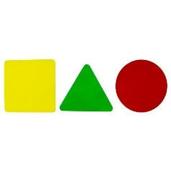A Green Card is simply a warning and does not carry any penalty besides shaming from your peers.

## Yellow Card

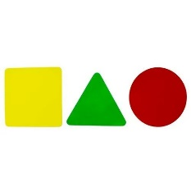A Yellow Card carries a suspension from between 3 and 12 rounds. Yellow Cards that are for repeated green offences will (usually) carry a 3-round suspension, but Yellow Cards for Dissent, Disrespect or Equipment abuse can often utilize the maximum 12-round suspension.

## Red Card

A Red Card is the maximum penalty that a player can receive, and it represents suspension from the remainder of the game, as well as a talking to by the Tournament Director.