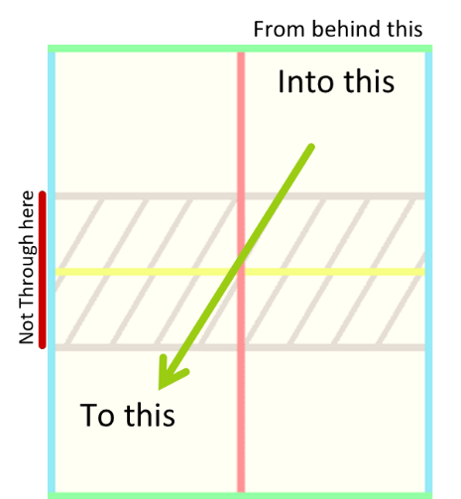

**HANDBALL F R**

**DUMMIES**

THE GAME

The objective of handball is to beat the opponent to 11 points,

winning by two. There are two teams per court, with two players per team.

A substitute may be appointed if desired.

SERVING  
A serve consists of an above the waist throw, the ball bouncing into the players square then the opposing square on the diagonal.

* This serve must be made from behind the back line.
* The serve also must not exit the court within the sides of the B.R.A.

If these rules are not conformed to, a fault is received. Two faults in a row, and the other team wins the point.

WINNING / LOSING A POINT

After a successful serve, the teams alternate hitting the ball to each other until it is hit “out”. The other team then wins a point. There are many ways for the ball you hit to be “out”:

DOUBLE BOUNCE

The ball bounces twice in a row on your side of the court, before or after it is hit.

STRAIGHT

The ball is directly hit into the other team’s square without bouncing into your court first.

OUT OF COURT

The ball doesn’t land in the opponents square after being hit by a player.

ROLLS

The ball rolls upon the hit, so it’s difficult to tell where it bounces.

DOUBLE TOUCH

The ball is touched twice by your team upon the hit.

GRABS

The ball comes to rest inside your hand. Carries are legal, but only within reason.

LINES

Lines are no longer replayed. Side lines and back lines are considered “in”, and on serves, the cross line is considered “in”. In play, the centre line is considered part of the opponent’s square.

This means that lines lean towards straights being out, and double bounces being in.

TIMEOUTS

Each team is entitled to one 30 second time-out.

A time-out is called by the captain stepping into the B.R.A. (with permission) then creating a ‘T’ shape with their arms.

REBOUNDS

Once a ball hits a rebound surface, the ball is allowed to bounce again, even if this would normally qualify as double bounce.

If the ball would’ve been in if the wall was not there, the rebound is in.

BODY PARTS

Body parts include any part of the body not between the hand and elbow.

Body parts are not subject to the straight rule, meaning the ball can be directly hit into the opponent’s square.

GENERAL CONDUCT

NO SWEARING

There is a strict no swearing rule. This includes blasphemy.

TALKING TO THE UMPIRE

To talk to the umpire, the captain of your team must first ask the umpire if they may approach the B.R.A., and the umpire may refuse if not referred to as “Sir”, “Ma’am” or “Your Excellency”.

After this, the captain may talk to the umpire in a respectful manner and must not make any attempt to undermine the umpire’s decisions.

EQUIPMENT ABUSE

The provided equipment must be used respectfully and safely. Dangerous behaviour, such as throwing handballs at people, will not be tolerated as it has already led to injuries in our sport’s short existence.

PENALTIES

Penalties can be awarded in the form of green, yellow, or red cards. These cards stack over the course of the tournament so for example, if a second green card is received it would become a yellow card.

YELLOW CARD

A Yellow Card carries a suspension from between 3 and 12 rounds.

For repeated green offences, a yellow card will (usually) carry a 3-round suspension.

Yellow Cards for dissent, disrespect or equipment abuse can enforce a maximum 12-round suspension.

RED CARD

A Red Card represents suspension from the remainder of the game, as well as a talking to by the Tournament Director.

carry any penalty besides shaming from your peers.

GREEN

CARD

A Green Card is simply a warning and does not