ILI9341 240x320 2.2” TFT display

This project aims to create a display driver for the ILI9341 display module issued along with the University of Southampton Il Matto boards.

We are using an 8-bit Parallel Interface (Type 1) to communicate with the display

System Interfaces
- 8/9/16/18-bit interfaces with 8080 series MCU
- 6/16/18-bit RGB interface with Graphic Controller
- ¾ line serial interface

Pins on Il Matto board:
- CS Chip Select (active low)
- BLC Backlight Control (active low?)
- RESET Reset (active low)
- WR Data Write Strobe (rising edge)
- RS Data(1)/Command(0) selection
- RD Data Read Strobe (rising edge)
- VSYNC VSYNC
- FMARK Frame Mark
- D[7:0] Data Bus

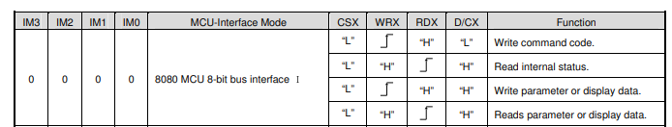

This is an Asynchronous process, which is nice as it lets us take our time. I am curious as to how fast we can clock our FPGA side though.

Timing Requirements
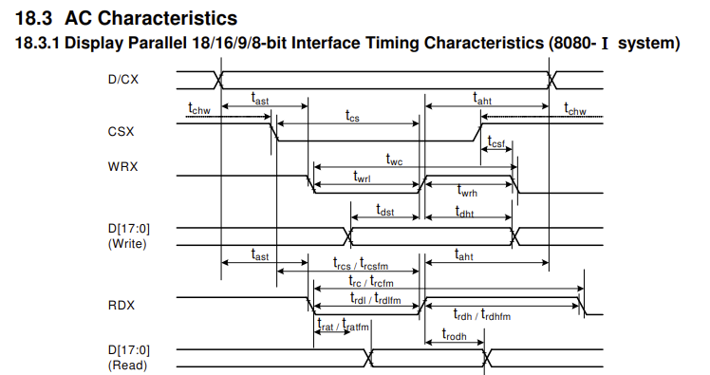
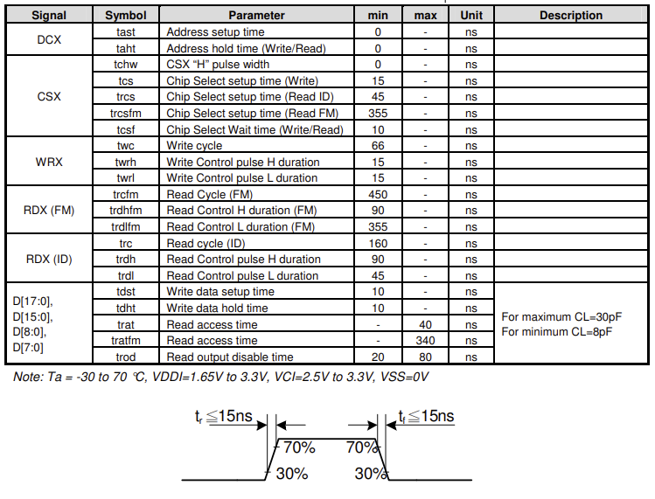
Frame Memory (FM) reads are much much slower than Register reads (ID)

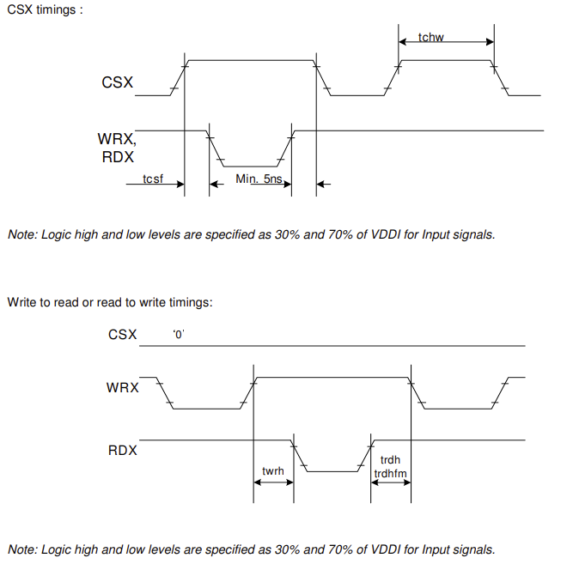

Interfacing

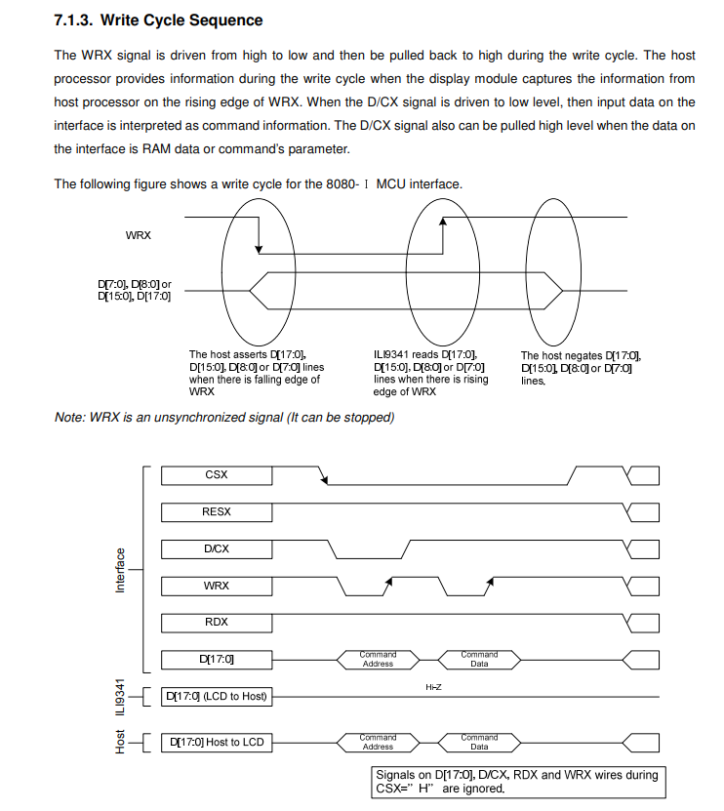
Write Cycle Sequence

Read Cycle Sequence
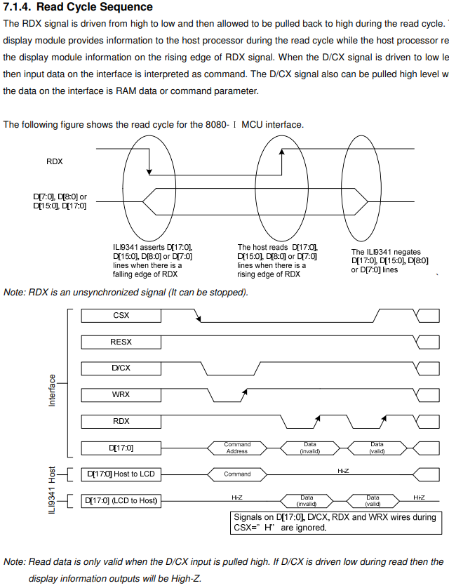

Using VSYNC
If the ILI9341 is in VSYNC mode, the VSYNC pin will control the framerate, and it will stall writes to the GRAM until a few lines after the falling edge of VSYNC to ensure no screen tearing is visible.
See the datasheet section 7.3 (page 52) for more details.

Display Data Format
Depending on if we want 16 bit colour or 18 bit colour, we have different options:
Using 16bpp, we have faster transfers but they are somewhat less intuitive as we are splitting the colours across different transfers (in practice, won’t be a problem in VHDL)
Using 18bpp, we have neater transfers with Red, Green and Blue in their own separate transfers, but we take 1 more cycle per pixel which is a big bandwidth reduction.
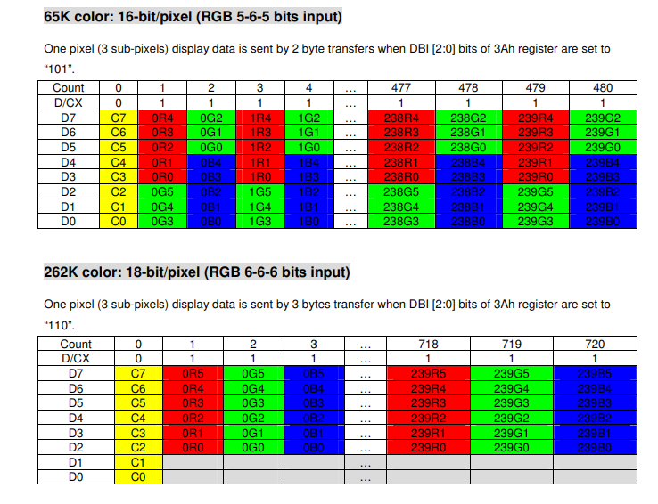

Command Reference

Initialisation
These are the commands send by ili9341_init in ili9341.h from the Il Matto library

Initial Conditions and Hardware Reset
TFT_PCTRL = 0xFF & ~TFT_FMK; // Set FMARK as input pin
TFT_WCTRL = 0xFF & ~TFT_BLC; // Disable background light

RECV(); //Switch DATA port to INPUT and enable pullups

// Hardware Reset
LOW(TFT_RST); // Assert Active Low Reset
LOW(TFT_CS); // Assert Active Low Chip Select
HIGH(TFT_WR); // Put the Read/Write Strobes HIGH
HIGH(TFT_RD);
HIGH(TFT_RS); // Put the IO bus in Data Mode
HIGH(TFT_VSY); // Put VSYNC HIGH
_delay_us(10); // Min: 10us delay for hardware reset
HIGH(TFT_RST); // deassert RESET pin
_delay_ms(120); // wait until we are fully out of reset

Software Setup

SEND(); // Switch DATA port to OUTPUT
ili9341_cmd(0x28); // Display OFF
ili9341_cmd(0x11); // Exit Sleep Mode
_delay_ms(120);
ili9341_cmd(0x34); // Tearing Effect Line OFF
ili9341_cmd(0x38); // Idle Mode OFF
ili9341_cmd(0x13); // Normal Display Mode ON
ili9341_cmd(0x20); // Display Inversion OFF
ili9341_cmd(0x3A); // COLMOD: Pixel Format Set
ili9341_data(0x55); // 16 bits/pixel
ili9341_cmd(0x36); // Memory Access Control
ili9341_data(0x48); // Column Adress Order, BGR
ili9341_cmd(0x2C); // Memory Write
for (r = 0; r < 320; r++) // Black screen
for (c = 0; c < 240; c++) {
ili9341_data(0x00);
ili9341_data(0x00);
ili9341_data(0x00);
}
ili9341_cmd(0xB1); // Frame Rate control, normal
ili9341_data(0x00); // 70Hz
ili9341_data(0x1B);
ili9341_cmd(0xB3); // Frame Rate control, partial
ili9341_data(0x00); // 70Hz
ili9341_data(0x1B);
ili9341_cmd(0x29); // Display On

Commands

COLMOD Settings (0x3A) Pixel Format Settings
we write 0x55 for 16-bit colour or 0x66 for 18-bit colour
0x2A Column Address Set
Write 2 16 bit numbers of the Start Column and End Columnn
SC[15:8] SC[7:0] EC[15:8] EC[7:0]
Default Start Column = 0x0000 = 0
Default End Column = 0x00EF = 239
0x2B Page Address Set
Write 2 16 bit numbers of the Start Page (row) and End Page (row)
SP[15:8] SP[7:0] EP[15:8] EP[7:0]
Default Start Row = 0x0000 = 0
Default End Row = 0x013F = 319

0x2C Memory Write
This starts the writing of memory to the framebuffer

Pinout
ILI9341 Datasheet Pin | Direction | Il Matto Display Schematic Pin | Description
IM[3:0] | I | IM[3:0] (GND) | MCU Interface Mode
RESX | I | RESET | Active Low Reset
EXTC | I | Unused/NC? | Extended Command Set Enable (extended commands not available)
CSX | I | CS | Active Low Chip Select
D/CX | I | RS | Data/Command Select
RDX | I | RD | Read Strobe (rising)
WRX | I | WR | Write Strobe (rising)
D[17:0] | IO | D[7:0] | Parallel Data Bus
SDI/SDA | IO | SDI (GND) | Serial Data In
SDO | O | SDO (floating) | Serial Data Out
TE | O | FMARK? | Tearing Effect Output to synchronise MPU to frame writing, activated by SW command (else LOW)
DOTCLK | I | DOTCLK (GND) | RGB Mode Pixelclk
VSYNC | I | VSYNC | VSYNC input
HSYNC | I | HSYNC (GND) | HSYNC input
DE | I | ENABLE (GND) | Data Enable Signal for RGB mode

Additionally, we have BLC on the Il Matto Display module that activates LEDK[3:1]
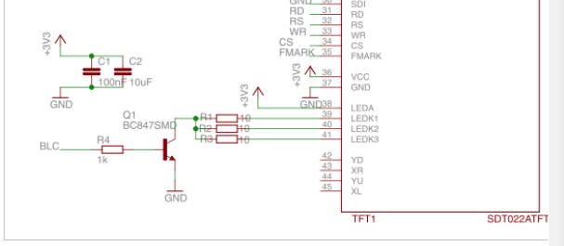

Controller Notes – Adding BRAM and colour conversion
We want a framebuffer BRAM that is 256x320 for easy address calculation
In portrait mode:
Address [7:0] is the column addresses X (8 bits)
Address [16:8] is the row address Y (9 bits)

What are we storing (note, we can use different read/write widths if thats what we want):
Lets start with 8 bit colour (3-3-2 RGB) to nicely match with processors

Scaling 8 bit to 16 bit (5-6-5 RGB)

Red
3 bit 0-7 to 5 bit 0-31

Green
3 bit 0-7 to 6 bit 0-63

Blue
2 bit 0-3 to 5 bit 0-31

Image Conversion using GIMP
See https://www.youtube.com/watch?v=uqY3FMuMuRo for more details

Resizing (to 320x240 or 240x320)
Image → Scale Image

Crop
Image → Canvas Size
Can drag to adjust what gets cropped out

Change Colour Palette
Image → Mode → Indexed Colour

I have made a new Palette from the wikipedia image of 8bit GRB (3-3-2) and this can be selected to adjust the image. Images with lots of similar colours should enable dithering for best results.

Rotating
The image should be rotated if necessary to be portrait 240x320

Exporting
File → Export As → PNG (leave all settings default)

Convert PNG to HEX
Activate the vivado/ virtual environment
https://code.visualstudio.com/docs/python/python-tutorial
.venv/scripts/activate
You may need to allow scripts to run with
Set-ExecutionPolicy -ExecutionPolicy RemoteSigned -Scope Process

Then run the conversion script convert_png_to_hex.py
The output file is 1 byte (pixel) per line, with the following format
GGGRRRBB
I think something is odd with the Palette GIMP created. Regardless, this is manageable as long as we bear this in mind.

