**오픈소스기초설계**

**셸 스크립트 과제 제출**

**숭실대학교 AI융합학부**

**20243305 하정훈**

1. **ex3-0.sh**

**코드**

| echo 'hello world' |
| --- |

**결과**

1. **ex3-1.sh**

**코드**

| count=${3:-10}  for i in $(seq 1 $count)  do  echo "hello, world"  done  exit 0 |
| --- |

**결과**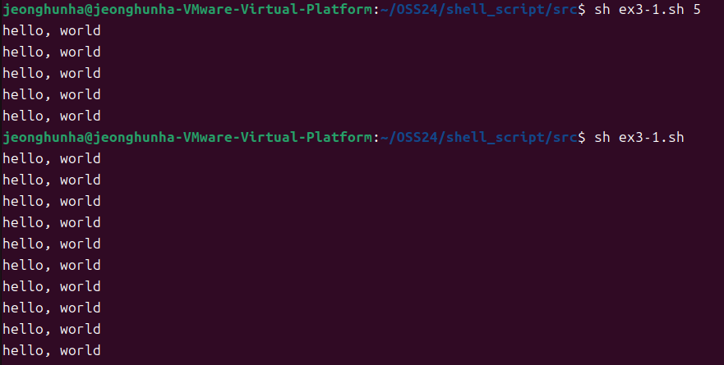

1. **ex3-2.sh**

**코드**

| num1=$1  operator=$2  num2=$3  if [ "$operator" = '+' ]; then  result=$((num1 + num2))  echo "$result"  elif [ "$operator" = '-' ]; then  result=$((num1 - num2))  echo "$result"  else  echo "유효하지 않은 연산자입니다."  fi  exit 0 |
| --- |

**결과**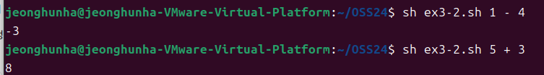

1. **ex3-3.sh**

**코드**

| height=$1  weight=$2  bmi=$(echo "scale=1; ($weight * 10000) / ($height * $height)" | bc)  if [ $(echo "$bmi <= 18.5" | bc) -eq 1 ]; then  echo "저체중입니다."  elif [ $(echo "$bmi > 18.5" | bc) -eq 1 ] && [ $(echo "$bmi < 23.0" | bc) -eq 1 ]; then  echo "정상체중입니다."  else  echo "과체중입니다."  fi  exit 0 |
| --- |

**결과**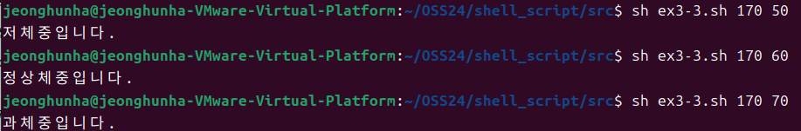

1. **ex3-4.sh**

**코드**

| echo "리눅스가 재미있나요?(yes / no)"  read answer  case "$answer" in  y|Y|yes|Yes|YES|yesyes|yesyesyes)  echo "yes" ;;  n|N|no|No|NO|nono|nonono)  echo "no" ;;  *)  echo "yes or no로 입력해 주세요.";;  esac  exit 0 |
| --- |

**결과**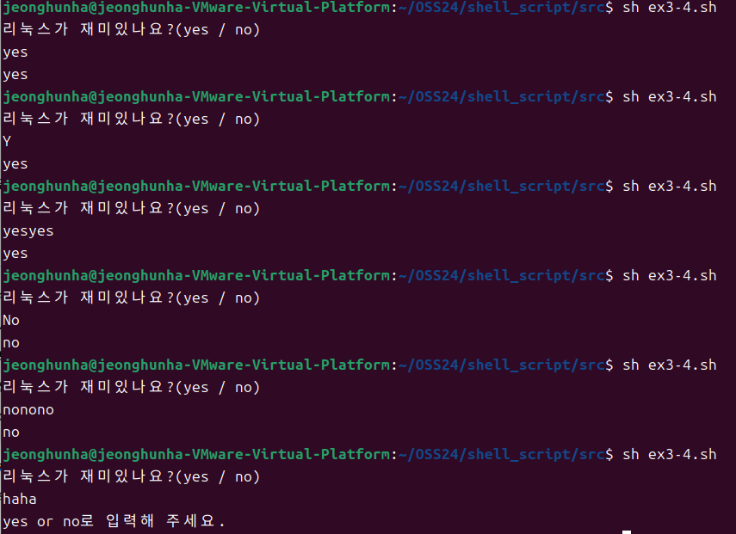

1. **ex3-5.sh**

**코드**

| func() {  echo "함수 안으로 들어 왔음"  ls "$@"  }  echo "프로그램을 시작합니다."  func "$@"  echo "프로그램을 종료합니다."  exit 0 |
| --- |

**결과**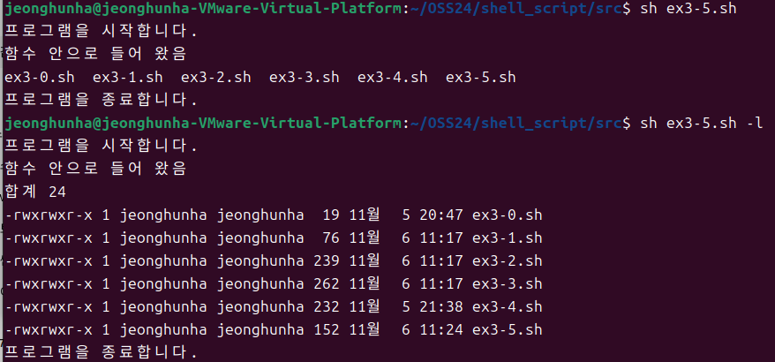

1. **ex3-6.sh**

**코드**

| folder_name=$1  if [ -d "$folder_name" ]; then  echo "$folder_name 폴더는 존재하므로 폴더 생성하지 않습니다."  else  mkdir $folder_name  fi  cd $folder_name  for i in `seq 0 4`  do  touch "$folder_name$i.txt"  done  mkdir $folder_name  cd $folder_name  tar -cvf $folder_name.tar ../*.txt  tar -xvf $folder_name.tar  exit 0 |
| --- |

**결과**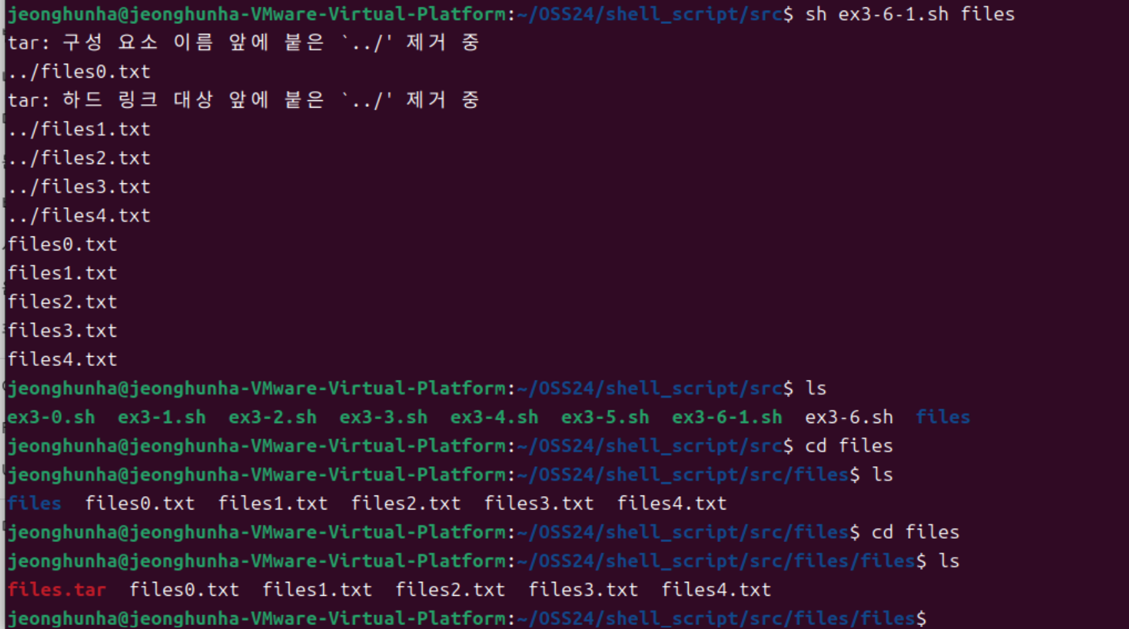

1. **ex3-7.sh**

**코드**

| folder_name=$1  if [ -d "$folder_name" ]; then  echo "$folder_name 폴더는 존재하므로 폴더 생성하지 않습니다."  else  mkdir $folder_name  fi  cd $folder_name  for i in `seq 0 4`  do  touch "$folder_name$i.txt"  mkdir "$folder_name$i"  ln -s "../$folder_name$i.txt" "$folder_name$i/$folder_name$i.txt"  done  exit 0 |
| --- |

**결과**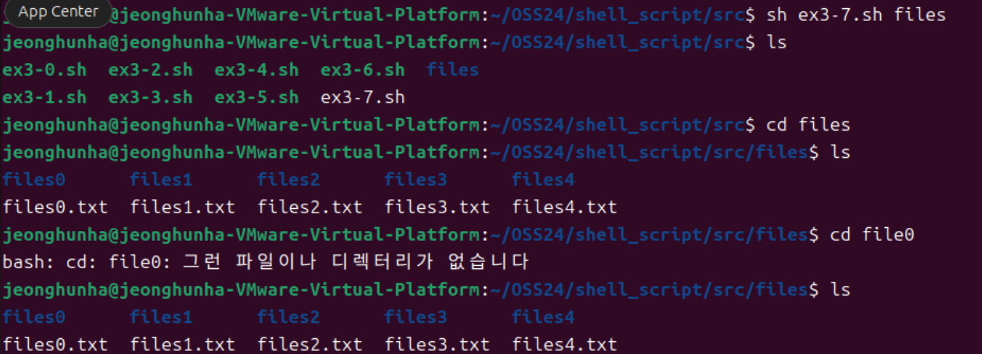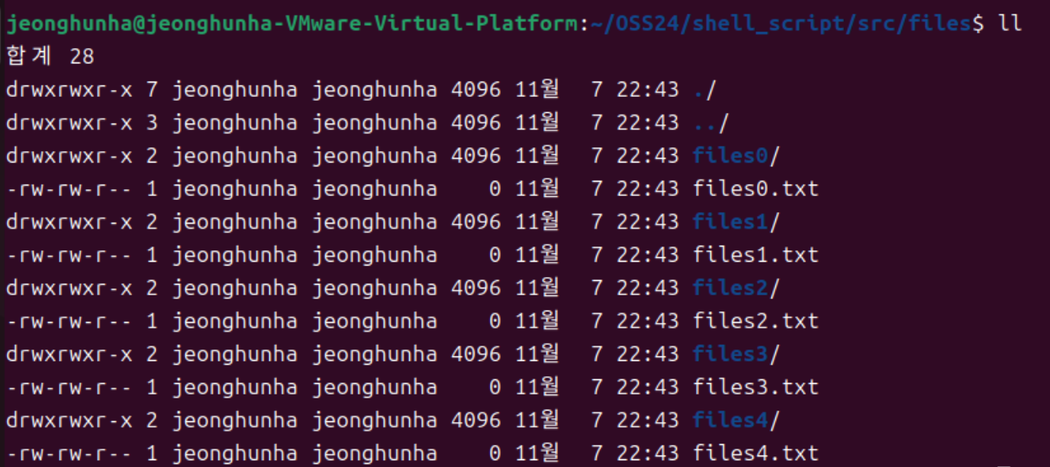

1. **ex3-8.sh**

**코드**

| name=$1  phone=$2  if [ ! -f DB.txt ]; then  touch DB.txt  fi  echo "$name $phone" >> DB.txt  exit 0 |
| --- |

**결과**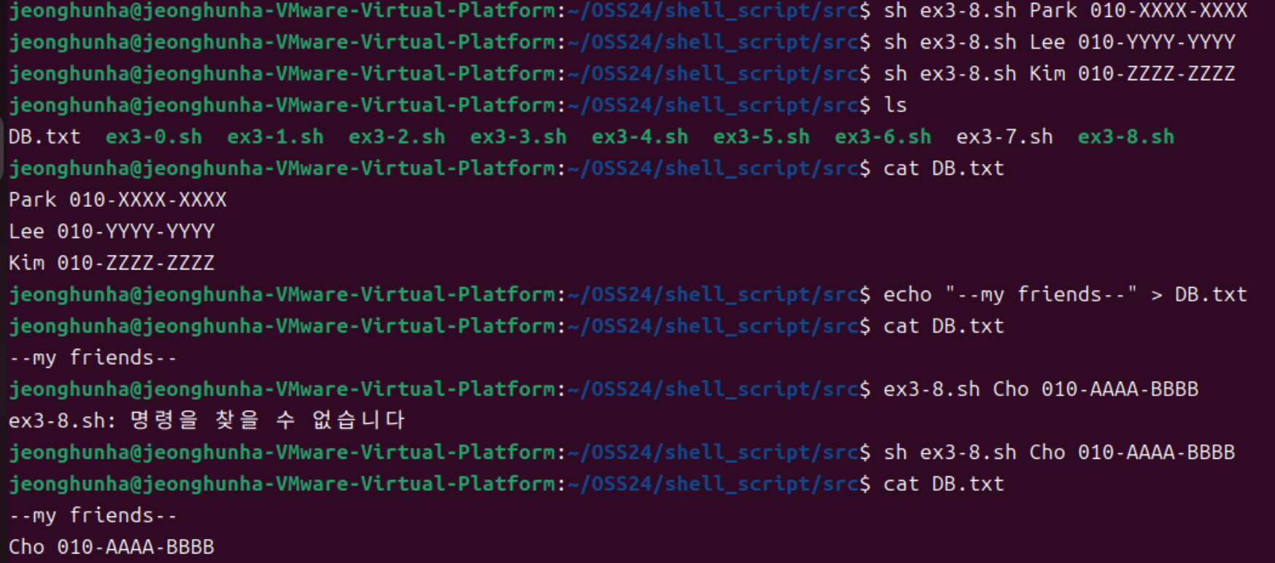

1. **ex3-9.sh**

**코드**

| search_term=$1  if [ ! -f DB.txt ]; then  echo "DB.txt 파일이 존재하지 않습니다."  exit 1  fi  result=$(grep -i "$search_term" DB.txt)  if [ -z "$result" ]; then  echo "해당하는 전화번호가 없습니다."  else  echo "$result"  fi  exit 0 |
| --- |

**결과**