**Hrishikesh Kumar Jha**

**Mobile:** 7776921013**, Personal ID:** [hrishikesh-kumar.a.jha@capgemini.com](mailto:hrishikesh-kumar.a.jha@capgemini.com)**, Address:** NCL Colony, Pune, Maharashtra

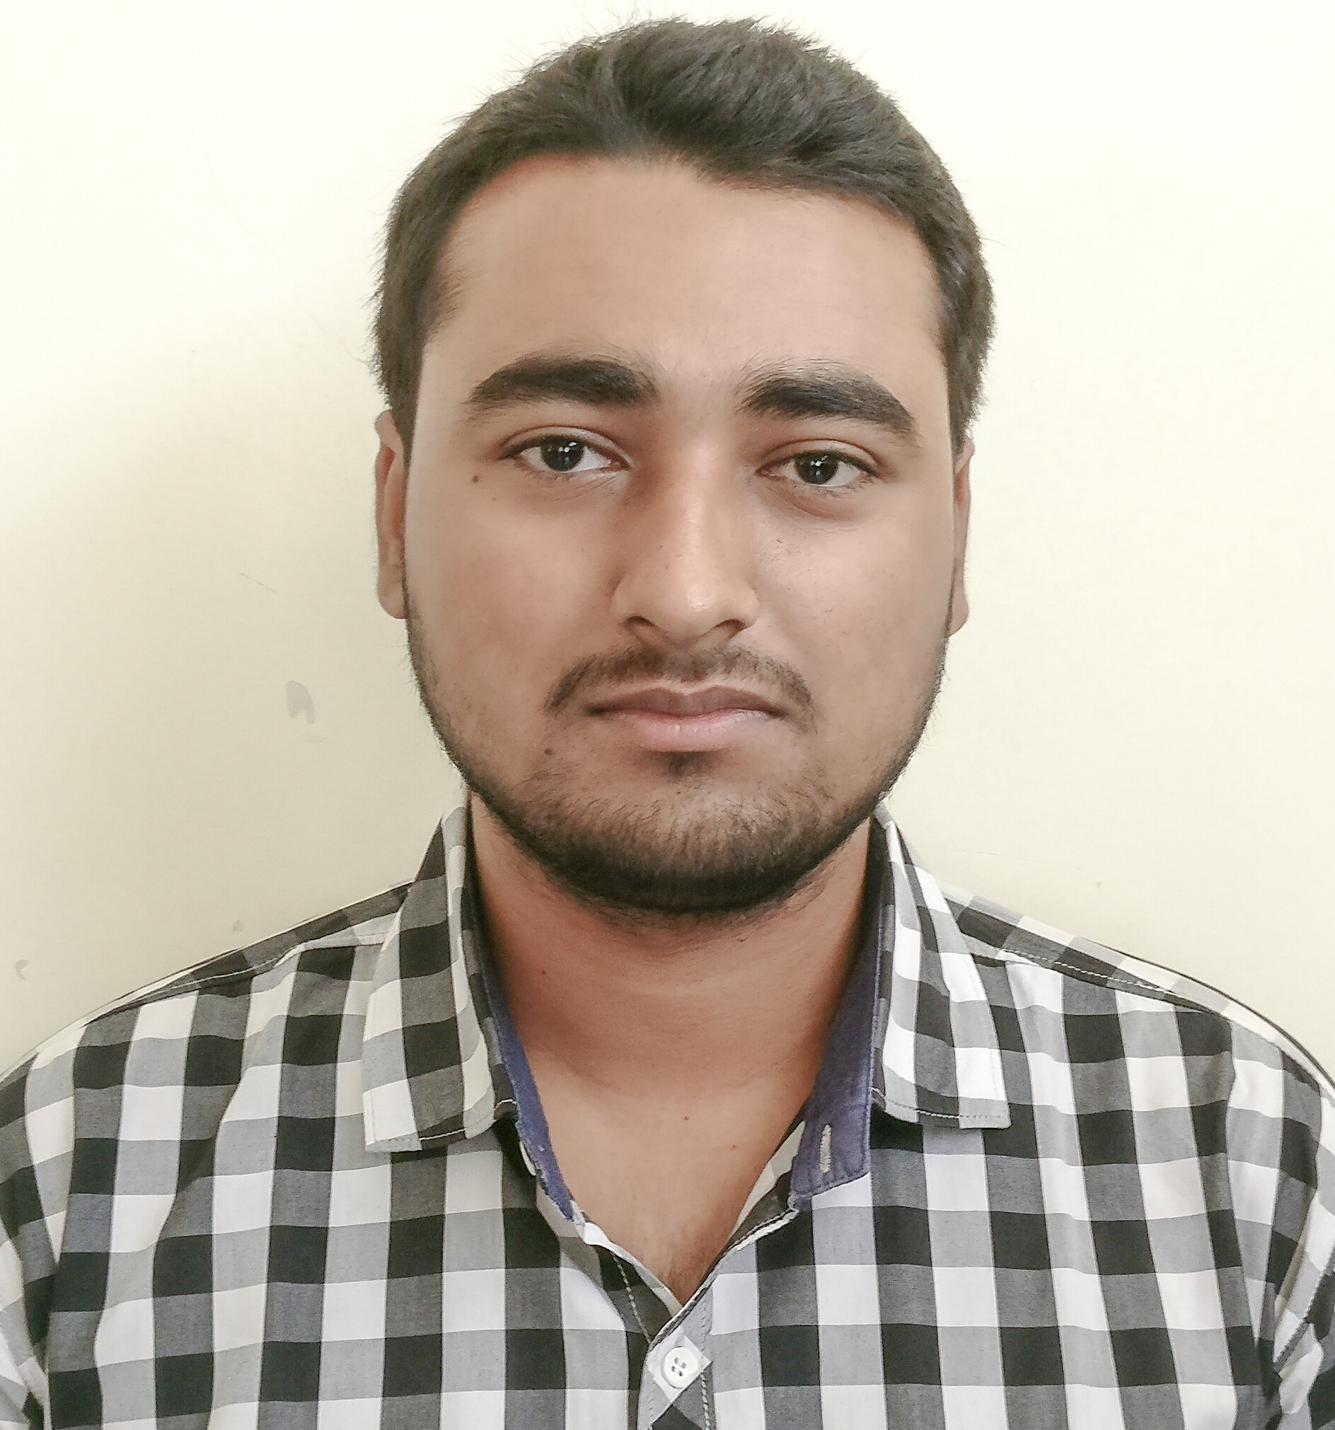

|  |  |
| --- | --- |
| **Title:** | Senior Analyst |
| **Location:** | Pune, India |
| **Languages:** | Hindi (native),English (fluent) |

# Experience Summary

I’ve worked as intern in 2 organizations. I worked on python and data analysis in 2 person team in one of the organization. In another organization I worked on Java Full Stack and also worked in teams of several people for some projects.

From the experience one can say that the strengths I am having are working in different technologies and also a good team mate as I’ve worked in several teams and enjoyed working with them.

**KEY SKILLS:**

* **Functional:** Project Management, Team Building, Strategic/Tactical Planning, Excellent Communication and Interpretation skills
* **Technical:** Java, Oracle Database, C, C++, Spring Boot, Angular

# Experience

|  |  |  |
| --- | --- | --- |
| **01** | **Type of Industry:** | Government Organization |
|  | **Project Description:** | Data Analysis |
|  | **Role/Title:** | Intern |
|  | **Project Duration:** | 2 Months |
|  | **Responsibilities:** | * One needed to study data analysis and apply it on different datasets. Also studied about different methods to encoding categorical variables. |
|  | **Software / Languages:** | Python |
|  | **Special Tools:** | Jupyter Notebook |

|  |  |  |
| --- | --- | --- |
| 02 | Type of Industry: | IT Service |
|  | **Project Description:** | Java Full Stack |
|  | **Role/Title:** | Intern |
|  | **Project Duration:** | 3 Months |
|  | **Responsibilities:** | * Studied and applied various concepts of full stack development. Including frontend as well as backend development. |
|  | **Software / Languages:** | Java, Spring Boot, Angular, HTML, CSS |
|  | **Special Tools:** | Eclipse, Visual Studio, Spring Tool Suite |

##### 

# Training, Certifications & Affiliations

* DBMS (Database Management System) Certification from NPTEL. Covered topics such as Relational Model, SQL, Relational Database Design, Query Processing.
* Intorduction to Internet of Things Certification from NPTEL. Covered topics such as Basics of Networking, Introduction to Arduino, Introduction to Raspberry Pi.

# Published & Presented / Awards

* Published Research Paper in International Journal of Advanced Science and Technology, Volume. 29, No.6. Paper Title: Boosting Performance of Machine Learning based Melanoma Detection using GLCM Features Extracted with Luminance Chromaticity Color Spaces

# Higher Education

* Pimpri Chinchwad College of Engineering – BE (Bachelor of Engineering)