DATA

The data was collected from the finance library “yfinance” in python.

We are studying data from 1981 to 2020 and will forecast for 2021.
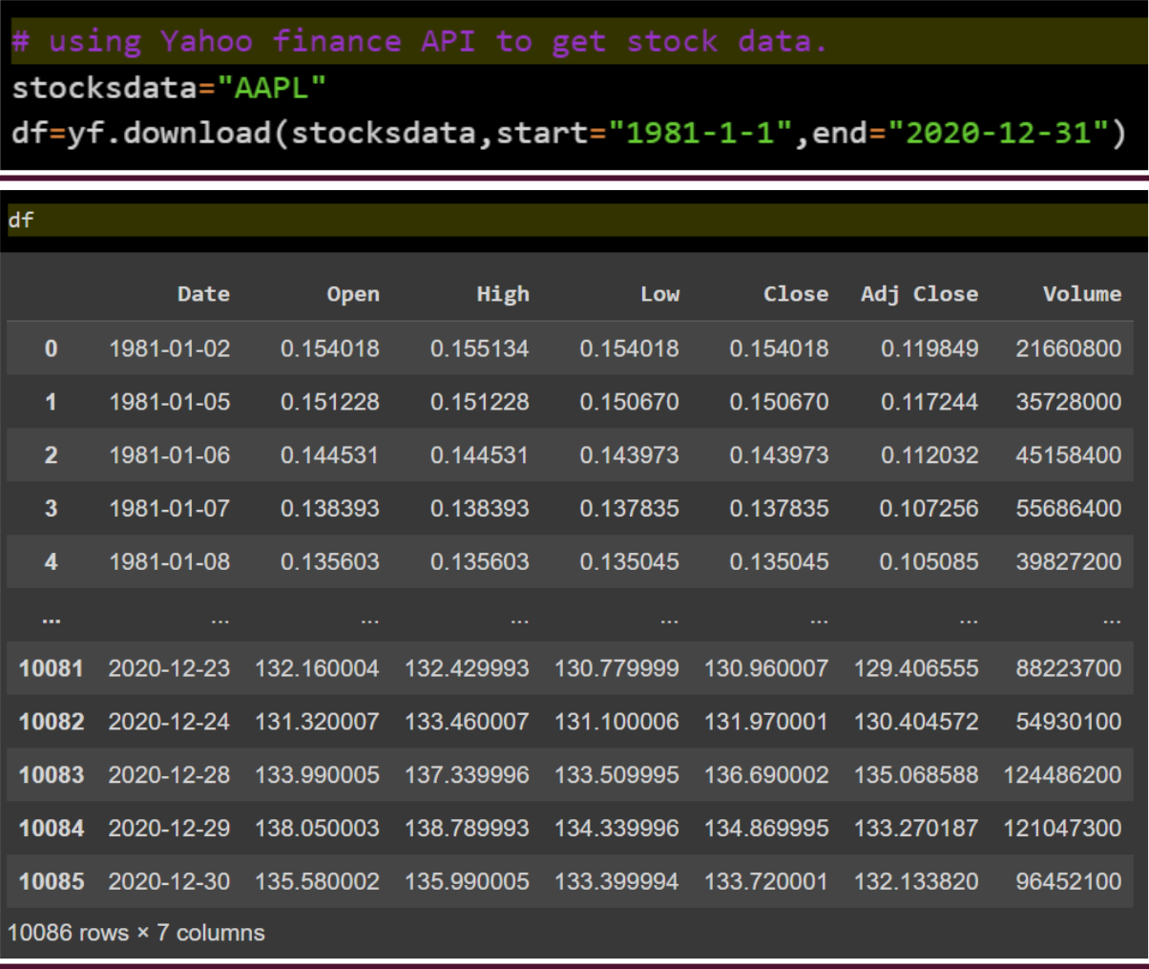
2

Predictions using LR:

Lr of sf adaniport.ipynb - Colaboratory (google.com)

R2-score: 0.9913189150766206
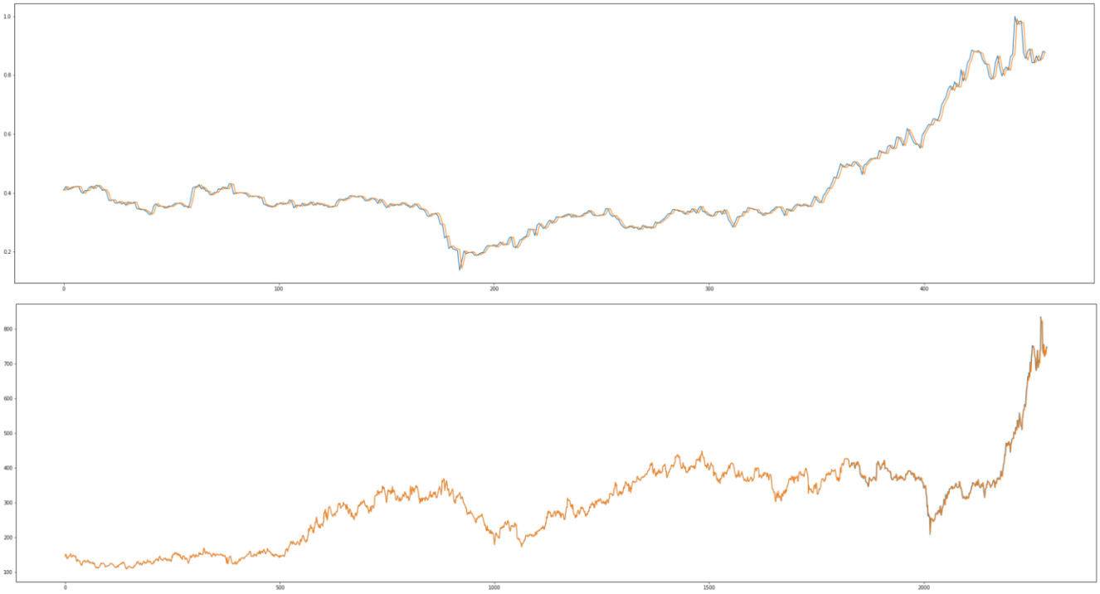
3

Predictions Using LSTM:
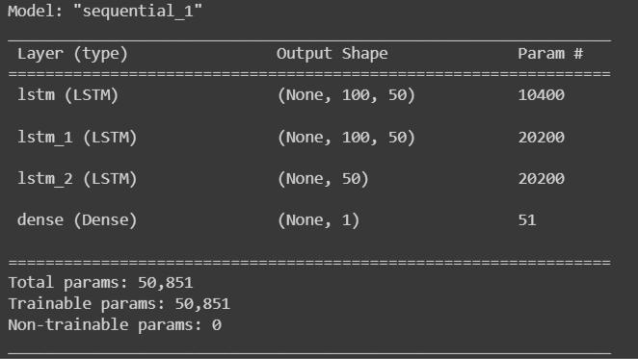

LSTM ARCHITECTURE:
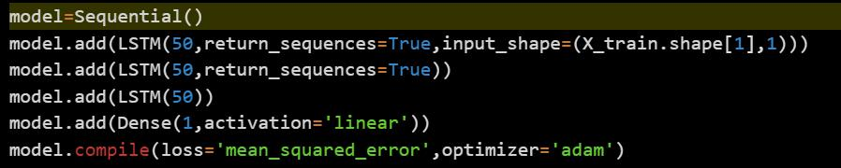

APPLE

4
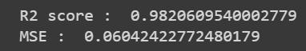

Stock forecasting apple.ipynb - Colaboratory (google.com)
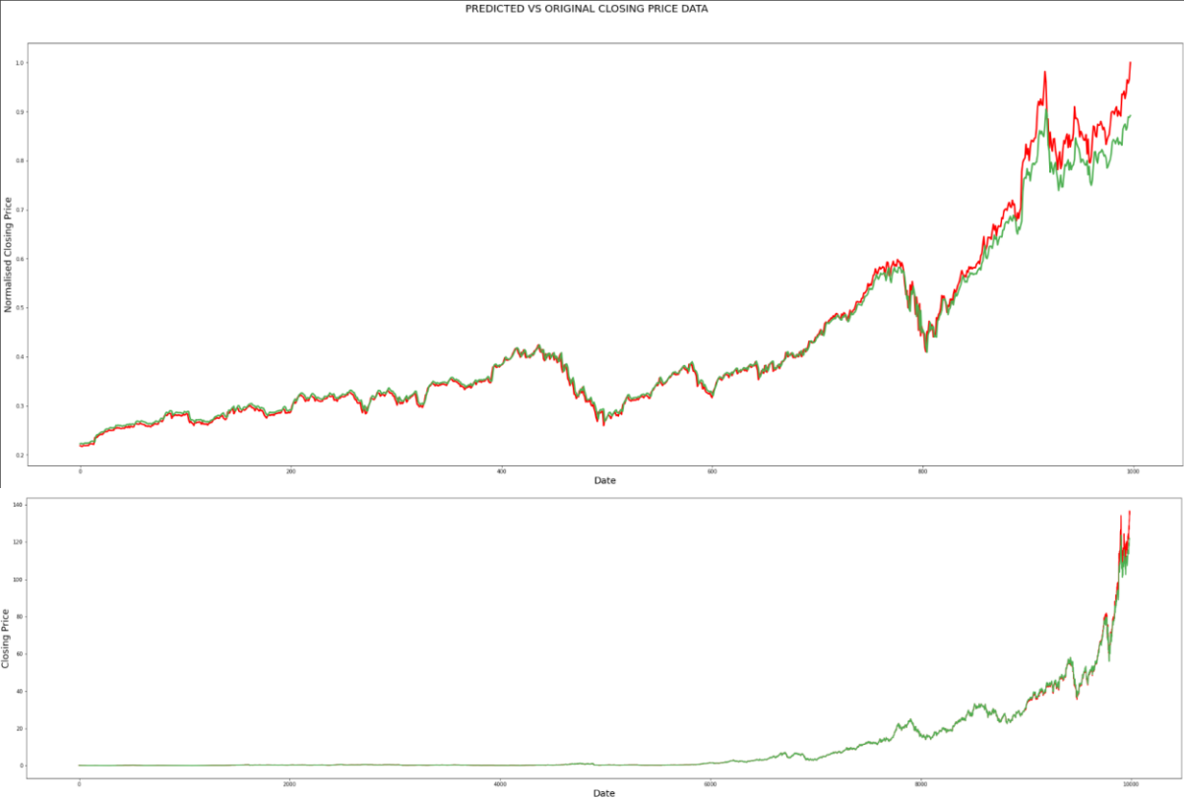

Forecasting USING LSTM:
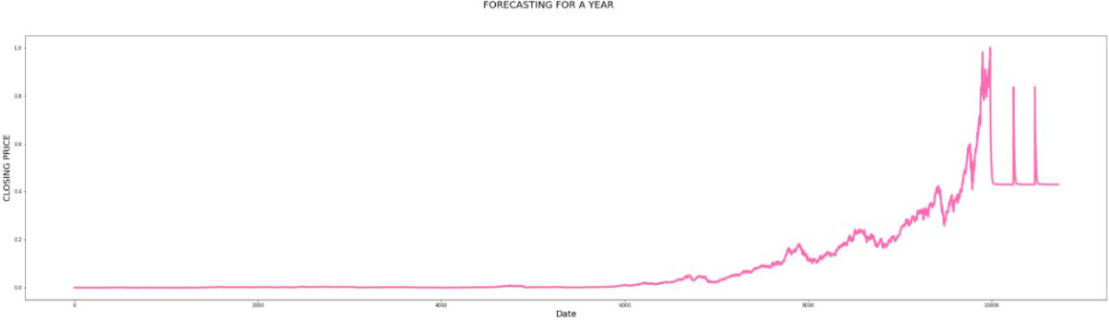

GOLDMAN SACHS

R2-Score - 0.9762633409794264

Stock forcasting GS.ipynb - Colaboratory (google.com)

5
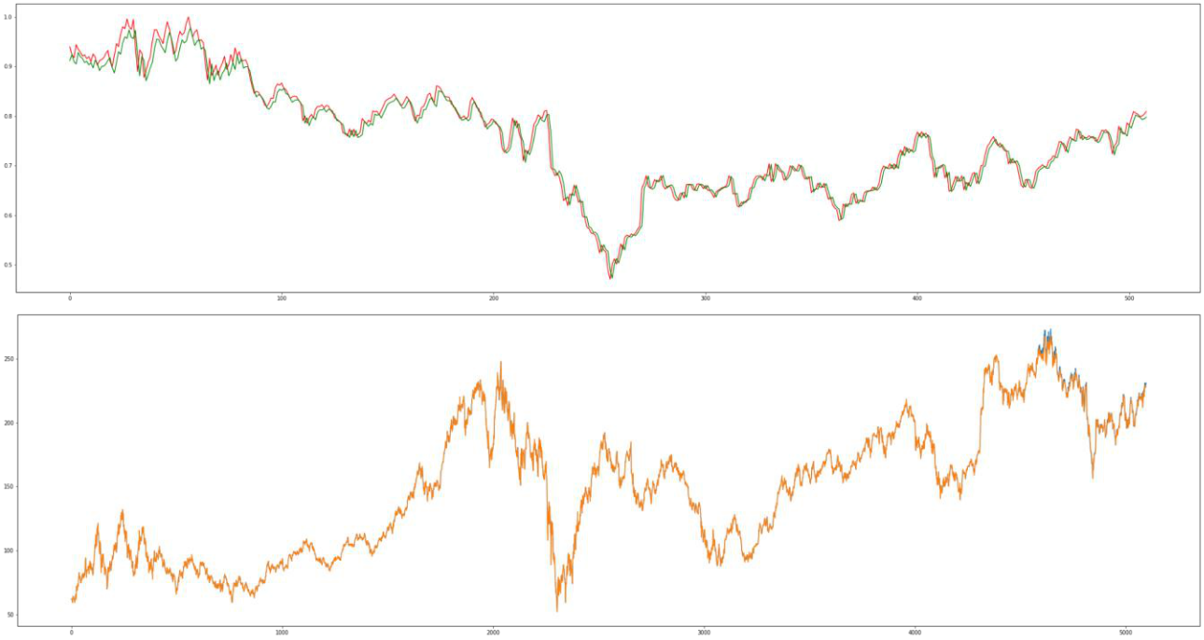

Forecasting USING LSTM:
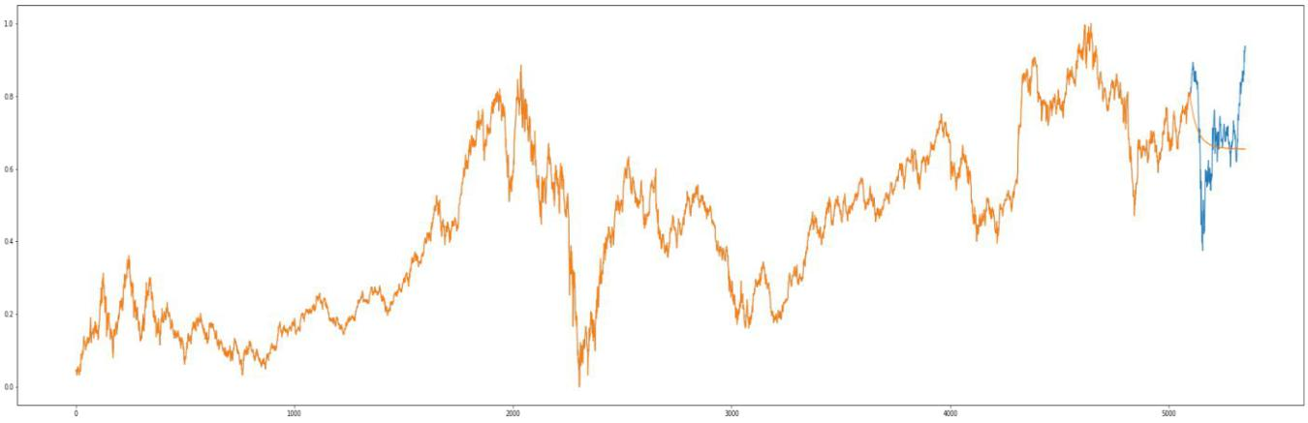

COCA-COLA

R2-Score-0.9630954002841426

Stock forecasting coca-cola.ipynb - Colaboratory (google.com)
6
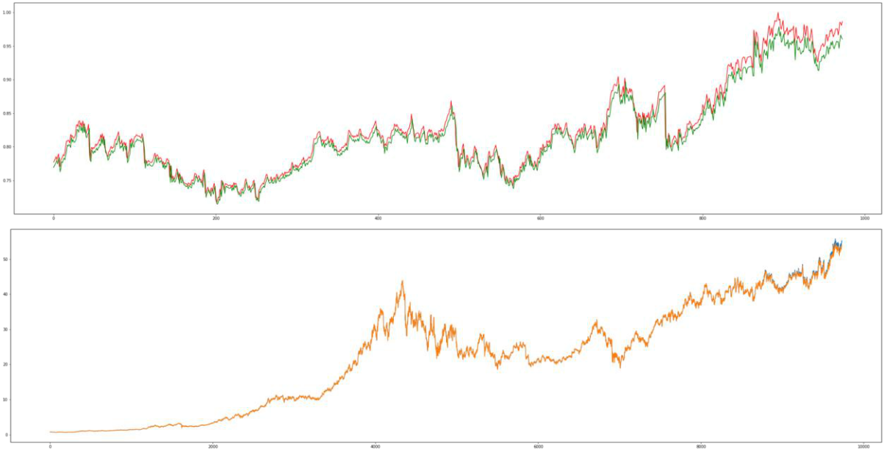

Forecasting USING LSTM:
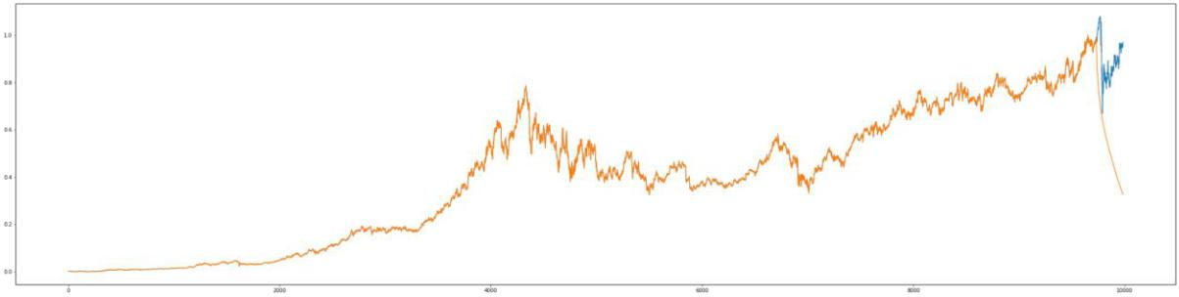

IBM

R2-Score-0.978463002841426

Stock forecasting IBM.ipynb - Colaboratory (google.com)
7
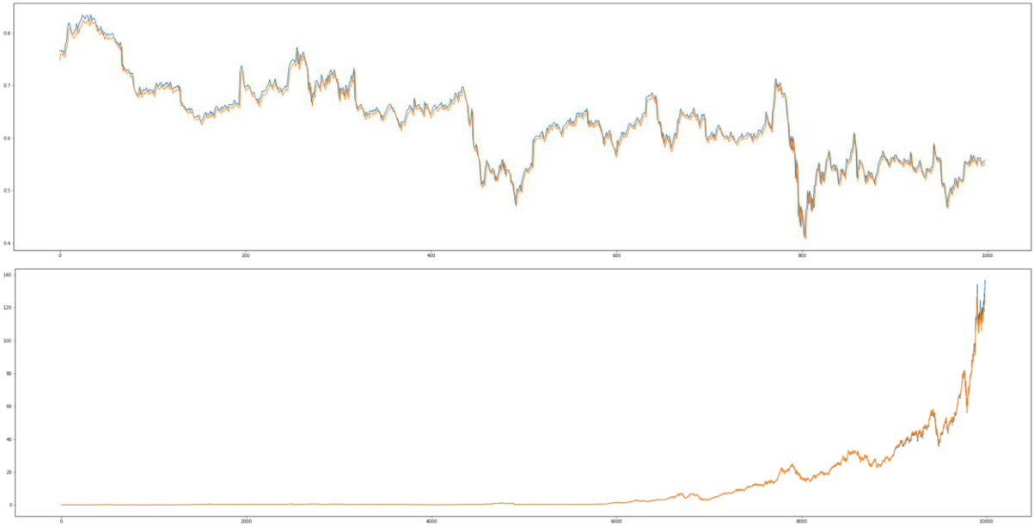
8

USING TRANSFORMERS

APPLE_STOCKS(moving_average).ipynb

Time Embeddings:

Transformers combined with natural language data tend to utilize positional encoding to provide the model with word order. In detail, the positional encoding represents a word’s value and position in a sentence, allowing the Transformer to obtain knowledge about a sentence structure and word inter-dependencies, so for the information of time to go through the network, we will use TIME2VEC.

Time to vector:
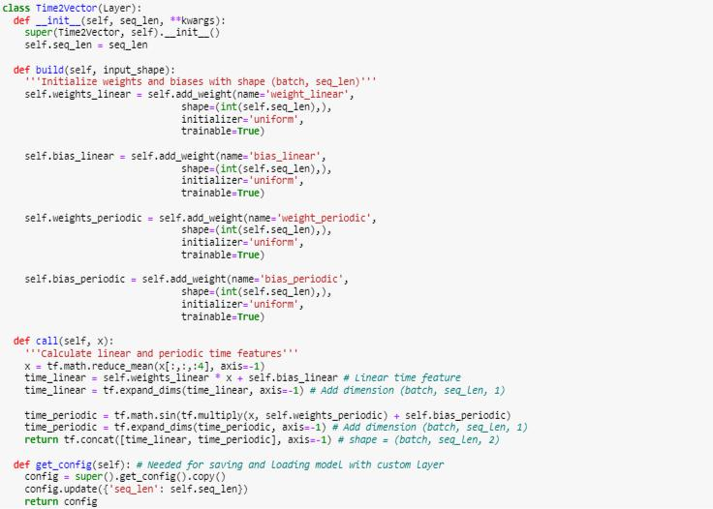
9

Transformer Architecture:
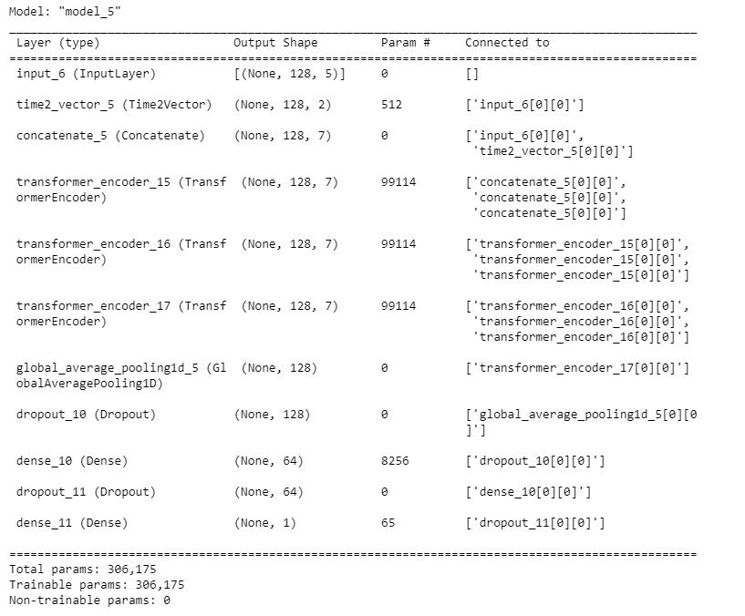
10

RESULT OF TRANSFORMER MODEL:
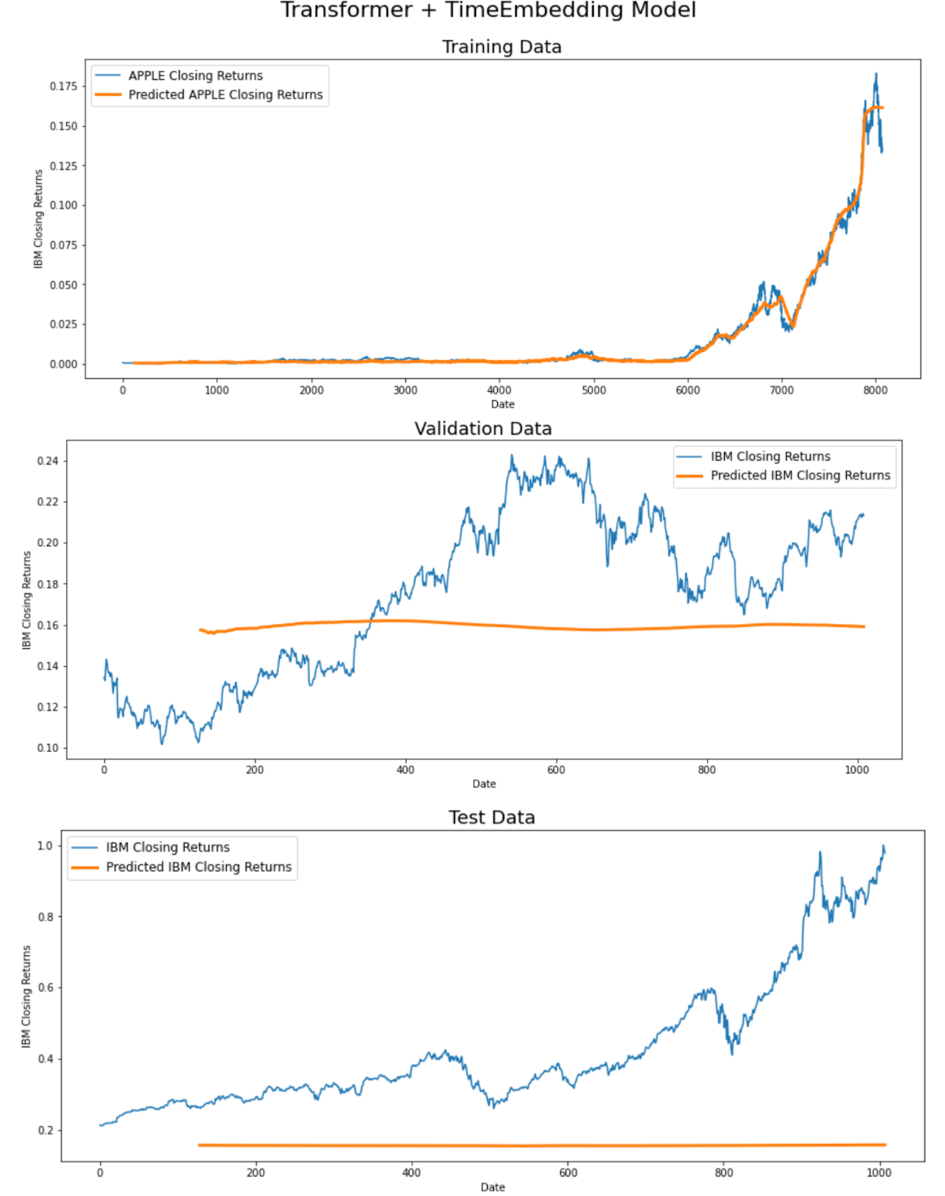

Ig, we can conclude that this transformer model is shit.
11

TEMPORAL FUSION TRANSFORMER

We trained the model to forecast the values of stock closing price for 154 days based on the given context data of 308 days.
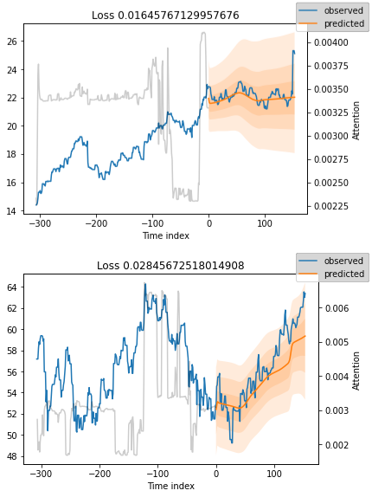
12
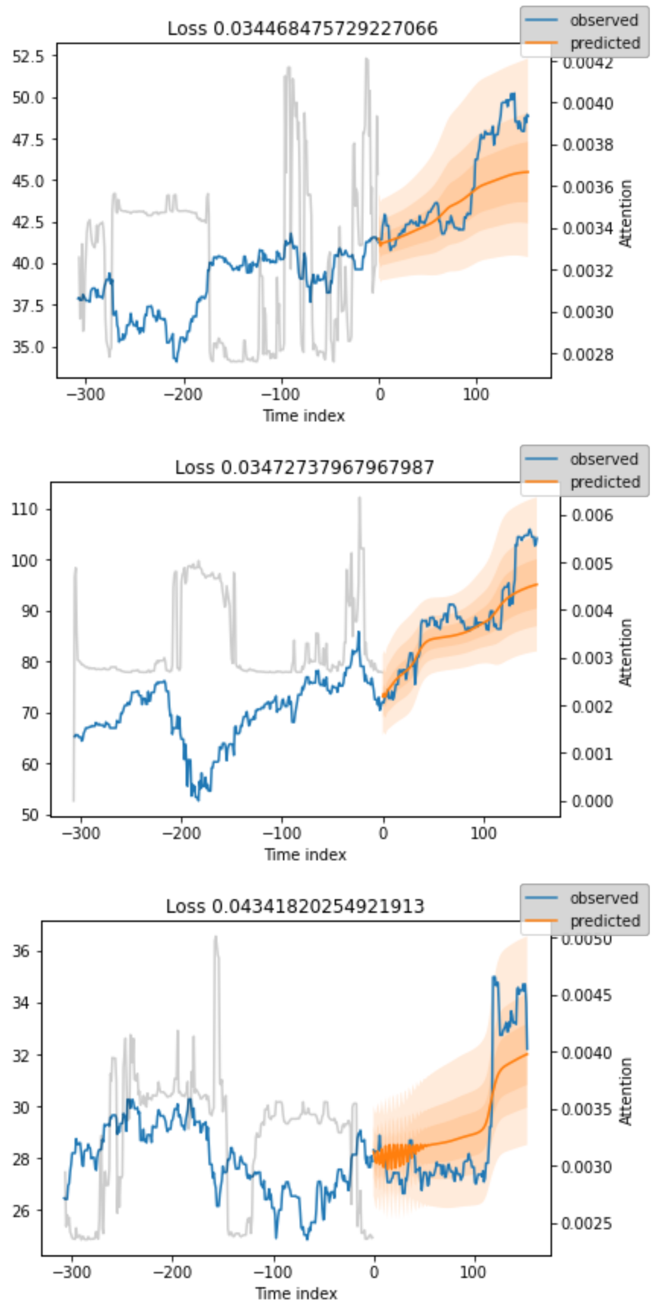
13
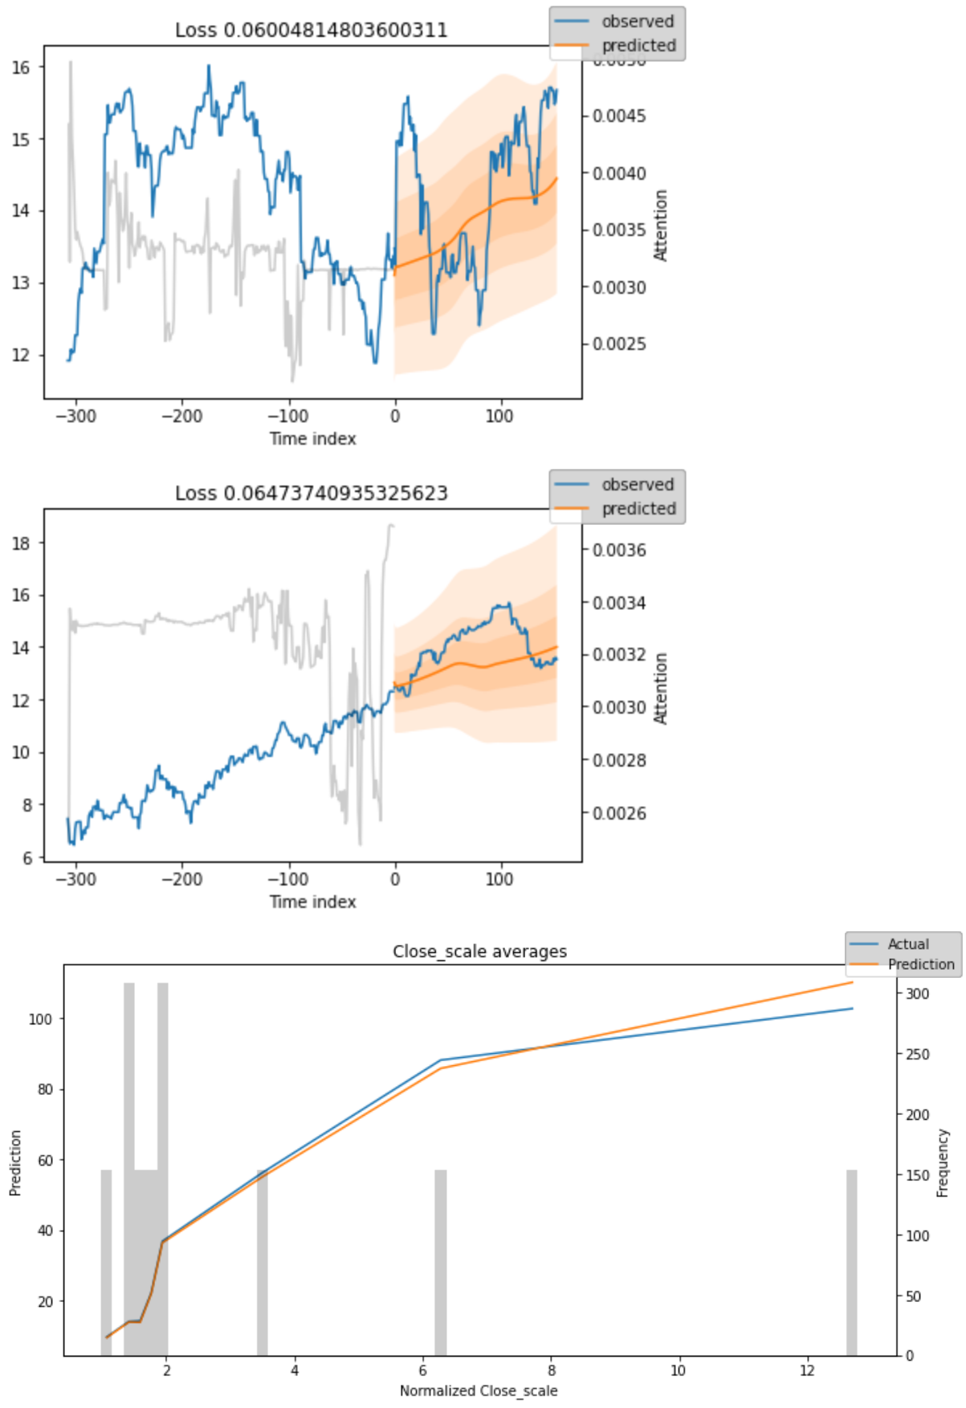

PROPHET - Facebook’s Time Series Forecasting model

14

forcasting using prophet.ipynb - Colaboratory (google.com)

We trained Prophet on apples stocks from 1998 to 2020.
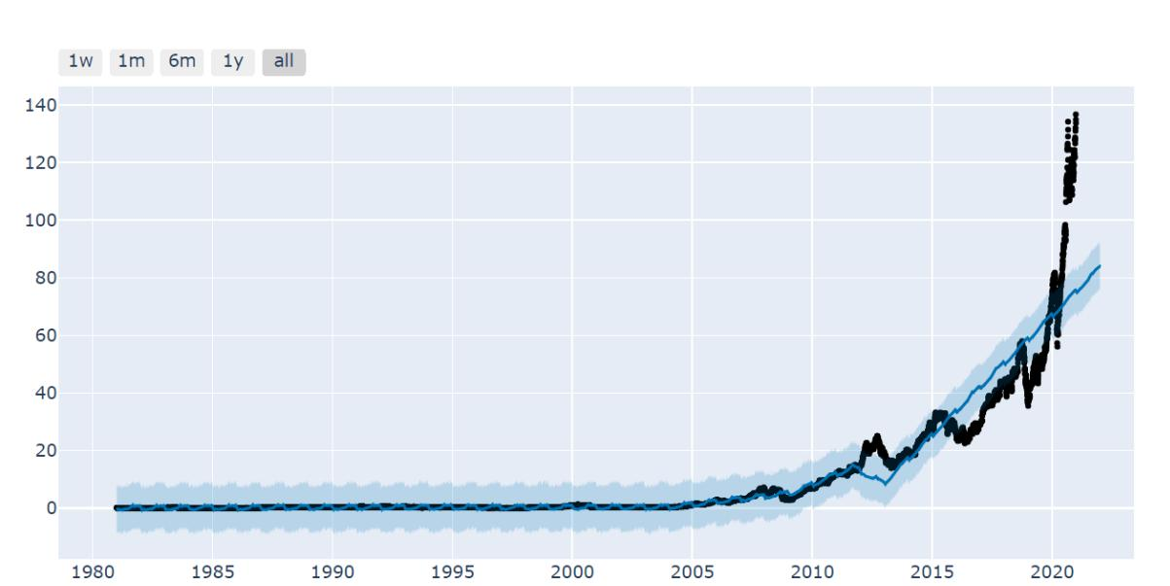

We got following results in forecasting for the year 2021.
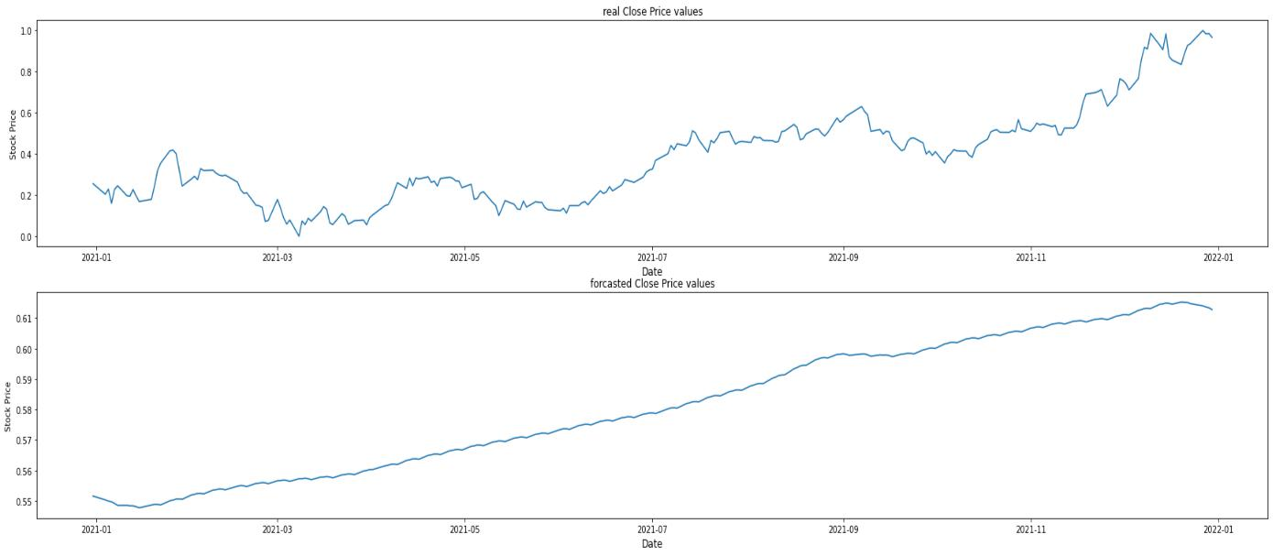

We used the Base model as it was not showing much improvement on hyperparameter tuning.
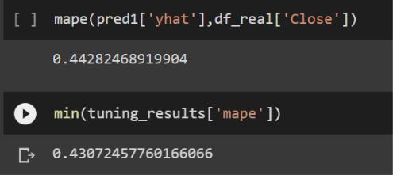
15

Forecasting for One Month.
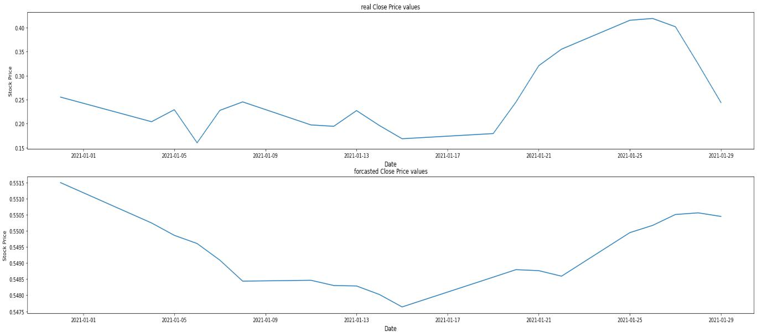
TEMPORAL FUSION TRANSFORMER

We trained the model to forecast the values of stock closing price for 154 days based on the given context data of 308 days.
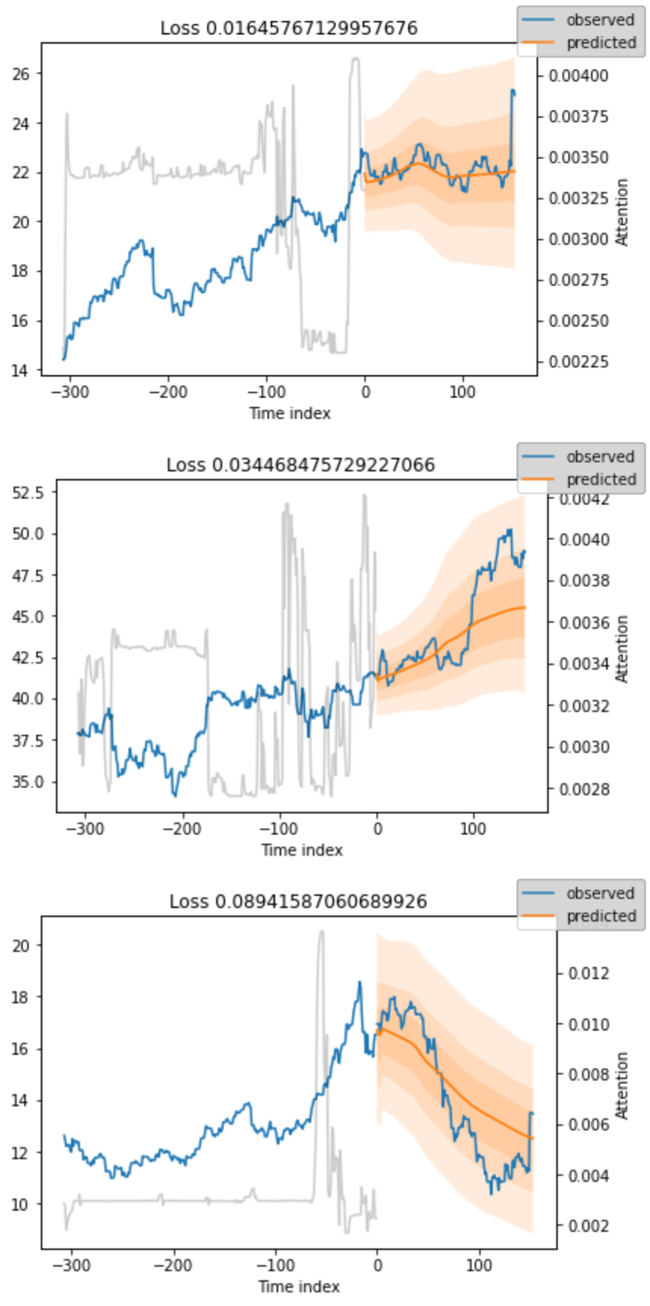
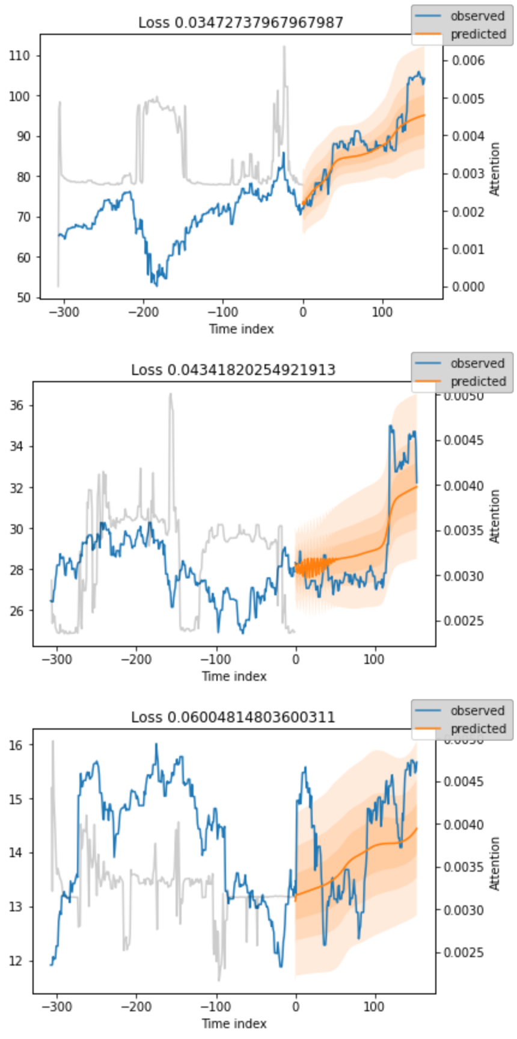
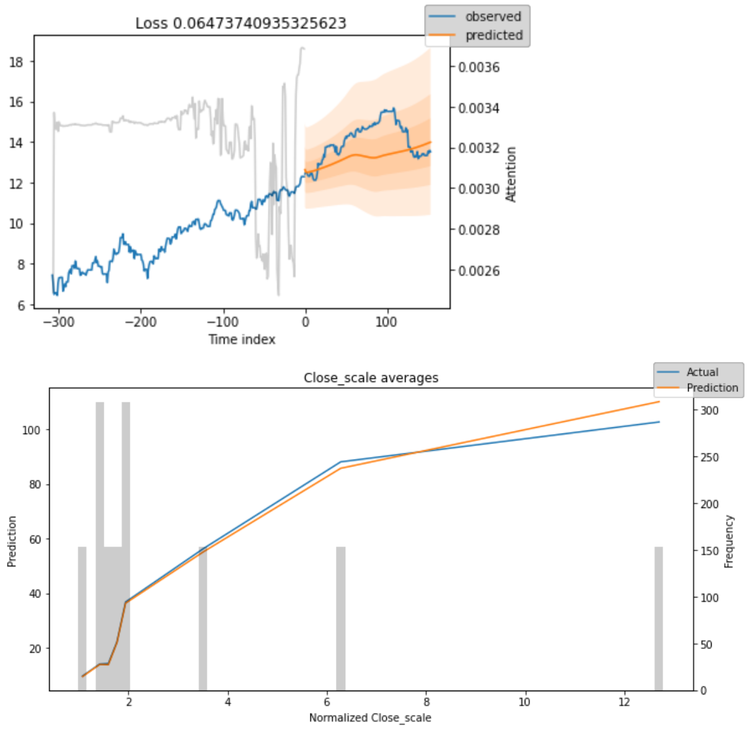

Prophet
