1. **Progress Bar Test Selenium Enable Firefox**

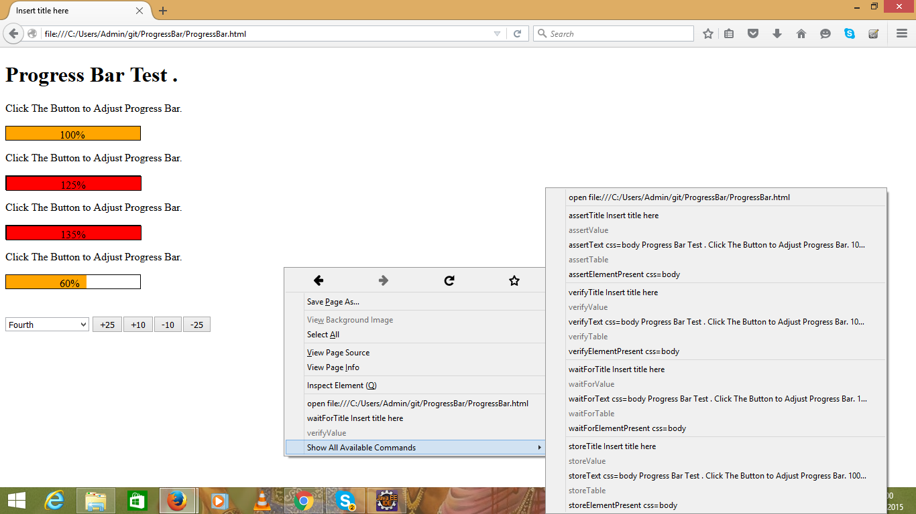

1. **Selenium IDE Test result of Progress Bar**

