SCREENSHOTS

SCREENSHOTS FOR FILE SPLITTER

STEP 1 : Splitter Folder contain the test(.txt) file.

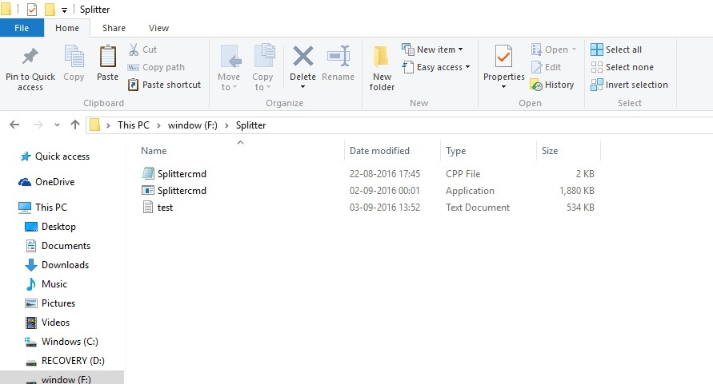

Step2 : Open Command Prompt

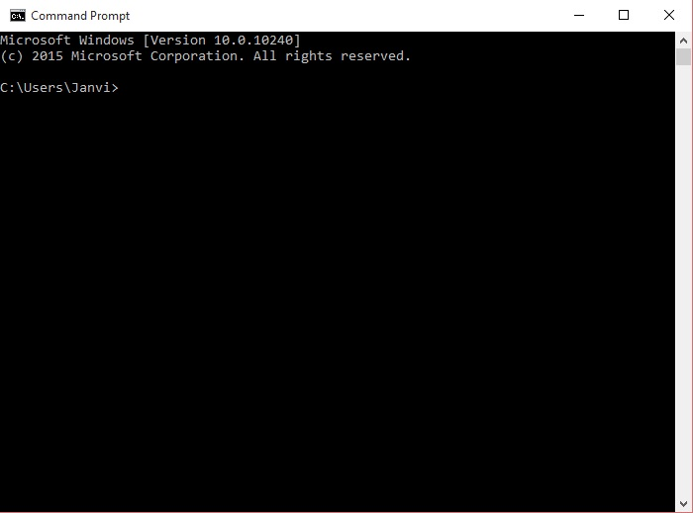

Step 3 : Opening F: drive and Folder Splitter containing Test file that is to be Splitted.

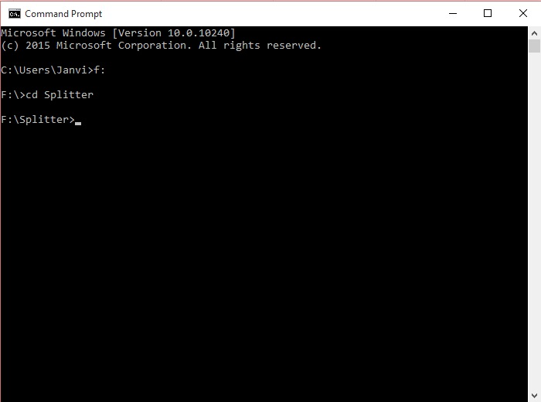

Step 4 : Input

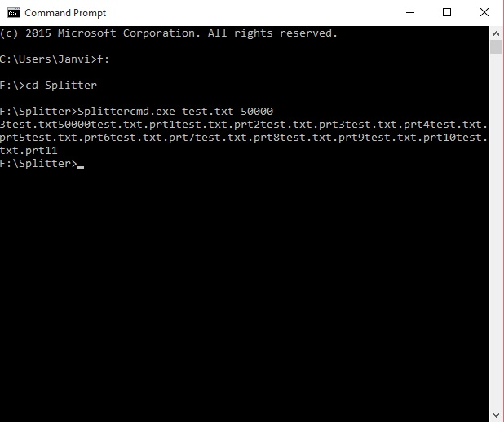

Step 5 : Output – Test File Splitted in 11 parts.

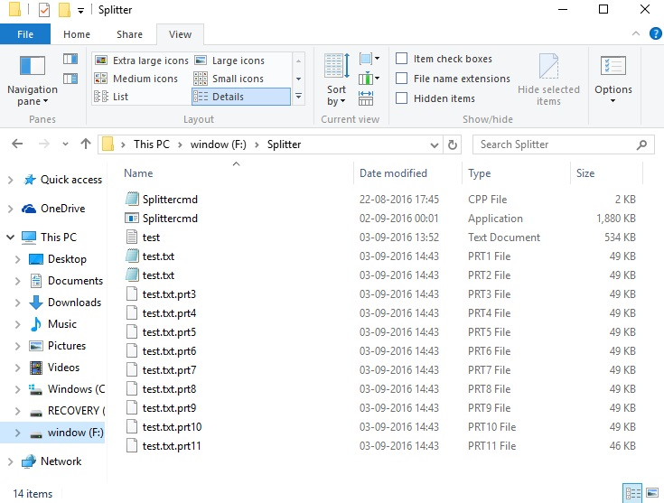

SCREENSHOTS FOR FILE MERGER

STEP 1 : The folder named Merged containing Files to be Merged .Here we have 11 files that we splitted earlier and now we will merge them.

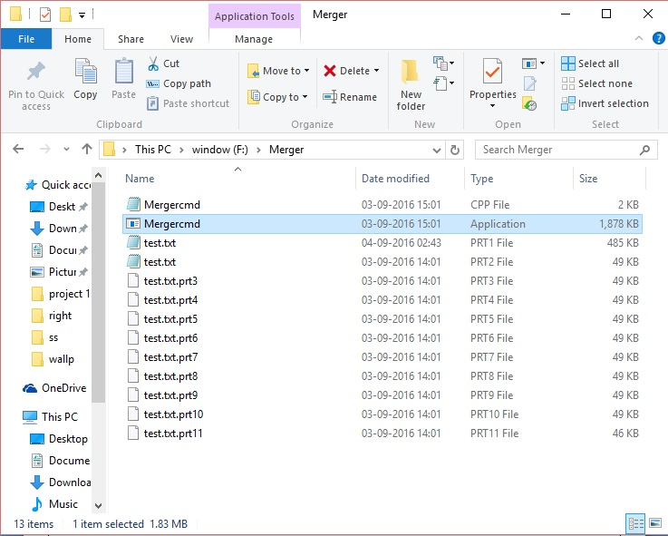

STEP 2 : open command prompt.

STEP 3: Changing Directory and Opening the folder where files are loacated.

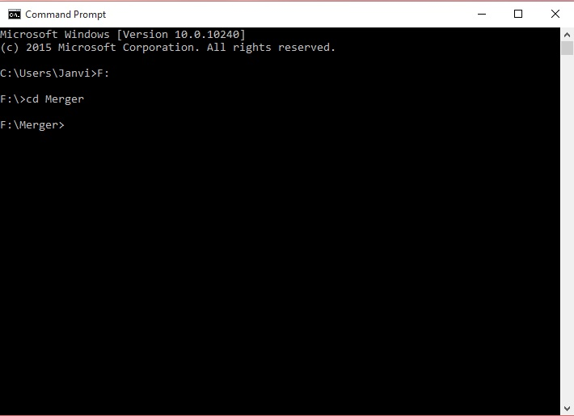

STEP 4 : Enter the inputs and press enter.

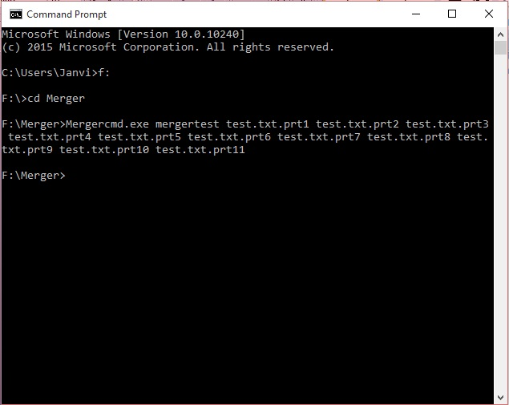

STEP 5 : Now when we open the Merger folder we see a new .txt file mergertest where our files are merged.

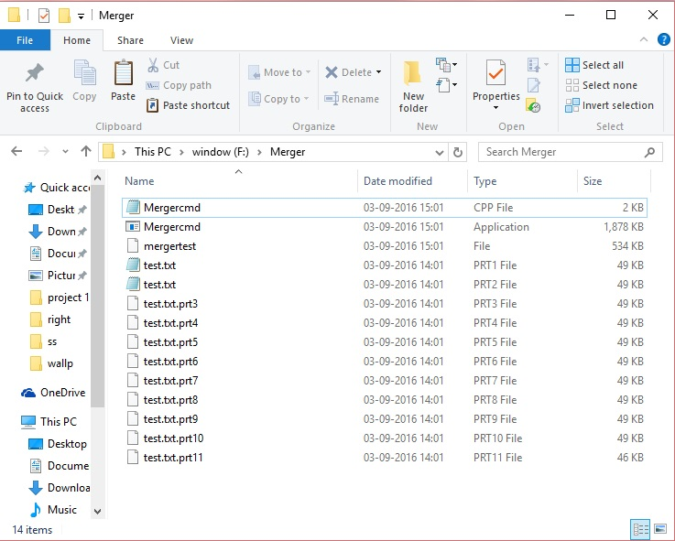

Comparing Size of Splitted File and Merged File

Comparing the Size of Orignal Splitted (test.txt) File and new Merged(merger.txt) File. Size of File test and mergetest is same (i.e. 5,46,616 bytes)

