I work at General Motors (GM) analyzing 12V battery data to identify potential vehicle issues. Since all vehicle electronics draw power from the 12V battery while the vehicle is off, the battery often acts as a "canary in the coal mine" for software problems in off-power mode – such as control units not shutting down properly, or features activating unexpectedly.
To detect these problems, we analyze signals that vehicles transmit to GM’s servers (telemetry) along with diagnostic trouble codes (DTCs). GM also collects approximately real-world usage data from employees who drive company vehicles in their daily lives. We then classify whether a vehicle’s battery is draining excessively and determine if the issue is a previously known problem or a new one requiring deeper engineering investigation.
Some predictors that we use in our classification work are:
- Telemetry signals sent by the vehicle
- Software versions or modules running on the vehicle
- Whether the driver is a known “super user” who may have non-standard equipment installed
- Presence of diagnostic trouble codes (DTCs).

Part A
Note: This is my first time programming in R, so I relied heavily on Google and Stack Overflow; however, all code is original. As recommended all code is saved in a single file Homework1.R. To further organize the code, I placed all analysis for this section in Problem2_PartA.

Methodology
Since I did not know an appropriate value for $C$, I decided to do an initial domain search plotting loss against a range of values. To reduce boilerplate through the rest of the code, I defined a model_generator function defining the parameters laid out in the assignment. Then using sapply as a for loop generated the loss for a range of $C$ values using the svm_plot_range (again to reduce boilerplate).
The caret was used to create a confusion matrix for the chosen model to reveal additional information about the accuracy of the classifier.

Results
The domain search shows a wide range $C$ that the analysis is insensitive to the choice in parameter with a constant error floor from $C = \left[2×{10}^{-3}, 5×{10}^{2}\right]$.
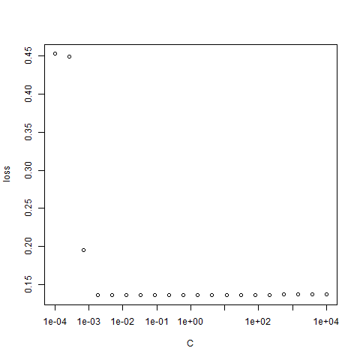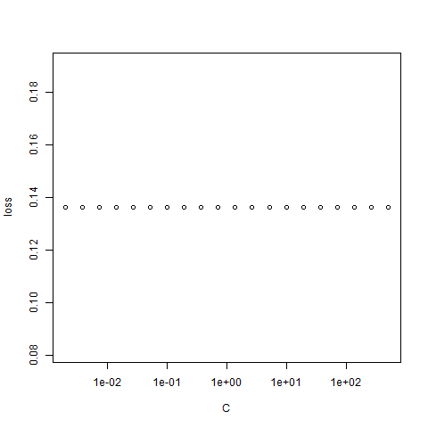
Since there is negligible difference over this range, I will choose to use $C=10$ for the remaining calculations.
Using the code provided in the assignment I exported the coefficients to show the equation for this classifier:
$$0=8.16×{10}^{-2}-9.03×{10}^{-4}A_{1}- 7.89×{10}^{-4}A_{2}-1.70×{10}^{-3}A_{3}+2.61×{10}^{-3}A_{8}+1.01×{10}^{0}A_{9}-2.84×{10}^{-3}A_{10}-1.57×{10}^{-4}A_{11}-3.93×{10}^{-4}A_{12}-1.28×{10}^{-3}A_{14}+1.06×{10}^{-1}A_{15}$$
The confusion matrix for this classifier is:
 |  | Actual
 |  | 0 | 1
Predicted | 0 | 286 | 17
Predicted | 1 | 72 | 279

The accuracy for the classifier is 86.3%.

Discussion of results
The stability across a wide range of hyperparameters points to the classifier not being overfit, which we would generally assume because there are so few parameters relative to the number of datapoints.
The small scale of coefficients except for $A_{9}$ and $A_{15}$ shows the other factors are relatively insignificant, this was verified because limiting to these two factors still generates an error of 86.3%.
We can see that the model is much more likely to misclassify defaulters as safe risks, this points to needing shift the model to be more risk averse.

Part B
Note: This is my first time programming in R, so I relied heavily on Google and Stack Overflow; however, all code is original. As recommended all code is saved in a single file Homework1.R. To further organize the code, I placed all analysis for this section in Problem2_PartB.

Methodology
Similar to the strategy used in Part A, I created a boilerplate function knn_leave_one_out_no_test_set_iteration that fits a KNN for $n$ neighbors while excluding the i^{th} point (using the indexing technique recommended). To find the accuracy of the $n$ nearest neighbors KNN, I used sapply to exclude it from training while using it for inference in the knn_leave_one_out_no_test_set function. The individual nearest neighbor function was used to scan a range of possible neighbors with the results shown below.
The caret was used to create a confusion matrix for the chosen model to reveal additional information about the accuracy of the classifier.

Results
This showed that the best number of neighbors to use is 12 with an accuracy of 85.3%, although all the classifiers performed similarly with a relatively large jump in accuracy for 5 or more neighbors.
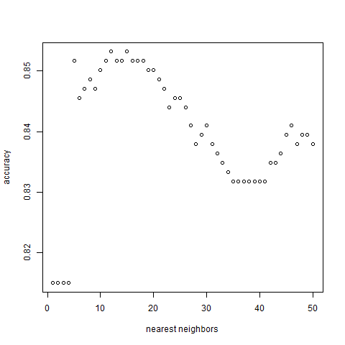

The confusion matrix for this classifier is:
 |  | Actual
 |  | 0 | 1
Predicted | 0 | 308 | 46
Predicted | 1 | 50 | 250

Discussion of results
The KNN classifier is relatively stable across a wide range of parameters and for the k=12 classifier being the highest accuracy is a good sign the model was not overfit to the training data. Additionally, even though the KNN model had slightly worse accuracy (1%), it produced fewer false positives which we were told were more costly than false negatives in this application meaning it may be the “better” model.

