ABSTRACT

Dice Game is so old game and in which game player choose the 1 number and roll the dice if dice number match with player choose number then player win otherwise player loose.

Once Player win then message generate win message otherwise receive loss message.

INDEX

S. N CONTENTS

- INTRODUCTION
2. ANALYSIS
2.1 SYSTEM ANALYSIS
2.2 SYSTEM SPECIFICATIONS
3. DESIGN APPROACH
3.1 INTRODUCTION TO DESIGN
3.2 UML DIAGRAMS
3.3 DATA FLOW DIAGRAMS
3.4 E-R DIAGRAMS
4. PROJECT MODULES
5. IMPLEMENTATION
4.1 CONCEPTS AND TECHNIQUES
4.2 TESTING
4.2.1 TEST CASES
6. OUTPUT SCREENS
7. CONCLUSION
8. FUTURE ENHANCEMENTS
9. BIBILIOGRAPHY

INTRODUCTION:

Dice Game is so old game and in which game player choose the 1 number and roll the dice if dice number match with player choose number then player win otherwise player loose.

Once Player win then message generate win message otherwise receive loss message.

SYSTEM ANALYSIS:

1. Proposed System

The Dice Game system is a software application which avoids more take game of player number and less chance of cheating in game. In this software there is no possible for manual intervention and no way to impact the result of game. Once player choose the number there is no way to change the number and admin have no way to change the result.

3. Objective of the System

The goal of the system is to bring down the cheating and any player play this game from any where.

System Specifications

Hardware Requirements:-
- Pentium-IV(Processor).
- 256 MB Ram
- 512 KB Cache Memory
- Hard disk 10 GB
- Microsoft Compatible 101 or more Key Board

Software Requirements: -
- Operating System : Window / Mac / Ubantu
- Programming language: Javascript
- Web-Technology : HTML
- Web Server : Not Requirement



INTRODUCTION:

Design is the first step in the development phase for any techniques and principles for the purpose of defining a device, a process or system in sufficient detail to permit its physical realization.

Once the software requirements have been analyzed and specified the software design involves three technical activities - design, coding, implementation and testing that are required to build and verify the software.

The design activities are of main importance in this phase, because in this activity, decisions ultimately affecting the success of the software implementation and its ease of maintenance are made. These decisions have the final bearing upon reliability and maintainability of the system. Design is the only way to accurately translate the customer’s requirements into finished software or a system.

Design is the place where quality is fostered in development. Software design is a process through which requirements are translated into a representation of software. Software design is conducted in two steps. Preliminary design is concerned with the transformation of requirements into data.

UML Diagrams:
Actor:
A coherent set of roles that users of use cases play when interacting with the use `cases.

Use case:
A description of sequence of actions, including variants, that a system performs that yields an observable result of value of an actor.

UML stands for Unified Modeling Language. UML is a language for specifying, visualizing and documenting the system. This is the step while developing any product after analysis. The goal from this is to produce a model of the entities involved in the project which later need to be built. The representation of the entities that are to be used in the product being developed need to be designed.
There are various kinds of methods in software design:
They are as follows:
- Use case Diagram
- Sequence Diagram
- Collaboration Diagram
- Activity Diagram
- State chat Diagram

USECASE DIAGRAMS:

Use case diagrams model behavior within a system and helps the developers understand of what the user require. The stick man represents what’s called an actor.
Use case diagram can be useful for getting an overall view of the system and clarifying who can do and more importantly what they can’t do.
Use case diagram consists of use cases and actors and shows the interaction between the use case and actors.

- The purpose is to show the interactions between the use case and actor.
- To represent the system requirements from user’s perspective.
- An actor could be the end-user of the system or an external system.

USECASE DIAGRAM:
A Use case is a description of set of sequence of actions. Graphically it is rendered as an ellipse with solid line including only its name. Use case diagram is a behavioral diagram that shows a set of use cases and actors and their relationship. It is an association between the use cases and actors. An actor represents a real-world object. Primary Actor – Sender, Secondary ActorReceiver.

. 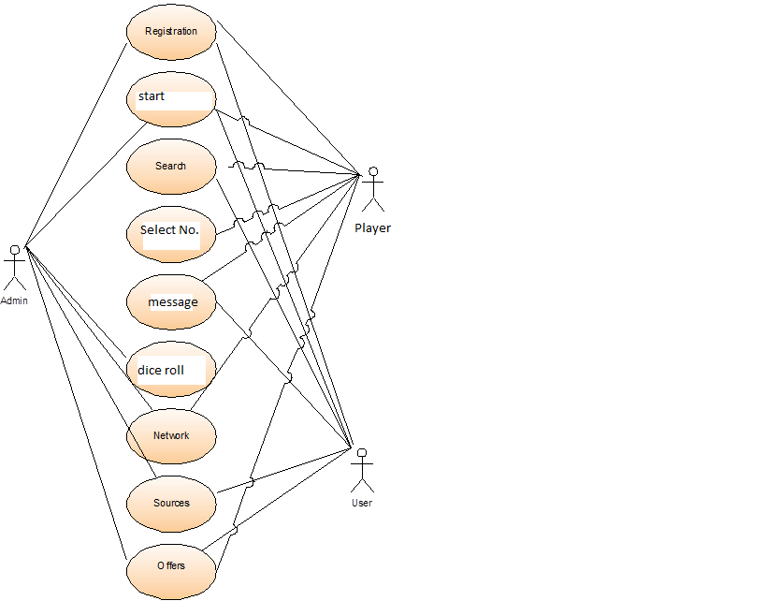

SEQUENCE DIAGRAM:
Sequence diagram and collaboration diagram are called INTERACTION DIAGRAMS. An interaction diagram shows an interaction, consisting of set of objects and their relationship including the messages that may be dispatched among them.
A sequence diagram is an introduction that empathizes the time ordering of messages. Graphically a sequence diagram is a table that shows objects arranged along the X-axis and messages ordered in increasing time along the Y-axis

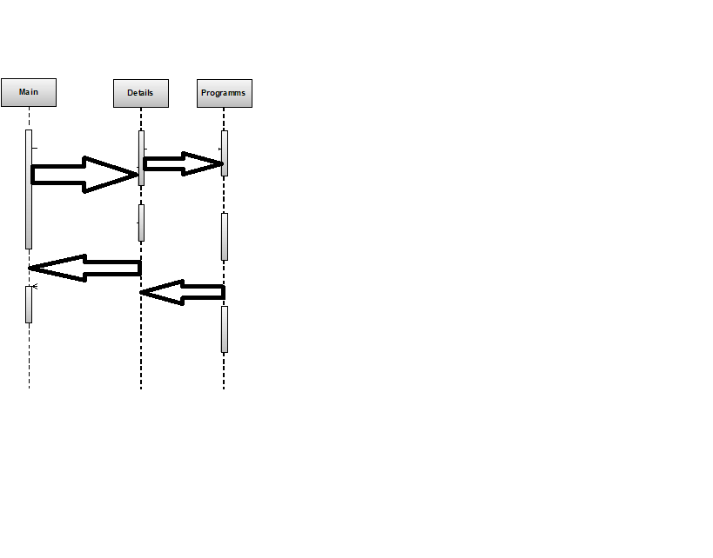
State Chart Diagram

user registration
checkingforvaliduse
Library
user validation
valid user
not validuser

DATA FLOW DIAGRAMS:

The DFD takes an input-process-output view of a system i.e. data objects flow into the software, are transformed by processing elements, and resultant data objects flow out of the software.

Data objects represented by labeled arrows and transformation are represented by circles also called as bubbles. DFD is presented in a hierarchical fashion i.e. the first data flow model represents the system as a whole. Subsequent DFD refine the context diagram (level 0 DFD), providing increasing details with each subsequent level.

The DFD enables the software engineer to develop models of the information domain & functional domain at the same time. As the DFD is refined into greater levels of details, the analyst perform an implicit functional decomposition of the system. At the same time, the DFD refinement results in a corresponding refinement of the data as it moves through the process that embody the applications.

A context-level DFD for the system the primary external entities produce information for use by the system and consume information generated by the system. The labeled arrow represents data objects or object hierarchy.

RULES FOR DFD:

- Fix the scope of the system by means of context diagrams.
- Organize the DFD so that the main sequence of the actions
- Reads left to right and top to bottom.
- Identify all inputs and outputs.
- Identify and label each process internal to the system with Rounded circles.
- A process is required for all the data transformation and Transfers. Therefore, never connect a data store to a data Source or the destinations or another data store with just a Data flow arrow.
- Do not indicate hardware and ignore control information.
- Make sure the names of the processes accurately convey everything the process is done.
- There must not be unnamed process.
- Indicate external sources and destinations of the data, with Squares.
- Number each occurrence of repeated external entities.
- Identify all data flows for each process step, except simple Record retrievals.
- Label data flow on each arrow.
- Use details flow on each arrow.
- Use the details flow arrow to indicate data movements.

E-R Diagrams:
The Entity-Relationship (ER) model was originally proposed by Peter in 1976 [Chen76] as a way to unify the network and relational database views. Simply stated the ER model is a conceptual data model that views the real world as entities and relationships. A basic component of the model is the Entity-Relationship diagram which is used to visually represents data objects. Since Chen wrote his paper the model has been extended and today it is commonly used for database design For the database designer, the utility of the ER model is:
- it maps well to the relational model. The constructs used in the ER model can easily be transformed into relational tables.
- it is simple and easy to understand with a minimum of training. Therefore, the model can be used by the database designer to communicate the design to the end user.
- In addition, the model can be used as a design plan by the database developer to implement a data model in a specific database management software.

Connectivity and Cardinality
The basic types of connectivity for relations are: one-to-one, one-to-many, and many-to-many. A one-to-one (1:1) relationship is when at most one instance of a entity A is associated with one instance of entity B. For example, "employees in the company are each assigned their own office. For each employee there exists a unique office and for each office there exists a unique employee.
A one-to-many (1:N) relationships is when for one instance of entity A, there are zero, one, or many instances of entity B, but for one instance of entity B, there is only one instance of entity A. An example of a 1:N relationships is a department has many employees each employee is assigned to one department.
A many-to-many (M:N) relationship, sometimes called non-specific, is when for one instance of entity A, there are zero, one, or many instances of entity B and for one instance of entity B there are zero, one, or many instances of entity A. The connectivity of a relationship describes the mapping of associated

ER Notation
There is no standard for representing data objects in ER diagrams. Each modeling methodology uses its own notation. The original notation used by Chen is widely used in academics texts and journals but rarely seen in either CASE tools or publications by non-academics. Today, there are a number of notations used, among the more common are Bachman, crow's foot, and IDEFIX.
All notational styles represent entities as rectangular boxes and relationships as lines connecting boxes. Each style uses a special set of symbols to represent the cardinality of a connection. The notation used in this document is from Martin. The symbols used for the basic ER constructs are:
- entities are represented by labeled rectangles. The label is the name of the entity. Entity names should be singular nouns.
- relationships are represented by a solid line connecting two entities. The name of the relationship is written above the line. Relationship names should be verbs
- attributes, when included, are listed inside the entity rectangle. Attributes which are identifiers are underlined. Attribute names should be singular nouns.
- cardinality of many is represented by a line ending in a crow's foot. If the crow's foot is omitted, the cardinality is one.
- existence is represented by placing a circle or a perpendicular bar on the line. Mandatory existence is shown by the bar (looks like a 1) next to the entity for an instance is required. Optional existence is shown by placing a circle next to the entity that is optional

PROJECT MODULES

MODULES USED:-
The proposed system categories and follows these modules to implement

Login component
- Administrator
- Player

MODULES DESCRIPSTION:-
User: User just click on game icon and after click game main screen open when user click on number. Dice start roll once admin click the stop button dice return 1number if number is same as player’s number the get message otherwise return better luck next time.

Functions

Functions are bet declared between the <Head> tag of HTML page. Functions are called by user-initiated events. Seems reasonable to keep the functions between the <Head> tags. They are loaded first before a user can do anything that might call a function. Scripts can be placed between inside comment fields to ensure that older browser do not display the script itself.

<html>

<head>

<title> Dice Gambelling </title>

<meta charset="utf-8">

<script>

</script>

<style>

</style>

</head>

<body style="background :aliceblue">

</body>

</html>

INTRODUCTION TO HTML4.0

What is the World Wide Web?
The World Wide Web is a network of information resources. The Web relies on three mechanisms to make these resources readily available to the widest possible audience.

- A uniform naming scheme for locating resources on the Web (e.g. URLs)
- Protocols, for access to named resources over the Web (e.g. HTTP)
- Hypertext, for easy navigation among resources (e.g.HTML)
The ties between the three mechanisms are apparent throughout this specification.

What is HTML?
To publish information for global distribution, one needs a universally understood language, a kind of publishing mother tongue that all computers may potentially understand. The publishing language used by the World Wide Web is HTML (from Hyper Text Markup Language). HTML gives authors the means to
- Publish online documents with headings, text, tables, lists, photos, etc.
- Retrieve online information via hypertext links, at the click of a button
- Design forms for conducting transactions with remote services, for use in searching for information, making reservations, ordering products etc.
- Include spread - sheets, video clips, sound clips, and other applications directly in their documents.

A brief history of HTML:
HTML was originally developed by Tim Berners-Lee while at CERN, and popularized by the Mosaic browser developed at NCSA. During the course of the 1990s it has blossomed with the explosive growth of the Web during this time. HTML has been extended in a number of ways. The Web depends on Web page authors and vendors sharing the same conventions for HTML. This has motivated joint work on specifications for HTML.
HTML 2.0 (November 1995) was developed under the aegis of the Internet Engineering Task Force (IETF) to codify common practice in late 1994. HTML (1993) and ([HTML.30]) (1995) proposed much richer versions of HTML, despite never receiving consensus in standards discussions, these drafts led to the adoption of a range new features. The efforts of the World Wide Web Consortium’s HTML working group to codify common in 1996 resulted in HTML 3.2 (January 1997). Most people agree that HTML documents should work well across different browsers and platforms. Achieving interoperability lowers costs to content providers since they must develop only one version of a document. If the effort is not made, there is much greater risk that the Web will devolve into a proprietary world of incompatible formats, ultimately reducing the Web’s commercial potential for all participants.

SOFTWARE METHODOLOGY

The software methodology followed in this project includes the object-oriented methodology and the application system development methodologies. The description of these methodologies is given below.

Application System Development – A Life cycle Approach

Although there are a growing number of applications (such as decision support systems) that should be developed using an experimental process strategy such as prototyping, a significant amount of new development work continue to involve major operational applications of broad scope. The application systems are large highly structured. User task comprehension and developer task proficiency is usually high. These factors suggest a linear or iterative assurance strategy. The most common method for this stage class of problems is a system development life cycle modal in which each stage of development is well defined and has straightforward requirements for deliverables, feedback and sign off. The system development life cycle is described in detail since it continues to be an appropriate methodology for a significant part of new development work.

The basic idea of the system development life cycle is that there is a well-defined process by which an application is conceived and developed and implemented. The life cycle gives structure to a creative process. In order to manage and control the development effort, it is necessary to know what should have been done, what has been done, and what has yet to be accomplished. The phrases in the system development life cycle provide a basis for management and control because they define segments of the
flow of work, which can be identified for managerial purposes and specifies the documents or other deliverables to be produced in each phase.

The phases in the life cycle for information system development are described differently by different writers, but the differences are primarily in the amount of necessity and manner of categorization. There is a general agreement on the flow of development steps and the necessity for control procedures at each stage.

The information system development cycle for an application consists of three major stages.

- Definition.
- Development.
- Installation and operation.

The first stage of the process, which defines the information requirements for a feasible cost effective system. The requirements are then translated into a physical system of forms, procedures, programs etc., by the system design, computer programming and procedure development. The resulting system is test and put into operation. No system is perfect so there is always a need for maintenance changes. To complete the cycle, there should be a post audit of the system to evaluate how well it performs and how well it meets the cost and performance specifications. The stages of definition, development and installation and operation can therefore be divided into smaller steps or phrases as follows.

Definition

Proposed definition : preparation of request for proposed applications.
Feasibility assessment : evaluation of feasibility and cost benefit of proposed system.
Information requirement analysis : determination of information needed.

Design
Conceptual design : User-oriented design of application development.
Physical system design : Detailed design of flows and processes in applications processing system and preparation of program specification.
Development
Program development : coding and testing of computer programs.
Procedure development : design of procedures and preparation of user instructions.

Installation and operation

Conversion : final system test and conversion.
Operation and maintenance : Month to month operation and maintenance
Post audit : Evaluation of development process,application system and results of use at the completion of the each phase, formal approval sign-off is required from the users as well as from the manager of the project development.

Code

<html>
<head>
<title> Dice Gambelling </title>
<meta charset="utf-8">
<meta name="viewport" content="width=device-width, initial-scale=1">
<link rel="stylesheet" href="https://maxcdn.bootstrapcdn.com/bootstrap/3.4.1/css/bootstrap.min.css">
<script src="https://ajax.googleapis.com/ajax/libs/jquery/3.6.1/jquery.min.js"></script>
<script src="https://maxcdn.bootstrapcdn.com/bootstrap/3.4.1/js/bootstrap.min.js"></script>
<script>

function openMainDiv(){
if(document.getElementById('chooseNum').innerHTML == ''){
alert("Please Select Number before click play button");
return false;
}
document.getElementById('mainDivDiceGame').style.display = 'block';
}
function generateNum(){
document.getElementById('stopDic').style.display = 'none';
generateRandomNum();
document.getElementById('startDic').style.display = 'block';
}

function generateRandomNum(){
var randomImageName = (Math.floor(Math.random()*6)+1);
messageDiceStop(randomImageName);
}

function messageDiceStop(randomImageName){
if(randomImageName == document.getElementById('chooseNum').innerHTML){
alert("Congurations ! You win the prize.");
}else{
alert("Better Luck Next Time");
}
}
function valueSelect(selectedValue){
document.getElementById('chooseNum').innerHTML = selectedValue;
document.getElementById('numberTable').style.background = 'yellow';
for(var i=1;i<7;i++){
document.getElementById('td'+i).onclick = null;
}
openMainDiv();
}
</script>
<style>
td:hover {
background-color: yellow;
}

#mainDivDiceGame {
width: 500px;
height: 170px;
}

#mainDivDiceGame img {
max-width: 100%;
max-height: 100%;
}
</style>
</head>
<body style="background :aliceblue">
<div id="gameMainFrame" class="container">
<h3 class="text-info"> Choose Dic Number for player between 1 to 6</h3>
<div id="ruleId">
<span class="text-info">Please follow below mentioned rule. </span><br/>
<span class="text-info">1. Click on number for select & once you select the number screen going freeze.</span><br/>
<span class="text-info">2. If you number is same as dice return you will be reward.</span><br/>
<span class="text-info">3. Please click on number for role the dice. </span><br/>
<br/>
<table class="table table-bordered" id ="numberTable">
<tr>
<td id="td1" onclick = "$(this).css('background', 'red') ; valueSelect(1)">1</td>
<td id="td2" onclick = "$(this).css('background', 'red') ;valueSelect(2)">2</td>
<td id="td3" onclick = "$(this).css('background', 'red') ;valueSelect(3)">3</td>
</tr>
<tr>
<td id="td4" onclick = "$(this).css('background', 'red') ; valueSelect(4)">4</td>
<td id="td5" onclick = "$(this).css('background', 'red') ; valueSelect(5)">5</td>
<td id="td6" onclick = "$(this).css('background', 'red') ; valueSelect(6)">6</td>
</tr>
</table>
<br/>
</div>
</div>

<div id="mainDivDiceGame" style="display :none " class="container">

<h3> Choosed Number :- <span id="chooseNum" class="badge badge-secondary"></span></h3>
<img id="dicImg" src="./image/mainDic.gif" style="width :100px ; height:100px; ">
<button id="stopDic" onclick="generateNum()" class="btn btn-light"> Stop </button>
<button id="startDic" onClick="window.location.reload()" style="display :none " class="btn btn-light"> Click For Restart the Game </button>
</div>
</body>
</html>

Testing is a process of executing a program with the indent of finding an error. Testing is a crucial element of software quality assurance and presents ultimate review of specification, design and coding.
System Testing is an important phase. Testing represents an interesting anomaly for the software. Thus a series of testing are performed for the proposed system before the system is ready for user acceptance testing.
A good test case is one that has a high probability of finding an as undiscovered error. A successful test is one that uncovers an as undiscovered error.
Testing Objectives:
- Testing is a process of executing a program with the intent of finding an error
- A good test case is one that has a probability of finding an as yet undiscovered error
- A successful test is one that uncovers an undiscovered error
Testing Principles:
- All tests should be traceable to end user requirements
- Tests should be planned long before testing begins
- Testing should begin on a small scale and progress towards testing in large
- Exhaustive testing is not possible
- To be most effective testing should be conducted by a independent third party

The primary objective for test case design is to derive a set of tests that has the highest livelihood for uncovering defects in software. To accomplish this objective two different categories of test case design techniques are used. They are
- White box testing.
- Black box testing.

White-box testing:
White box testing focus on the program control structure. Test cases are derived to ensure that all statements in the program have been executed at least once during testing and that all logical conditions have been executed.

Block-box testing:
Black box testing is designed to validate functional requirements without regard to the internal workings of a program. Black box testing mainly focuses on the information domain of the software, deriving test cases by partitioning input and output in a manner that provides through test coverage. Incorrect and missing functions, interface errors, errors in data structures, error in functional logic are the errors falling in this category.
Testing strategies:
A strategy for software testing must accommodate low-level tests that are necessary to verify that all small source code segment has been correctly implemented as well as high-level tests that validate major system functions against customer requirements.
Testing fundamentals:
Testing is a process of executing program with the intent of finding error. A good test case is one that has high probability of finding an undiscovered error. If testing is conducted successfully it uncovers the errors in the software. Testing cannot show the absence of defects, it can only show that software defects present.
Testing Information flow:
Information flow for testing flows the pattern. Two class of input provided to test the process. The software configuration includes a software requirements specification, a design specification and source code.
Test configuration includes test plan and test cases and test tools. Tests are conducted and all the results are evaluated. That is test results are compared with expected results. When erroneous data are uncovered, an error is implied and debugging commences.
Unit testing:
Unit testing is essential for the verification of the code produced during the coding phase and hence the goal is to test the internal logic of the modules. Using the detailed design description as a guide, important paths are tested to uncover errors with in the boundary of the modules. These tests were carried out during the programming stage itself. All units of ViennaSQL were successfully tested.
Integration testing :
Integration testing focuses on unit tested modules and build the program structure that is dictated by the design phase.
System testing:
System testing tests the integration of each module in the system. It also tests to find discrepancies between the system and it’s original objective, current specification and system documentation. The primary concern is the compatibility of individual modules. Entire system is working properly or not will be tested here, and specified path ODBC connection will correct or not, and giving output or not are tested here these verifications and validations are done by giving input values to the system and by comparing with expected output. Top-down testing implementing here.

Acceptance Testing:
This testing is done to verify the readiness of the system for the implementation. Acceptance testing begins when the system is complete. Its purpose is to provide the end user with the confidence that the system is ready for use. It involves planning and execution of functional tests, performance tests and stress tests in order to demonstrate that the implemented system satisfies its requirements.
Tools to special importance during acceptance testing include:
Test coverage Analyzer – records the control paths followed for each test case.
Timing Analyzer – also called a profiler, reports the time spent in various regions of the code are areas to concentrate on to improve system performance.
Coding standards – static analyzers and standard checkers are used to inspect code for deviations from standards and guidelines.
Test Cases:
Test cases are derived to ensure that all statements in the program have been executed at least once during testing and that all logical conditions have been executed.
Using White-Box testing methods, the software engineer can drive test cases that
- Guarantee that logical decisions on their true and false sides.
- Exercise all logical decisions on their true and false sides.
- Execute all loops at their boundaries and with in their operational bounds.
- Exercise internal data structure to assure their validity.
The test case specification for system testing has to be submitted for review before system testing commences.

Home Page
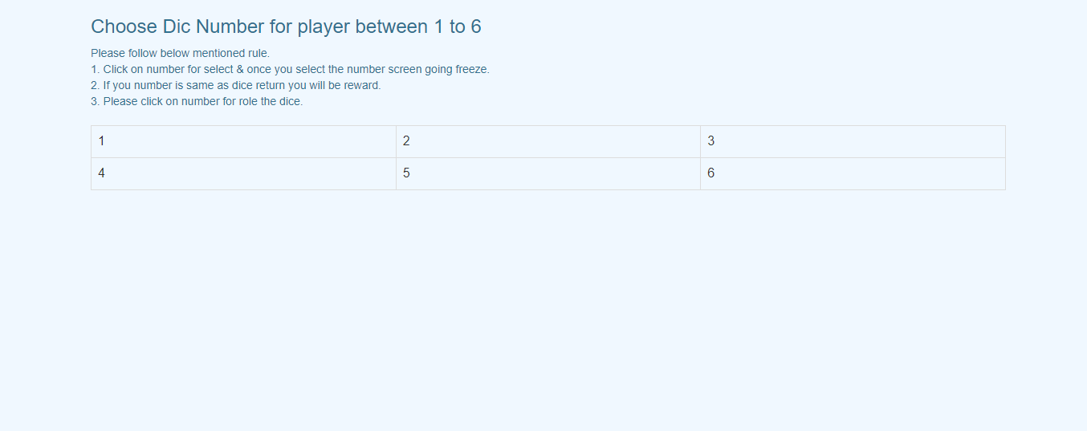

Player’s Number Choose

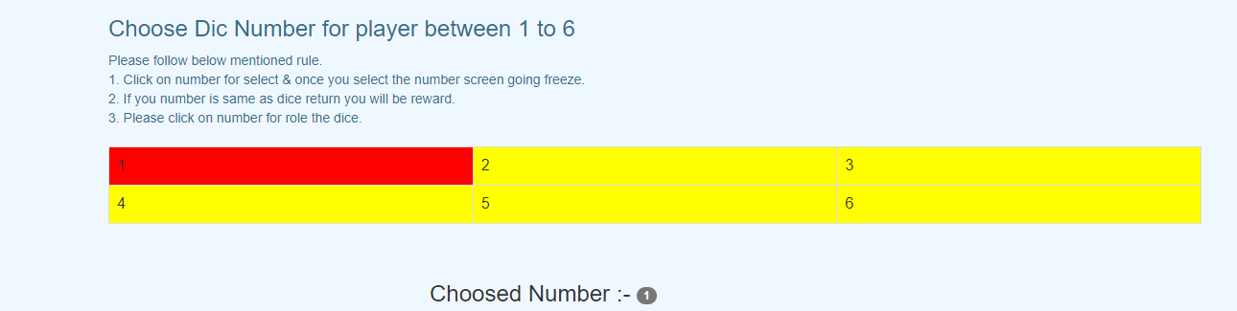
Dice Roll

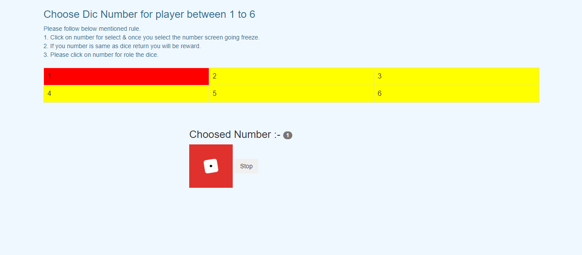

Click on Stop Button

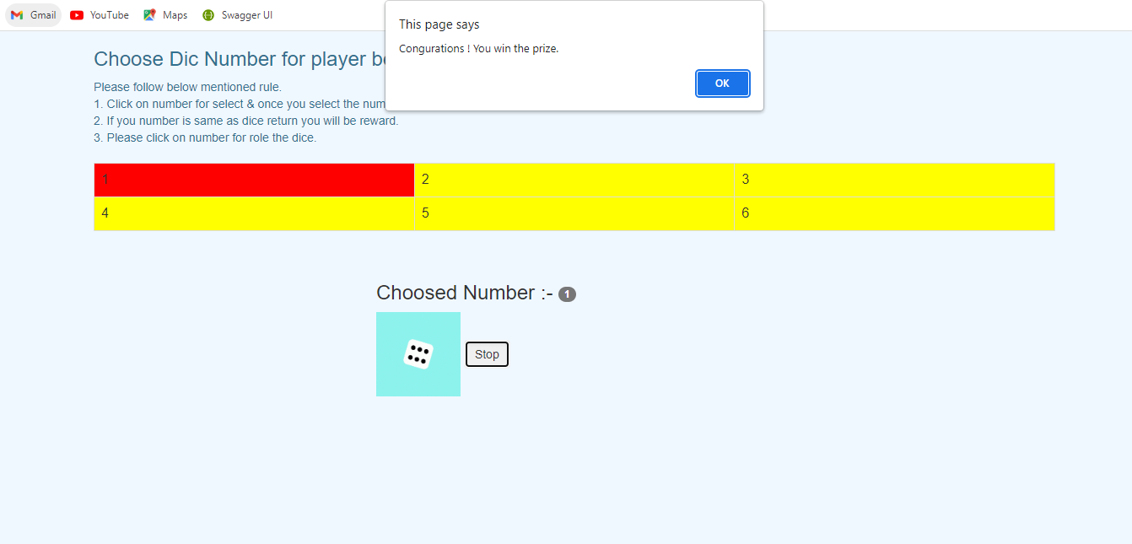

Final Screen

