W241 Final Project Analysis

Table of Contents

# Load the raw data

library(data.table)  
d <- fread('./w241_survey_responses.csv')  
head(d)

## StartDate EndDate Status IPAddress Progress  
## 1: 4/8/18 15:49 4/8/18 15:53 0 72.220.195.220 100  
## 2: 4/8/18 15:49 4/8/18 15:53 0 71.224.2.157 100  
## 3: 4/8/18 15:49 4/8/18 15:53 0 157.50.93.56 100  
## 4: 4/8/18 15:49 4/8/18 15:54 0 106.76.229.89 100  
## 5: 4/8/18 15:49 4/8/18 15:54 0 23.242.120.131 100  
## 6: 4/8/18 15:50 4/8/18 15:54 0 142.196.15.248 100  
## Duration (in seconds) Finished RecordedDate ResponseId  
## 1: 230 1 4/8/18 15:53 R_pyjMxtSQmkqsiqd  
## 2: 217 1 4/8/18 15:53 R_Ox3zj5E4OYwKjmN  
## 3: 251 1 4/8/18 15:53 R_2xE3zsAFzPgUONy  
## 4: 268 1 4/8/18 15:54 R_1hyjBJIr9tC9dbB  
## 5: 295 1 4/8/18 15:54 R_3lAHYaTI21y6zpE  
## 6: 264 1 4/8/18 15:54 R_1rMIUUjNEgA9v90  
## RecipientLastName RecipientFirstName RecipientEmail ExternalReference  
## 1: NA NA NA NA  
## 2: NA NA NA NA  
## 3: NA NA NA NA  
## 4: NA NA NA NA  
## 5: NA NA NA NA  
## 6: NA NA NA NA  
## LocationLatitude LocationLongitude DistributionChannel UserLanguage Q1  
## 1: 32.73711 -117.08810 anonymous EN 1  
## 2: 39.76900 -75.80020 anonymous EN 1  
## 3: 13.08330 80.28329 anonymous EN 1  
## 4: 17.37531 78.47440 anonymous EN 1  
## 5: 33.90810 -117.10820 anonymous EN 2  
## 6: 29.20210 -80.99980 anonymous EN 1  
## Q2 Q3_First Click Q3_Last Click Q3_Page Submit Q3_Click Count Q4 Q5  
## 1: 5 0.623 1.969 2.695 3 2 2  
## 2: 39 0.639 2.387 3.626 3 5 2  
## 3: 47 0.699 5.341 11.875 3 5 1  
## 4: 30 1.561 15.322 17.214 5 7 2  
## 5: 5 0.785 2.964 3.842 3 3 2  
## 6: 10 2.187 3.867 5.506 3 5 1  
## Q34_First Click Q34_Last Click Q34_Page Submit Q34_Click Count Q7 Q8 Q9  
## 1: 28.901 30.522 31.250 2 NA NA 1  
## 2: 0.913 2.308 3.319 2 NA NA 1  
## 3: 3.839 4.862 6.466 2 NA 1 NA  
## 4: 2.040 7.358 8.994 3 NA NA 2  
## 5: 1.233 2.945 4.240 3 NA 1 NA  
## 6: 1.561 2.752 4.178 2 1 NA NA  
## Q37_First Click Q37_Last Click Q37_Page Submit Q37_Click Count  
## 1: 144.273 144.771 145.747 2  
## 2: 137.672 137.672 138.653 1  
## 3: 7.228 7.228 150.675 1  
## 4: 11.347 11.347 150.671 1  
## 5: 14.133 202.181 202.499 3  
## 6: 180.748 180.748 182.297 1  
## Q32  
## 1: The US was increasing support by ground troops in Syria to liberate Raqqa.  
## 2: Neighboring countries to Syria in addition to the US, are helping to fight off ISIS.  
## 3: news discussions about terriost attack and also village attack  
## 4: the war of syria isis and how it happend and which will be effected this  
## 5: Two members of ISIS were interviewed from prison by RT. They were asked what their roles were and what their justification for killing people were. They said they had no justification and were just following orders.  
## 6: It was about the weather in California. Talked about the atmospheric river.  
## Q11 Q12_First Click Q12_Last Click Q12_Page Submit Q12_Click Count Q13  
## 1: 1 1.540 1.540 4.202 1 1  
## 2: 1 2.966 2.966 7.398 1 2  
## 3: 1 0.946 0.946 2.642 1 4  
## 4: 1 2.849 2.849 6.041 1 2  
## 5: 4 4.590 4.590 5.811 1 2  
## 6: 2 1.628 1.628 2.898 1 2  
## Q14 Q15 Q16_First Click Q16_Last Click Q16_Page Submit Q16_Click Count  
## 1: 3 3 2.532 6.075 6.996 3  
## 2: 2 3 1.663 6.315 7.252 4  
## 3: 5 5 1.016 5.963 7.790 4  
## 4: 3 4 3.267 11.998 13.409 3  
## 5: 4 2 2.653 11.321 12.041 5  
## 6: 4 4 3.090 14.099 15.033 6  
## Q17 Q18 Q19_First Click Q19_Last Click Q19_Page Submit Q19_Click Count  
## 1: 5 1 2.762 7.519 9.015 2  
## 2: 3 4 3.720 6.028 6.756 2  
## 3: 4 3 0.417 0.955 1.958 2  
## 4: 3 2 1.493 5.051 6.549 3  
## 5: 5 5 3.054 7.383 8.742 3  
## 6: 4 4 3.037 5.258 7.083 2  
## MTurkCode  
## 1: 1228  
## 2: 77725668  
## 3: 84764331  
## 4: 3980411  
## 5: 84290823  
## 6: 65067867

# Remove unnecessary columns

colnames(d)

## [1] "StartDate" "EndDate"   
## [3] "Status" "IPAddress"   
## [5] "Progress" "Duration (in seconds)"  
## [7] "Finished" "RecordedDate"   
## [9] "ResponseId" "RecipientLastName"   
## [11] "RecipientFirstName" "RecipientEmail"   
## [13] "ExternalReference" "LocationLatitude"   
## [15] "LocationLongitude" "DistributionChannel"   
## [17] "UserLanguage" "Q1"   
## [19] "Q2" "Q3_First Click"   
## [21] "Q3_Last Click" "Q3_Page Submit"   
## [23] "Q3_Click Count" "Q4"   
## [25] "Q5" "Q34_First Click"   
## [27] "Q34_Last Click" "Q34_Page Submit"   
## [29] "Q34_Click Count" "Q7"   
## [31] "Q8" "Q9"   
## [33] "Q37_First Click" "Q37_Last Click"   
## [35] "Q37_Page Submit" "Q37_Click Count"   
## [37] "Q32" "Q11"   
## [39] "Q12_First Click" "Q12_Last Click"   
## [41] "Q12_Page Submit" "Q12_Click Count"   
## [43] "Q13" "Q14"   
## [45] "Q15" "Q16_First Click"   
## [47] "Q16_Last Click" "Q16_Page Submit"   
## [49] "Q16_Click Count" "Q17"   
## [51] "Q18" "Q19_First Click"   
## [53] "Q19_Last Click" "Q19_Page Submit"   
## [55] "Q19_Click Count" "MTurkCode"

not.needed <- c("StartDate", "EndDate", "Status", "IPAddress", "Progress", "Duration (in seconds)",   
 "Finished", "RecordedDate", "ResponseId", "RecipientLastName", "RecipientFirstName", "RecipientEmail",   
 "ExternalReference", "LocationLatitude", "LocationLongitude", "DistributionChannel", "UserLanguage",   
 "Q3_First Click", "Q3_Last Click", "Q3_Page Submit", "Q3_Click Count",   
 "Q34_First Click", "Q34_Last Click", "Q34_Page Submit", "Q34_Click Count",   
 "Q37_First Click", "Q37_Last Click", "Q37_Page Submit", "Q37_Click Count",   
 "Q12_First Click", "Q12_Last Click", "Q12_Page Submit", "Q12_Click Count",   
 "Q16_First Click", "Q16_Last Click", "Q16_Page Submit", "Q16_Click Count",   
 "Q19_First Click", "Q19_Last Click", "Q19_Page Submit", "Q19_Click Count", "MTurkCode", "Q32")  
d[, (not.needed) := NULL]

# Rename columns to be more descriptive

q.names <- c("gender", "state", "education", "served_military",   
 'weather', 'terrorists', 'marines', 'video_topic_check',   
 'us_involved', 'us_send_aid', 'us_send_troops',   
 'raise_tax_rate', 'join_armed_forces')  
  
setnames(d, q.names)

# Convert weather, terrorists and marines to dummy variables

# Treat non-compliers as compliers

# Replace NA with 0  
# NA means that the subject did not see the video in question  
d[is.na(weather), weather := 0]  
d[is.na(terrorists), terrorists := 0]  
d[is.na(marines), marines := 0]

# Get a descriptive summary of data

library(psych)  
  
for (q.n in (q.names)) {  
 hist(d[, get(q.n)], xlab = (q.n), freq = FALSE )  
}

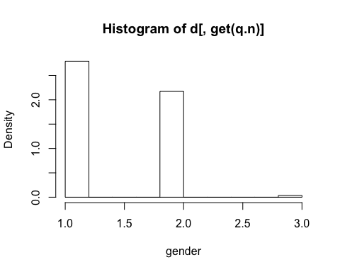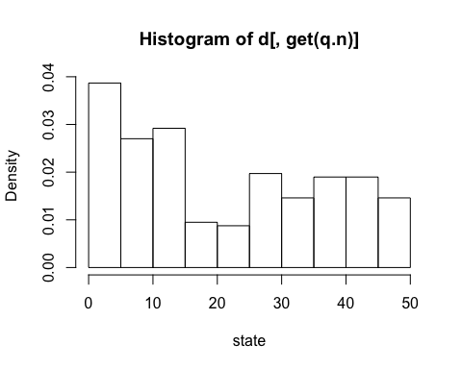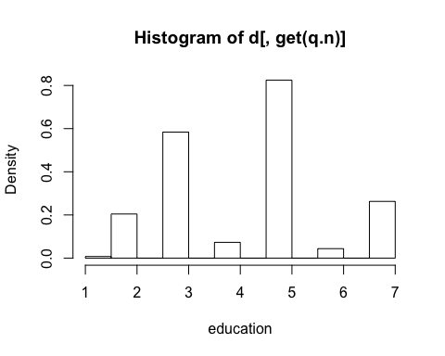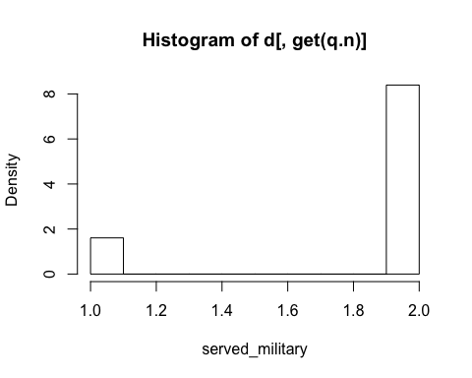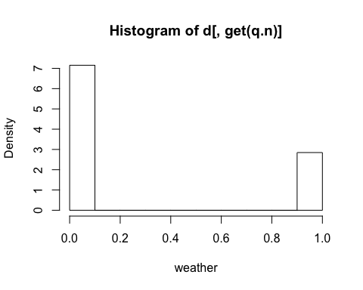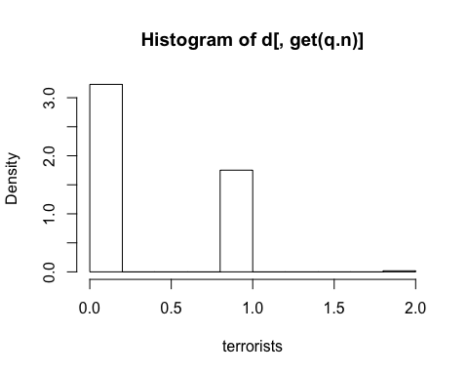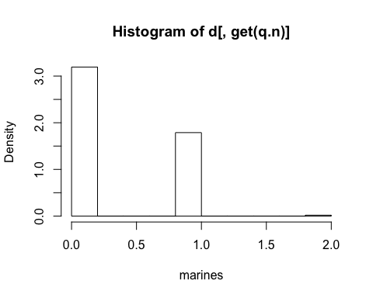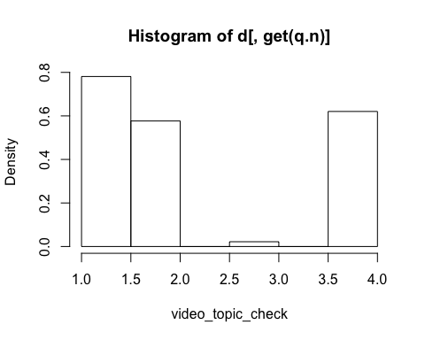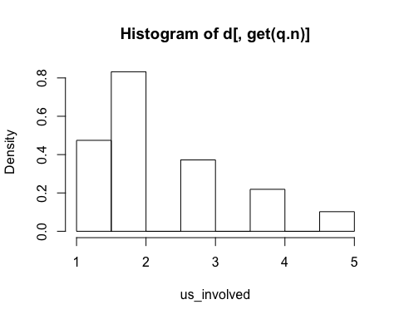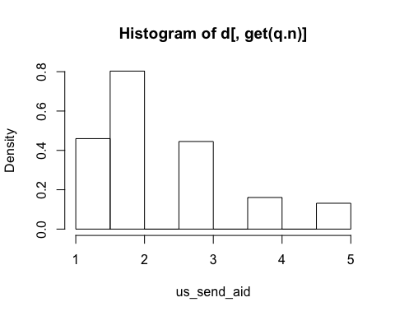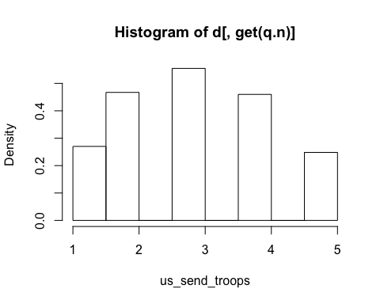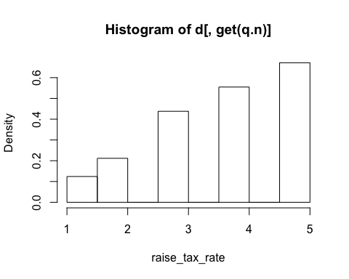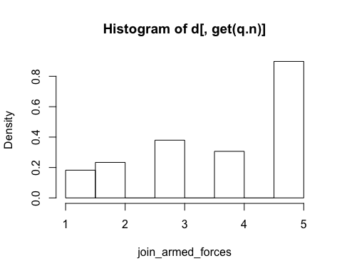 # Check how many subjects selected the wrong video topic # And drop their responses from the data

# Topic choices:   
# 1. marines  
# 2. weather  
# 3. nfl draft  
# 4. terrorists  
# 5. scott foster   
  
sum(d$video_topic_check == 3)

## [1] 3

sum(d$video_topic_check == 5)

## [1] 0

d <- d[video_topic_check %in% c(1, 2, 4)]

# Treat non-compliers as compliers

# 1 subject said that they did not watch the marines video.  
# 1 subject said that they did not watch the terrorists video.  
# We will count both of them as treatment compliers.  
  
d[weather == 2, weather := 1]  
d[terrorists == 2, terrorists := 1]  
d[marines == 2, marines := 1]  
  
sum(d$weather) # 78

## [1] 78

sum(d$terrorists) # 96

## [1] 96

sum(d$marines) # 97

## [1] 97

# Convert gender, state, served_military to factors (aka. dummy variables)

d$gender <- as.factor(d$gender)  
d$state <- as.factor(d$state)  
d$served_military <- as.factor(d$served_military)

# Multivariate regression

deps <- c('us_involved', 'us_send_aid', 'us_send_troops',   
 'raise_tax_rate', 'join_armed_forces')  
indeps <- c("gender", "state", "education", "served_military")  
treats <- c('weather', 'terrorists', 'marines', 'treats')  
  
m <- lm( cbind(us_involved, us_send_aid, us_send_troops, raise_tax_rate, join_armed_forces) ~ terrorists + marines, data = d)  
  
# library(mvinfluence)  
  
# influence(m, TRUE, 1)

# Create a column of treatments

d$treatment <- ifelse(d$weather == 1, 0, 0)  
d$treatment <- ifelse(d$terrorists == 1, 1, d$treatment)  
d$treatment <- ifelse(d$marines == 1, 2, d$treatment)  
# d$treatment <- factor(d$treatment)

# Randomization Inference

deps <- c('us_involved', 'us_send_aid', 'us_send_troops',   
 'raise_tax_rate', 'join_armed_forces')  
indeps <- c("gender", "state", "education", "served_military")  
treats <- c('weather', 'terrorists', 'marines', 'treats')  
  
df <- data.frame(d)  
df[, deps] <- 6 - df[, deps]  
  
weather.means <- apply(df[df$treatment == 0, deps], 2, mean)  
terrorists.means <- apply(df[df$treatment == 1, deps], 2, mean)  
marines.means <- apply(df[df$treatment == 2, deps], 2, mean)  
  
deps.means <- data.frame(weather.means, terrorists.means, marines.means)  
deps.means$TminusW <- deps.means$terrorists.means - deps.means$weather.means  
deps.means$MminusW <- deps.means$marines.means - deps.means$weather.means  
deps.means$TminusM <- deps.means$terrorists.means - deps.means$marines.means  
deps.means

## weather.means terrorists.means marines.means TminusW  
## us_involved 3.576923 3.583333 3.896907 0.006410256  
## us_send_aid 3.410256 3.572917 3.927835 0.162660256  
## us_send_troops 2.820513 3.031250 3.175258 0.210737179  
## raise_tax_rate 2.179487 2.250000 2.371134 0.070512821  
## join_armed_forces 1.923077 2.218750 2.494845 0.295673077  
## MminusW TminusM  
## us_involved 0.3199841 -0.3135739  
## us_send_aid 0.5175786 -0.3549184  
## us_send_troops 0.3547449 -0.1440077  
## raise_tax_rate 0.1916468 -0.1211340  
## join_armed_forces 0.5717684 -0.2760954

deps.means$id <- row.names(deps.means)  
  
RandomInference <- function(vec, ate, n.trials) {  
 set.seed(1234)  
 rands <- replicate(n.trials, sample(c(TRUE, FALSE), length(vec), replace = TRUE))  
  
 treats <- apply(rands, 2, FUN = function(x) {return(mean(vec[x]))})  
 controls <- apply(rands, 2, FUN = function(x) {return(mean(vec[!x]))})  
 rand.ate <- treats - controls  
 p <- sum(rand.ate > ate) / length(rand.ate)  
 std.err <- sd(rand.ate) / sqrt(length(rand.ate))  
 low.bound <- ate - 1.96 * std.err  
 high.bound <- ate + 1.96 * std.err  
   
   
 return(c(ate, std.err, p, low.bound, high.bound))  
}

# All with correction for multiple comparisons

deps <- c('us_involved', 'us_send_aid', 'us_send_troops',   
 'raise_tax_rate', 'join_armed_forces')  
n.t = 10000  
  
EmbellishP <- function(p.val) {  
 if(p.val*15 <= 0.01) {  
 return(paste0(p.val, '**'))  
 }  
   
 if(p.val*15 <= 0.05) {  
 return(paste0(p.val, '*'))  
 }   
   
 return(p.val)  
}  
  
for (row.name in deps) {  
 deps.sub <- deps.means[deps.means$id == row.name,]  
   
 cat('######### ', row.name, ' ###########', '\n')  
 m.ate <- deps.sub[deps.sub$id == row.name, 'TminusW']  
 res <- RandomInference(df$us_involved, m.ate, n.t)  
 cat(res[3])  
 p <- EmbellishP(res[3])  
 cat(row.name, ': Terror vs. Weather: ate:', res[1], paste0('(', res[2], ')'), 'p-value: ', p, 'ci: ', res[4], res[5], '\n')  
   
 m.ate <- deps.sub[deps.sub$id == row.name, 'MminusW']  
 res <- RandomInference(df$us_involved, m.ate, n.t)  
 p <- EmbellishP(res[3])  
 cat(row.name, ': Marines vs. Weather: ate:', res[1], paste0('(', res[2], ')'), 'p-value: ', p, 'ci: ', res[4], res[5], '\n')  
   
 m.ate <- deps.sub[deps.sub$id == row.name, 'TminusM']  
 res <- RandomInference(df$us_involved, m.ate, n.t)  
 p <- EmbellishP(res[3])  
 cat(row.name, ': Terror vs. Marines: ate:', res[1], paste0('(', res[2], ')'), 'p-value: ', p, 'ci: ', res[4], res[5], '\n')  
   
 cat('####################################\n\n')  
}

## ######### us_involved ###########   
## 0.4798us_involved : Terror vs. Weather: ate: 0.006410256 (0.00135190409440195) p-value: 0.4798 ci: 0.003760524 0.009059988   
## us_involved : Marines vs. Weather: ate: 0.3199841 (0.00135190409440195) p-value: 0.0084 ci: 0.3173344 0.3226339   
## us_involved : Terror vs. Marines: ate: -0.3135739 (0.00135190409440195) p-value: 0.9912 ci: -0.3162236 -0.3109242   
## ####################################  
##   
## ######### us_send_aid ###########   
## 0.1166us_send_aid : Terror vs. Weather: ate: 0.1626603 (0.00135190409440195) p-value: 0.1166 ci: 0.1600105 0.16531   
## us_send_aid : Marines vs. Weather: ate: 0.5175786 (0.00135190409440195) p-value: 1e-04** ci: 0.5149289 0.5202284   
## us_send_aid : Terror vs. Marines: ate: -0.3549184 (0.00135190409440195) p-value: 0.9964 ci: -0.3575681 -0.3522687   
## ####################################  
##   
## ######### us_send_troops ###########   
## 0.0559us_send_troops : Terror vs. Weather: ate: 0.2107372 (0.00135190409440195) p-value: 0.0559 ci: 0.2080874 0.2133869   
## us_send_troops : Marines vs. Weather: ate: 0.3547449 (0.00135190409440195) p-value: 0.0044 ci: 0.3520952 0.3573946   
## us_send_troops : Terror vs. Marines: ate: -0.1440077 (0.00135190409440195) p-value: 0.8553 ci: -0.1466575 -0.141358   
## ####################################  
##   
## ######### raise_tax_rate ###########   
## 0.3039raise_tax_rate : Terror vs. Weather: ate: 0.07051282 (0.00135190409440195) p-value: 0.3039 ci: 0.06786309 0.07316255   
## raise_tax_rate : Marines vs. Weather: ate: 0.1916468 (0.00135190409440195) p-value: 0.0791 ci: 0.1889971 0.1942966   
## raise_tax_rate : Terror vs. Marines: ate: -0.121134 (0.00135190409440195) p-value: 0.8117 ci: -0.1237838 -0.1184843   
## ####################################  
##   
## ######### join_armed_forces ###########   
## 0.013join_armed_forces : Terror vs. Weather: ate: 0.2956731 (0.00135190409440195) p-value: 0.013 ci: 0.2930233 0.2983228   
## join_armed_forces : Marines vs. Weather: ate: 0.5717684 (0.00135190409440195) p-value: 0** ci: 0.5691187 0.5744182   
## join_armed_forces : Terror vs. Marines: ate: -0.2760954 (0.00135190409440195) p-value: 0.98 ci: -0.2787451 -0.2734456   
## ####################################

# Results

**After correcting for multiple comparisons i.e. 3 treatments x 5 dependent variables, we see that only the following results are significant.**

1. **us_send_aid (placebo value 3.410256)** : Marines vs. Weather: ate: 0.5175786 (0.00135190409440195) p-value: 1e-04** ci: 0.5149289 0.5202284. For sending aid, the average effect was to move the sample from being inbetween "Neither in favor nor opposed" to "Somewhat in favor".
2. **join_armed_forces (placebo value 1.923077)** : Marines vs. Weather: ate: 0.5717684 (0.00135190409440195) p-value: 0** ci: 0.5691187 0.5744182. For joining the armed forces, the average effect was to move the sample from "Somewhat opposed" to "Neither in favor nor opposed".

**That is, subjects who saw the marines video were likely to increase their support for sending Aid to countries fighting terrorists, and joining armed forces, by approx. half a category.**

# MANOVA

library(car)

##   
## Attaching package: 'car'

## The following object is masked from 'package:psych':  
##   
## logit

m <- lm( cbind(us_involved, us_send_aid, us_send_troops, raise_tax_rate, join_armed_forces) ~ terrorists + marines, data = df)  
summary(m)

## Response us_involved :  
##   
## Call:  
## lm(formula = us_involved ~ terrorists + marines, data = df)  
##   
## Residuals:  
## Min 1Q Median 3Q Max   
## -2.8969 -0.5833 0.1031 0.4231 1.4231   
##   
## Coefficients:  
## Estimate Std. Error t value Pr(>|t|)   
## (Intercept) 3.57692 0.12321 29.031 <2e-16 ***  
## terrorists 0.00641 0.16588 0.039 0.9692   
## marines 0.31998 0.16549 1.934 0.0542 .   
## ---  
## Signif. codes: 0 '***' 0.001 '**' 0.01 '*' 0.05 '.' 0.1 ' ' 1  
##   
## Residual standard error: 1.088 on 268 degrees of freedom  
## Multiple R-squared: 0.01928, Adjusted R-squared: 0.01196   
## F-statistic: 2.634 on 2 and 268 DF, p-value: 0.07363  
##   
##   
## Response us_send_aid :  
##   
## Call:  
## lm(formula = us_send_aid ~ terrorists + marines, data = df)  
##   
## Residuals:  
## Min 1Q Median 3Q Max   
## -2.92784 -0.57292 0.07216 0.58974 1.58974   
##   
## Coefficients:  
## Estimate Std. Error t value Pr(>|t|)   
## (Intercept) 3.4103 0.1247 27.356 <2e-16 ***  
## terrorists 0.1627 0.1678 0.969 0.3333   
## marines 0.5176 0.1674 3.091 0.0022 **   
## ---  
## Signif. codes: 0 '***' 0.001 '**' 0.01 '*' 0.05 '.' 0.1 ' ' 1  
##   
## Residual standard error: 1.101 on 268 degrees of freedom  
## Multiple R-squared: 0.03716, Adjusted R-squared: 0.02998   
## F-statistic: 5.172 on 2 and 268 DF, p-value: 0.006253  
##   
##   
## Response us_send_troops :  
##   
## Call:  
## lm(formula = us_send_troops ~ terrorists + marines, data = df)  
##   
## Residuals:  
## Min 1Q Median 3Q Max   
## -2.17526 -1.03125 -0.03125 0.96875 2.17949   
##   
## Coefficients:  
## Estimate Std. Error t value Pr(>|t|)   
## (Intercept) 2.8205 0.1384 20.379 <2e-16 ***  
## terrorists 0.2107 0.1863 1.131 0.2591   
## marines 0.3547 0.1859 1.908 0.0574 .   
## ---  
## Signif. codes: 0 '***' 0.001 '**' 0.01 '*' 0.05 '.' 0.1 ' ' 1  
##   
## Residual standard error: 1.222 on 268 degrees of freedom  
## Multiple R-squared: 0.01344, Adjusted R-squared: 0.006073   
## F-statistic: 1.825 on 2 and 268 DF, p-value: 0.1632  
##   
##   
## Response raise_tax_rate :  
##   
## Call:  
## lm(formula = raise_tax_rate ~ terrorists + marines, data = df)  
##   
## Residuals:  
## Min 1Q Median 3Q Max   
## -1.371 -1.179 -0.250 0.750 2.821   
##   
## Coefficients:  
## Estimate Std. Error t value Pr(>|t|)   
## (Intercept) 2.17949 0.13731 15.873 <2e-16 ***  
## terrorists 0.07051 0.18486 0.381 0.703   
## marines 0.19165 0.18443 1.039 0.300   
## ---  
## Signif. codes: 0 '***' 0.001 '**' 0.01 '*' 0.05 '.' 0.1 ' ' 1  
##   
## Residual standard error: 1.213 on 268 degrees of freedom  
## Multiple R-squared: 0.004212, Adjusted R-squared: -0.003219   
## F-statistic: 0.5668 on 2 and 268 DF, p-value: 0.568  
##   
##   
## Response join_armed_forces :  
##   
## Call:  
## lm(formula = join_armed_forces ~ terrorists + marines, data = df)  
##   
## Residuals:  
## Min 1Q Median 3Q Max   
## -1.4949 -1.2188 -0.4949 0.7812 3.0769   
##   
## Coefficients:  
## Estimate Std. Error t value Pr(>|t|)   
## (Intercept) 1.9231 0.1531 12.558 < 2e-16 ***  
## terrorists 0.2957 0.2062 1.434 0.15269   
## marines 0.5718 0.2057 2.780 0.00582 **   
## ---  
## Signif. codes: 0 '***' 0.001 '**' 0.01 '*' 0.05 '.' 0.1 ' ' 1  
##   
## Residual standard error: 1.352 on 268 degrees of freedom  
## Multiple R-squared: 0.02808, Adjusted R-squared: 0.02083   
## F-statistic: 3.871 on 2 and 268 DF, p-value: 0.022

summary(Anova(m))

##   
## Type II MANOVA Tests:  
##   
## Sum of squares and products for error:  
## us_involved us_send_aid us_send_troops raise_tax_rate  
## us_involved 317.3409 156.73348 208.0795 105.6344  
## us_send_aid 156.7335 324.85622 151.2516 136.1043  
## us_send_troops 208.0795 151.25164 400.4140 209.4535  
## raise_tax_rate 105.6344 136.10435 209.4535 394.1264  
## join_armed_forces 134.1600 69.89421 221.8545 253.0125  
## join_armed_forces  
## us_involved 134.15999  
## us_send_aid 69.89421  
## us_send_troops 221.85446  
## raise_tax_rate 253.01249  
## join_armed_forces 490.19213  
##   
## ------------------------------------------  
##   
## Term: terrorists   
##   
## Sum of squares and products for the hypothesis:  
## us_involved us_send_aid us_send_troops raise_tax_rate  
## us_involved 0.001768347 0.04487179 0.05813439 0.01945181  
## us_send_aid 0.044871795 1.13862179 1.47516026 0.49358974  
## us_send_troops 0.058134394 1.47516026 1.91116821 0.63947834  
## raise_tax_rate 0.019451813 0.49358974 0.63947834 0.21396994  
## join_armed_forces 0.081564987 2.06971154 2.68144894 0.89721485  
## join_armed_forces  
## us_involved 0.08156499  
## us_send_aid 2.06971154  
## us_send_troops 2.68144894  
## raise_tax_rate 0.89721485  
## join_armed_forces 3.76218501  
##   
## Multivariate Tests: terrorists  
## Df test stat approx F num Df den Df Pr(>F)  
## Pillai 1 0.0184010 0.9897859 5 264 0.42438  
## Wilks 1 0.9815990 0.9897859 5 264 0.42438  
## Hotelling-Lawley 1 0.0187459 0.9897859 5 264 0.42438  
## Roy 1 0.0187459 0.9897859 5 264 0.42438  
##   
## ------------------------------------------  
##   
## Term: marines   
##   
## Sum of squares and products for the hypothesis:  
## us_involved us_send_aid us_send_troops raise_tax_rate  
## us_involved 4.426752 7.160331 4.907642 2.651297  
## us_send_aid 7.160331 11.581931 7.938178 4.288509  
## us_send_troops 4.907642 7.938178 5.440773 2.939315  
## raise_tax_rate 2.651297 4.288509 2.939315 1.587931  
## join_armed_forces 7.910008 12.794544 8.769294 4.737510  
## join_armed_forces  
## us_involved 7.910008  
## us_send_aid 12.794544  
## us_send_troops 8.769294  
## raise_tax_rate 4.737510  
## join_armed_forces 14.134116  
##   
## Multivariate Tests: marines  
## Df test stat approx F num Df den Df Pr(>F)   
## Pillai 1 0.0620071 3.490404 5 264 0.0045099 **  
## Wilks 1 0.9379929 3.490404 5 264 0.0045099 **  
## Hotelling-Lawley 1 0.0661061 3.490404 5 264 0.0045099 **  
## Roy 1 0.0661061 3.490404 5 264 0.0045099 **  
## ---  
## Signif. codes: 0 '***' 0.001 '**' 0.01 '*' 0.05 '.' 0.1 ' ' 1