Tech Crunch Assignment

Jeff Hackmeister
Northeastern University
ALY6030 Data Warehousing & SQL
Professor Nayem Rahman
January 18, 2026

Part 1 – Normalization
- What is a good choice for a primary key here? In contrast, give an example of an attribute (or composite) that would not be a valid primary key.
  - The best option for a primary key for the tech crunch dataset would be the fund_id variable. It provides a unique value for each row of the table and is a simple integer value which is easy to continue providing as the table grows.
- Does the table satisfy 1NF? Why or why not?
  - Yes, this table satisfies 1NF. Each value in the table is unique and only contains atomic values and there are no repeating groups present.
- Does the table satisfy 2NF? Why or why not?
  - No, the table does not satisfy 2NF. The company value is repeated and the numEmps, city, and state values are dependent on those values.
- Does the table satisfy 3NF? Why or why not?
  - Since the table does not satisfy 2NF, it cannot satisfy 3NF. To meet 3NF, a second table should be created with company information and a primary key/foreign key relationship between the company table and the remaining funding table – which would need a new primary key.
- Sketch a proposed Entity-Relationship diagram that would bring this dataset into 3NF.
Company |  | Funding
company_id (PK) | 1 <---- M | company_id (FK)
company_name |  | funding_id (PK)
category |  | fundedDate
numEmps |  | raisedAmt
city |  | raisedCurreny
state |  | round

Part 2 – Case Study
- Use the INSERT INTO statement to insert new information about two (2) completely new recipes of your choosing into the database.
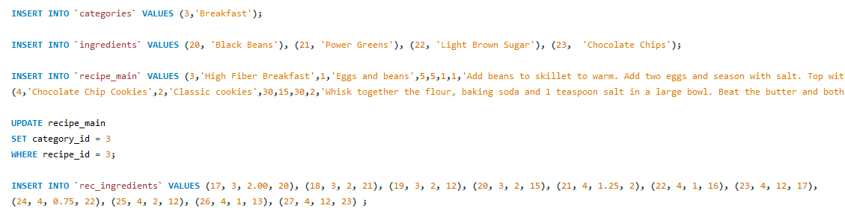
- Write only one SQL query that returns all information on only the two new recipes you inserted from all the tables you created in step 1 above.
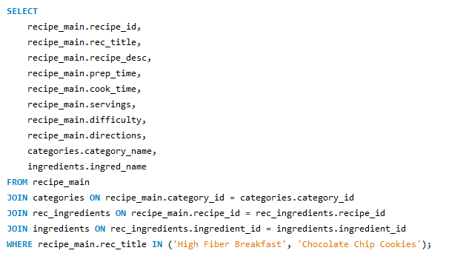
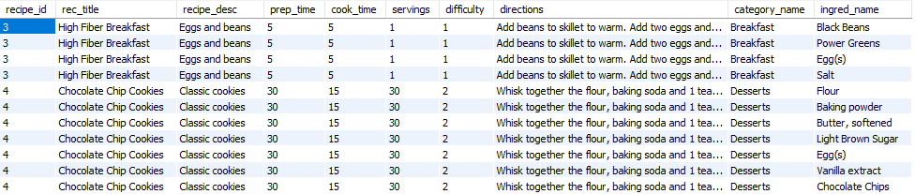

- Write a SELECT query that identifies the recipe name, category name, and ingredient name, and ingredient amount. No other variables should be included. Your output should be sorted first by descending category name, then by ascending recipe name, followed by descending ingredient name.
