Final Project –

Pharmacy Claims

Jeff Hackmeister
Northeastern University
ALY6030 Data Warehousing & SQL
Professor Nayem Rahman
February 13, 2026

Part One
- There are two facts in this table. The first is copay, which is an additive fact. The second is insurance_paid which is also an additive fact.
- The grain of the fact table is a single prescription fill, each row in the fact table represents one prescription being filled.
Part 2
- For dim_member the primary key is member_id, which is a natural key, it was already assigned to each member. For dim_drug, the primary is is drug_ndc which is also a natural key and is assigned to each drug by the FDA. For fact_prescription the primary key is fill_id, this is a surrogate key that I added as a auto-incrementing value given to each new row of the table.
- The two foreign keys reside in the fact_presecription table and are member_id from dim_member and drug_ndc from dim_drug.
- I chose CASCADE for both foreign keys for both update and delete. If a member is removed from the system, the records from the prescription should also be removed to avoid referential integrity problems. For updates, if a member_id or drug_ndc is altered, those changes should also be reflected in the fact_prescription table to ensure records are accurate.
Part 3
See jeff_hackmeister_final_project_ERD.pdf
Part 4
- There were five prescriptions filled for Ambien
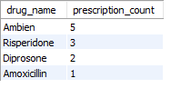
- There is one member over 65 and they filled 65 total prescriptions.
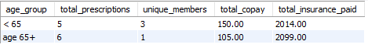
- For Jane Doe, member 10003, the most recent drug fill was Ambien. Their insurance paid 322.00.

