Hospital Nursing Intervention Pilot Program

Jeff Hackmeister
Northeastern University
ALY6030 Data Warehousing & SQL
Professor Nayem Rahman
February 1, 2026
Step 1
For the bed_type table, all variables are dimensions because the table contains no numeric measures. The primary key bed_id identifies each bed type, while bed_code and bed_desc provide descriptive context. In the business table, the three dimensions are ims_org_id (the primary key), business_name, and bed_cluster_id, which categorizes hospitals. The remaining variables in the business table represent facts because they are numeric and aggregatable.
Step 2
In the bed_fact table, license_beds, census_beds, and staffed_beds are fact variables because they are numeric and aggregatable, while ims_org_id and bed_id function as dimensions since they are foreign keys that identify the hospital and bed type.
Step 3 – Star Schema
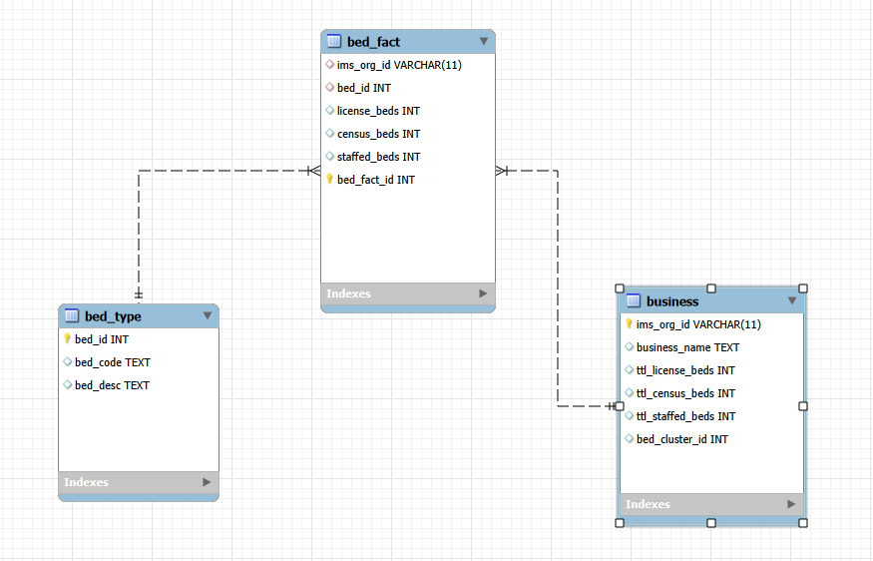

Step 4a: Analysis for Leadership (see SQL file for queries)
- Licensed beds
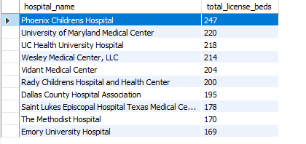
- Census beds
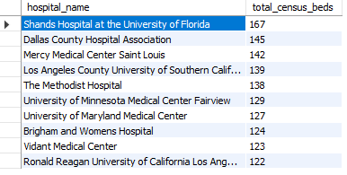
- Staffed beds
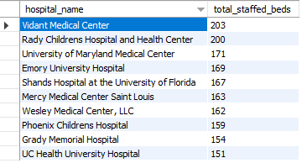
Step 4b: Interpretation of findings
In looking at the three summary tables above, only the University of Maryland Medical Center and Vidant Medical Center appear in all three lists. Phoenix Medical Center has the highest legal bed capacity with 247 licenses, and while they only have 117 beds on site (census_beds), they do have staffing for up to 159 beds (staffed_beds). Vidant Medical Center has the most staffed beds at 203, which is nearly all their 204 licenses but only a total of 123 current beds on site. To better explore which hospitals might be the best candidates for an additional staffing pilot, the percentage of staffing to census and licensed beds was calculated.
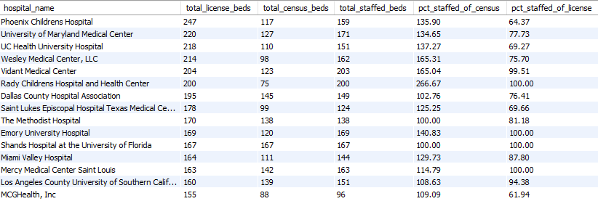
Here only The Methodist Hospital and Shands Hospital at the University of Florida did not have staffing levels in excess of census beds, while only 4 (Rady Children’s, Emory University, Shands, and Mercy Medical Center Saint Louis) had staffing to accommodate all of their licensed beds.
Step 5a: Drill down investigation (see SQL file for queries)
- Licensed beds
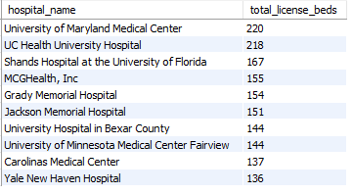
- Census beds
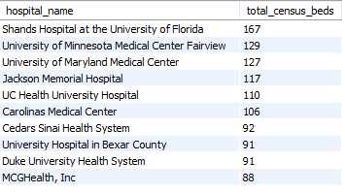
- Staffed beds
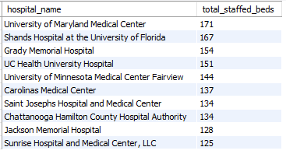
Step 5b: Final recommendation
After recalculating the reports from step 4 to only include hospitals that have sufficient volume of both ICU and SICU beds, the staffing ratios were calculated for the top 15 hospitals by total licensed beds.
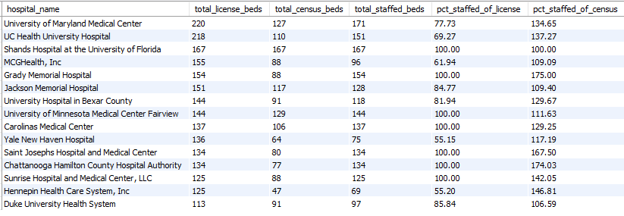
When determining locations for an increased staffing pilot program, those that are at the lowest rates of staffed versus licensed beds would be ideal candidates. These represent locations with the capacity to add physical beds to their locations and staffing to provide care for patients who utilize those beds. From the report above, Yale New Haven Hospital and Hennepin Heath Care System, Inc stand out as being below 60% in the percentage staffed of licenses metric. As leadership has requested up to two pilot sites, those would be the recommended starting locations for the pilot program.

