When it comes to car accidents, one of the keys that can be the difference between a victim fully recovering or dying due to their injuries is how quickly they can receive care. Because of this, it is vital for first responders to be able to get to the scene of the accident as soon as possible after it occurs. For the IBM / Coursera Applied Data Science Capstone, I took a look at ten years of accident data for the Seattle metro area. I wanted to see if it would be possible to predict whether an accident would be fatal based on the weather and road conditions that were present when the crash occurred. If these factors turned out to be statistically significant, Seattle first responders could have more people on duty when conditions that are more likely to produce serious accidents were present, in order to more quickly respond to the scene. I took a look at three road conditions: wet, dry, and icy; and five weather conditions: Clear, Overcast, Raining, Snowing, and Fog/Smog/Smoke. I found that there was a statistically significant difference in the fatality rates of accidents based on which of these conditions was present. It is clear from this heatmap that dry, snowing conditions as well as icy road conditions with poor visibility are the most likely to result in a fatal accident.

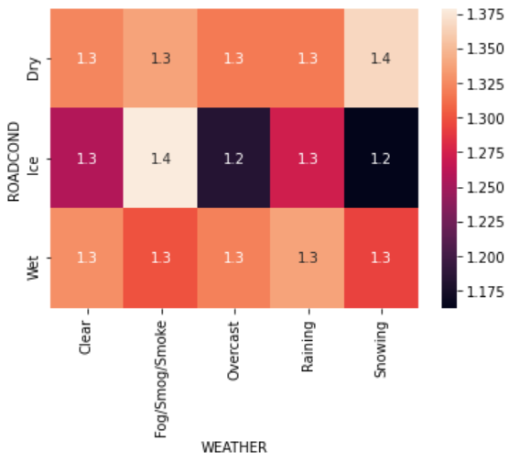

Once I knew the difference between conditions was significant, I wanted to be able to predict if an accident would be fatal based on the condition. I trained a machine learning algorithm to take the weather and road condition as input, and predict if the accident would produce a fatality or not. When testing this algorithm on data it had never seen before I was able to achieve 68% accuracy in predicting whether an accident would be fatal or not. This information could be very useful to those that need to know how many first responders to have on call each day!

Over the course of this study, I also discovered some interesting information. While accidents that occur when the roads are icy are less likely than average to be fatal, they are by far the most likely to be caused by speeding. I think if the general public new about this, they would be slowing down during icy conditions!

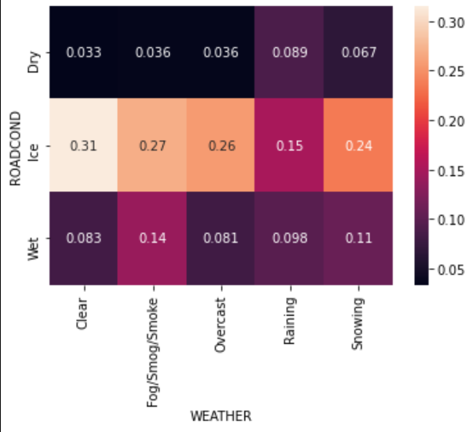

The heatmap clearly shows that icy conditions and speeding accidents go hand in hand.