Lab Report 1 (Weeks 1–2): Shear-Aware Agentic Grasping
Dohyun (@DHLeexpress) and Jihoon (@jhahn2) · AM/ME/CE 295, Caltech · Due Sunday, October 18, 2026
Repository: github.com/DHLeexpress/ME295 (public): README, running log (LOG.md), draft proposal, related-work note, Markdown version of this report
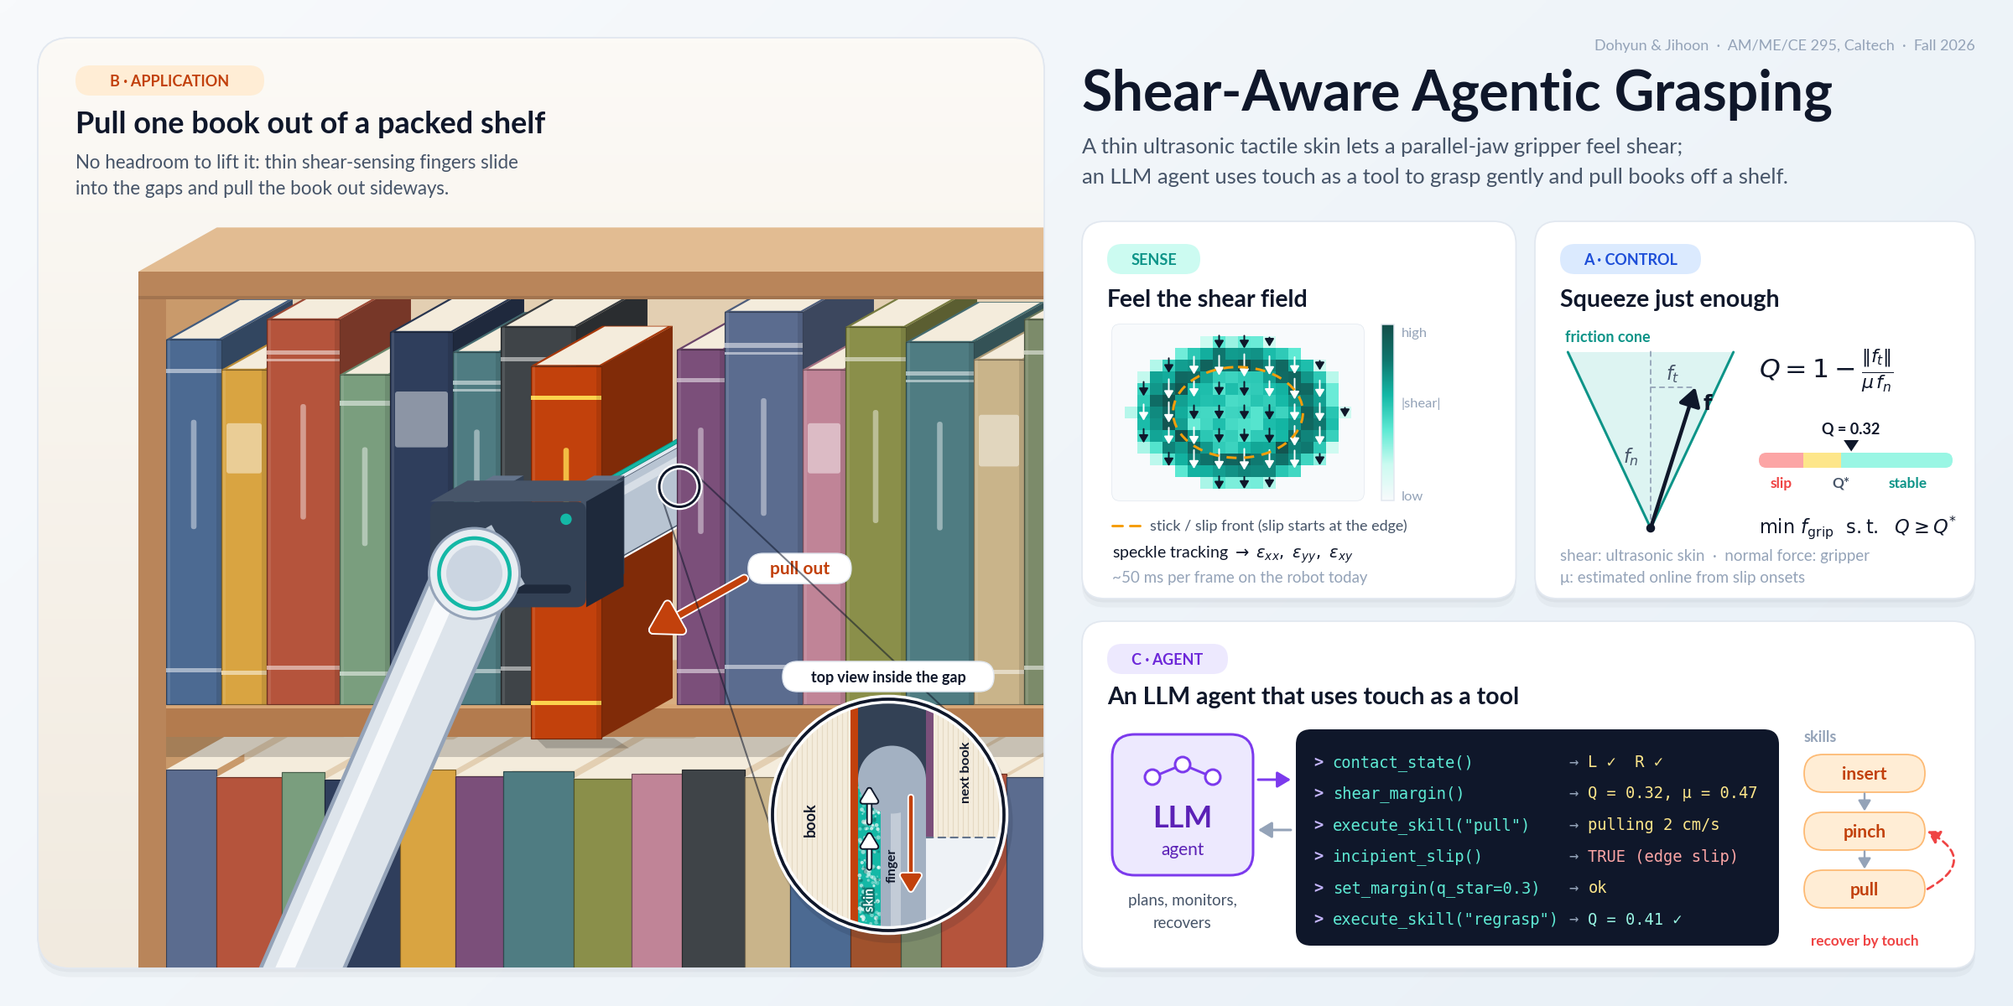
Figure 1. Project overview. (B) The gripper approaches a packed shelf horizontally, slides thin ultrasonic-skin fingers into the gaps beside one book and pulls it out sideways; the inset is a top view of the gap, where the skin shears as the book drags. (Sense) Shear field from ultrasound speckle tracking. (A) The friction-cone margin Q lets the gripper squeeze just enough. (C) An LLM agent calls these tactile signals as tools.
Goal (draft, to be locked in LR2). A parallel-jaw gripper knows how far it closed and roughly how hard it squeezes, but not how close each contact is to slipping, and vision cannot see that inside a packed shelf. We ask whether real-time shear sensing from Jihoon’s thin ultrasonic tactile skin on a Robotiq 2F-140 helps when it is used (A) inside a friction-margin grip controller and (C) as tools an LLM agent can call, on (B) pulling one book sideways out of a tightly packed shelf, where there is no headroom to lift it. “Helps” means more reliable and gentler than fixed-force, slip-reactive, LLM-prior and vision-only baselines.

1. Progress (from the running log)
Done.
- Literature: 3 core and 9 adjacent papers, synthesized in docs/related_work.md (Section 3).
- Direction: A+B+C. The book-shelf application follows our last discussion with Prof. Burdick. A learned visuo-tactile policy stays as a stretch comparison; pretrained optical tactile encoders were dropped (optical-to-ultrasound domain gap).
- Repo and environment: public repo, Python package shear_agent (numpy + matplotlib only), 23 unit tests that run offline, CI on every push.
- API access, safe for a public repo: keys live only in a git-ignored .env, and a pre-commit hook plus CI reject key-shaped strings. The dependency-free LLM client (Anthropic by default, any OpenAI-compatible endpoint optional) has timeouts, capped retries with backoff and token/turn limits, and never prints the key. Every tool call from the model is schema-validated before it can reach the robot.
- Working pieces (Section 2): friction-margin Q and a gentlest-closure helper; a toy evaluation harness with 4 controllers and a latency sweep; the agent’s tool-use loop, runnable offline with a scripted mock LLM.
- Hardware carried in from earlier lab work: tactile gripper v1 (ultrasonic skin on one 2F-140 finger, dummy finger on the other); ultrasound → strain → ROS → UR10e at ~50 ms per cycle; UR10e pushing tests on flat, inclined and compliant surfaces.
Remaining before LR2. Lock the question and write the 1-page proposal; calibrate shear strain → tangential force and gripper setting → normal force; measure how fast the Robotiq can change force mid-grasp; verify the API key; build shelf testbed v0.
Bottlenecks.
- Double-sided sensing waits on the new ultrasound system (ETA ~2 weeks), so A and C start with one sensed finger.
- Latency: the loop is ~50 ms and images are the slow link (a single .bmp at ~5 fps vs. a 10×10 matrix at ~20 kHz in our link test), so we will compute strain on the ultrasound PC and stream features only.
- Normal force is hard to read from ultrasound images, so f_n comes from the gripper and the skin is used for shear only.
- The Robotiq takes a force limit plus a position, not torque control; mid-grasp force changes may need position-increment squeezing.

2. Demo: current state
Hardware. Tactile gripper v1 streams shear strains to the UR10e controller in real time; we show the setup live (photos stay in the internal deck while the sensor design is unpublished). (a) Toy evaluation harness (python scripts/run_toy_benchmark.py). The numbers are synthetic: the simulator encodes our assumptions and exists to fix metrics, baselines and a latency budget before hardware time. Setup: 500 random books, 50 ms sensing loop.
Controller | Failed pulls | Mean slip | Mean grip force
Fixed 15 N (gripper default, gentle) | 13.4 % | 3.6 mm | 15.0 N
Fixed 60 N (gripper default, strong) | 0 % | 0 mm | 60.0 N
Slip-reactive regrasp (Dong et al. 2017 style) | 0.4 % | 3.9 mm | 15.7 N
Shear-margin, ours (Q ≥ Q*, slip reflex) | 0 % | 1.2 mm | 16.7 N
Takeaways: holding Q ≥ Q* matches the strong grip’s 0 % failures at ~28 % of its force, with ~3× less slip than slip-reactive control. Slip grows roughly linearly with sensing latency (ours: 0.4 → 1.2 → 3.0 mm at 0 / 50 / 200 ms), so streaming features instead of images is worth doing. Our first controller lost to slip-reactive at ≥150 ms latency until we added a slip reflex and matched its feed-forward lead to the loop delay.
(b) Agent loop, offline (python scripts/run_agent.py --mock): insert → pinch → contact_state → pull → shear_margin (Q = 0.00) → incipient_slip (true) → set_margin (Q* = 0.3) → regrasp → shear_margin (Q = 0.30). The same loop runs with the real model once the key is in .env, and scripts/check_llm_api.py verifies the key, the network and tool calling in one short episode.

3. Related work and the gap
- Trixi the Librarian (Wieczorek et al., arXiv 2022). A PR-2 extracts books bimanually: a Shadow-hand finger tilts the book, and the other arm’s gripper grasps, releases, regrasps and pulls. It uses no contact sensing, and the one-hand attempt failed. Our task baseline for B.
- DeliGrasp (Xie et al., CoRL 2024). An LLM guesses mass, μ and stiffness from text and writes a physics-based grasp policy for a current-limited two-finger gripper; it beats classic adaptive and LLM-as-code policies on 12 delicate items. The parameters are priors and nothing measures shear. Our agentic baseline for A and C.
- Reactive Diffusion Policy (Xue et al., RSS 2025). A slow diffusion policy plus a fast tactile/force loop, trained from AR-teleoperation demos with GelSight-type sensors; it beats vision-only imitation learning. Our scaled-up, learned comparator (stretch).
Gap. Shear feedback exists for thick optical fingertips; book extraction has used dexterous hands, special hardware or no touch; LLM grasp agents set force open-loop or watch through vision. A thin shear-sensing parallel-jaw finger whose margin is exposed to an agent as a tool, on a confined task where vision is weak, has not been tried.

4. Next two weeks (to LR2, November 1)
Task | Owner | Done when
Lock the research question; 1-page proposal; confirm the team with the TA | Both | Proposal submitted
Shear strain → tangential force calibration (UR10e wrist F/T or load cell) | Jihoon | Fit + held-out error in repo
Stream strain features (not images) over ROS 2; measure end-to-end latency | Jihoon + Dohyun | Latency histogram in repo
Robotiq 2F-140: force setting → measured grip force; mid-grasp re-command latency | Dohyun | Script + table in repo
Verify the LLM API key; first real agent run on the mock gripper | Dohyun | check_llm_api.py exits 0
Shelf testbed v0 (adjustable packing); finger thickness vs. book gaps; first scripted-baseline pulls | Both | Photos + trials in LOG
Integrate the new ultrasound system (both fingers sensing); move sensing code into sensing/ | Jihoon | Both sides streaming; first commits

