Practical - 5

5.Implement a producer-consumer communication system using anonymous pipes where the parent process generates data and the child process consumes it. Measure the communication efficiency.
Develop a program that executes the equivalent of the shell command ls -l | grep ".c" using fork(), pipe(), dup2(), and exec() system calls.
Input code:

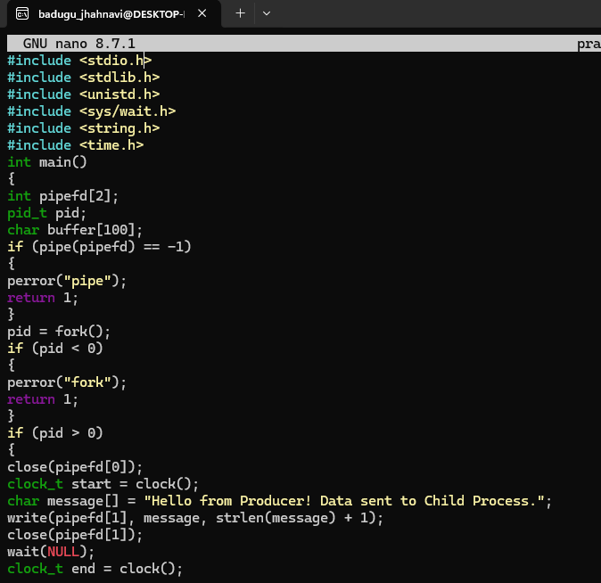

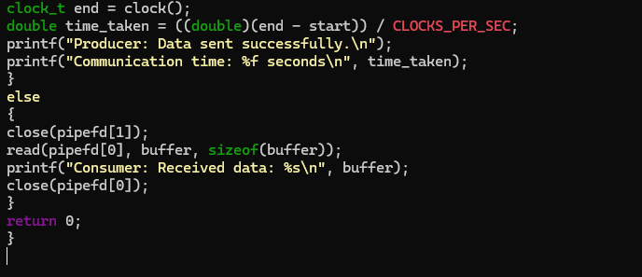
Output:
