Practical2

Question
Develop a C program that uses the system calls open(), read(), write(), and close() to copy the contents of one file to another. Explain how control transitions between user space and kernel space during execution.
Use the strace utility to trace all system calls generated by the command cat sample.txt. Analyze the sequence of system calls and identify the kernel services involved.

Simple C Program
#include <stdio.h>
#include <stdlib.h>
#include <fcntl.h>
#include <unistd.h>
int main() {
int source_fd, dest_fd;
char buffer[1024];
ssize_t bytes_read, bytes_written;
// Open source file for reading
source_fd = open("sample.txt", O_RDONLY);
if (source_fd == -1) { perror("Error opening source file");
return 1;
}
// Create destination file for writing
dest_fd = open("copy.txt", O_WRONLY | O_CREAT | O_TRUNC, 0644);
if (dest_fd == -1)
{
perror("Error creating destination file");
close(source_fd);
return 1;
}
// Read from source and write to destination
while ((bytes_read = read(source_fd, buffer, sizeof(buffer))) > 0)
{
bytes_written = write(dest_fd, buffer, bytes_read);
if (bytes_written != bytes_read)
{
perror("Error writing to destination file");
close(source_fd);
close(dest_fd); return 1;
}
}
if (bytes_read == -1)
{
perror("Error reading source file");
}
// Close both files
close(source_fd);
close(dest_fd);
printf("File copied successfully!\n");
return 0;
}
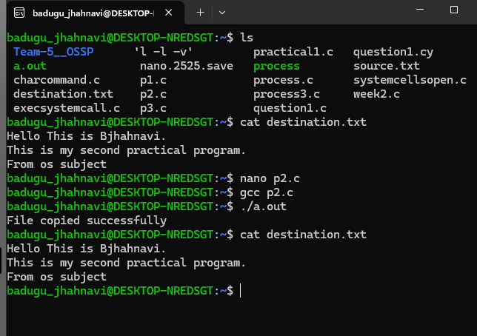
OUTPUT:

