Flood Alert System

Israel Candido

Illinois Institute of Technology

3201 S State Street

Box #2225

Chicago, IL - 60616

+1-312-401-5853

iairesca@hawk.iit.edu

Luiz Pinto

Illinois Institute of Technology

3201 S State Street

Box #2839

Chicago, IL - 60616

+1-312-316-2948

lmariano@hawk.iit.edu

Alysson Souza

Illinois Institute of Technology

3201 S State Street

Box #2845

Chicago, IL - 60616

aandrad6@hawk.iit.edu

ABSTRACT

In this paper, we propose a simple flood alert system, composed by three main parts: sensor modules, a data central, and a remote server. Each sensor module, installed near a river or in the sewers, is composed by an ultrasound distance sensor, a radio transmitter and an Arduino microcontroller. The data central, located near the sensor modules, receives data from all sensor modules, and re-transmits these, via Ethernet, to the remote server. The remote server is implemented in software, and runs specific algorithms to calculate the probability of floods happening in the area where the sensor modules are located. This server would be accessible to competent authorities, such as governments, research centers and universities, who would be free to implement client software to access and retrieve its data. The first two parts of the system have been built as a prototype.

General Terms

Algorithms, Measurement, Performance, Design, Economics, Reliability, Experimentation, Security, Human Factors, Verification.

Keywords

Alert, Arduino, data central, distance, floods, sensor, server, warning, water level, XBee.

# INTRODUCTION

Floods are a serious problem in many parts of the world, which affects developed and developing countries alike. They usually affect urban areas, where concrete and asphalt are used extensively, preventing the water from being drained into the soil. As they affect mostly urban areas, where commercial and industrial activity is greater, floods have the potential to damage the economy, by damaging property and having work spaces filled with water. They can also affect residential areas, and are a serious hazard to the health of homeless people. And while urban areas are more affected, floods can be an issue in rural settings as well, by destroying crops and livestock. There are multiple social and economic issues caused by floods.

Ideally, floods should not only be predicted, but prevented and corrected. Correction systems would aim to drain water from rivers, lakes and sewers to stop overflow. Prevention systems would aim to keep the water level in reservoirs controlled and below a certain limit. Both systems would require good measuring instrumentation, in the form of water level sensors. Unlike preventive and corrective systems, prediction and alert systems do not aim to fix the problem, but simply to measure the water level in reservoirs and compute the probability of a flood happening. They are easier to implement and can serve as a first block in larger preventive and corrective systems.

This paper proposes a simple, yet effective flood alert system, composed of a mesh sensor network installed in multiple points of a water reservoir. Ultrasonic distance sensors are used to measure the water level in such reservoir, and a data central, located near the reservoir, collects the data from all sensors, and transmits it to a remote server, via internet. Specific algorithms can be run in the server, and predict the probability of a flood happening based on the water level measurements transmitted by the data central. While the data central is supposed to be located inside a building, and connected to both the internet and mains electricity, sensor modules are built to remain in the water reservoir for long periods of time, and must be self-powered. For that reason, data transmission between the central and the sensor modules is done via radio. Each sensor module is powered by a built-in battery, connected to a solar panel.

As a prototype, the sensor network has been developed, with three sensor modules and the data central.

# SYSTEM OVERVIEW

The flood alert system is composed by three distinct parts: sensor modules, data central, and remote server. Communication between each sensor module and the data central is done via XBee radios. Communication between the data central and the remote server is done via internet.

## Sensor Modules

Each sensor module is composed by a PING)))™ Ultrasonic Distance Sensor, produced by Parallax, Inc., connected to an Arduino Uno microcontroller board, which is, in turn, connected to an XBee radio module configured as a router.

Sensor modules are built in a plastic case, which is made to provide protection from water and natural phenomena (rain, snow, wind etc.).

Each module is powered by a 9-volt battery, which is charged by a solar panel.

Modules are built on top of posts inside the reservoir, and the water level is calculated based on the distance between the sensor and the top of the water.

The ultrasonic sensor keeps track of the water level by outputting a pulse directly to the water and receiving the time the signal took to make the round-trip. To get only the one-way trip, the Arduino calculates the distance based on the speed of sound and the time divided by 2 (two).

$$DistanceToObject=\frac{SpeedOfSound*TimeOfPulse}{2}$$

Transmission is done via the XBee module through the Arduino microcontroller. Sensor data is read by the Arduino and written into the XBee through its serial port. Data should be transmitted periodically, every couple hours.

Schematics:

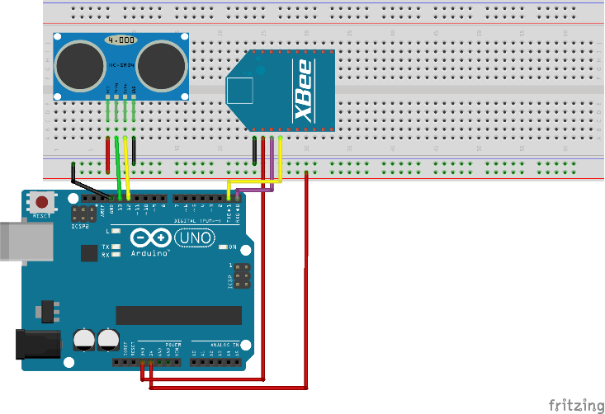

## Data Central

The data central is secured within a building located near the water reservoir. It is powered by mains electricity, and is composed by an XBee radio module configured as a coordinator, connected to an Arduino Uno microcontroller board. The Arduino is, in turn, connected to the internet via an Ethernet shield and a network router.

The XBee module is used to receive data from sensor modules. Data is received every couple hours, and transmitted to the remote server via internet.

The Data Central must be powered all the time, because without the coordinator, there is no network. Which means that the Data Central is the critical point of the system.

Schematics:

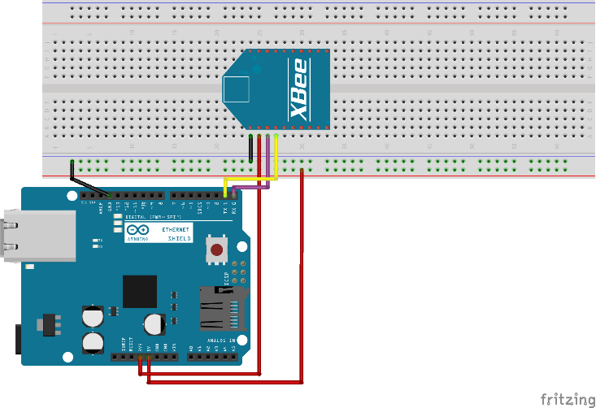

Observation: the Ethernet shield consumes the pins 13, 12, 11 and 10 of the Arduino Uno microcontroller board.

The router is not illustrated, but it should be connected to the Ethernet shield by using a network cable.

## Remote Server

The remote server can be located anywhere in the city, or even elsewhere. It is composed by a database with historical water level data, and an application capable of running an algorithm to predict the probability of a flood happening based on current water level measurements and historical data. Such application requires a powerful processor.

## Clients

Ideally, the server should be open to competent authorities, who are able to take appropriate action when a flood is predicted. These include universities, governments, and research centers. Alternatively, the system could be open to other users as well. A client application could be run in a cellphone, and send out alerts when a flood is predicted.

Competent authorities and the general population would be welcome to develop their own client applications and access the data from the server.

# PROTOTYPE BUILT

Based on the designed flood alert system, a prototype network has been built. It is composed by three sensor modules and a non-transmitting data central. A small parallelepipedic reservoir was filled with water, and the sensor modules were installed on the edges. The central was connected to a laptop, and the distance data was read.

# CONCLUSION

The flood alert system described here is relatively easy to implement, and requires only three main components: sensor modules, a data central, and a remote server. While the first two have been built, as a prototype, implementing the remote server would require more time, and is a task left for the future.

Predicting floods and alerting the general population and competent authorities is the first step in taking preventive or corrective action. We hope that the system proposed here may serve as a basis for future projects on flood prediction, prevention and control.

# ACKNOWLEDGMENTS

Our thanks to Professor Jeremy Hajek and Doctor Dan Tomal for their help and support in this project.

# REFERENCES

Digi International Inc. (n.d.). Digi. Retrieved 12/2014 from XBee® ZB:

http://www.digi.com/products/wireless-wired-embedded-solutions/zigbee-rf-modules/zigbee-mesh-module/xbee-zb-module#specs

Parallax Inc. (n.d.). Parallax. Retrieved 12/2014 from:

http://www.parallax.com/sites/default/files/downloads/28015-PING-Detect-Distance.pdf