Intermediate Linux - Taming the Penguin

Understanding the Technology and Philosophy of Unix/Linux Part II
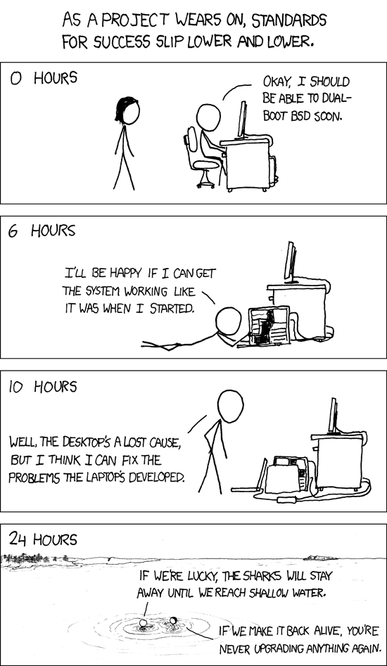
Understanding the Technology and Philosophy of Unix/Linux

Table of Contents
- Introduction and Notes
- Objectives of this book/project
- Who should read it?
- Who are we?
- How this book/project works
- Acknowledgements
- Linux/Unix History and Philosophy (pulled from other book)
- Environment setup
- Resources for you beyond this book
  - Blogs and Podcasts
- Capacity Planning
- Tools of Troubleshooting
  - Measure CPU usage
  - Measure memory usage
  - Measure disk I/O
  - Measure network I/O
  - Measure firewalling and routing throughput
  - Map client bandwidth usage
  - Match / correlate system symptoms with likely problems
  - Estimate throughput and identify bottlenecks in a system including networking
- Predict Future Resource Needs
  - Use collectd to monitor IT infrastructure usage
  - Predict capacity break point of a configuration
  - Observe growth rate of capacity usage
  - Graph the trend of capacity usage
  - Awareness of monitoring solutions such as Nagios, MRTG and Cacti
  - Monitoring tools such as Ganglia and Vector
- The Linux Kernel
- Kernel 2.6.x documentation
- Kernel 3.x documentation
  - Compiling a kernel
  - /usr/src/linux/
  - Kernel Makefiles
  - Kernel 2.6.x/3.x make targets
  - Customize the current kernel configuration.
  - Build a new kernel and appropriate kernel modules.
  - Install a new kernel and any modules.
  - Ensure that the boot manager can locate the new kernel and associated files.
  - Module configuration files
  - Awareness of Dracut
- Kernel runtime management and troubleshooting
  - Use command-line utilities to get information about the currently running kernel and kernel modules
  - Manually load and unload kernel modules
  - Determine when modules can be unloaded
  - Determine what parameters a module accepts
  - Configure the system to load modules by names other than their file name.
  - /proc filesystem
  - Content of /, /boot/ , and /lib/modules/
  - Tools and utilities to analyze information about the available hardware
    - udev rules
- System Start Up and Recovery
- SysVInit
  - Customizing SysV-init system startup
  - Linux Standard Base Specification (LSB)
- Introduction to Systemd start up
  - Details about systemd
- System Recovery
  - GRUB version 2 and Legacy
  - Grub shell
  - Boot loader start and hand off to kernel
  - Kernel loading
  - Hardware initialization and setup
  - Daemon/service initialization and setup
  - Know the different boot loader install locations on a hard disk or removable device *
  - Overwriting standard boot loader options and using boot loader shells
  - Awareness of UEFI
- Alternate bootloaders
  - PXE
  - Grub and Grub2
- Filesystem and Devices
- History of Linux filesystems
  - The concept of the fstab configuration
  - Tools and utilities for handling SWAP partitions and files
  - Use of UUIDs
- Maintaining a Linux filesystem
  - Tools and utilities to manipulate and ext2, ext3 and ext4
  - Tools and utilities to manipulate xfs
  - Awareness of Btrfs and ZFS and FUSE
- Advanced Storage Device Administration
- Software raid configuration files and utilities
  - mdadm.conf
  - mdadm
  - /proc/mdstat
- Adjusting Storage Device Access
  - Tools and utilities to configure DMA for IDE devices including ATAPI and SATA
  - Tools and utilities to manipulate or analyze system resources (e.g. interrupts)
  - Awareness of sdparm command and its uses
  - Tools and utilities for iSCSI
- Logical Volume Manager
  - LVM suite
  - Resizing, renaming, creating, and removing logical drives
  - Snapshots
  - Active volume groups
- Network Configuration
- Configure and manipulate Ethernet settings
- Configure wireless access via iw
- Manipulate route tables
- Monitor traffic
- Troubleshooting network issues
- System Maintenance and Tools
- tar
- make
- uname
- compression
  - bzip
  - gzip
  - xz
- configure
- install
- Web Services
- APACHE
  - Apache mods
  - Reverse proxy
  - SSL configuration
- NGINX
  - As a reverse proxy
- Domain Name Server
- BIND
- DNSMASQ
- File Sharing
- NFS
- SAMBA
- Object Storage (Perhaps just an overview of how it works in comparison?)
- Network Client Management
- DHCP server setup
- PAM
- OpenLDAP
- E-Mail Services
- System Security
- Configuring a router
- Managing FTP servers
- Secure shell (SSH)
- Security tasks
- OpenVPN
- Operations Deployment at Scale
- Packer.io
- Vagrant
- AWS/AZURE commandline
- The Future
Appendix A: Glossary
Appendix B: Notes
## ![ > | C Un As | hapter 00 - Introduction derstanding the Technology and Philosophy of Unix/Linux](images/cautionary.png "Understanding the Technology and Philosophy of Unix/Linux") tute quote goes here
## | # | 0.1 - Objectives of this book/project
Wh | y | undertake another Linux book? Isn't the world filed with enough documents and books? On one hand you are correect there are many books in print and available. Linux/Unix has a unique place in computing. Entering now it's 4th decade of existance we are facing a new dawn of the use of Linux. Devices such as Android proliferating 1 and companies such as RedHat being a billion dollar company 2.
## | ## | Course Objectives: Administer a small to medium-sized site Plan, implement, maintain, keep consistent, secure, and troubleshoot a small mixed (MS, Linux) network, including a: LAN server (Samba, NFS, DNS, DHCP, client management) Internet Gateway (firewall, VPN, SSH, web cache/proxy, mail) Internet Server (web server and reverse proxy, FTP server) Supervise assistants Advise management on automation and purchases Guidelines from LPI II
## | # | 0.2 - Who should read it?
Yo | u | =)
## | # | 0.3 - Who are we?
## | # | 0.4 - How this book/project works
## | # | 0.5 - Acknowledgements
## | # | 0.6 - Linux/Unix History and Philosophy (pulled from other book)
## | # | 0.7 - Environment setup
## | # | 0.8 - Resources for you beyond this book
 | Th | ere are many resources out there on the internet. You should go beyond what just your teacher tells you or expect that they will be like Master Yoda and just dump all knowledge into you. Though a professor or a mentor is a great place to start, you need to do some work finding communities and resources on the Net you can use to put yourself ahead of the competition. Here is a short list that helped me greatly and are considered industry wide tools and communities you can participate in at any level.
 | ## | ## Twit.tv
 | Th | is is more than one site it's really the evolution of Television if you think about it.
 | ## | ## Stackoverflow

Chapter 01 - Measure and Troubleshoot Resource Usage
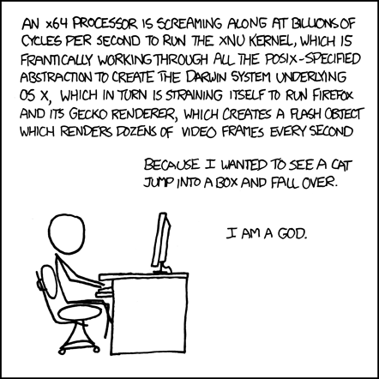 > Astute quote goes here

1.1 Tools of Troubleshooting
1.1.1 - Measure CPU usage
1.1.2 - Measure memory usage
1.1.3 - Measure disk I/O
1.1.4 - Measure network I/O
1.1.5 - Measure firewalling and routing throughput
1.1.6 - Map client bandwidth usage
1.1.7 - Match / correlate system symptoms with likely problems
1.1.8 - Estimate throughput and identify bottlenecks in a system including networking

1.2 Predict Future Resource Needs
1.2.1 - Use collectd to monitor IT infrastructure usage
1.2.2 - Predict capacity break point of a configuration
1.2.3 - Observe growth rate of capacity usage
1.2.4 - Graph the trend of capacity usage
1.2.5 - Awareness of monitoring solutions such as Nagios, MRTG and Cacti
1.2.6 - Monitoring tools such as Ganglia and Vector

