**Individual Assignment # 2**

***I pledge, on my honor, that I have neither received nor given any unauthorized assistance on this assignment.***

**Name: ____KHUSHBOO JHA_______**

**(30 points) Data Visualization and Sales Diagnosis**

ABC is an online cosmetic retailer, selling products from all over the world to Chinese customers on Alibaba’s B2C platform. ABC provides us with all historical sales data to evaluate their sales performance (cosmetics retailer_1.csv on Blackboard). The data has been aggregated up to the product level. The variables included in the data are:

SKU (num_iid)

Transaction Date (createdate)

revenue (numiidrev)

quantity (quantity)

sale sign (salesign: =1 on sale; =0 otherwise)

average selling price (averageprice)

days in the market (daysinmarket)

category (category)

brand (brand)

brand’s country of origin (Country)

sample or full size product (=1 sample, =0 full size)

moisturize (fun_mois=1 has such function, =0 no such function) such binary coding apply to all production functions below

sunscreen (fun_sun)

antiage (fun_antiage)

anti wrinkle (fun_antiwrinkle)

whitening (fun_white)

deep clean (fun_deepclean)

clean (fun_clean)

minimize pore (fun_minpore)

firming (fun_firm)

brightening (fun_bright)

nurturing (fun_nurture)

improve sensitive skin (fun_antisensitive)

antioxidant (fun_antioxy)

oil control (fun_oilcontrol)

spot treatment (fun_antispot)

soothing (fun_soothing)

concealing (fun_conceal)

**To provide actionable insight and sales diagnosis, let’s use Tableau to generate descriptive and diagnostic dashboards. Please choose any appropriate format of graphs that you believe is the most informative to reveal insights. Please make sure that they are self-explanatory and easy to read. Attach all your graphs here.**

**Question 1:**

**Please generate plots to evaluate ABC overall sales performance. How does ABC perform in the recent years?**

**Answer 1:** Attached Tableau dashboard shows ABC overall sales performance from 2006 to 2014. Overall revenue generated by ABC sales depicts upward trend from 2006 to 2012.

In recent years i.e. after 2012 to 2014, ABC depicts negative trend.

* There is sudden decrease in sales or revenue being generated after year 2012.
* Revenue generated by top 10 brands is also decreasing after year 2012.
* The quantity of overall products being sold after year 2012 is also decreasing.
* There is sudden decrease in the average price of brand Su Ye after year 2011.
* Rest of the top 10 brands like Elizabeth Arden also depicts some fall in average price after year 2013. Kose also displays constant fall in average price after 2012. Rest of the top 10 brands are having minor changes in average price. Only brand Lancome average price has increased after year 2012.

**Answer1: Dashboard 1**

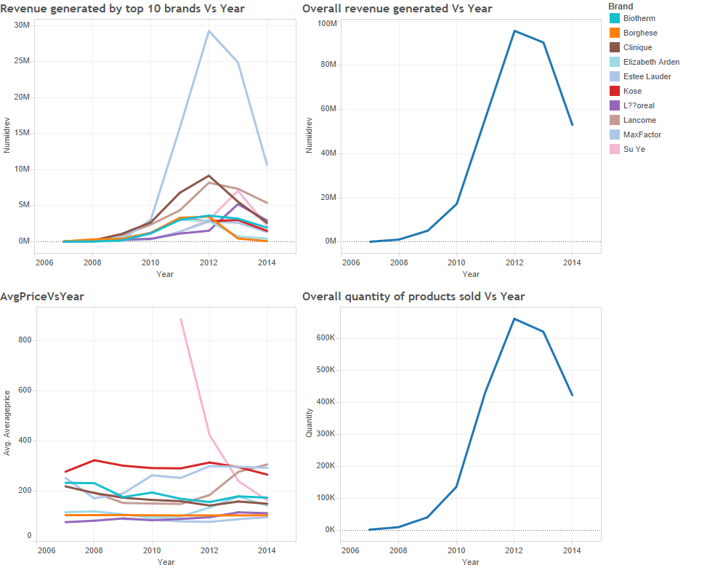



**Question 2:**

**Please generate plots to explain the changes in ABC’s sales performance. What are the possible drivers based on these plots? What are the actionable insights from these plots? What are your recommendations? Please make sure that your answers are based on the plots and the given data (not your gut feeling or intuition).**

**Answer 2:** ABC’s change in sales performance could be explained by below graph.

**Answer 2: Dashboard 1**

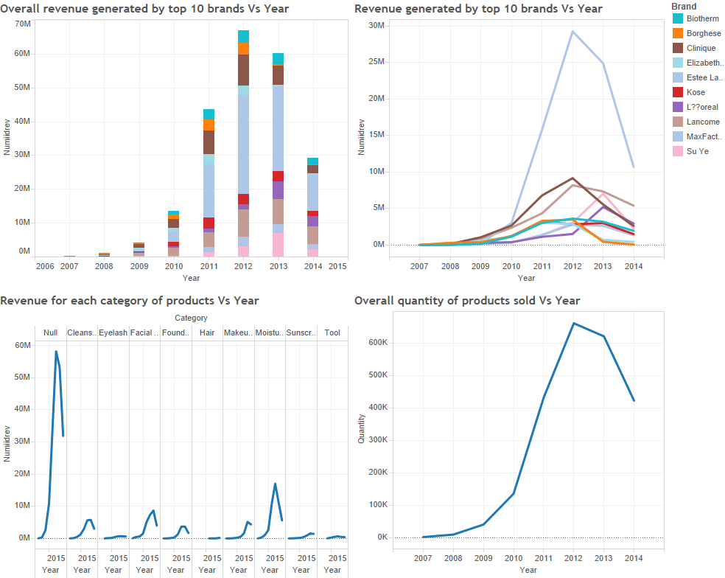

 Attached is the dashboard.

From these plot it is clear that most of the top ten brands revenue is decreasing after 2012. Su Ye, L’Oréal, Kose revenue is decreasing after 2013. The maximum downfall in revenue is observed due to Estee Lauder, as it is market leader and there is sudden, steep downfall in its revenue. Then Clinique and Lancom who are 2nd and 3rd major contributor in revenue generation, there revenue is also decreasing after 2012.

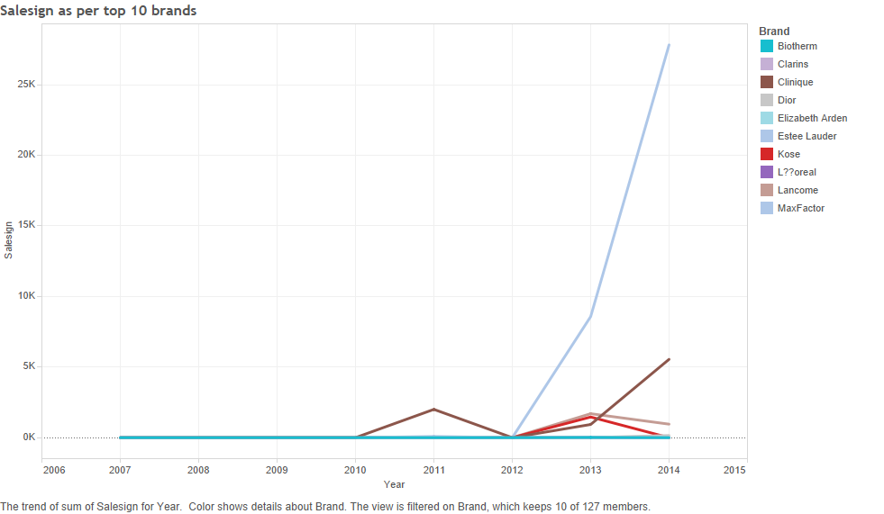

**Reasons for decrease in revenue:**

1. The main reason for the sudden downfall in revenue after 2012 is because there is sudden rise in the number of products selling on sale as represented by Sale sign graph above. Sale sign is shooting up especially for Estee Lauder, which is market leader after 2012.
2. Product Estee Lauder which is the major contributor towards revenue generation, its revenue is decreasing. Overall quantity of products being sold are decreasing. Products being sold on sale is increasing. This contributes to decrease in revenue generated.
3. Quantity of products sold (i.e. sum of quantity of different brands and categories of products) is decreasing after 2012.
4. Brand Lancome revenue and demand is decreasing, but its average price is increasing. This also leads to decrease in revenue.
5. Maximum revenue generated is from moisturizer (known category), but after 2012 there is huge downfall in the revenue of moisturizer. This also contributes to decrease in revenue generated.
6. There is downfall in the revenue generated and quantity imported from the top players (i.e. France, UK, USA etc.) in the market of China except Korean and Switzerland products. Though these are small player in the market of China, there is upward trend in the revenue generated.

**Answer 2: Dashboard 2**

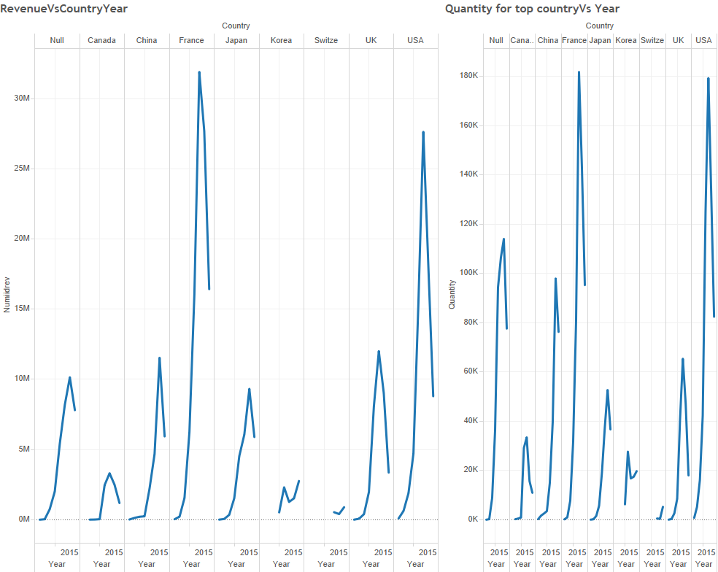

**Recommendations:**

**Answer 2: Dashboard 3**

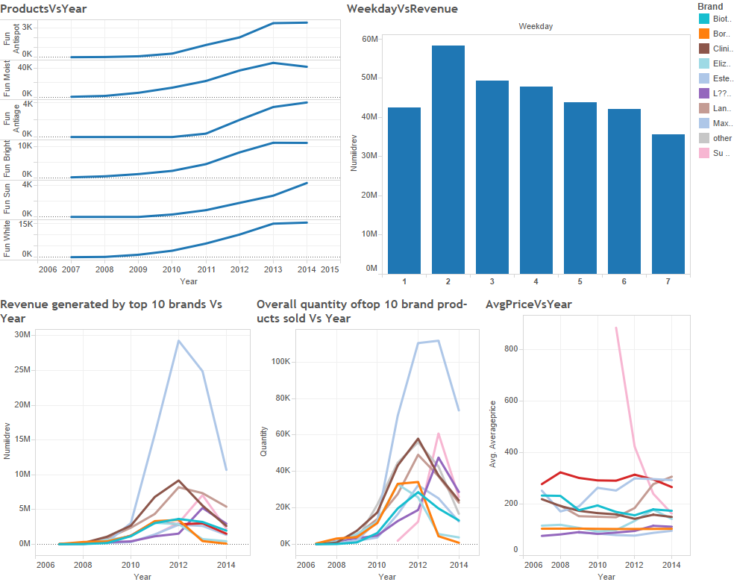

Attached dashboard:



1. From Sale sign graph, it is clear that selling maximum products on sale is causing revenue to decrease, especially for brand Estee Lauder, as it is market leader. So reducing sale is recommended.
2. From above dashboard, weekday 7 least revenue generated, weekday 2 maximum revenue generated. So try selling maximum products on second day of the week.
3. There is an upward trend for category -- antiaging products and sunscreen product after 2012. Antispot, bright and white features in the products see flat trend from 2013 to 2014. So there is neither increase nor decrease in demand for these features in the products. Rest of the products (ant wrinkle, deep clean, clean, minimize pore, firming, nurturing, improve sensitive skin, antioxidant, oil control, soothing, concealing) see downward trend. So one should focus on antiaging, sunscreen, antispot, bright and white features in the products. For hair product, revenue generated observes positive trend (from 1st dashboard of answer 2), so it could be considered, as it is not negative.
4. Brand Lancome revenue and demand is decreasing, but its average price is increasing. Its market price should be modified.
5. Since there is upward trend in Korea and Switzerland revenue generation (**Answer 2: Dashboard 2**), ABC can import more products from these countries in a progressive manner, to increase the revenue as they are very small players in the current market.

Tableau notes:

1. The “dimensions” section include all categorical variables (data slicer). Only these variables can be dragged onto color, size, labor, detail, and shape in “marks” section. If some variables that you want to use to slice the data are in “measures” section, you need to first drag them to the “dimensions” section and then drag them to “marks” section.
2. If multiple graphs share the same row (or column) axis, you can include them in one panel for easier comparison. Just drag multiple variables to the row (or column, or both) axis. In this way, you can plot a matrix of graphs.