Introduction to Computational Medicine

Project 1 Part 2

Joe and the Joes

Joe Hakim, Steven Chen, Christopher Le, Richard Liu

In Parlikar et al (2007), the authors derived a relationship between cardiac output and measurable vital quantities, including beat to beat pressure, duration of each cardiac cycle, pulse pressure and diastolic arterial pressure. The final equation they derived, using essentially an improved Windkessel model (which in turn is essentially an RC circuit), requires sequential calculation of taun = *Rn*Cn* from known data, *Cn* from known data, and using these two to calculate *CO*, or cardiac output.

To calculate taun, we implemented a sliding window approach instead of a more naive instantaneous value for taun. This results in a smoother measurement Essentially, this is analogous to taking a moving average of the values that would be calculated using the ABP data; this smooths taun, but note that after a certain threshold (out of scope to calculate), we would eventually lose information, interpreted by the algorithm as fluctuation. However, due to the fact that the solved equation for taun has a difference (of pulse pressure and average pressure) in the denominator, if these approach zero the noise present in those values is amplified, and the noise that this acquires would be carried to the end calculations.

Next, we implemented the affine-function-of-pressure (AFOP) calculation of Cn, the compliance. For the guidelines for this report, we were asked to simply calibrate (find C, as a normalization constant for CO) using the first thermodilution (TD) value, and assume constant compliance. We did this method, but also the AFOP method in order to compare the effect on the final Cardiac output estimation. Finally, we compared both of these measures vs. a measure that simply averaged the effective values from TD measurements. The comparison is in figure 1, indicating that the regression method was the best in terms of minimizing least square error (but note these were still further than the Liljestrand algorithms).

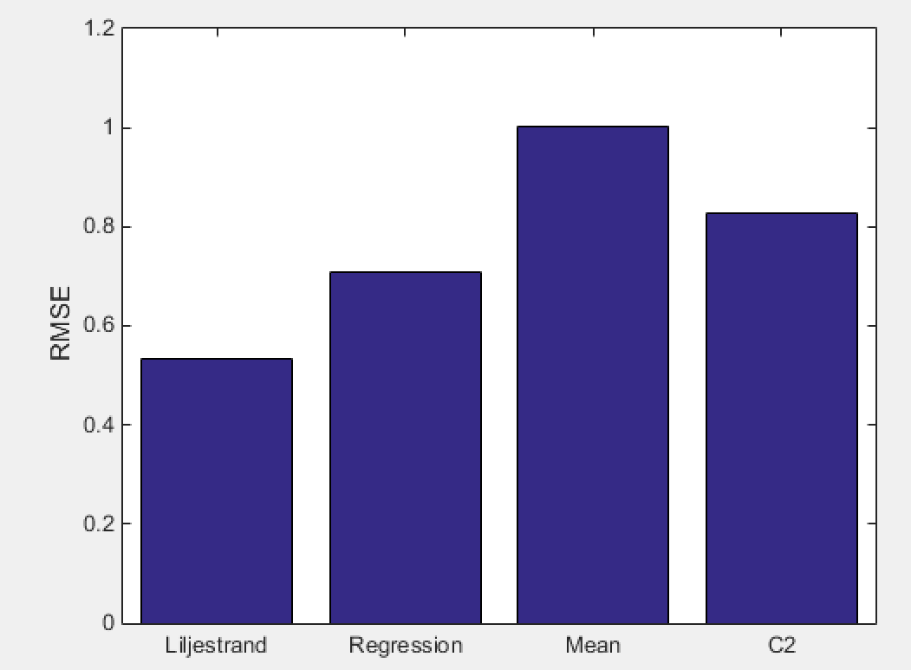

Figure 1. Comparison of cardiac output with different compliance calculation methods. For the more naive approach, there is more significant divergence. The difference is quantified via a RMS error with a difference between measured (TD) and the CO estimated via the Parlikar method. This indicates that the Liljestrand algorithm is still closest to predicting the actual TD values in the two cases analyzed (here shown patient 20, 708 yielded similar results), however this might not hold in more dynamically changing cardiac outputs.

Once we had calculated Tau and C_n, these could be used to find CO via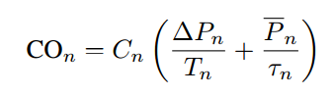,

The other quantities of the equation follow directly from the measured data.

We also included analysis of TPR (total peripheral resistance). TPR is important clinically, since it essentially represents blood viscosity, blood vessel radius, and indicate vasodilation and vasoconstriction. This is useful in predicting the likelihood of clotting and other cardiovascular diseases, however that analysis is out of the scope of this work. TPR data for patients 20 and 708.

TPR was calculated as given in the paper, with 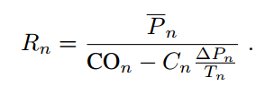, but multiplied by a scaling factor of 0.06 to convert from minutes * mmHg * Liters^-1 to seconds * mmHg * mL^-1. The TPR for patient 708 is shown in figure 2.

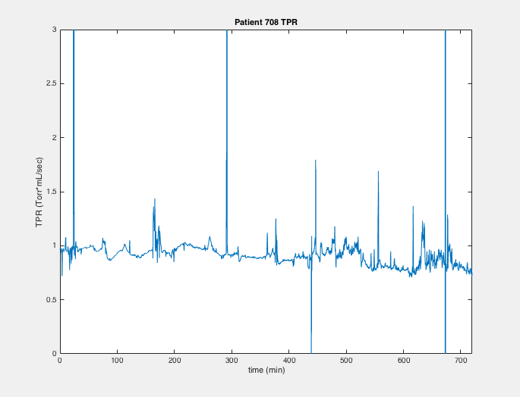

Figure 2. TPR for patient 708. Note that the approximate average, about 1 seconds * mmHg * mL^-1, is on the same order of magnitude as what was given in the Parlikar report. However, much more noise was seen in our data, perhaps due to more fluctuation in our calculated C_n values (and therefore reducing the denominator, enhancing noise). The effect of this is a propagation of inaccuracy to the final CO value.

Some challenges presented while writing this code. Firstly, the waveform data, the thermodilution data, and the onset times of beats were all indexed by different time scales. To resolve these differences, we converted each of the indices to use beat number, so as to easily perform arithmetic element-wise, instead of performing analogous conversions during usage, so as to make the code more easily amenable by multiple writers. Next, we calculated Tn using a sliding window approach, which led to problems in the size of that vector (which would necessarily truncate the ends of the vector it was calculated from), as well as the implementation of the concept itself. Also, the window size was not specified in the original paper, so we qualitatively had to judge that about 1001 window size was best. Finally, we had to understand the Cn variable as a nonconstant function of average pressure. The goal was to be able to use both a naive, straightforward approach to calculate the compliance, C, and compare to the method used in Parlikar et al (2007). This was the main challenge in implementing code from just a description; the strategy used was not clearly communicated (we eventually followed one of the citations of the published articles for elaboration).

In conclusion, the analysis shows that the Parlikar method yields an accurate estimation of cardiac output, but is still further (in an RMSE sense) from accuracy than the Liljestrand model. This, however, is subject to change in cases where the CO values vary beat-to-beat in a way, for example with highly dynamically changing cardiac output. For instance, if the onset of arrhythmia is within the recording scope, an estimator whose parameters change more rapidly would be likely to detect the change more reliably.

Contributions:

Joe: wrote report, worked on alternate calibration methods

Chris: worked on estimator, presentation

Steven: implemented time constant calculation

Richard: established eureka cohorts