Joe Hakim, Chris Le, Steven Chen, Richard Liu – Joe and the Joes

Project 1 Part 1 Question 5 Written Report

September 23, 2015

**Introduction**

For this project we used Eureka to choose two cohorts which we would use as a single unit to evaluate the performance of the Liljestrand, Herd, SAwessCL estimators, and use the Liljestrand algorithm to evaluate differences between the cohorts. After searching Eureka for all subjects for whom cardiac output was measured by other methods (not oxygen consumption) we found 279 subjects. After cross referencing these subjects against the excel sheet containing MIMIC and i2b2 patient name mappings for all subjects with arterial blood pressure data on OneDrive, we found just 22 subjects available. We then searched Eureka for all patients with hypertensive disorders, finding 176 patients, which yielded 16 subjects with arterial blood pressure on OneDrive, after which we decided to divide the 22 subjects into two cohorts of those with hypertensive disorders and those without hypertensive orders, of cohort size 16 and 6, respectively. Though we considered the benefits of having more patients would produce more powerful and statistically significant results, we decided that the difference in cohort size could be a potential complication in statistical analysis and comparison. After excluding unusably short-timed data, we were left with a hypertensive cohort of size 6 and a non-hypertensive cohort of size 4.

We hypothesized that the hypertensive cohort would have a higher cardiac output than the non-hypertensive group based on the model in Mayet et al (2003), which indicates that MAP = CO * TPR, where MAP is mean arterial pressure, CO is cardiac output, and TPR is total peripheral resistance. Given that the hypertensive cohort has a higher average blood pressure than the non-hypertensive cohort, we assume that this could be due to CO being higher. However, we observed the opposite effect, which is explained below.

To analyze differences between the cohorts, we evaluated the group mean and group standard deviation of the measured cardiac output values from thermodilution, as well as the group mean and group standard deviation of cardiac output as estimated by the Liljestrand algorithm, the Herd algorithm, and the SAwessCl algorithm. To identify any possible behaviors in the waveform, we also overlaid average waveforms and waveform deviations to identify any statistically significant deviations between the two cohorts. In sum, we compared the CO values from each cohort, as well as the performance of the estimators on the subgroups of hypertensive and non-hypertensive patients.

Within our hypertensive condition, the bulk of our COest points were in the 3-6 L/min region, and averaged around 4 L/min. However, for our non-hypertensive condition, there were two clusters: one that had CO appeared from 3-5 L/min and one that appeared in a 6+ L/min. These two clusters resulted in a cohort group mean of around 5 L/min.

**Methods of estimator comparison:**

In order to evaluate the different estimators in aggregate, we needed a way to quantify how well they estimated the measured TD data. To do this, several methods were used:

*Root Mean Square Error:*

This method entails taking each of the estimated values and comparing with each of the estimated CO values to the measured CO values. We produced one RMSE per estimator per patient. The equation for this is: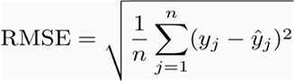

where n is the number of TD values, y_j is the actual TD measurement, and y_hat_j is the estimated CO. The results are in figure 1.

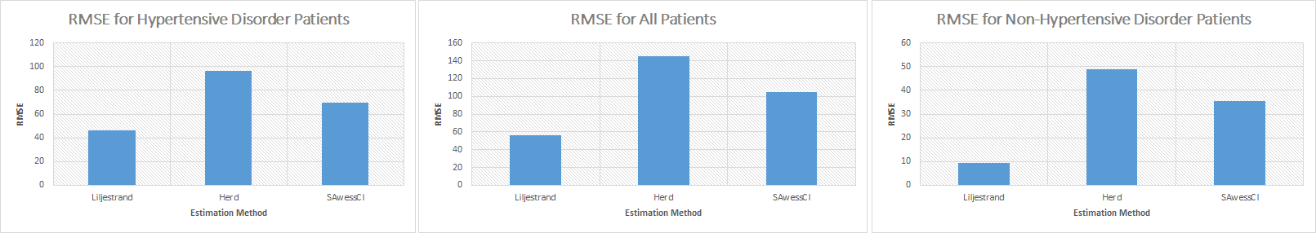

Figure 1. RMSE for estimation methods, different patients.

Note that RMSE values become large after the inclusion of a large amount of patients, and are susceptible to outliers. However, the relative magnitudes of these can be used to evaluate the estimators. Based on these magnitudes, Liljestrand is the closest estimator, followed by SAwessCl, followed by Herd.

*Coefficient of correlation of estimated CO vs. actual CO:*

R^2, the correlation coefficient, is a measure of how correlated two sets of data are. R^2 = 1 means that the two sets increase with the same magnitude, simultaneously, and if the actual and estimated CO values have a R^2 of 1, that means the estimator perfectly matches the actual value. R^2 of less than one indicated less than perfect prediction. Thus, we use correlation coefficients to measure the quality of estimation in each of the three estimators.

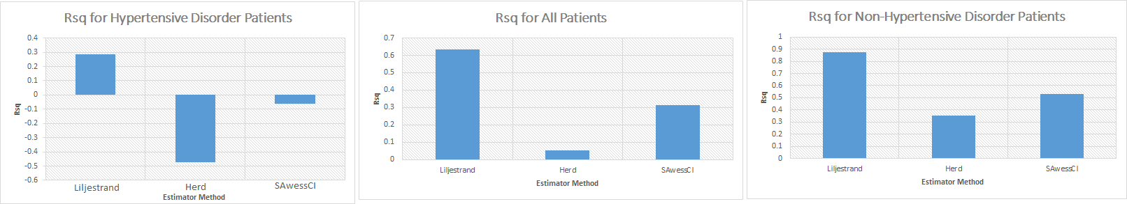

Figure 2. Correlation coefficients. Liljestrand consistently has r^2 closest to 1. For smaller patient sets, i.e. in the cohorts, the r^2 strays far from one due to random variation. However as the data size grows, the r^2 all approach +1, indicating some utility of each of the estimators.

**Cohort Cardiac Output Comparison***:*

Here, for each of the three estimators, we averaged the estimated CO values for each of the cohorts. This was simply an average of the continuous time waveform. The results are summarized below.

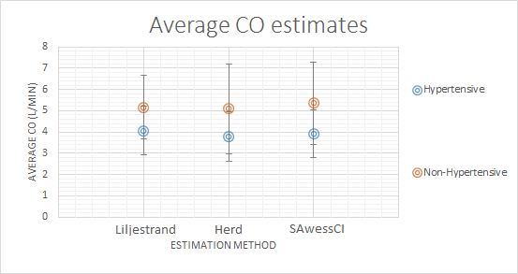

Figure 3. Magnitude of CO for hypertensive, non-hypertensive, and total patients (+- STDEV). For each of the estimators, we saw an increase in the average CO for each patient without hypertensive disorder than with hypertensive disorder. This seems counterintuitive, however the result can be explained by the equation MAP = CO * TPR [1]. We know patients with hypertensive disorder have higher MAP, however the decrease in CO can be compensated by a higher increase in TPR. We can explain this by saying that CO might increase to compensate for very high TPR in patients with hypertensive disorder, in a negative feedback system.

**Scatter Plots and Waveforms:**

In this section, we plot CO (thermodilution) against CO (estimated, for each estimator) as well as the waveforms produced by each estimator. This was to qualitatively evaluate the performance of each estimator in two different ways.

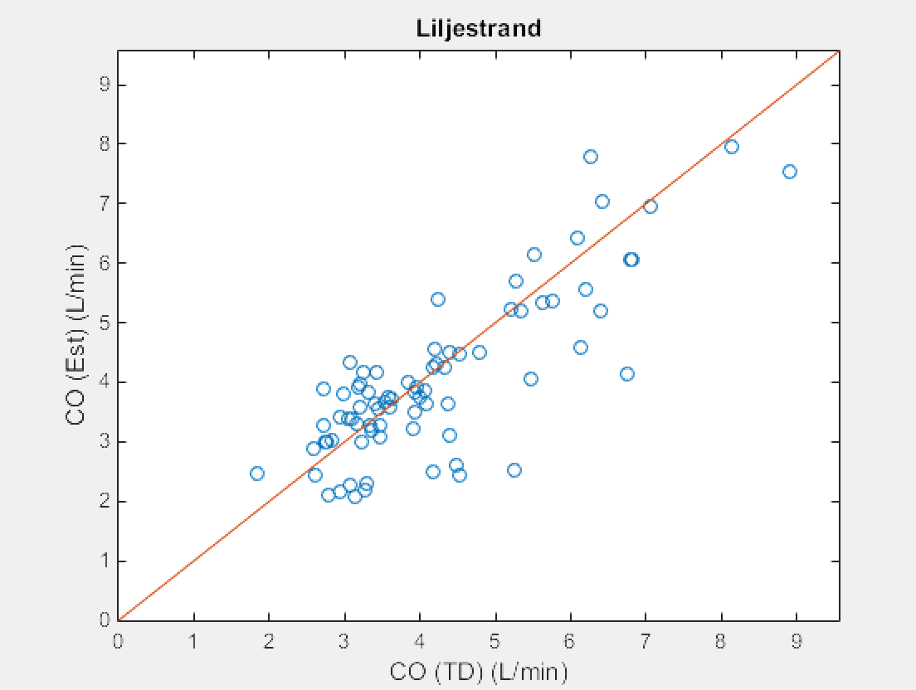

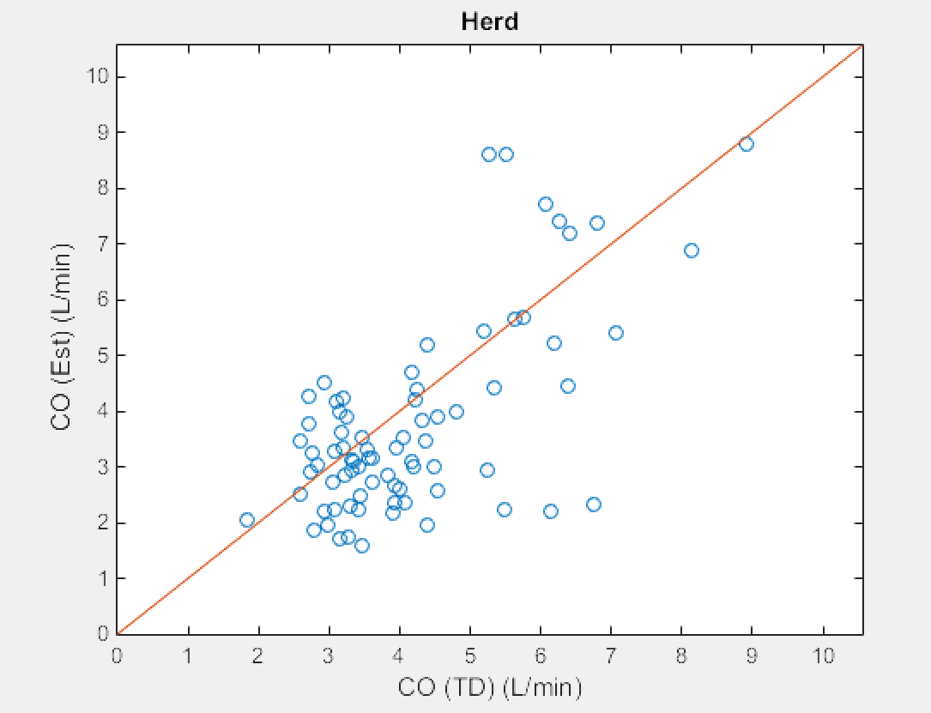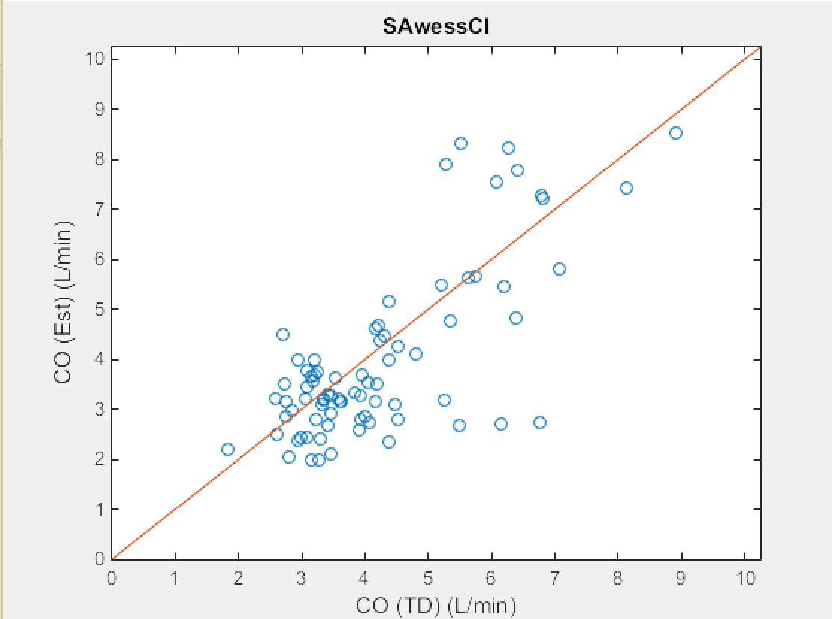

Figure 4. Scatter plot for all patients. In all of our estimators, there was a cluster in the 3-5 L/min region and then a spread of data points at higher CO values. Of our three estimators, Liljestrand has the most number of data points that are qualitatively close to the slope = 1 line, where COest = COTD, while SAwessCL appears to have the second most, and Herd has the most deviation from the slope = 1 line. This trend in estimator ability is confirmed in the Group Mean and Standard Deviation plots: Liljestrand has the least deviation, while SAwessCL has the second least, and Herd has the most.

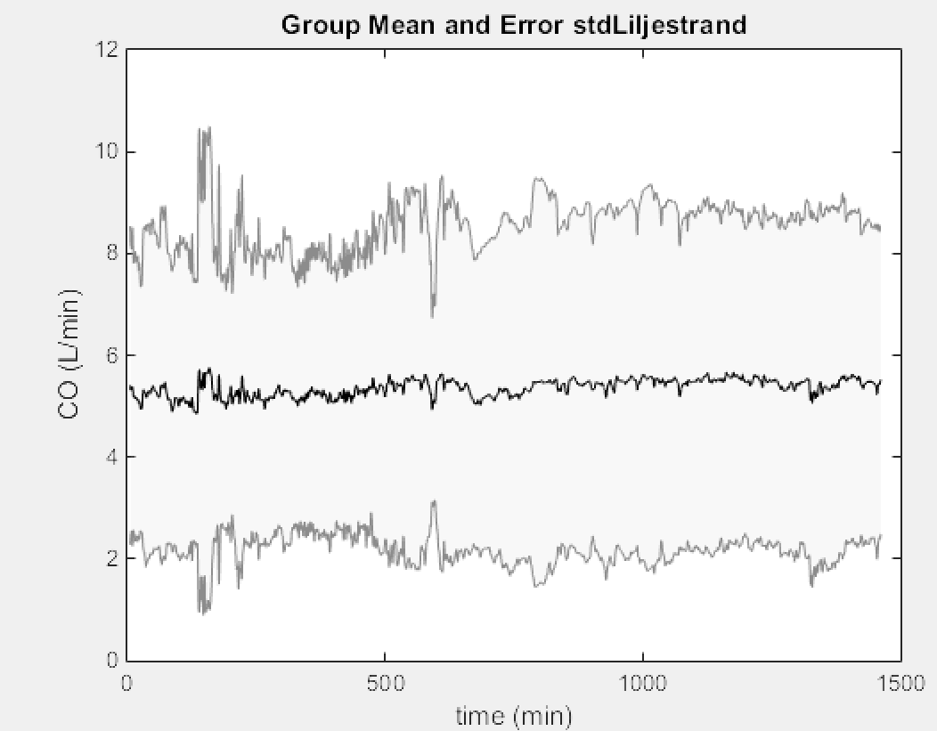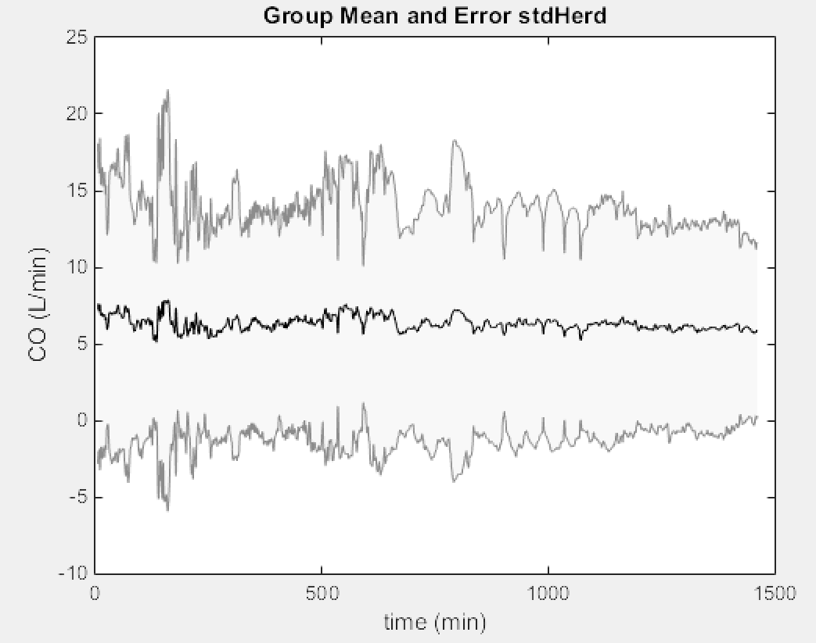

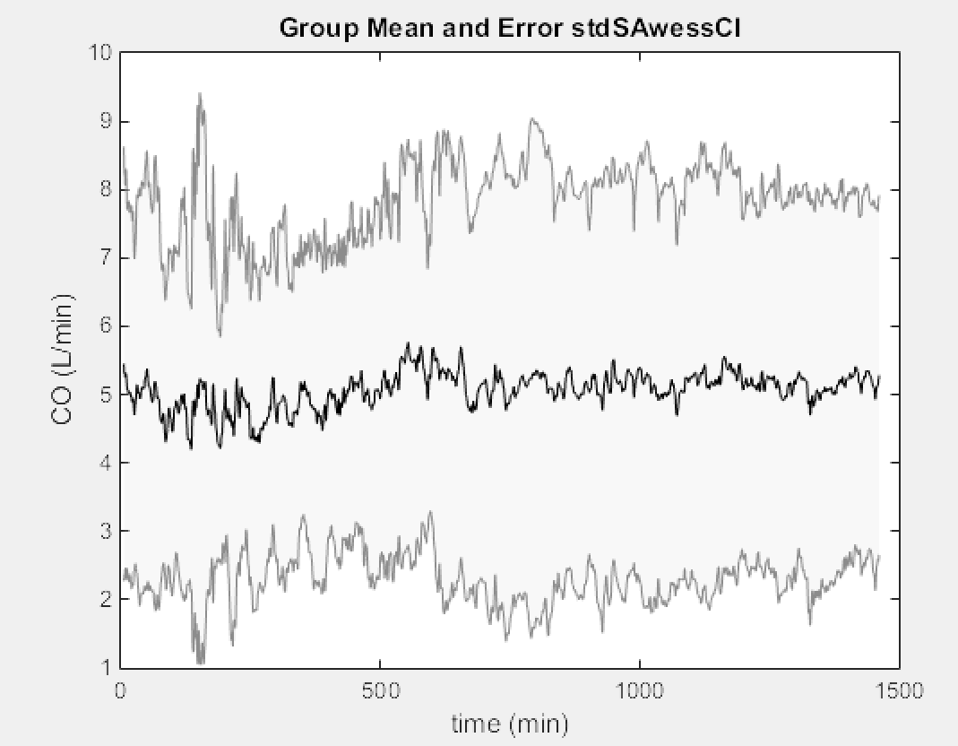

Figure 5. These figures demonstrate qualitative aspects of each of the estimators. The Liljestrand has the smoothest curve, followed by the Herd method, lastly the SAwessCI method. The absolute magnitude of the standard deviation of the Liljestrand is also smaller. Note that the magnitudes are approximately the same all around, however not exactly the same (see below).

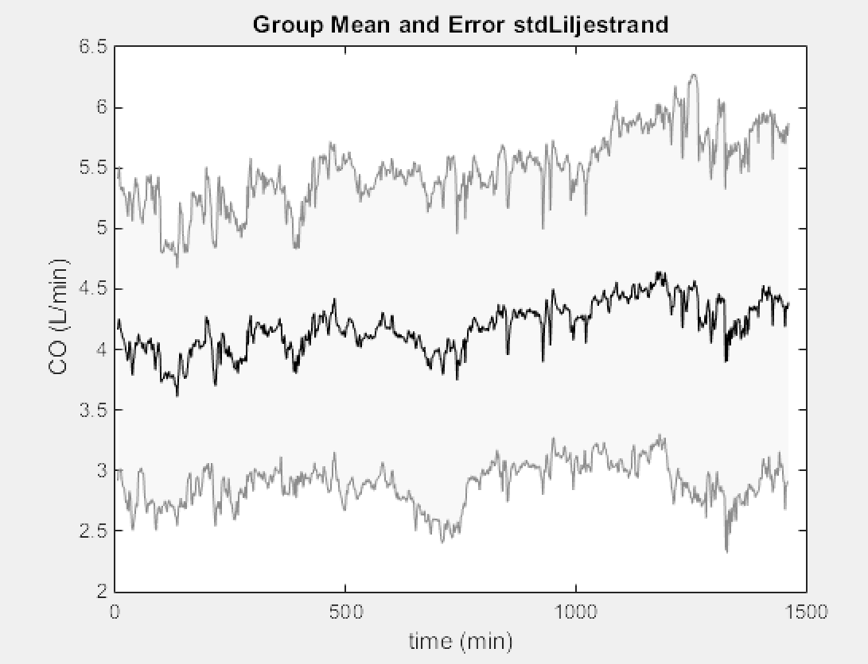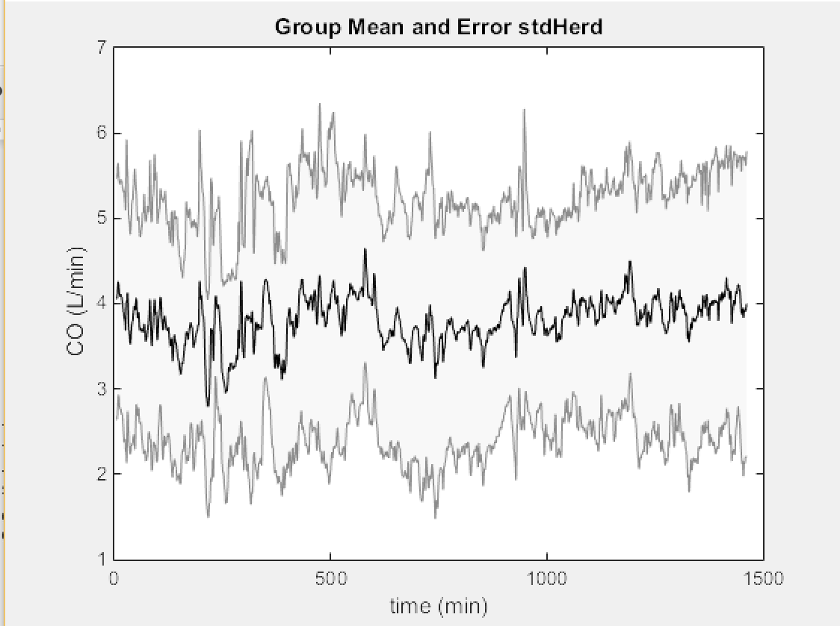

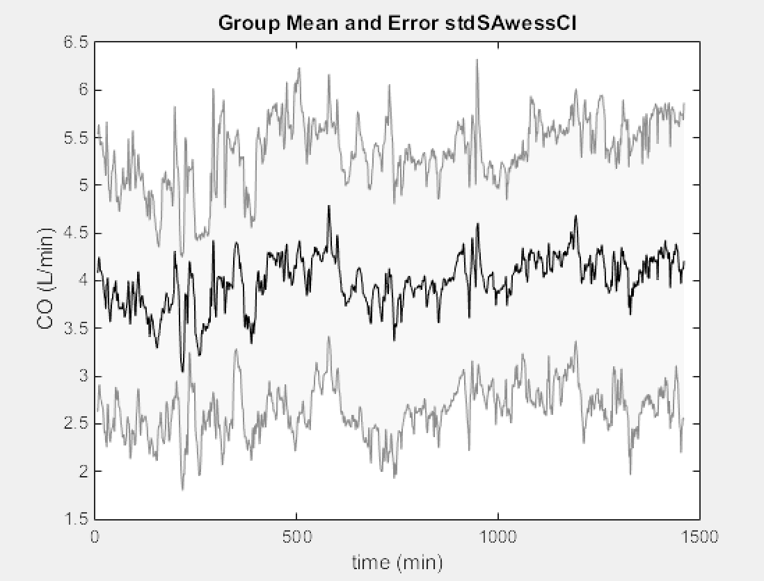

Figure 6. The comparison of the estimators for the hypertensive patients. Again, the Liljestrand seems qualitatively better based on size of standard deviation, and overall smoothness.

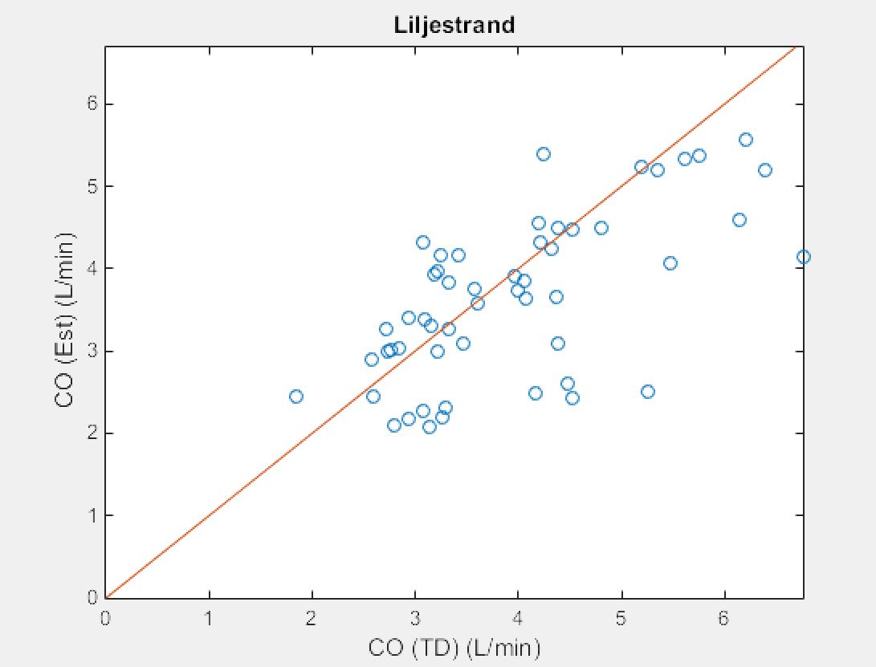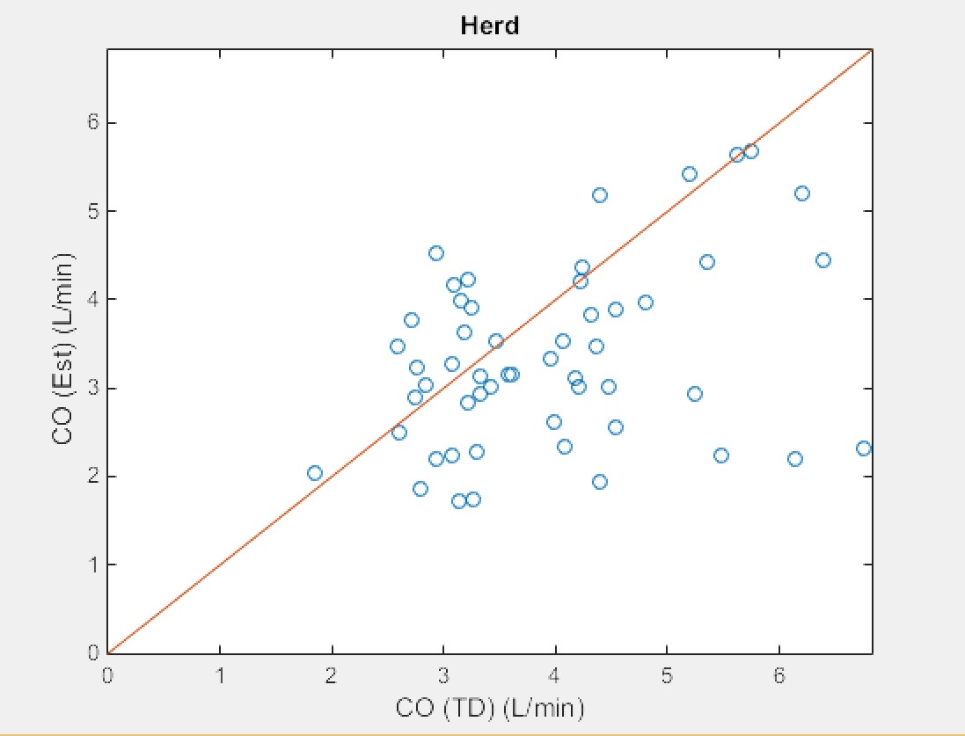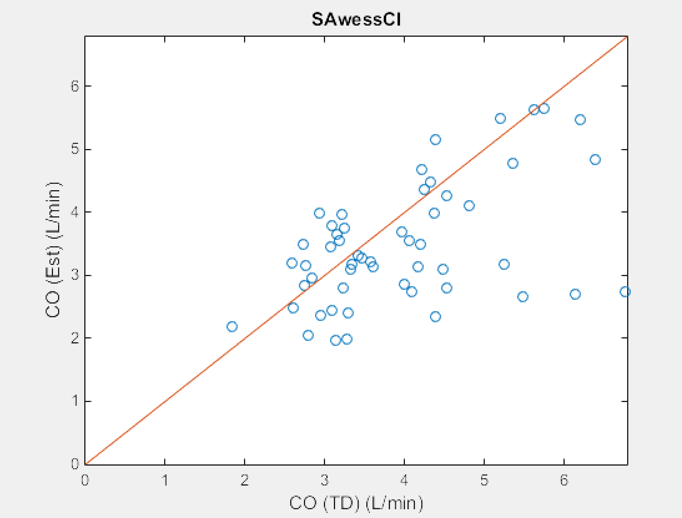

Figure 7. Hypertensive patients. Comparison of accuracy of estimation methods by scatter plot. (Same as above). The distance from the center line (y=x) is inverse to the quality of the estimate. This is quantified by RMSE, but can be analyzed qualitatively to say that Liljestrand and SAwessCL are better estimators than Herd.

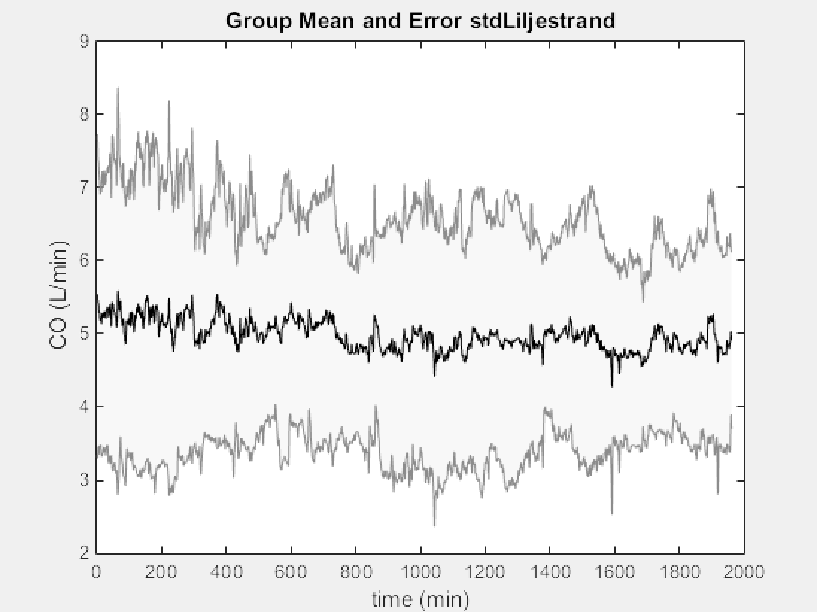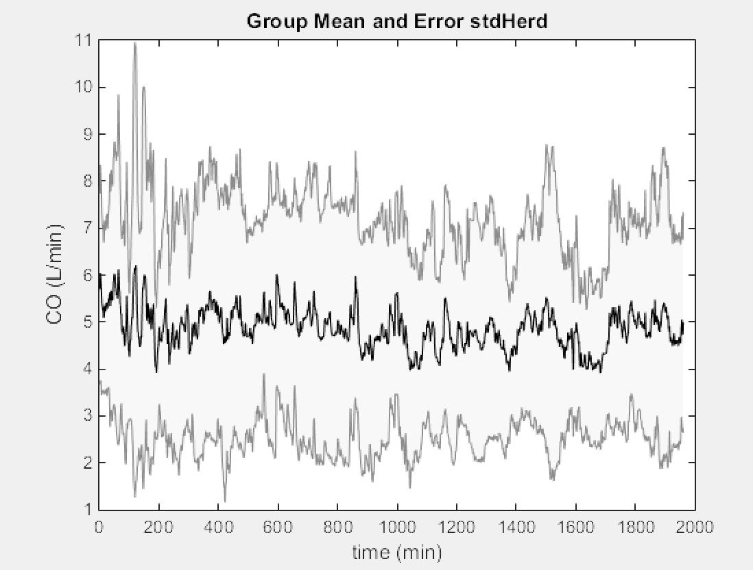

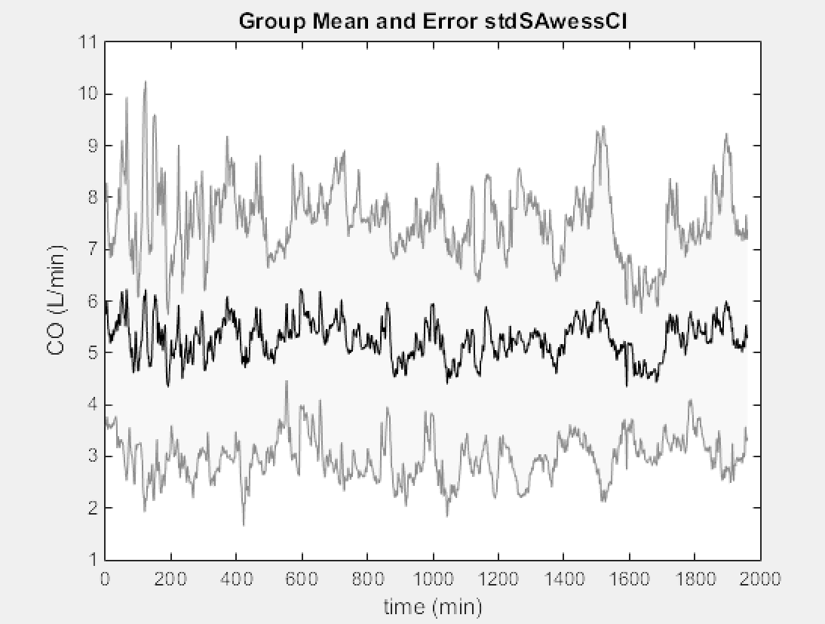

Figure 8. The comparison of the estimators for the non-hypertensive patients. Again, the Liljestrand seems qualitatively better based on size of standard deviation, and overall smoothness.

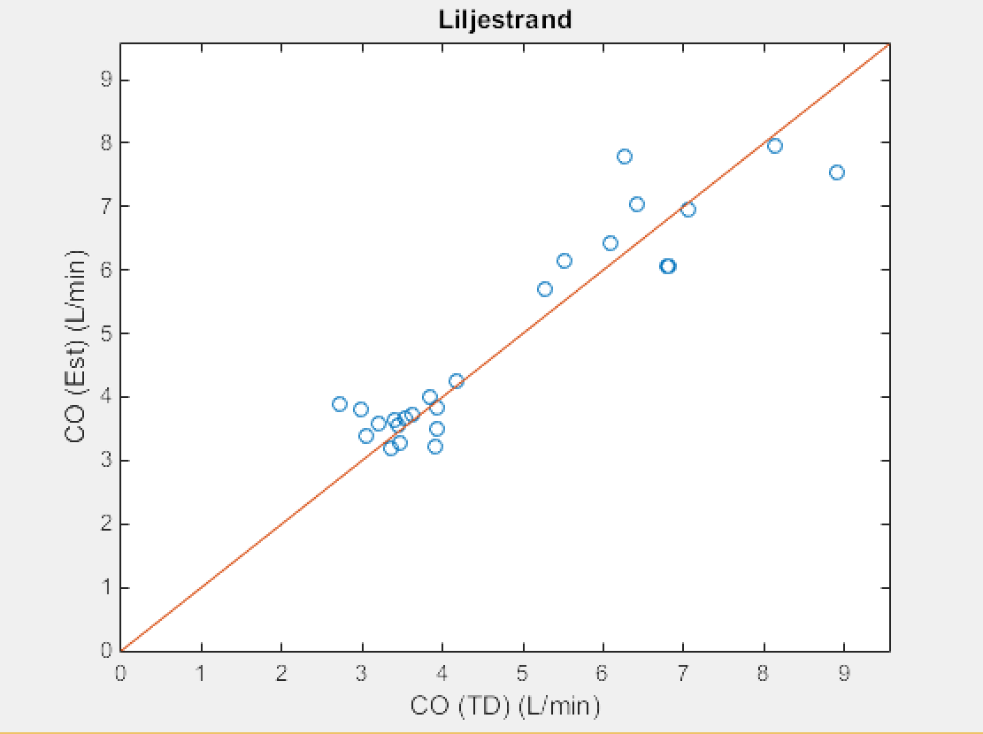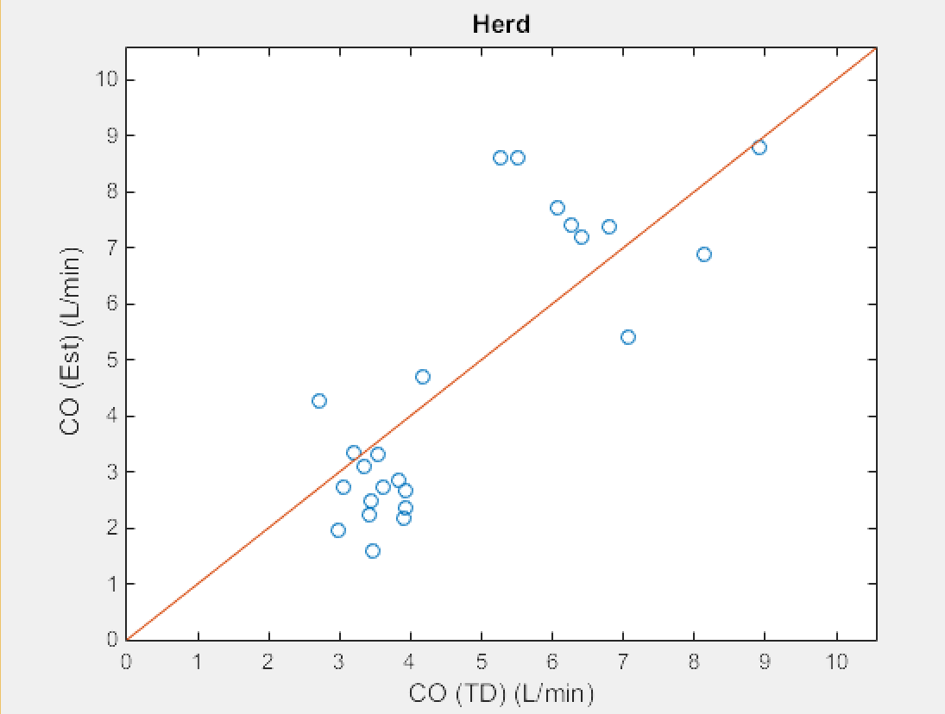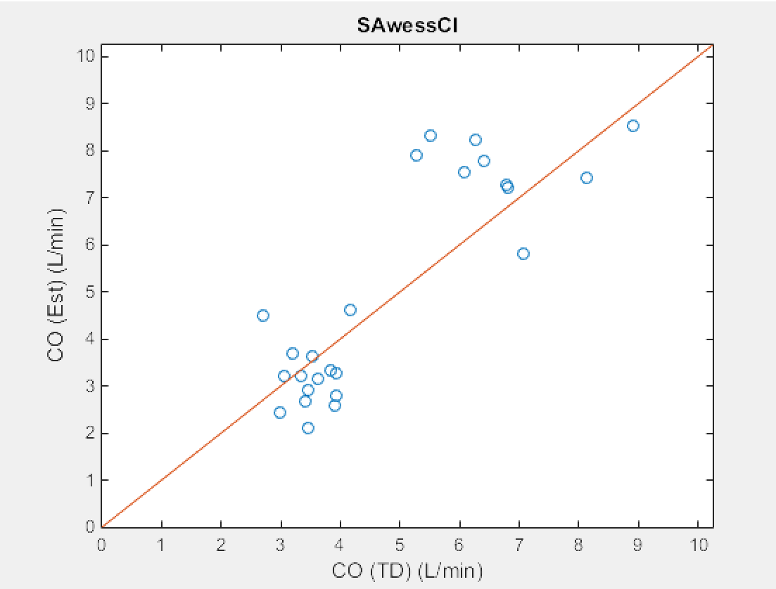

Figure 9. Non-hypertensive patients. Scatter plot of thermodilution vs estimated CO values. Qualitatively, Liljestrand is more accurate than SAwessCl, which is better than Herd. Note the two clusters are shown here again.

**Conclusion:**

We observed that Liljestrand is a better estimator than the other two, by r^2, RMSE, the noise in the CO waveform, and qualitative analysis of the scatter plots. For the two cohorts, we observed that the patients with hypertensive disorder were more likely to have lower CO values (as an average of the CO waveform), contrary to intuition. However, this can be explained by the fact that CO is being depleted to compensate for much higher TPR, as expressed in MAP = CO * TPR.

Working with real patient interactions was interesting to us because in our differentiation, we happened to be able to resolve the average CO of each cohort, and therefore make a conclusion about the nature of each cohort. Moreover, the conclusion the data produced was different from a logical hypothesis of increased CO with higher pressure, preventing modeling assumptions and indicating a deeper and more complex system being analyzed.

Some difficulties we encountered in this project were the effect of noise on correlation coefficient. We do not expect there to be a negative correlation between the estimation and the actual values, however due to the small patient sets, this was observed occasionally. Essentially, the main problem faced was the small amount of suitable patients, as well as differences in the length of recording CO, which created difficulties in some hard-coded sections of our source.

**Contributions:**

Richard Liu – Provided insight to the statistical analysis used.

Christopher Le – Provided background information and reasoning behind the choice of cohorts.

Joe Hakim – Coded and produced scatter plots for COtd and COestimate comparisons.

Steven Chen – Coded and produced waveform plots for COestimates.

All members of the group contributed to the written report and statistical analysis of the two cohorts.

[1] Mayet, J. (n.d.). Cardiac And Vascular Pathophysiology In Hypertension. Heart, 1104-1109.