PRACTICAL NO. 1
An electricity board charges the following rates to domestic users to discourage large consumption of energy. For the first 100 units: - 60 P per unit For the next 200 units: -80 P per unit Beyond 300 units: -90 P per unit All users are charged a minimum of Rs 50 if the total amount is more than Rs 300 then an additional surcharge of 15% is added. Implement a C++ program to read the names of users and number of units consumed and display the charges with names)
SOURCE CODE :
#include <iostream>
#include <string>
using namespace std;

float calc(int unit)
{
float amt = 50.0; // minimum charge
if (unit <= 100)
amt = unit * 0.60;
else if (unit <= 300)
amt = (100 * 0.60) + (unit - 100) * 0.80;
else
amt = (100 * 0.60) + (200 * 0.80) + (unit - 300) * 0.90;

// Additional surcharge if amount exceeds Rs 300
if (amt > 300)
amt = amt + (amt * 0.15);

return amt;
}

int main()
{
int unit;
float total;
string name;

cout << "Enter your name: ";
getline(cin, name);

cout << "Enter the no. of units consumed: ";
cin >> unit;

total = calc(unit);

cout << "\nElectricity Bill" << endl;
cout << "Name : " << name << endl;
cout << "Units Consumed : " << unit << endl;
cout << "Total Charges : Rs " << total << endl;

return 0;
}
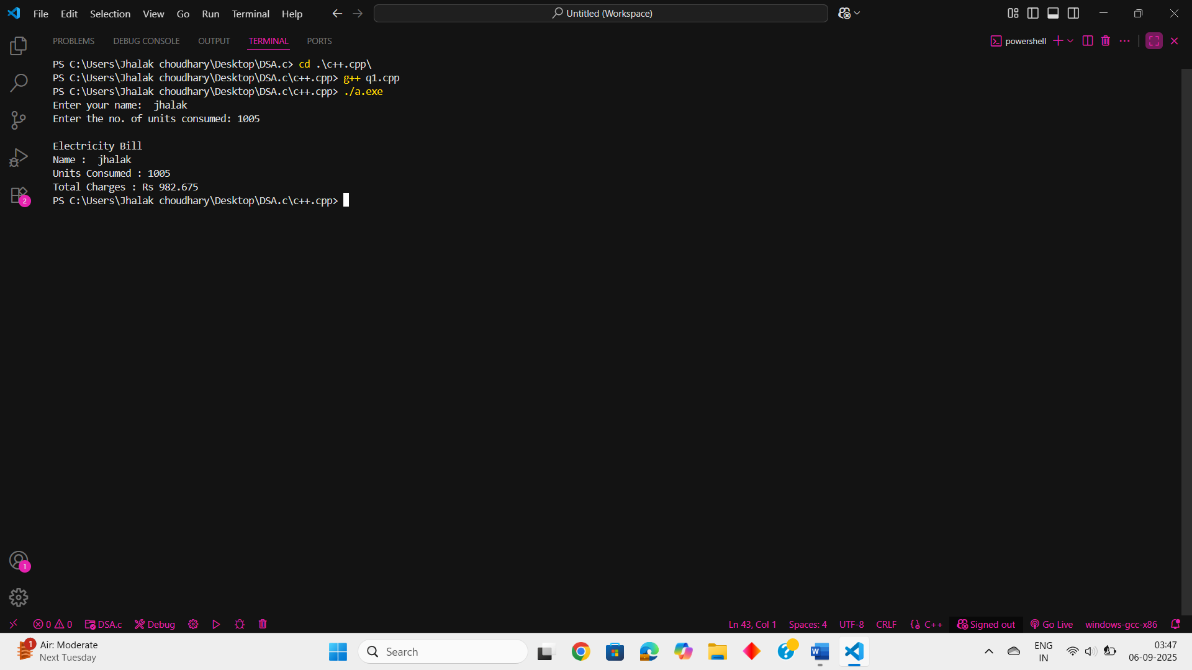

PRACTICAL NO. 2
Q2. Construct a C++ program that removes a specific character from a given string and return the updated string.
Typical Input: computer science is the future
Typical Output: compuer science is he fuure.
SOURCE CODE :
#include <iostream>
#include <string>
using namespace std;

int main()
{
char ch;
int len;
string line;
string update = "";

cout << "Enter a string: ";
getline(cin, line);

cout << "Enter the character to be removed: ";
cin >> ch;

len = line.length();
cout << "Length of string: " << len << endl;

for (int i = 0; i < len; i++)
{
if (line[i] != ch) // if current character is NOT the one to be removed
{
update += line[i]; // append it to new string
}
}

cout << "Updated string is: " << update << endl;
return 0;
}

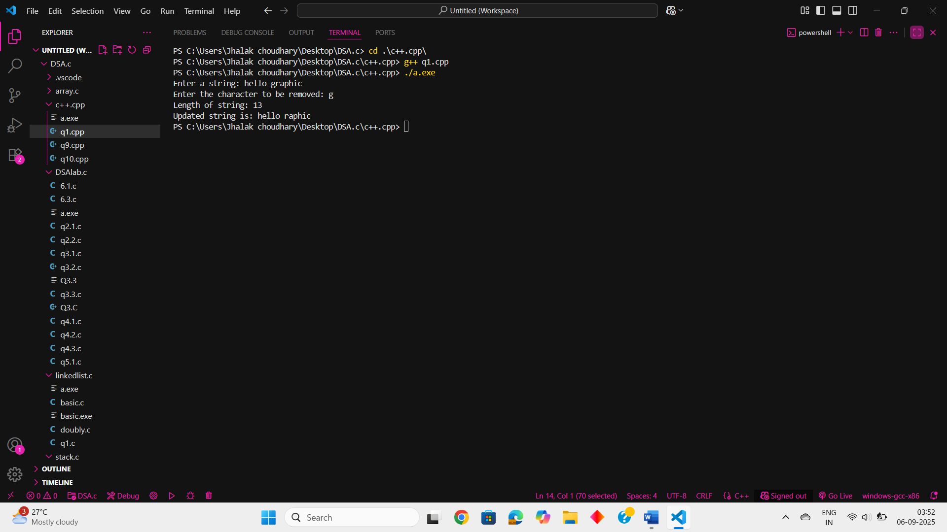

PRACTICAL NO. 3
Implement a C++ program to find the non-repeating characters in string.
Typical Input: graphic era university
Typical Output: c g h n p s t u v y
SOURCE CODE :
#include <iostream>
#include <string>
using namespace std;

int main()
{
int f = 0;
int len;
string line;
string result;

cout << "Enter a string: ";
getline(cin, line);

len = line.length();
cout << "Length of string: " << len << endl;

for (int i = 0; i < len; i++)
{
f = 0;
for (int j = 0; j < len; j++) // check against entire string, not just from i
{
if (line[i] == line[j])
f++;
}
if (f == 1) // only if character is unique
{
result += line[i];
result += ' ';
}
}

cout << "Unique characters are: " << result << endl;
return 0;
}

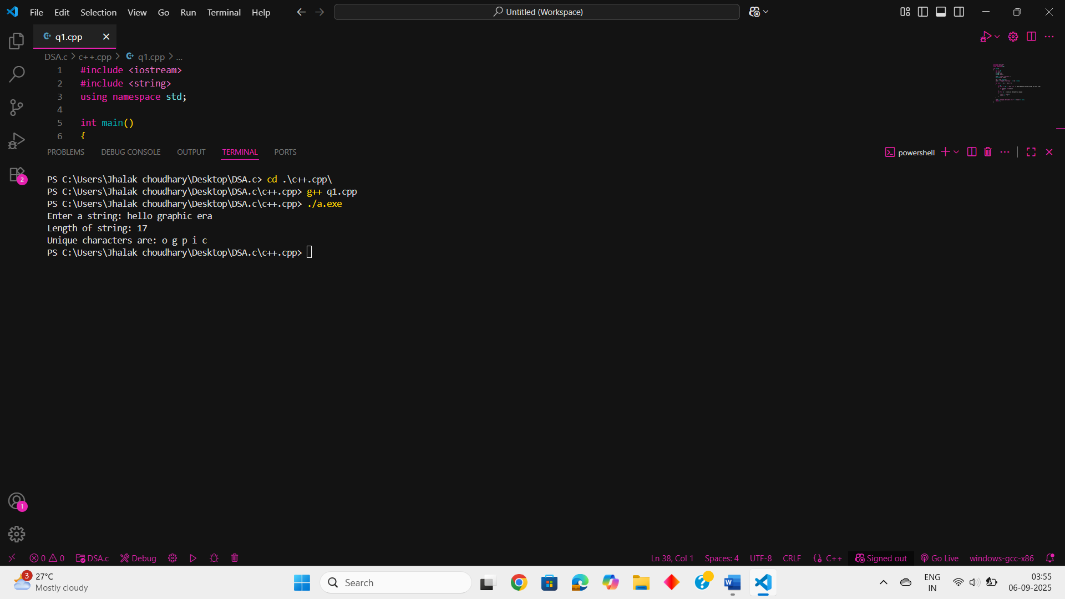

PRACTICAL NO. 4
You are given an array of elements. Now you need to choose the best index of this array. An index of the array is called best if the special sum of this index is maximum across the special sum of all the other indices. To calculate the special sum for any index you pick the first element that is and add it to your sum. Now you pick next two elements i.e., and and add both of them to your sum. Now you will pick the next elements, and this continues till the index for which it is possible to pick the elements. Find the best index and in the output print its corresponding special sum. Note that there may be more than one best index, but you need to only print the maximum special sum. Input: First line contains an integer as input. Next line contains space separated integers denoting the elements of the array. Output: In the output you have to print an integer that denotes the maximum special sum
SOURCE CODE :
#include <iostream>
#include <climits> // for INT_MIN
using namespace std;

int maxSpecialSum(int arr[], int n) {
int maxSum = INT_MIN;

for (int i = 0; i < n; i++) {
int total = 0;
int step = 1;
int j = i;

while (j + step <= n) {
// Sum elements from j to j+step-1
for (int k = j; k < j + step; k++) {
total += arr[k];
}
j += step;
step++;
}

maxSum = max(maxSum, total);
}
return maxSum;
}

int main() {
int n;
cout << "Enter the no. of elements: ";
cin >> n;

int arr[100];
cout << "Enter elements:\n";
for (int i = 0; i < n; i++) {
cin >> arr[i];
}

cout << "Special sum = " << maxSpecialSum(arr, n) << endl;
return 0;
}

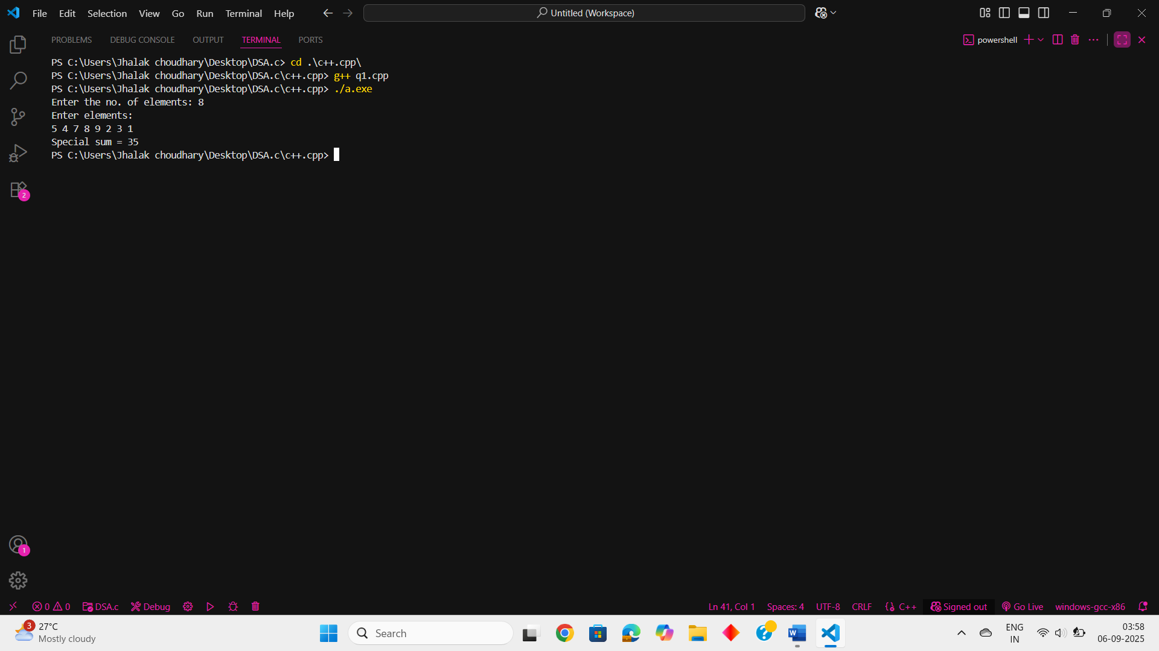

PRACTICAL NO. 5
Implement a C++ program to demonstrate the concept of data abstraction using the concept of Class and Objects.
SOURCE CODE :
#include <iostream>
using namespace std;

class Rectangle {
private:
int length;
int width;

public:
// Function to set dimensions
void setDimensions(int l, int w) {
length = l;
width = w;
}

// Function to calculate area
int getArea() {
return length * width;
}
};

int main() {
Rectangle rect;

rect.setDimensions(10, 5); // setting length = 10, width = 5

cout << "Area of rectangle: " << rect.getArea() << endl;

return 0;
}

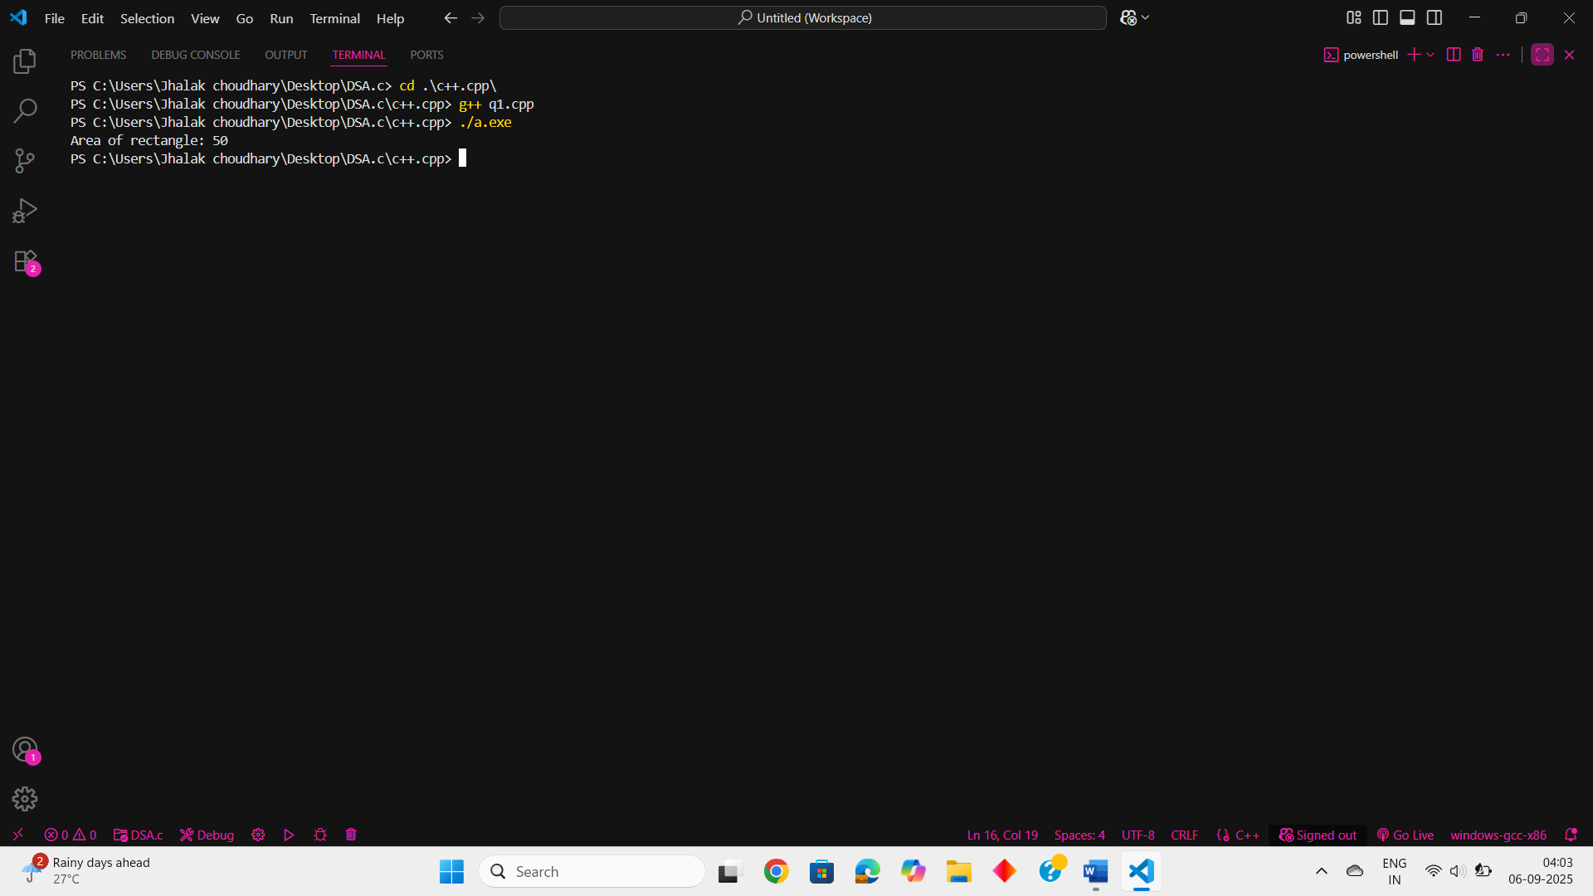

PRACTICAL NO. 6
Define a class Hotel in C++ with the following specifications Private members • Rno Data member to store room number • Name Data member to store customer name • Tariff Data member to store per day charges • NOD Data member to store number of days of stay • CALC() Function to calculate and return amount as NOD*Tariff ,and if the value of days* Tariff >10000, then total amount is 1.05* days*Tariff. Public members • Checkin() Function to enter the content Rno, Name, Tariff and NOD • Checkout() Function to display Rno, Name, Tariff, NOD and Amount .
SOURCE CODE :
#include <iostream>
using namespace std;
class Hotel {
private:
int Rno; // Room number
string name; // Customer name
float Tariff; // Per day charge
int NOD; // Number of days stayed

// Private function to calculate total bill
float CALC() {
float amt = NOD * Tariff;
if (amt > 10000) {
amt = amt * 1.05; // Add 5% extra if amount exceeds 10000
}
return amt;
}

public:
// Function to input details
void CheckIn() {
cin.ignore(); // clear input buffer in case of leftover newline
cout << "Enter your name: ";
getline(cin, name);
cout << "Enter your Room No.: ";
cin >> Rno;
cout << "Enter No. of days: ";
cin >> NOD;
cout << "Enter per day charge: ";
cin >> Tariff;
}

// Function to display bill details
void CheckOut() {
cout << "\n------ Hotel Bill ------" << endl;
cout << "Name : " << name << endl;
cout << "Room No. : " << Rno << endl;
cout << "No. of days : " << NOD << endl;
cout << "Per day charge : Rs " << Tariff << endl;
cout << "Total amount : Rs " << CALC() << endl;
cout << "------------------------" << endl;
}
};

int main() {
Hotel h;
h.CheckIn();
h.CheckOut();
return 0;
}

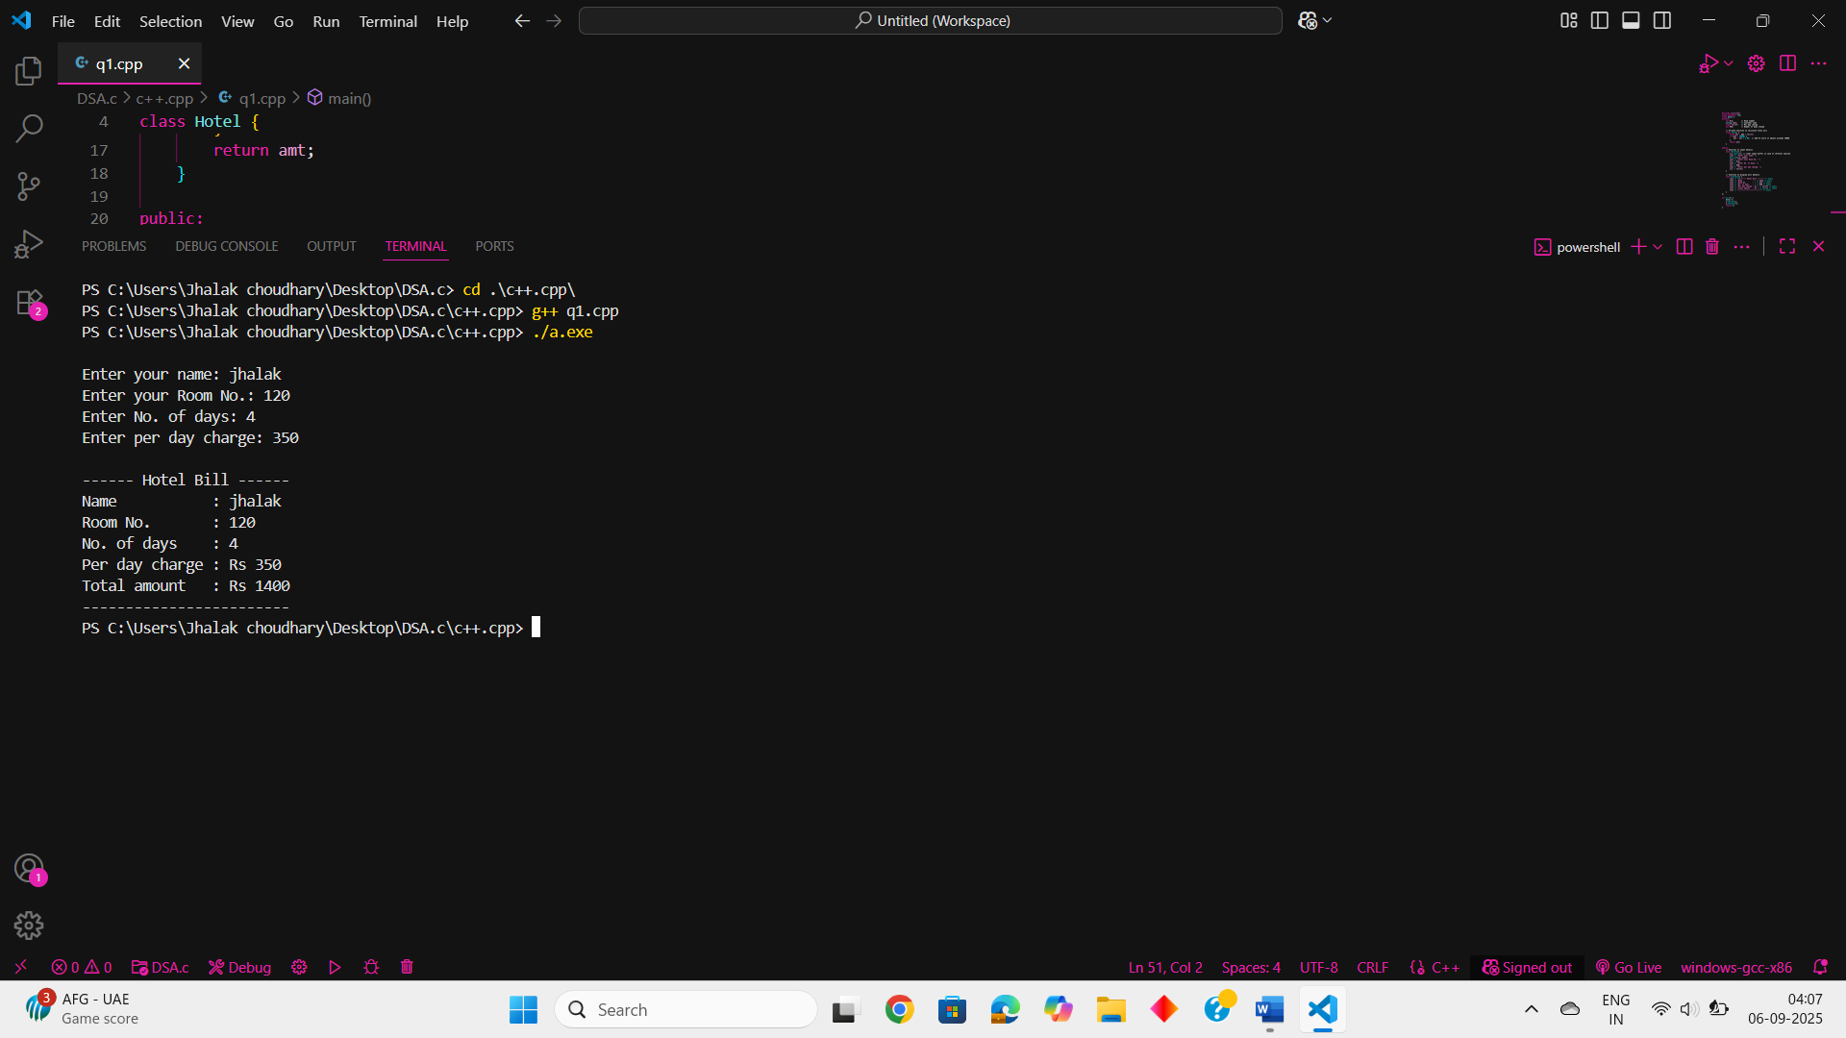

PRACTICAL NO. 7
Implement a Program in C++ by defining a class to represent a bank account. Include the following: Data Members ● Name of the depositor ● Account number ● Type of account (Saving, Current etc.) ● Balance amount in the account Member Functions ● To assign initial values ● To deposit an amount ● To withdraw an amount after checking the balance ● To display name and balance
SOURCE CODE :
#include <iostream>
using namespace std;

class Bank {
private:
int accno; // Account number
string name; // Account holder name
float balance; // Account balance
string type; // Account type

public:
// Initialize account details
void initial(string n, string t, int acc, float b) {
name = n;
type = t;
balance = b;
accno = acc;
}

// Deposit money
void deposit(float amt) {
if (amt > 0) {
balance += amt;
cout << "\nDeposited: " << amt;
cout << "\nCurrent balance is: " << balance;
} else {
cout << "\nAmount not valid for deposit.";
}
}

// Withdraw money
void withdraw(float w) {
if (w > 0 && w <= balance) {
balance -= w;
cout << "\nWithdrawn: " << w;
cout << "\nBalance after withdrawal: " << balance;
} else {
cout << "\nInsufficient balance or invalid withdrawal amount.";
}
}

// Display account details
void display() {
cout << "\n\n--- Account Details ---";
cout << "\nName: " << name;
cout << "\nAccount Number: " << accno;
cout << "\nType of account: " << type;
cout << "\nBalance: " << balance;
cout << "\n------------------------";
}
};

int main() {
Bank h;
h.initial("Ashish", "Saving", 240121263, 2534.6);

h.deposit(1000.0); // Deposit ₹1000
h.withdraw(500.0); // Withdraw ₹500
h.display(); // Display account details

return 0;
}
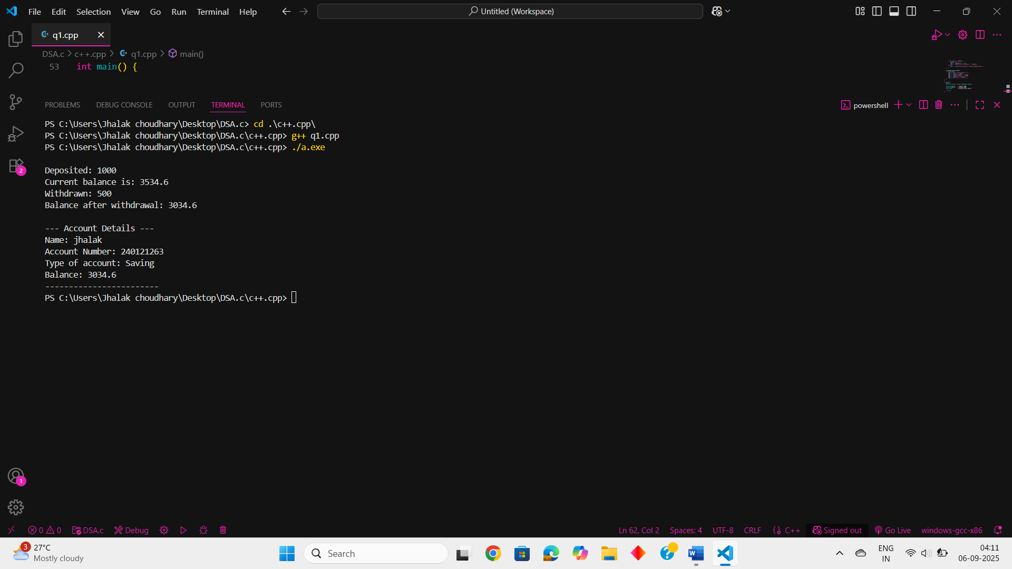

PRACTICAL NO. 8
Anna is a contender for valedictorian of her high school. She wants to know how many students (if any) have scored higher than her in the exams given during this semester. Create a class named Student with the following specifications
- An instance variable named scores holds a student's 5 exam scores.
- A void input () function reads 5 integers and saves them to scores.
- An int calculateTotalScore() function that returns the sum of the student's scores.
SOURCE CODE :
#include<iostream>
#include<string>
using namespace std;
class student{
int score[5];
public:
void input(){
for(int i=0;i<5;i++){
cin>>score[i];
}
}
int calculateTotalScore(){
int sum=0;
for(int i=0;i<5;i++)
sum+=score[i];
return sum;
}
};
int main(){
int n;
cout<<"No. of students : ";
cin>>n;
student s[n];
cout<<"Enter the marks of students: "<<endl;
for(int i=0;i<n;i++){
cout<<"STUDENT "<<i+1<<endl;
s[i].input();
}
int sum[n];
for(int j=0;j<n;j++){
sum[j]=s[j].calculateTotalScore();
}
cout<<"Anna's total score : "<<sum[0]<<endl;
int max=sum[0],i=0,c=0;
while(i<n){
if(sum[i]>max) c++;
i++;
}
if(c>0){
cout<<"No. of students who had scored more than Anna are: "<<c;
}
else
{ cout<<"No students have scored more marks than Anna."<<endl;
}
}

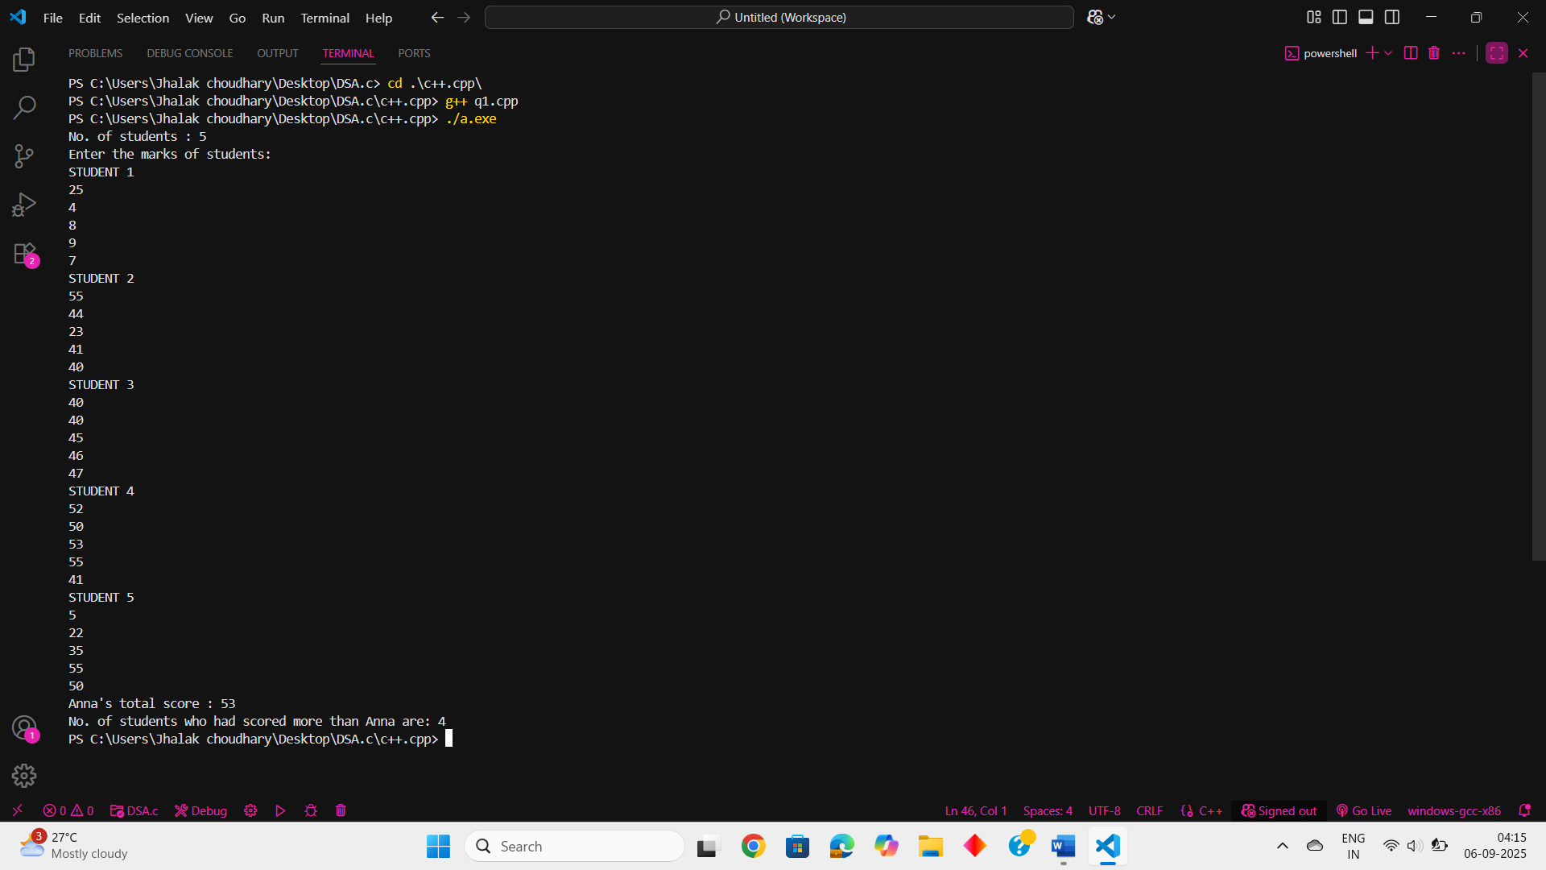

PRACTICAL NO. 9
Construct a Program in C++ to show the working of function overloading (compile time polymorphism) by using a function named calculate Area () to calculate area of square, rectangle and triangle using different signatures as required.
SOURCE CODE :
#include<iostream>
#include<string>
using namespace std;
void calculateArea(int side){
cout<<"Area of Square: "<<side*side<<endl;
}
void calculateArea(int length, int breadth){
cout<<"Area of rectangle: "<<length*breadth<<endl;
}
void calculateArea(int base, float height){
cout<<"Area of triangle: "<<base*height*0.5<<endl;
}
int main(){
int i=1;
while(i){
cout<<"Press: "<<"1-Square\t2-Rectangle\t3-Triangle"<<endl;
int ch;
cin>>ch;
switch(ch){
case 1: cout<<"Enter the side of square: ";
int s;
cin>>s;
calculateArea(s);
break;
case 2: cout<<"Enter the length and breadth of rectangle: ";
int l,b;
cin>>l>>b;
calculateArea(l,b);
break;
case 3: cout<<"Enter the base and height of triangle: ";
int ba;
float h;
cin>>ba>>h;
calculateArea(ba,h);
break;
default: cout<<"Invalid choice";
break;
}
cout<<"Do you want to continue. If yes(1) no(0) ";
cin>>i;
}
}

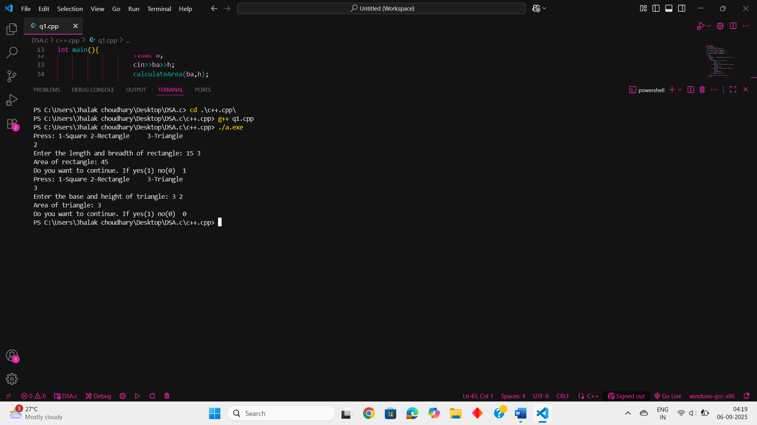
PRACTICAL NO. 10
Create a class called Invoice that a hardware store might use to represent an invoice for an item sold at the store. An Invoice should include four pieces of information as instance. Data Members - • partNumber (type String) • partDescription (type String) • quantity of the item being purchased (type int) • price_per_item (type double) Your class should have a constructor that initializes the four instance variables. Provide a set and a get method for each instance variable. In addition, provide a method named getInvoiceAmount() that calculates the invoice amount (i.e., multiplies the quantity by the price per item), then returns the amount as a double value. If the quantity is not positive, it should be set to 0. If the price per item is not positive,it should be set to0.0. Write a test application named invoiceTest that demonstrates class Invoice’s capabilities.
SOURCE CODE :
#include <iostream>
#include <string>
using namespace std;

class Invoice {
private:
string partNumber;
string partDescription;
int quantity;
double price_per_item;

public:
// Constructor
Invoice(string pNumber, string pDescription, int qty, double price) {
partNumber = pNumber;
partDescription = pDescription;
setQuantity(qty);
setPricePerItem(price);
}

// Setters
void setPartNumber(string pNumber) {
partNumber = pNumber;
}

void setPartDescription(string pDescription) {
partDescription = pDescription;
}

void setQuantity(int qty) {
if (qty > 0)
quantity = qty;
else
quantity = 0;
}

void setPricePerItem(double price) {
if (price > 0)
price_per_item = price;
else
price_per_item = 0.0;
}

// Getters
string getPartNumber() {
return partNumber;
}

string getPartDescription() {
return partDescription;
}

int getQuantity() {
return quantity;
}

double getPricePerItem() {
return price_per_item;
}

// Invoice amount
double getInvoiceAmount() {
return quantity * price_per_item;
}
};

int main() {
cout << "----- Invoice Test ------\n";

// Valid item
Invoice item1("A101", "Hammer", 5, 250.50);
cout << "Part Number: " << item1.getPartNumber() << endl;
cout << "Description: " << item1.getPartDescription() << endl;
cout << "Quantity: " << item1.getQuantity() << endl;
cout << "Price per Item: " << item1.getPricePerItem() << endl;
cout << "Total Invoice Amount: " << item1.getInvoiceAmount() << endl;

// Invalid values test
cout << "\n--- Testing invalid values ---\n";
Invoice item2("B202", "Screwdriver", -3, -150.0);
cout << "Part Number: " << item2.getPartNumber() << endl;
cout << "Description: " << item2.getPartDescription() << endl;
cout << "Quantity: " << item2.getQuantity() << endl;
cout << "Price per Item: " << item2.getPricePerItem() << endl;
cout << "Total Invoice Amount: " << item2.getInvoiceAmount() << endl;

return 0;
}

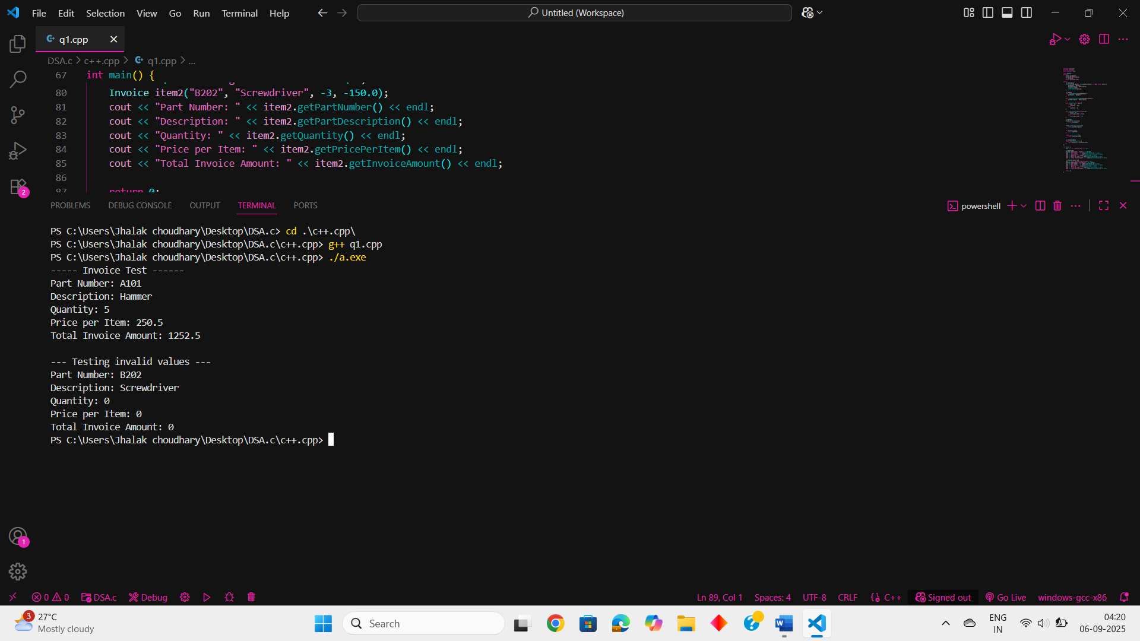

PRACTICAL NO. 11
Imagine a tollbooth with a class called TollBooth. The two data items are of type unsigned int and double to hold the total number of cars and total amount of money collected. A constructor initializes both of these data members to 0. A member function called payingCar( )increments the car total and adds 0.5 to the cash total. Another function called nonPayCar( )
. increments the car total but adds nothing to the cash total. Finally a member function called display( )shows the two totals. Include a program to test this class. This program should allow the user to push one key to count a paying car and another to count a non paying car. Pushing the ESC key should cause the program to print out the total number of cars and total cash and then exit.
SOURCE CODE :
#include <iostream>
#include <conio.h> // For _getch() and ESC key detection
using namespace std;

class TollBooth {
private:
unsigned int totalCars;
double totalCash;

public:
TollBooth() : totalCars(0), totalCash(0.0) {}

void payingCar() {
totalCars++;
totalCash += 0.5;
}

void nonPayCar() {
totalCars++;
}

void display() const {
cout << "\n--- TollBooth Summary ---" << endl;
cout << "Total Cars Passed: " << totalCars << endl;
cout << "Total Cash Collected: $" << totalCash << endl;
}
};

int main() {
TollBooth booth;
char ch;

cout << "TollBooth Simulation\n";
cout << "Press 'p' for paying car, 'n' for non-paying car, ESC to exit and display totals.\n";

while (true) {
ch = _getch();

if (ch == 27) {
booth.display();
break;
} else if (ch == 'p' || ch == 'P') {
booth.payingCar();
cout << "Paying car recorded.\n";
} else if (ch == 'n' || ch == 'N') {
booth.nonPayCar();
cout << "Non-paying car recorded.\n";
} else {
cout << "Invalid key. Use 'p', 'n', or ESC.\n";
}
}

return 0;
}

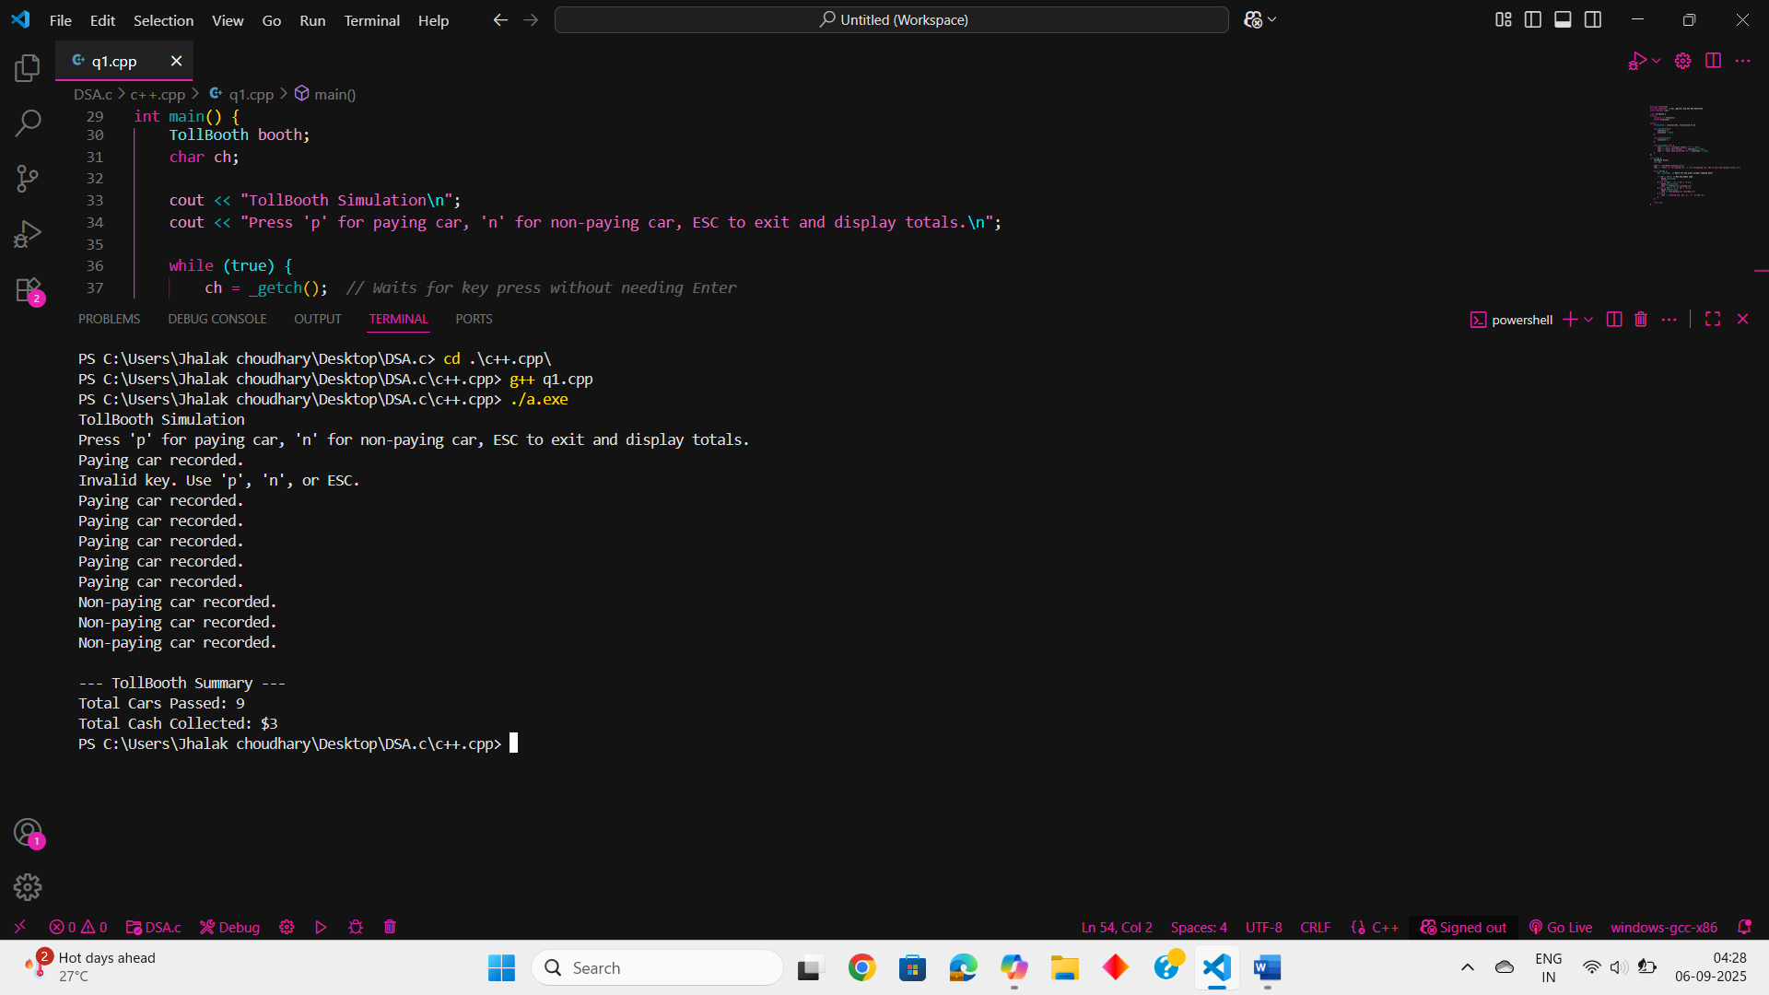

PRACTICAL NO. 12
Create a class called Time that has separate int member data for hours, minutes and seconds. One constructor should initialize this data to 0, and another should initialize it to fixed values. A member function should display
. it in 11:59:59 format. A member function named add() should add two objects of type time passed as arguments. A main ( ) program should create two initialized values together, leaving the result in the third time variable.
Finally it should display the value of this third variable
SOURCE CODE:
#include <iostream>
#include <iomanip>
using namespace std;

class Time {
private:
int hours;
int minutes;
int seconds;

public:
Time() : hours(0), minutes(0), seconds(0) {}
Time(int h, int m, int s) : hours(h), minutes(m), seconds(s) {}
void display() const {
cout << setfill('0') << setw(2) << hours << ":"
<< setfill('0') << setw(2) << minutes << ":"
<< setfill('0') << setw(2) << seconds << endl;
}
void add(const Time& t1, const Time& t2) {
seconds = t1.seconds + t2.seconds;
minutes = t1.minutes + t2.minutes + seconds / 60;
hours = t1.hours + t2.hours + minutes / 60;

seconds %= 60;
minutes %= 60;
hours %= 24; // Optional: wrap around 24-hour format
}
};

int main() {
Time time1(5, 45, 50);
Time time2(6, 20, 15);
Time result;
result.add(time1, time2);

// Display the result
cout << "Time 1: ";
time1.display();
cout << "Time 2: ";
time2.display();
cout << "Sum: ";
result.display();

return 0;}
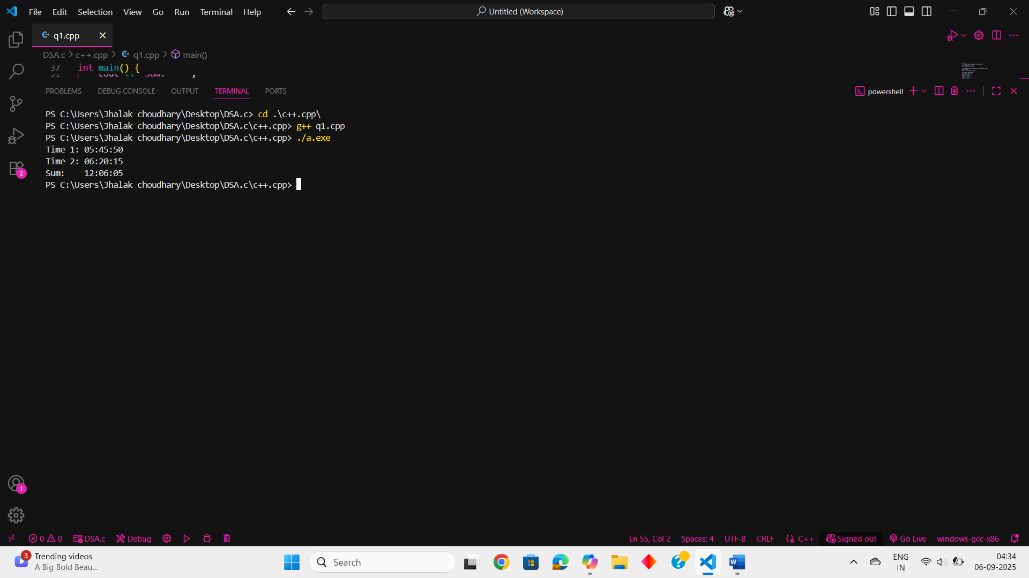

PRACTICAL NO. 13
Create class SavingsAccount. Use a static variable annualInterestRate to store the annual interest rate for all account holders. Each object of the class contains a private instance variable savingsBalance indicating the amount the saver currently has on deposit. Provide method calculateMonthlyInterest() to calculate the monthly interest by multiplying the savingsBalance by annualInterestRate divided by 12.This interest should be added tosavingsBalance. Provide a static method modifyInterestRate() that sets the annualInterestRate to a new value. Write a program to test class SavingsAccount. Instantiate two savingsAccount objects, saver1 and saver2, with balances of Rs2000.00 and Rs3000.00, respectively. Set annualInterestRate to 4%, then calculate the monthly interest and print the new balances for both savers. Then set the annualInterestRate to 5%, calculate the next month’s interest and print the new balances for both savers
SOURCE CODE:
#include <iostream>
#include <iomanip>
using namespace std;

class SavingsAccount {
private:
double savingsBalance;

// Static variable shared by all instances
static double annualInterestRate;

public:
// Constructor to initialize savings balance
SavingsAccount(double balance) {
savingsBalance = balance;
}
void calculateMonthlyInterest() {
double monthlyInterest = (savingsBalance * annualInterestRate) / 12;
savingsBalance += monthlyInterest;
}

// Displays current balance
void displayBalance() const {
cout << "Balance: Rs " << fixed << setprecision(2) << savingsBalance << endl;
}

// Static method to modify interest rate
static void modifyInterestRate(double newRate) {
annualInterestRate = newRate;
}
};

// Initialize static member
double SavingsAccount::annualInterestRate = 0.0;

int main() {
// Create two savings account objects
SavingsAccount saver1(2000.00);
SavingsAccount saver2(3000.00);
SavingsAccount::modifyInterestRate(0.04);
cout << "After applying 4% annual interest:" << endl;
saver1.calculateMonthlyInterest();
saver2.calculateMonthlyInterest();
cout << "Saver 1 - ";
saver1.displayBalance();
cout << "Saver 2 - ";
saver2.displayBalance();
SavingsAccount::modifyInterestRate(0.05);
cout << "\nAfter applying 5% annual interest:" << endl;
saver1.calculateMonthlyInterest();
saver2.calculateMonthlyInterest();
cout << "Saver 1 - ";
saver1.displayBalance();
cout << "Saver 2 - ";
saver2.displayBalance();

return 0;
}

