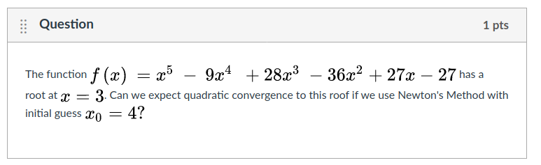
1) Midterm multiple choice and true/false questions.

No. x=3 is zero of multiplicity greater than 1

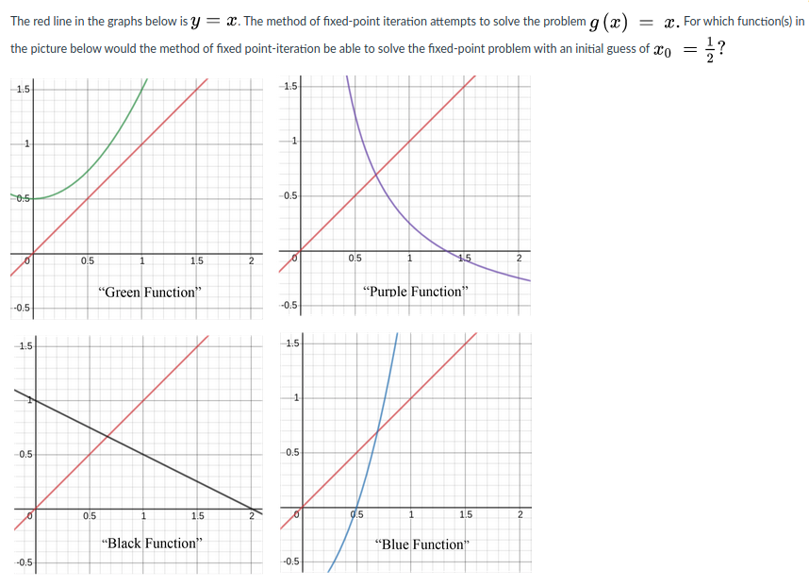
“Black function” only.

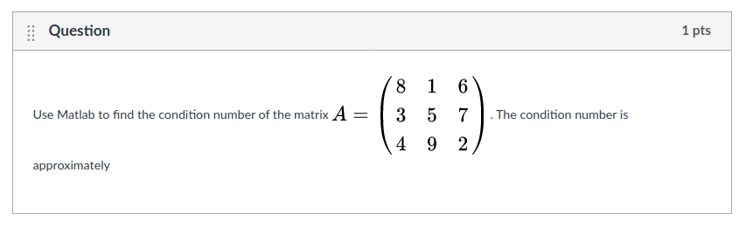
cond(A) = 4.33

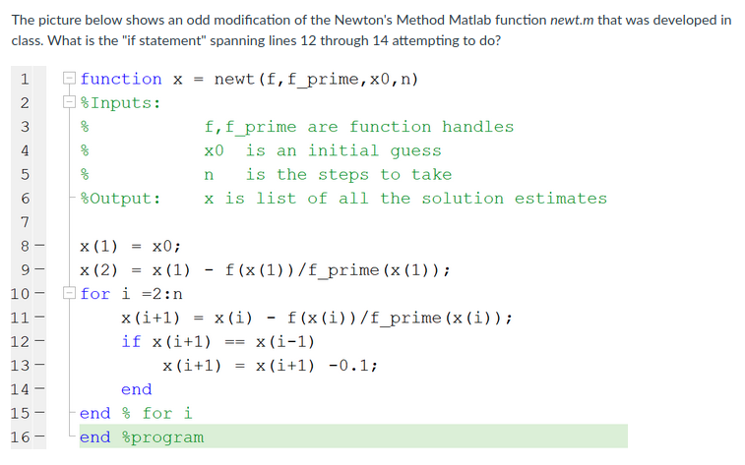
It is trying make the method move away from a repeating cycle of approximations if it "gets stuck."

Making sure it finds the solution x = 0.1 when there are many roots nearby.

Nothing, it's probably just an error in the program entry.

Increasing the rate of convergence when there is a root of multiplicity 2 or greater in the function.

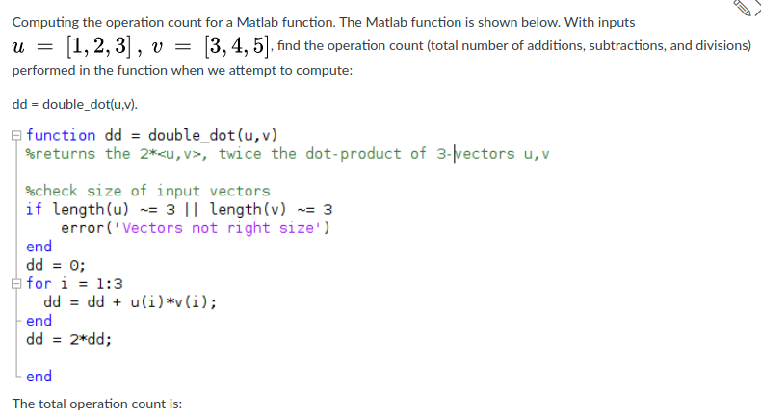
7

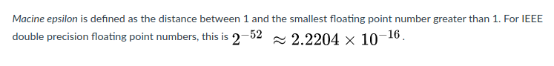
True

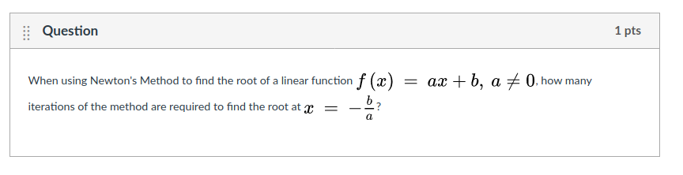
1

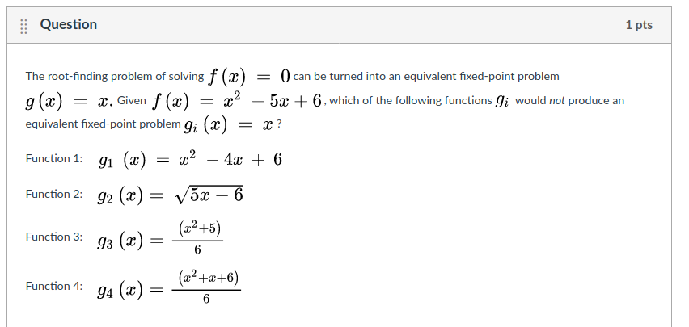
Function 3

Midterm Written questions

1) Perform the first two steps of the bisection method for the root of in the interval [0,2]. Describe your steps.
2) Explain why the fixed-point iteration on converges locally.
3) Find the roots of with three-digit accuracy. Show how you would arrange your computations to avoid loss of significance.
4) Let Prove that Newton’s Method will converge locally and quadratically to the root .
5)

