HW02b – answers

1a)







1b)

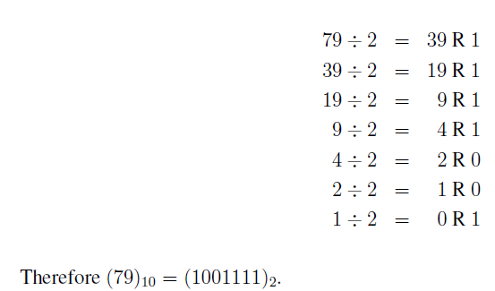

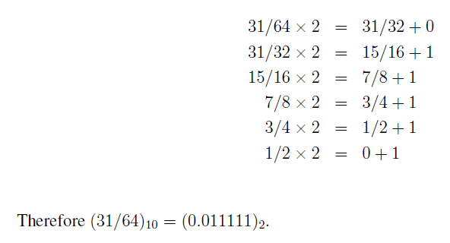

1c)



2a)



2b)

Use bisection to solve for the zero of a function like $f\left(x\right)=\sin\left(x\right)$

Code

f = @(x) sin(x);

bisect(f,3,3.2,0.5e-5)