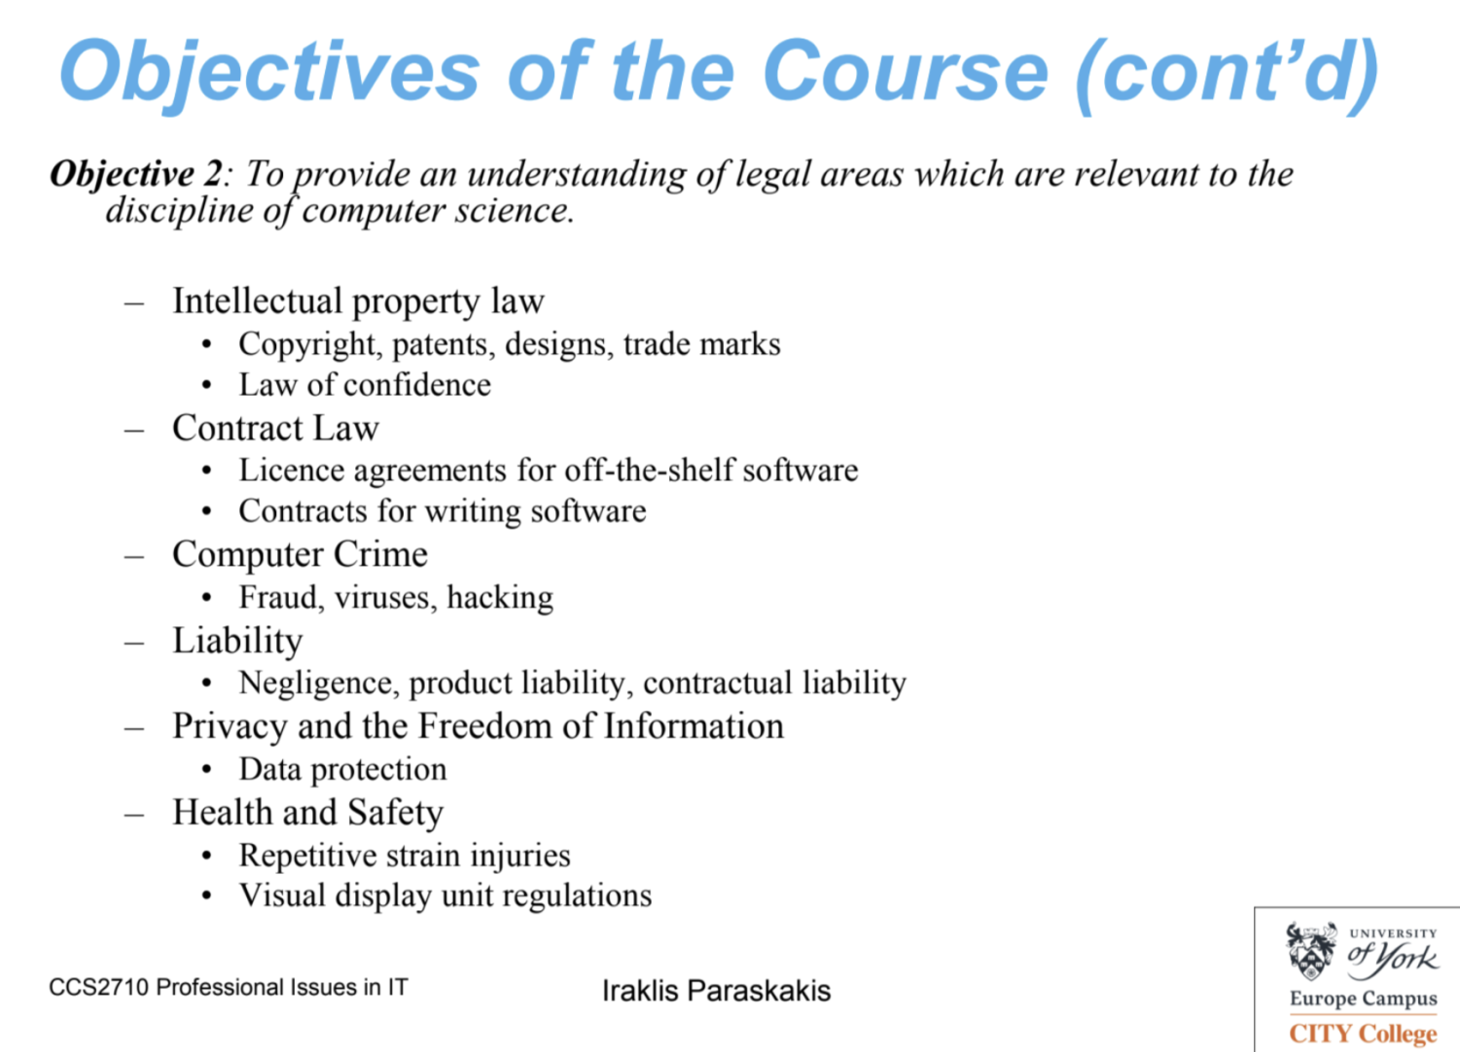

Question : When someone relies on the operation of a computer rather than his own expertise and causes loss to another, where does responsibility lie?

Answer:

The question of responsibility when someone relies on the operation of a computer rather than their own expertise and causes loss to another can be complex and often depends on the specific circumstances and legal context. Generally, several factors can influence where responsibility lies:

1. **Negligence**: If the person using the computer failed to exercise reasonable care in ensuring the computer system was functioning correctly, they could be found negligent. This includes ensuring the software is up to date, free of known bugs, and that they are properly trained in its use.
2. **Product Liability**: If the loss was caused by a defect in the computer system or software, the manufacturer or developer might be held responsible under product liability laws. This applies if the product was inherently flawed and caused the loss even when used correctly.
3. **Contractual Obligations**: If there is a contract in place that specifies the responsibilities and liabilities of the parties involved, the terms of the contract will often dictate where responsibility lies. For example, if a service provider guarantees certain outcomes or performance levels, they might be liable if those are not met.
4. **Professional Standards**: In some professions, there are established standards of care and expertise that practitioners are expected to adhere to. If reliance on a computer system falls below these standards, the professional may be held responsible for any resulting loss.
5. **Misuse or User Error**: If the person using the computer system did not follow proper procedures or misused the technology, they could be held responsible for the loss. This includes incorrect input, misunderstanding of the system’s capabilities, or ignoring warnings provided by the software.
6. **Shared Responsibility**: In some cases, liability might be shared between the user and the manufacturer or developer, especially if both parties had roles in contributing to the loss. For example, if a software flaw was combined with user negligence, both parties might bear some responsibility.

British Law:

Case are criminal and civil only.

The characteristics are Adversarial and Common Law.

Precedent is also called Case Law.

The are 2 kinds of Precedent: Binding Precedent and Persuasive Precedent.

Criminal Law:

Tries to find the Guilt or innocence of the accused.

A criminal act(actus reus) itself does not constitute guilt unless the mind is guilty(mens rea).

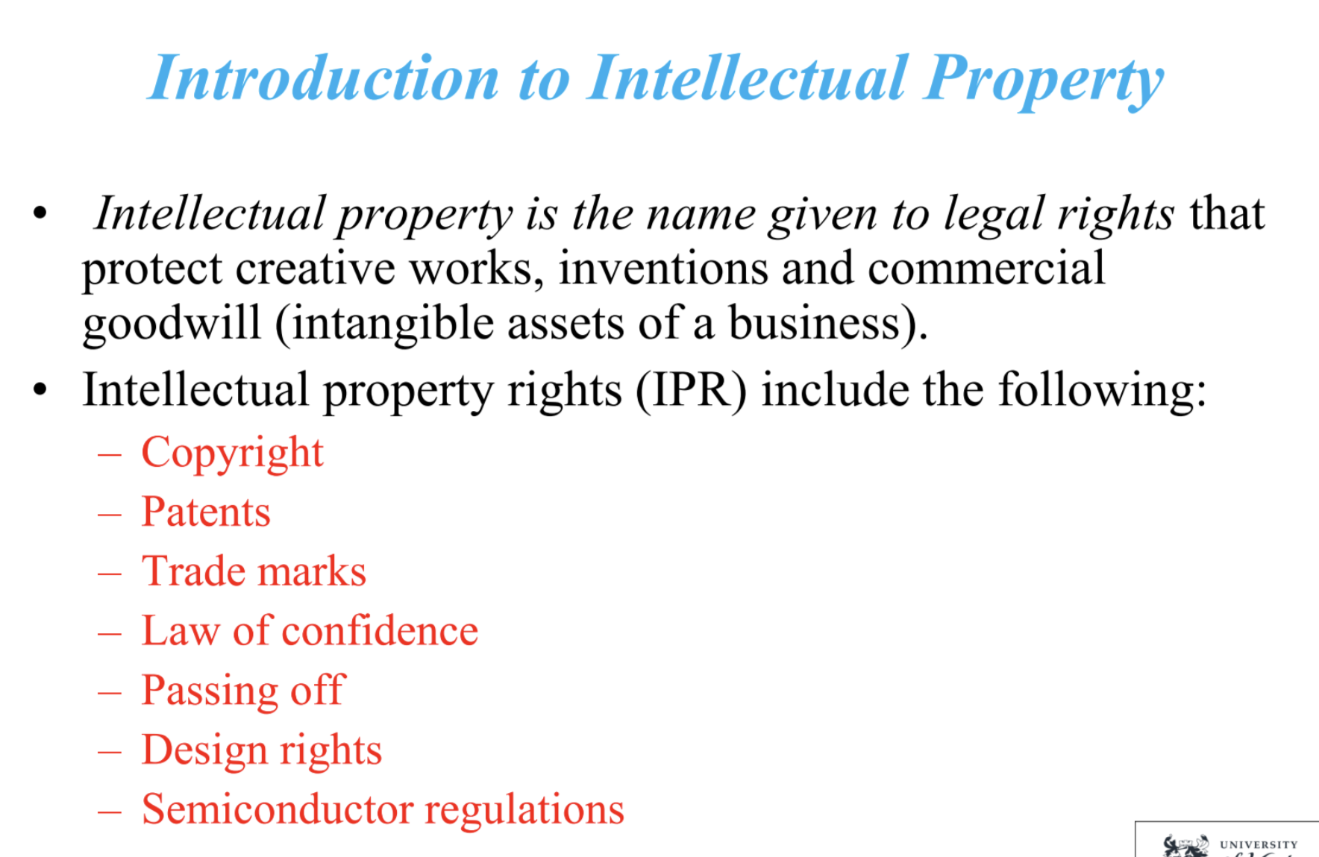

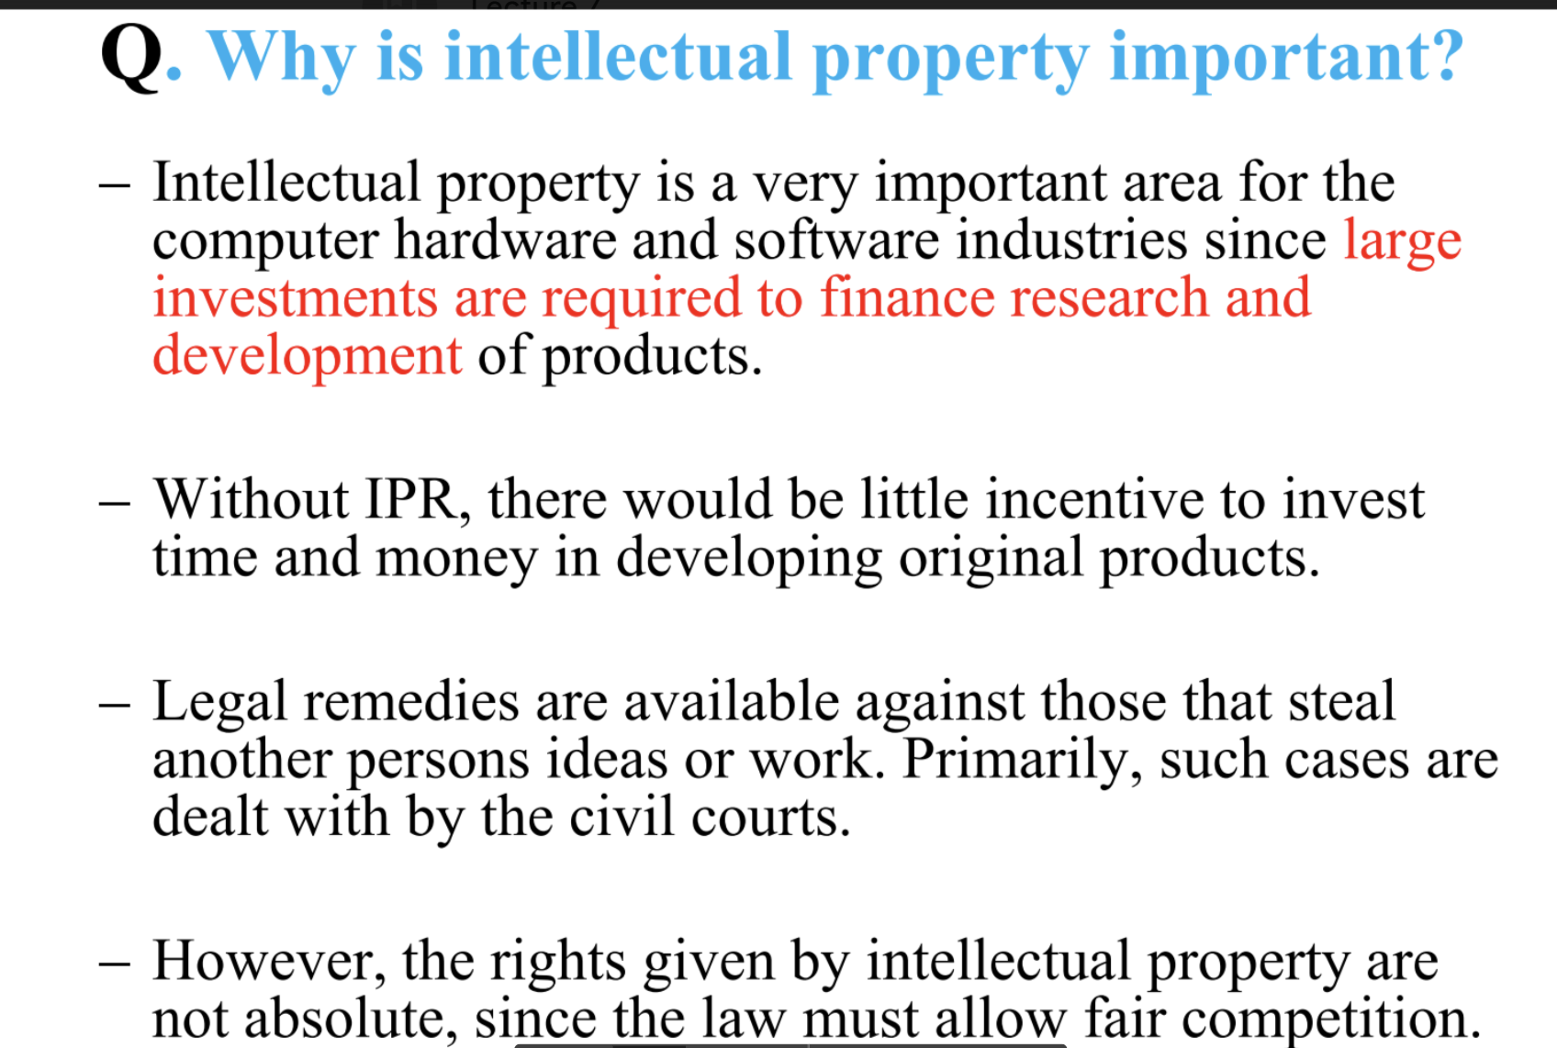

CDPA (Copyright, Designs and Patents Act):

Copyright Law -> Provides the owner with exclusive rights to publish, perform , broadcast , adapt or copy the whole or a substantial part of a work for a set period of time.

Copyright protects the expression of an idea not the idea itself

Patent Law: Gives the owner the exclusive right in an invention (such as a new type of computer hardware).

Law of Confidence: Protects information (ideas not expressed physically ).

The limitation of the Law of Confidence is that it must be confidential and not in the public domain.

Also the Law of Confidence is useful since it protects ideas before they are sufficiently developed.

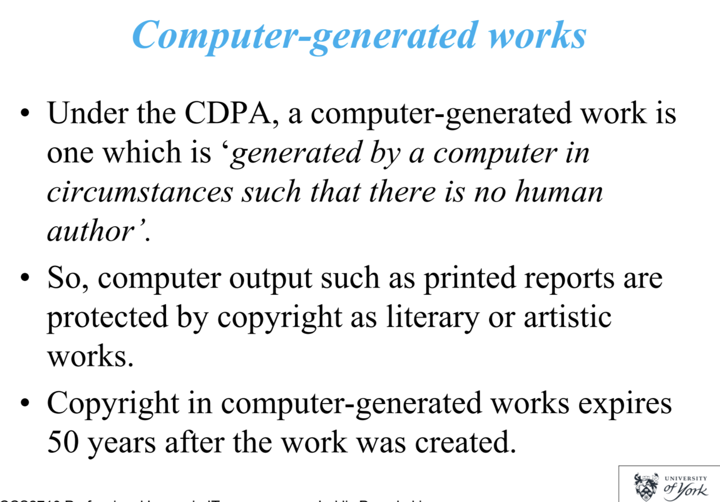

For example, if a business has a computer system which automatically generates financial reports without any human intervention, the person who manages the computer facilities will be the author.

However the organization will be the copyright owner !!!!

CCPR (Copyright Compute Programs Regulation 1992.