Jon Halverson

Homework 2

1. URL - <http://homepage.divms.uiowa.edu/~jmhalverson/>
2. 1. Web caching can reduce the delay in receiving a requested object by first checking if the object has been stored locally in the web cache. If the object has been stored locally, there is no need to establish a connection with the server that the object originates from. This also gets helps alleviate bottlenecks that might occur at the server since you can connect to the web cache instead of the server.
   2. First, a DNS request must be sent in-order to get a hostname-to-IP address mapping. This is how we will obtain the IP address of the http server. The http client must then establish a TCP connection to the server. At this point, a GET request can be sent over this connection requesting the web document
   3. 1. Non-persistent HTTP with no parallel TCP connection.

* Establish Connection + request/response = 2 RTT
* 9 connections required: 8 objects, 1 HTML file

Time = 9*(2RTT) = 18RTT

* + 1. Non-persistent HTTP with browser configured for 5 parallel connections
* With 5 parallel connections, we will need 2 connections in-order to deal with the 8 objects and 1 HTML file.

Time = (Connection) + (Download Exchanges)

Time = (2*2RTT) + (9RTT) = 13RTT

* + 1. Persistent HTTP (*Assumes Pipelining*)

Time = (Connection) + (HTML file) + (8 small objects)

Time = (RTT) + (RTT) + (RTT) = 3RTT

* 1. 1. day:

night:

* + 1. explanations: The access link’s capacity is only used if the web cache **cannot** directly respond to the HTTP request. In order to find how much of the volume the access link will have to handle, we do 1-y. We then take the result of 1-y and multiply it by the utilization of the access link during the day (28.6%), assuming no web cache.

28.6% (or .286) * (1-y)

* 1. DNS is required to translate hostnames to IP addresses. This is necessary because while it easier for us to remember hostnames, routers prefer structured IP addresses. Other important services provided by DNS include host aliasing, mail server aliasing, and load distribution.
  2. DNS is operated in a distributed and hierarchal manner because to deal with the issue of scale. With this structure, there is no single point of failure and it is easier to handle the traffic volume compared to having a single DNS server. A single DNS server would also run into a maintenance issue. It would have to keep records for all Internet hosts and would have to updated frequently to account for every new host.
  3. 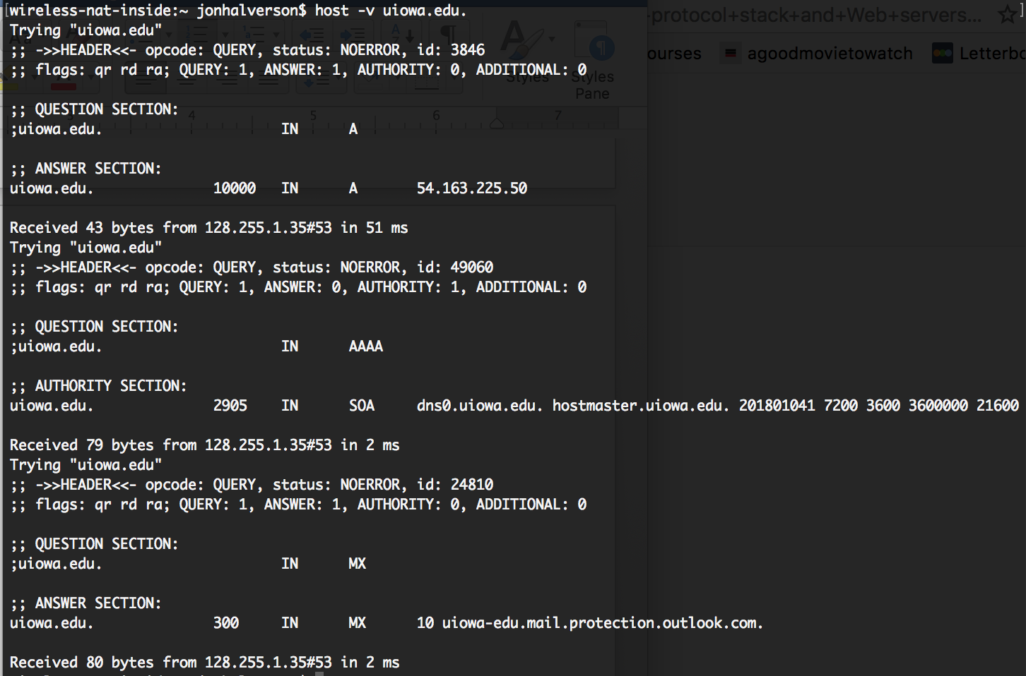

**Explanation**: the ‘host’ command is DNS lookup utility. ‘uiowa.edu’ is the hostname that is being looked up. ‘-v’ provides a verbose output of the host command

* 1. You could add the desired DNS server’s IP address to your DNS configuration under ‘DNS Servers’ (for mac).
* Amount of time it takes to get IP Address = ${RTT}_{1 }+ {RTT}_{2 }+…+{RTT}_{n}$
* TCP Connection + Request/Receive = $2{RTT}_{0}$

$$Time= 2{RTT}_{0}+{RTT}_{1 }+ {RTT}_{2 }+…+{RTT}_{n}$$