DSA Assignment

**Practical 1**

**Name:** Madhav Jha

**Roll no.:** 48

**Branch:** CSE (AI & ML)

# Q1. Write a program to swap numbers using call by value and call by reference and also print the difference in output.

## a.Swap by value

#include <stdio.h>

void swapByValue(int a, int b) {

    int temp = a;

    a = b;

    b = temp;

    printf("\nSwapped in function:\na: %d; b: %d", a, b);

}

int main()

{

    int a = 10, b = 15;

    printf("Call by value\n");

    printf("Before swap:\na: %d; b: %d", a, b);

    swapByValue(a, b);

    printf("\nAfter swap:\na: %d; b: %d", a, b);

    return 0;

}

## Output:

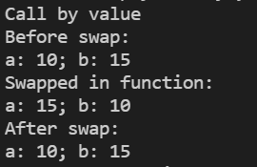

## b.Swap by reference

#include <stdio.h>

void swapByReference(int* a, int* b) {

    int temp = *a;

    *a = *b;

    *b = temp;

    printf("\nSwapped in function:\na: %d; b: %d", *a, *b);

}

int main()

{

    int a = 10, b = 15;

    printf("\n\nCall by Reference\n");

    printf("Before swap:\na: %d; b: %d", a, b);

    swapByReference(&a, &b);

    printf("\nAfter swap:\na: %d; b: %d", a, b);

    return 0;

}

## Output:

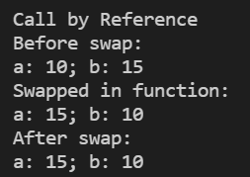

# Q2. Write a program to return multiple values through c program by following ways

## a.Using pointers

#include <stdio.h>

void initialize(int* a, int* b, char* c)

{

    *a = 10;

    *b = 20;

    *c = 'A';

}

int main(void)

{

    int a, b;

    char c;

    initialize(&a, &b, &c);

    printf("a = %d, b = %d, c = %c", a, b, c);

    return 0;

}

## Output:

## 

## b.Using structure

#include <stdio.h>

struct Tuple {

    int a, b;

    char c;

};

struct Tuple initialize()

{

    struct Tuple tuple = { 10, 20, 'A' };

    return tuple;

}

int main(void)

{

    int a, b;

    char c;

    struct Tuple tuple = initialize();

    a = tuple.a;

    b = tuple.b;

    c = tuple.c;

    printf("a = %d, b = %d, c = %c", a, b, c);

    return 0;

}

## Output:

## c.Using Array

#include <stdio.h>

#include <stdlib.h>

int* initialize()

{

    int* temp = (int*)malloc(sizeof(int) * 3);

    *temp = 10;

    *(temp + 1) = 20;

    *(temp + 2) = 30;

    return temp;

}

int main(void)

{

    int a, b, c;

    int* arr = initialize();

    a = arr[0];

    b = arr[1];

    c = arr[2];

    printf("a = %d, b = %d, c = %d", a, b, c);

    return 0;

}

## Output:

## 

# Q3.Search element in array

## a.Linear search

#include <stdio.h>

void linearSearch(int arr[], int* n, int* num, int* index) {

    for (int i = 0;i < *n;i++) {

        if (arr[i] == *num) {

            *index = i;

            break;

        }

    }

}

int main() {

    int n = 2;

    printf("\nEnter number of elements: ");

    scanf("%d", &n);

    int arr[n];

    printf("Enter array elements: ");

    for (int i = 0;i < n;i++) {

        scanf("%d", &arr[i]);

    }

    int num;

    printf("Enter number to search: ");

    scanf("%d", &num);

    int index = -1;

    linearSearch(arr, &n, &num, &index);

    if (index == -1) {

        printf("Number not found!!!");

    }

    else {

        printf("Number found at index: %d", index);

    }

    printf("\n\n");

    return 0;

}

## Output:

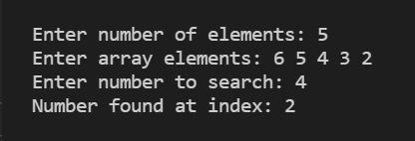

## b.Binary search

#include <stdio.h>

void printArray(int arr[], int n) {

    printf("[ ");

    for (int i = 0;i < n;i++) {

        printf("%d ", arr[i]);

    }

    printf("]");

}

int* bubbleSort(int arr[], int n) {

    for (int i = 0;i < n;i++) {

        for (int j = 0;j < n;j++) {

            if (arr[i] < arr[j]) {

                int temp = arr[i];

                arr[i] = arr[j];

                arr[j] = temp;

            }

        }

    }

    return arr;

}

void binarySearch(int arr[], int* n, int* num, int* index) {

    int l = 0, r = *n - 1, m;

    int count = 0;

    while (l <= r && count < 100) {

        m = (l + r) / 2;

        if (arr[m] == *num) {

            *index = m;

            break;

        }

        else if (arr[m] < *num) {

            l = m + 1;

        }

        else {

            r = m;

        }

        count++;

    }

}

int main() {

    int n = 2;

    printf("\nEnter number of elements: ");

    scanf("%d", &n);

    int* arr;

    printf("Enter array elements: ");

    for (int i = 0;i < n;i++) {

        scanf("%d", &arr[i]);

    }

    printf("After sorting: ");

    arr = bubbleSort(arr, n);

    printArray(arr, n);

    int num;

    printf("\nEnter number to search: ");

    scanf("%d", &num);

    int index = -1;

    binarySearch(arr, &n, &num, &index);

    if (index == -1) {

        printf("Number not found!!!");

    }

    else {

        printf("Number found at index: %d", index);

    }

    printf("\n\n");

    return 0;

}

## Output:

