**Computer Organization 2019**

**HOMEWORK 6**

系級: 資訊110 學號: E64056211 姓名: 詹康彬

**問題(Question)**

Q1. How do you know the number of block from input file?

(Cache_size * 1024) / block_size

Q2. How do you know how many set in this cache?

Directed map => set = block_num

Four way => set = block_num / 4

Fully associative => set = 1

Q3. How do you know the bits of the width of the Tag ?

32 – address_index - offset

Q4. Briefly describe your data structure of your cache.

因為不用實作write和read所以我只有用一個二維陣列存tag和一個一維陣列存valid bit

Q5. Briefly describe your algorithm of LRU

一個一維陣列存每個block的access次數.

一個二維陣列存每一個entry的最近被access是在哪次，所以一被access到就update成新的access次數

Q6. Briefly describe your algorithm of your policy.

我是Optimal LFU因為LFU是單純看access的次數來決定replace哪個entry，所以可能會一直replace前面的entry但後面可能也被access很少次的也佔一個位子，我的方法是只要一被replace就讓該entry的次數加上去而不是初始回1，這樣可以預防一直replace重複的entry的問題

Q7. Run trace2.txt, trace3.txt and then makefile to get the miss rate and put it in your report.

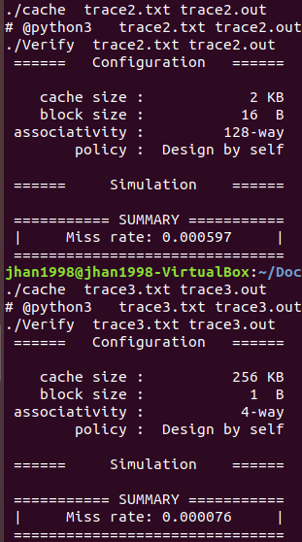

**心得(Report)**

(請寫下完成本次作業的心得、學到哪些東西、困難點的部分。)

(Please write your learned lesson and conclusion, and difficult point.)

這次的作業比起上次來的容易困難的點只有怎麼優化LFU來讓miss rate比random來的好，幸好最後有做出來，不然就只能用random了QQ