Question 1
1. np.floor(np.random.rand(6) * 6) + 1
2. z = y.reshape((3,2))
3. x = np.max(z)
r = np.where(z == x)[0][0]
c = np.where(z == x)[1][0]
4. x = (v == 1).sum()

Question 2
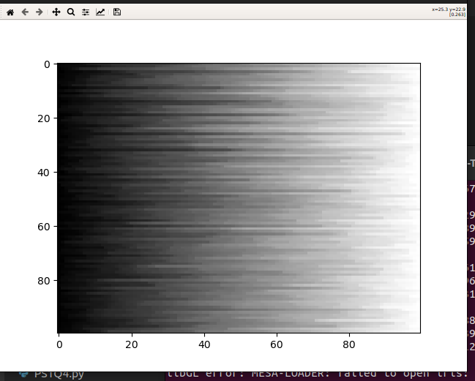
1.

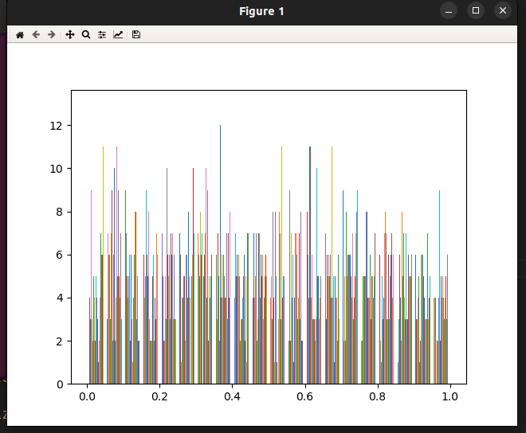
2

3.

