John Hancock
COP 6731 / Theory and Implementation of Database Systems
2014-09-18
ASSIGNMENT #1b

We coded an SQL script and executed it in SQL developer. A copy of the script output from SQL Developer appears below. The graphics required in problem 10(b) follow the script output. Please note that we had to capture multiple images of Query Builder output for the nested version of the query required in problem 1. Hence, the reader must see multiple pages for the complete answer to problem 10(b).

The script output begins after this line.
> /* Problem 6 */
> select p#,avg(qty) from spj
group by p#
having avg(qty) >
(select avg(qty) from spj where p# in (select p# from p where p.color='Red'))
P# AVG(QTY)
----- ----------
P4 650

> /* Problem 7 */
> select p# from p where
(select avg(qty) from spj where spj.p#=p.p#) >
(select avg(qty) from spj where p.color='Red')
P#
-----
P4

> /* Problem 8 (a) */
> select s# from spj where
j# in (select j# from j where j.city='Rome') and
p# in (select p# from p where p.color='Red')
group by s#, p#
having count(distinct j#)=(select count(*) from j where j.city='Rome')
S#
-----
S5
S3

> /* Problem 8 (b) */
> select distinct s# from s,p
where (select count(distinct j#) from spj where spj.s#=s.s#
and spj.j# in (select j# from j where j.city='Rome')
and spj.p# in (select p# from p where p.color='Red')
) =
(select count(*) from j where j.city='Rome')

S#
-----
S3
S5

> /* Problem 9 (a) */
> select s# from spj
where p# in (select p# from p where p.color='Red')
minus
select s# from spj
where p# in (select p# from p where p.color <> 'Red')
S#
-----
S1
S4

> /* Problem 9 (b) */
> select sname from s where s# in
(
select s# from spj
where p# in (select p# from p where p.color='Red')
minus
select s# from spj
where p# in (select p# from p where p.color <> 'Red')
)
SNAME
--------------------
Smith
Clark

> /* Problem 10 (a)*/
> select j1.j#, j2.j# from j j1, j j2 where j1.j# < j2.j#
minus
select spj1.j#, spj2.j# from spj spj1, s s1, spj spj2, s s2
where s1.city='London' and spj1.s#=s1.s#
and s2.city='London' and spj2.s#=s2.s#
J# J#
----- -----
J1 J2
J1 J5
J1 J6
J2 J3
J2 J4
J2 J5
J2 J6
J2 J7
J3 J5
J3 J6
J4 J5
J4 J6
J5 J6
J5 J7
J6 J7

15 rows selected

The script output is above this line.

Please scroll down to the next page to see the first image required in the answer for problem 10(b).
For problem 10(b) this is the first Query Builder diagram and criteria pane:
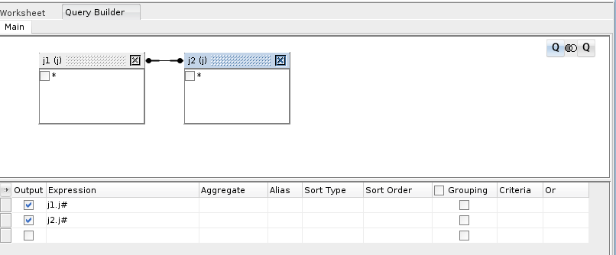
Please advance to the next page to see the second Query Builder diagram and criteria pane for problem 10(b)

For problem 10(b) this is the second Query Builder diagram and criteria pane:
