

Hounder Search System

Training Application

Introduction
This document describes operation of the Training Application. The purpose of the Training Application is to provide human feedback to the Bayesian Classifier. This document includes the file structure, an explanation of the web interface.

Overview

The training webapp is used to teach the application about a category. We do that by 'telling' the webapp when a URL page belongs to a category or not. It is pretty the same way we teach someone about the 'yellow' color by showing samples: the lemon is yellow; the school bus is yellow; the apple is not; etc.
For training the webapp, we collect a list of pages (URLs) and then we indicate for each of these pages if they belong to the category (or categories) or not.
After that, we let the webapp infer/deduce what all those pages have in common, and to calculate a way of predict if a new page belongs or not to that category.
Finally, we can check the webapp prediction, and give more examples to fix some error if necessary.
The way the webapp infer/deduce why a page belongs or not to a category is by using a Bayesian algorithm. It can be explained as follows: It takes all the pages belonging to the requested category and tokenizes them. It then takes all the pages that do not belong to that category and tokenizes them. Then, for each token it checks how often the token appears in the good pages, against the ratio on bad pages.
For example if the tokens 'foot' and 'time' appears in the 90% of the pages belonging to the 'run' category, and only in 3% of the 'not-run' category, it might infer that 'foot' and 'time' are good predictors of how much 'run' a page is. Hence next time a new url-page is given for categorization, it will check if it has the words 'foot' and 'time'. If so, will be categorized as 'run', else will be categorized as 'not-run.'

User Interface
In this section we show the existing pages in the webapp, and explain what the pages are for.

The Menu
Although not a page by itself, we decide to show it here as the menu appears on each page. Clicking a link on the menu, will show you one of the pages explained in this section.
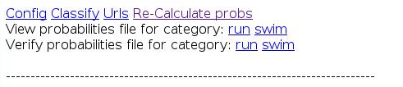Illustration 1: The menu

The configuration page
Once installed in the apache (or similar) web server, the WebApp is accessible through the url http://<IP>:<PORT>/learning/. The first access redirects the user to the configuration page, as shown in the following image:
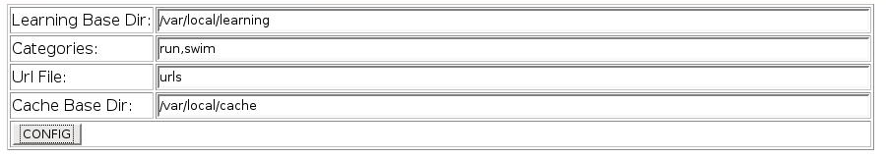Illustration 2: The configuration page

For the webapp to work, both the Learning Base Dir and the Cache Base Dir must already exist and be read/write-able for the web-server.
The Learning Base Dir will be used to store the list of pages belonging or not to each category, as well as the calculated .probabilities files.
The Categories box, is to be filled by a comma separated list of categories the categories that any page might belong or not.
The Url File box must be filled with the name of the file containing the list of URLs that will be used to train the application. This file must already exist, and be located in the 'Learning Base Dir' directory. Its format is a list of URLs (including the 'http://'), one per line:
http://511.dabomb.com.ar/categoria/navegadores/opera/
http://192.cl/sinalgoencomun
http://1hosting.cl/
http://1hosting.cl/enlaces.htm

The URLs file, must contain both “good pages” (pages that belong to at least one category) and “bad pages” (pages that don't belong to any categories). It is important not to use a list of only “good pages” as it biases the classifier results, making it produce too many false positives. Else is like teaching someone about the 'yellow' color, showing only things that are yellow. He/She may deduce that everything is yellow.
The Cache Base Dir will be used to store the retrieved pages, or to read alredy saved pages. This is necessary because we may classify a page today, and run the Bayesian calculator tomorrow. Meanwhile the page in the remote server might has change, making our yesterday classification wrong.

The classification page

Once configured, the webapp is redirected to the training (classify) page. The classification page is used to teach the application about the kind of pages: to which categories each page belongs. In our previous example, is the stage on which we we point a lemon and say 'yellow'.

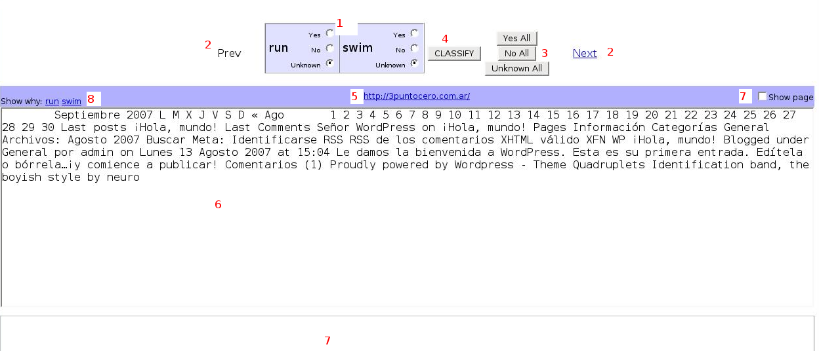Illustration 3: The classification page

The training page contains the following elements:

# | Element | Description
1 | Yes / No/ Unknonw radio-buttons | For each category, allows the user to indicate if the page belongs or not to that category. Unknown indicates that the page content must not be used when calculating the probabilities for the category.
2 | Prev/Next | Displays the Previous/Next page to classify, without changing the current classification of the current page
3 | Yes/No/Unknown All | Marks the page as a Yes/No/Unknown for every category. It doesn't commit the changes.
4 | Classify Button | Commits the values of the Yes/No/Unknown radio-buttons. Also displays next page.
5 | Webpage Link | Links to the site where the page comes from.
6 | Raw Content TextArea | Contains the page tokens as they will be processed by the classifier.
7 | Rendered Page Iframe and Show Page checkbox | Contains the rendered page. It is shown only if the 'Show Page' checkbox is checked.  Note that no matter what appears in the rendered page, the training is done ONLY by the tokens appearing in the Raw Content TextArea.  Hence be careful to classify a page only by the Raw Content TextArea, not by the data you see in this IFrame
8 | Show Why | For each of the linked categories, it will show the probability of each token in that category. IE, shows you how this page will be classified if using current <cat>.probabilities.  See the 'Why page' and the 'Re-Calculate probabilities page' below.

Notes:
- The rendered page should be used only as a hint to quickly determine if the content belongs to a category or not, but the final decision must be made based on the page's raw content. This is so because the browser may show a different content for the url (due to the use of frames, Javascript, images, etc.).
- In some cases, the rendered page could contain Javascript code to detect if it is being loaded in a frame, thus reloading itself to occupy the whole page. If this happens, the user should press the back button on the browser, uncheck the Show Page Checkbox and navigate up to the problematic page. After classifying it, the Show Page Checkbox can be checked again.

Re-calculate probabilities page

The recalculate probabilities page is used to (re) calculate the probabilities file, using the Bayesian calculus. In our previous example, it is the stage when we ask the application to infer/deduce what all the pages belonging (or not) to a category have in common.
We can decide to recalculate some or all of the .probabilities files.
The calculation for each category is done independently based on the pages belonging (or not) to the category. It can take a very long time, depending on the amount of URLs classified for the category, and on the amount of tokens of each page on that category.
Of course, (re)calculating of many categories takes the sum of the calculations of each category.
The page shows for each category, when was the .probabilities calculated last time.
It also gives the option to calculate the WhoHas file. The WhoHas is an help file used to know 'given a token, which page(s) have it'. It is useful to understand why a page was classified the way it was.
The WhoHas file is calculated once for all the categories. For any page belonging or not to a category (ie; the not unknown pages). It usually takes even longer than calculating one category .probabilities.
The WhoHas will be stored in the directory set in the classifier.properties file. Please see the Files and Directories section.

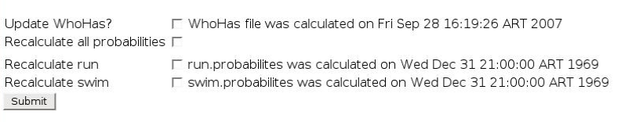Illustration 4: The re-calculate probabilities page
Verify Probabilities page
After the .probabilities was calculated, you can check how well the Bayesian will classify a group of pages.
You can do that by clicking one of the links in the menu: Verify probabilities for category <cat>

The page shows the category name, when was the .probabilities calculated, and the number and percentile of pages that were well/miss classified.
For each page, it shows a link to allow you re-classifying of that page, if necessary.
It also shows the value given to the page by the Bayesian calculator. Clicking this value/link shows you the tokens of the page and the value of each token. So you can know why the page was classified the way it was.
The results are grouped in true-positives, false-negatives, false-positives and true-negatives so it's easy to look for the pages that were miss-classified, check why, and (try to) solve the error.
Note that in this webapp, the belongs/not-belongs to a category treshold is set in 0.5. However in your application, the threshold is set in the corresponding crawler Bayesian module.
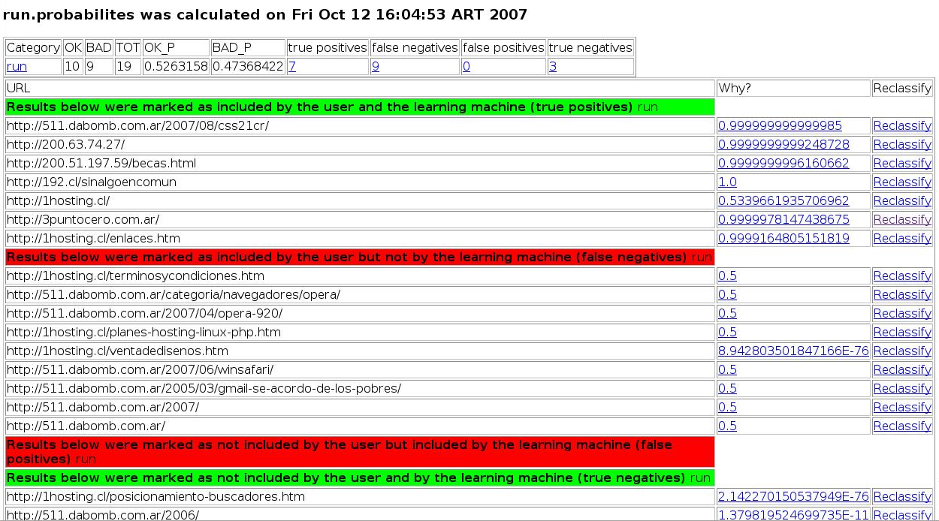Illustration 5: The Verify Probabilities page

View Probabilities page
The view probabilities page, allows you to view the content of the .probabilities file for a given category. Although DISCOURAGED, it allows you to modify the value of a given token and/or add new tokens and values to the .probabilities file.
The new tokens/values are saved only after submitting them by clicking the 'commit' button. You can add up to 4 new tokens each time, and modify as many values as you want. If you need to add more than 4 tokens, just do that in several commits.
Clicking a token will show you which pages have it (using the WhoHas file, assuming it was calculated).
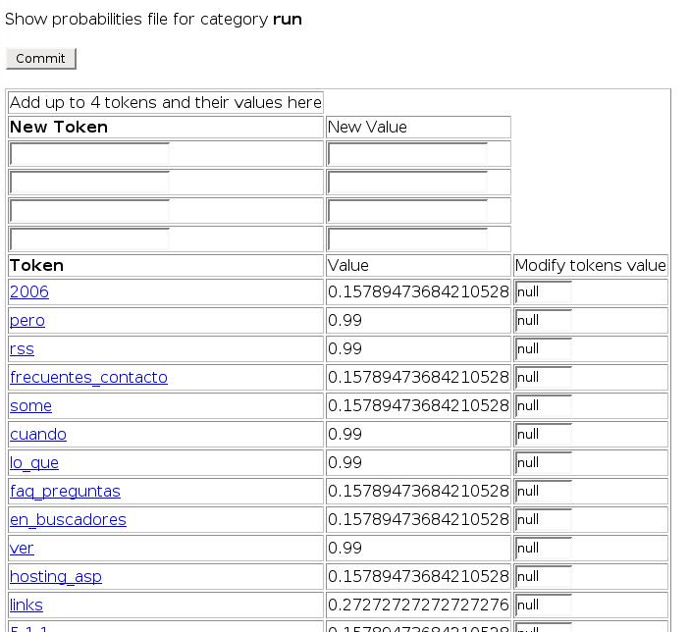Illustration 6: The view probabilities page

Why page
The Why page is very similar to the View probabilities page (and hence not shown here). It shows for a given page and category, all the tokens of that page and their values on the given category.
It also allows you to modify a token value (DISCOURAGED). Note that modifying the token value, modifies the value on all the pages of that category, not only on the current page.

Files and Directories
These are the files and directories used by the training application:

Directory | Description
Learning Base Dir | A local directory containing the url file. This directory is also used to write the inclusion files as well as the calculated .probabilities files.
Cache Base Dir | The directory of the cache used to train the classifier.

Files under the Learning Base DIr directory
File | Description
Url File | The file containing the list of urls to classify. Created by the user.
Inclusion Files | The files that indicate the urls of the pages that belong (or not) to a category. This files are created/updated each time the 'classify' buton is clicked in the 'classify page'.  category_included_urls, category_notIncluded_urls and category_unknown_urls
Probabilities Files | The files that contains the known terms' probabilities of belonging to a category:  These files are generated in the 'Re-calculate probabilities' page from the cache content and the urls listed in the inclusion files.  The files are to be copied to the 'crawler', for their use by the Crawler Bayesian Module(s)  category.probabilities: contains the calculated token preobabilities  category.my.probabilities: Contains the user added token-values or the user modified values for the tokens.

Installing the learning webapp

To install the webapp you should create its dist target with ant, and copy the resulting tgz to the application directory. Assuming the application will run at /var/local/learning :
ant dist-learning-web
cp dist/learning-web.tgz dist/plugin.tgz dist/lib.tgz /var/loca/learning
cd /var/local/learning
tar -xvzf learning-web.tgz
tar -xvzf lib.tgz
tar -xvzf plugin.tgz

After that, you must create a file containing all the urls (the Url File), and the Cache Base Dir:
mkdir /var/local/cache
echo "http://www.cnn.com" > urls

Then, you need to start the webapp:
cd learning-web
./start.sh
Then browse to http://localhost:47080/learning/ (The port number might be different. The used one is printed by the start.sh script).
The Learning Base Dir will be: /var/local/learning , the Cache dir: /var/local/cache and the Urls file urls.

