**Project Report CSC 621**

Jim Hankee

John Holiday

**Introduction**

We create the League Tracker Database. This database is intended to assist leagues in tracking family participation in the league. In this database Administrators can add\remote Families, add\remove players, assign players to teams. In addition, Coaches can be added and assigned\unassing to teams. Teams are created and assigned to Divisions. Divisions are broken up based on players ages. Families are charged based on the number of players registered; each division has a different cost. Invoices will be able to be mark as paid.

The database backend is housed the cloud at Amazon using MySql 8.0.23:

***sju-csc621-db.cwezplxtfcp4.us-east-2.rds.amazonaws.com***

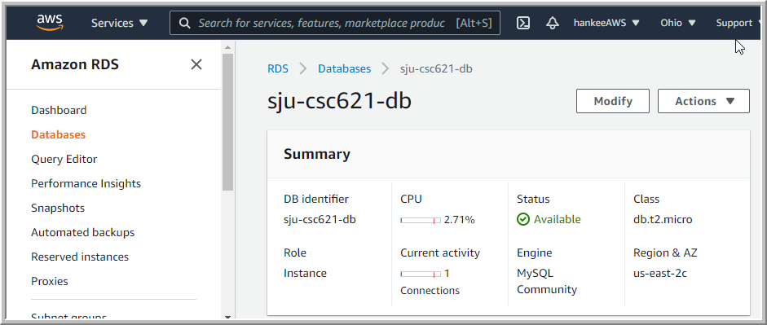

The front end has been coded using HTMP and PHP. And available on GitHub:

<https://github.com/jhankee/leagueTracker>

**Business Rules**

* Each Family is entered once.
* Families can have multiple players.
* Players are assigned to one team.
* Players can only be assigned to a team in their age-appropriate division.
* Divisions have multiple Teams.
* Teams have multiple players.
* Coaches can be assigned to multiple teams.
* Team can have multiple coaches.
* Teams have a maximum of 12 players.
* An invoice is generated when a player is added.

**Entity Relation Diagram (ERD)**

**Database Access**

An application account was create for database access: leagueAdmin

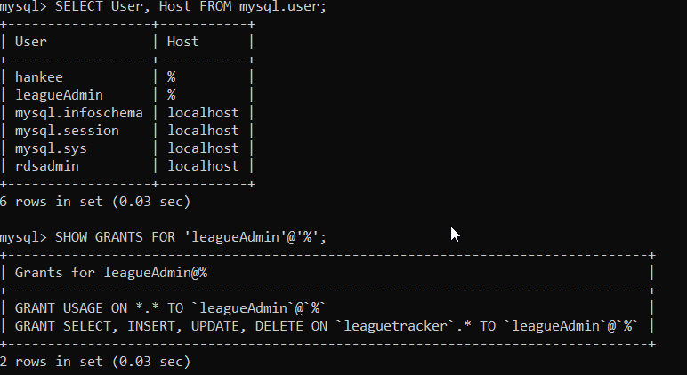

**Table Creation \ Constraints**

* **Family Table**

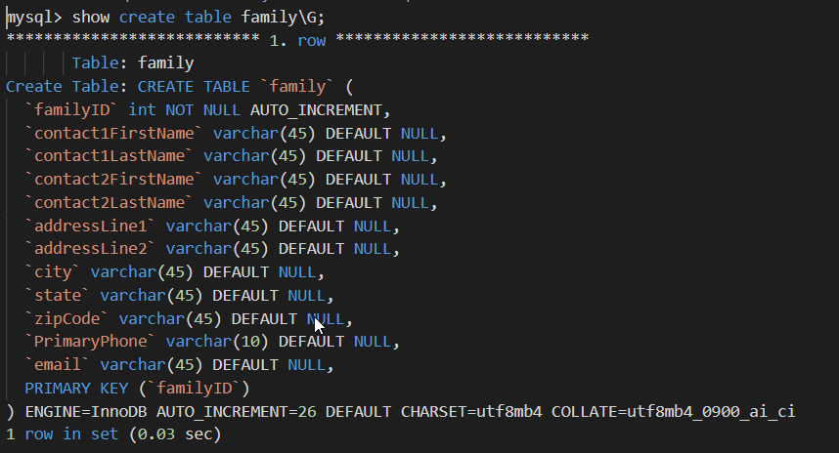

* **Player Table**

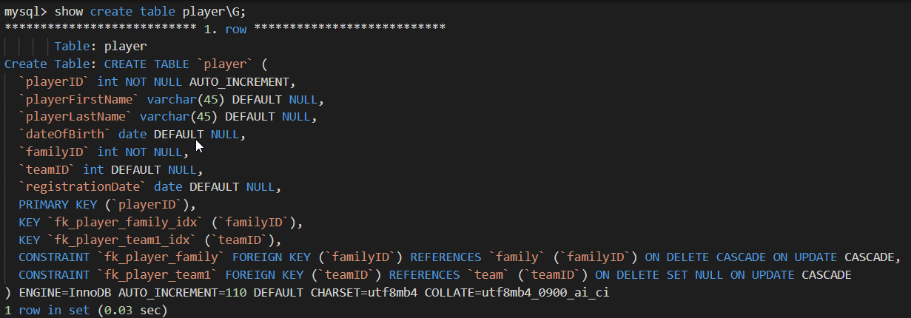

**Constraint 1**: Went Family is deleted, associated players are also deleted.

**Constraint 2**: When Team is deleted, player’s assignment to the team is set to null.

* **Division Table**

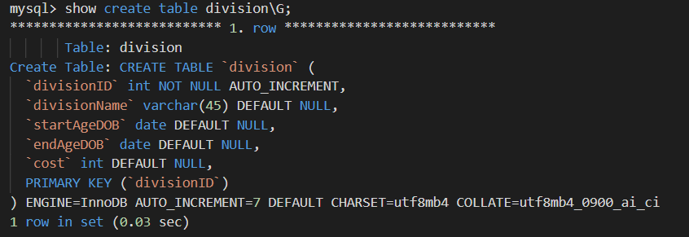

* **Team Table**

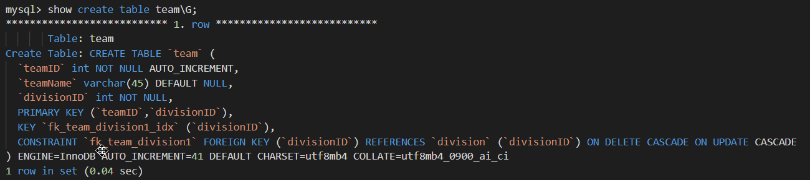

**Constraint 1**: If Division is deleted, teams assign to that division are deleted.

* **Coaches Table**

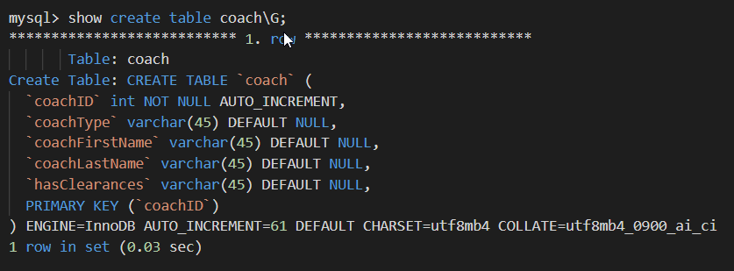

* **Coach_has_team table**

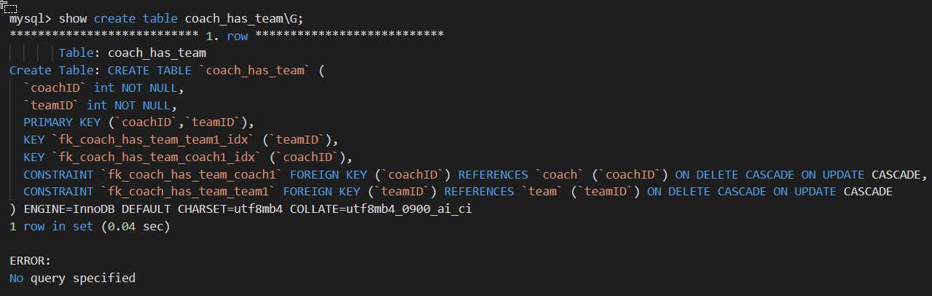

**Constraint 1:** If Coach is deleted, assignment to team is deleted.

**Constraint 2:** If Team is deleted, coach assignment is deleted.

**Triggers and Procedures**

**Procedure 1 ‘insert_invoice’:** This procedure inserts a row into the invoice table whenever a player is added to the database. It is called by the ‘after_player_insert’ trigger on the player table.

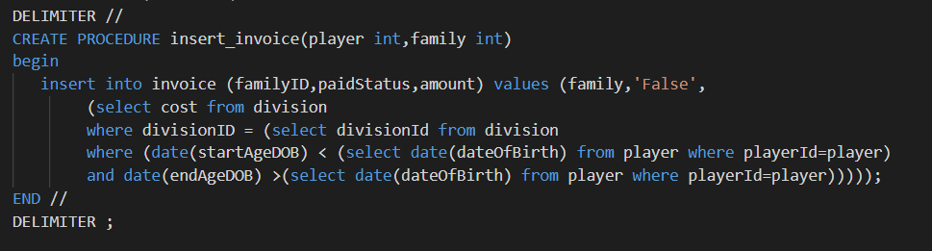

**Trigger 1 – ‘after_insert_player’:** This trigger is called after a player record has been added to the database and called the stored procedure ‘insert_invoice’.

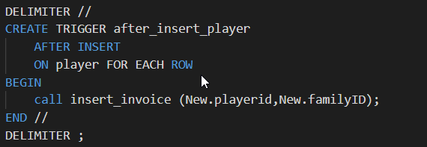

**Trigger 2 – ‘dob_validation’:** This trigger is called before a player record is inserted into the database to validate the player’s date of birth qualifies them for one for the divisions**.**

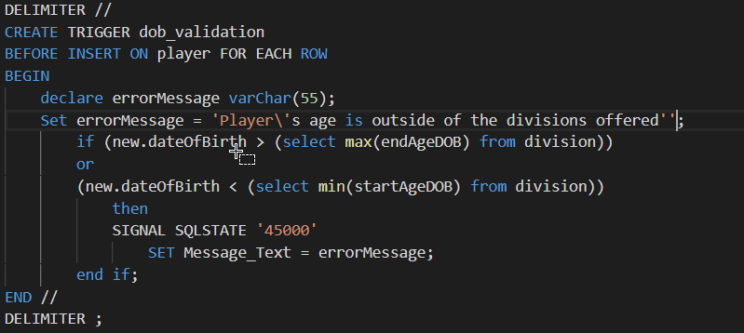

**Trigger 3 – ‘dob_validation_update’:** This trigger is called before a player record is updated into the database to validate the player’s date of birth qualifies them for one for the divisions.

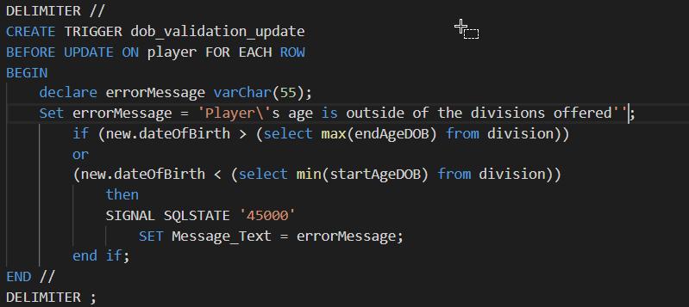

**Trigger 4 – ‘check_invoice_before_delete’:**  This trigger is called before a family record can be deleted, if checks the invoice table to ensure all invoices assigned to the family have been paid.

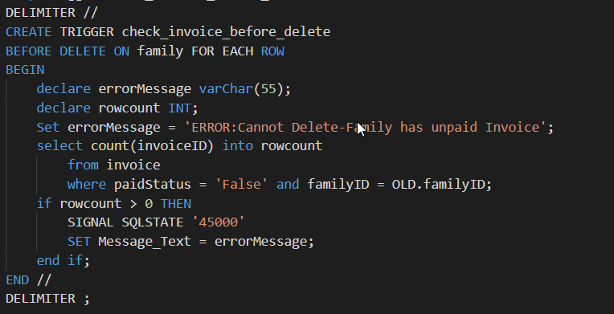

**Reports\Views**

**The following reports were created using views:**

* **Unassigned Players –** Displays all players not assigned to team**.**

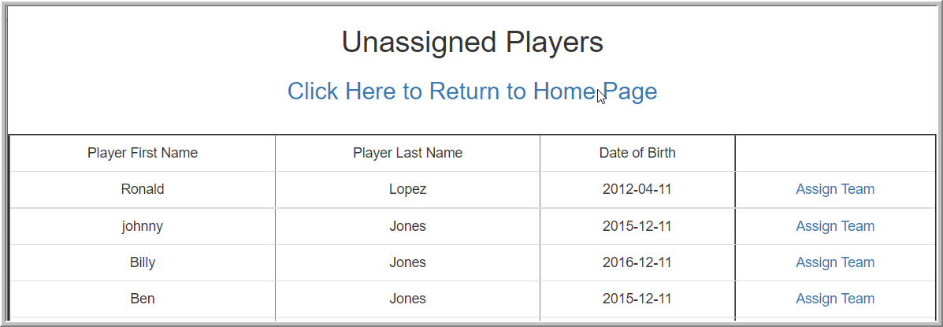

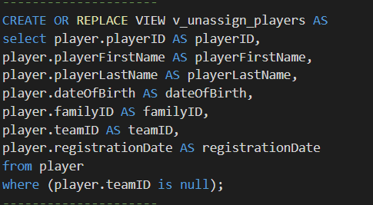

* **Coaches Clearances –** Displays all coaches with ‘hasClearances’ as ‘False’.

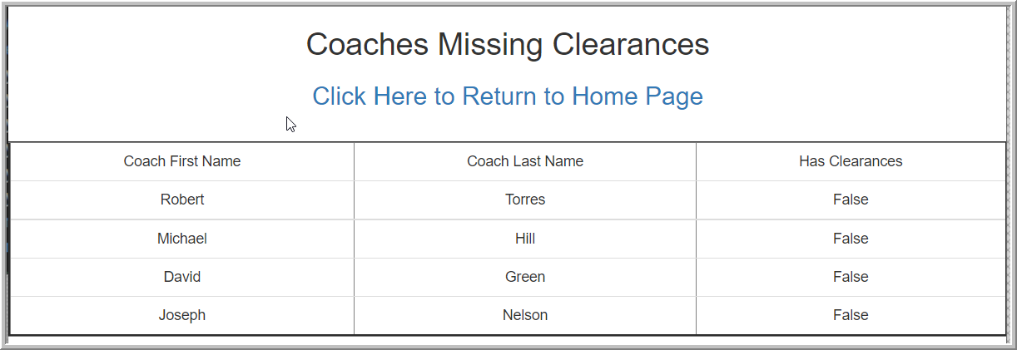

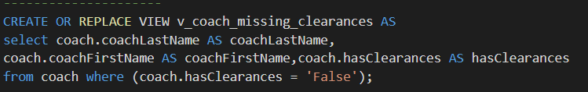

* **Rosters –** List all players assigned to team, ordered by Division, then Team.

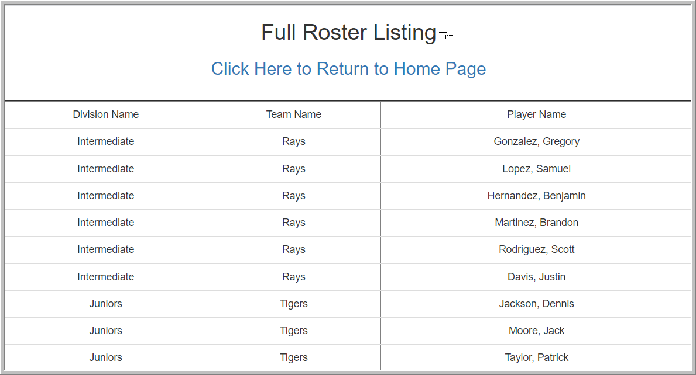

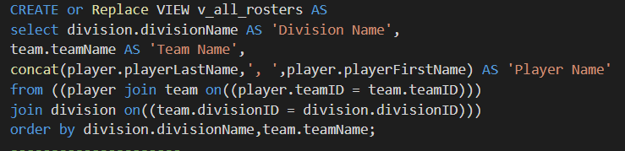

* **Team Roster Size –** Displays the current number of players assigned to a team.

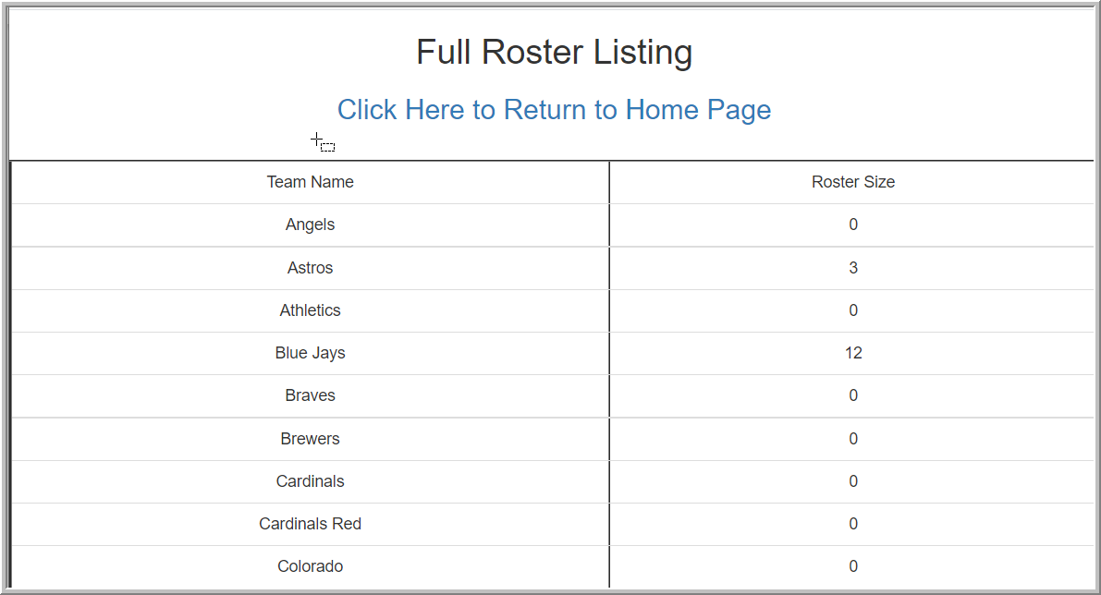

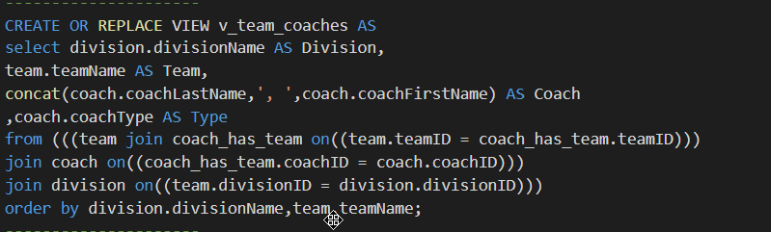

* **Team Coaches –** List all coaches assigned to team, displayed by division, then team.

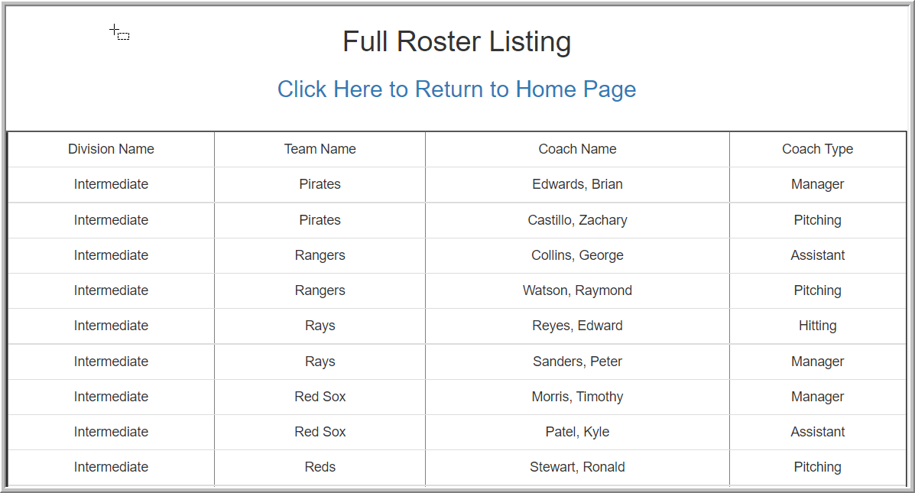

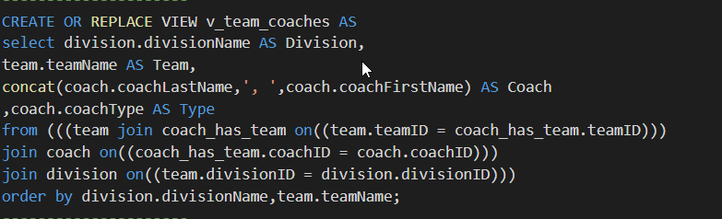

* **Unpaid Invoices (not a view):** List by Last Name the total outstanding due for a family.

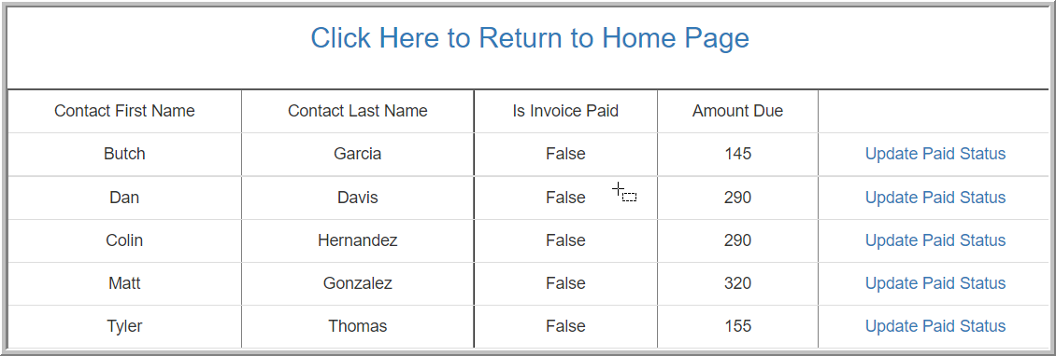

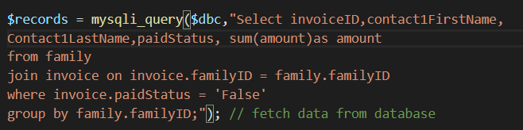

**Application Screen Shots**

* Display Family Information

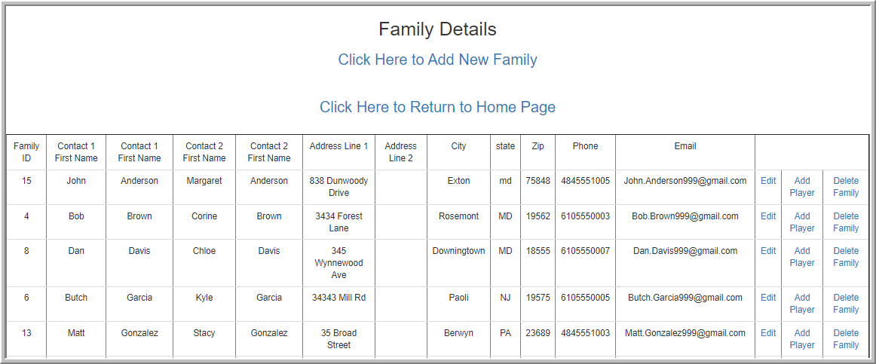

* Add a New Family

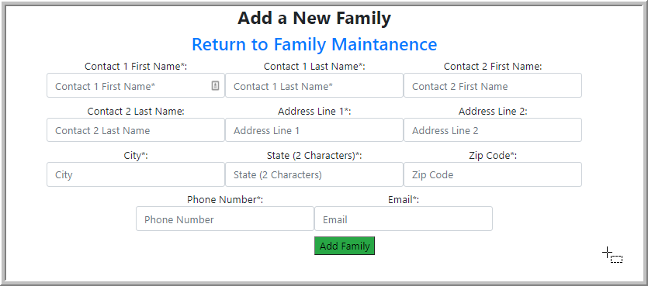

* Edit Family Data

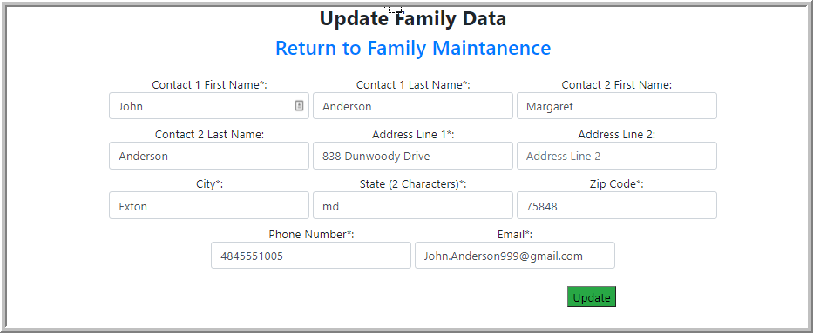

* Add a new player for a Family

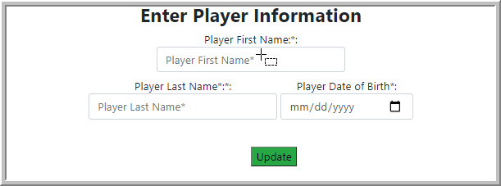

* Display all Player information.

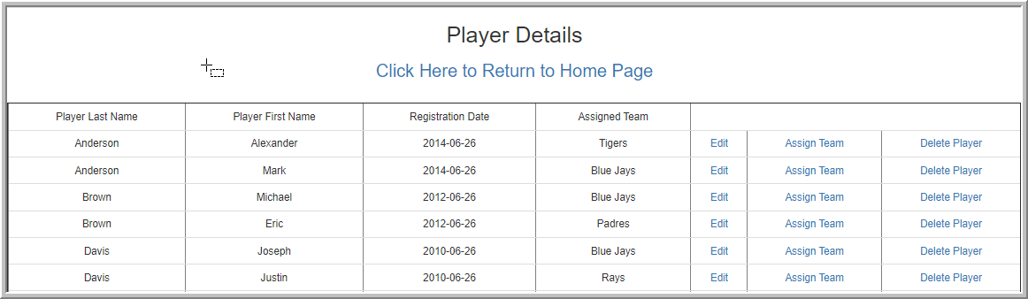

* Edit Player information

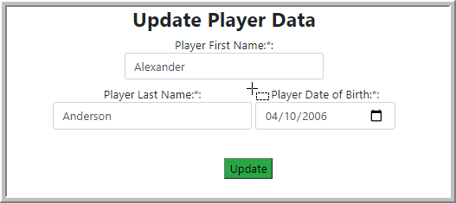

* Assign a Player to a Team

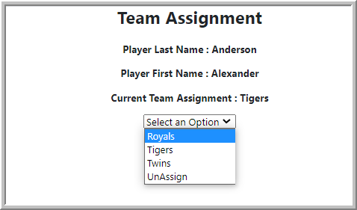

* Display all Coach’s information

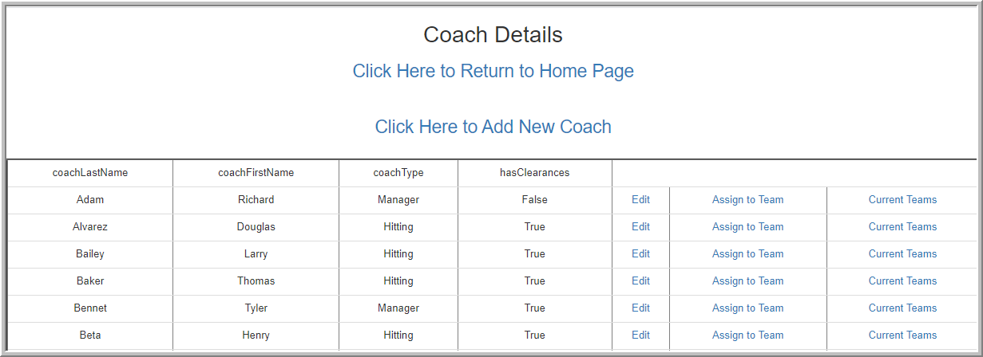

* Add new Coach

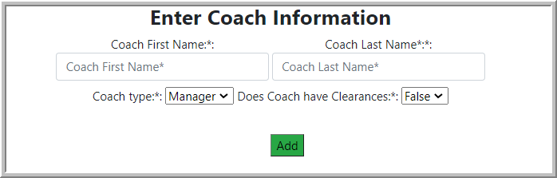

* Update Coach’s information

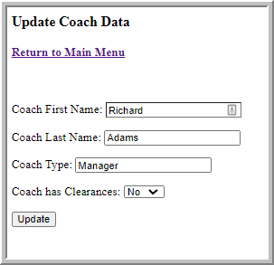

* Assign Coach to team

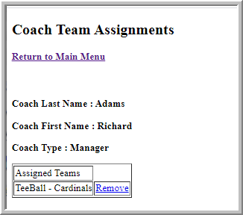

* Display all Divisions

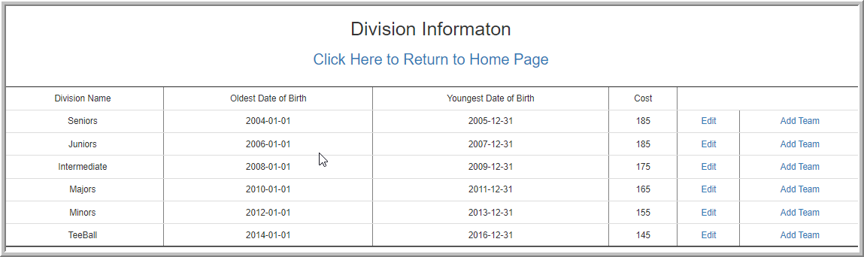

* Edit Division data

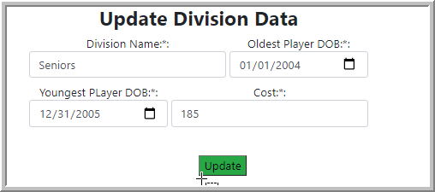

* Add a new team to a division.

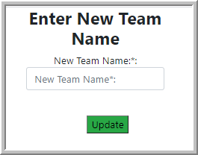



**mysqli_connect.php**

<?php

// Opens a connection to the database

// Since it is a php file it won't open in a browser

// It should be saved outside of the main web documents folder

// and imported when needed

// Defined as constants so that they can't be changed

DEFINE ('DB_USER', 'leagueAdmin');

DEFINE ('DB_PASSWORD', 'password');

DEFINE ('DB_HOST', 'sju-csc621-db.cwezplxtfcp4.us-east-2.rds.amazonaws.com');

DEFINE ('DB_NAME', 'leaguetracker');

// $dbc will contain a resource link to the database

// @ keeps the error from showing in the browser

$dbc = @mysqli_connect(DB_HOST, DB_USER, DB_PASSWORD, DB_NAME)

OR **die**('Could not connect to MySQL: ' .

mysqli_connect_error());

?>

**getFamilyInfo2.php**

<!DOCTYPE html>

<**html**>

<**head**>

<**title**>Display Family records from Database</**title**>

<**link** rel="stylesheet" href="https://maxcdn.bootstrapcdn.com/bootstrap/3.4.1/css/bootstrap.min.css">

</**head**>

<**body**>

<**div** style="**text-align**:center">

<**h2** style="**text-align**:center">Family Details</**h2**>

<**h3**><**a** href="http://localhost/leagueTracker/family/familyadded.php">Click Here to Add New Family</**a**></**h3**>

</**br**>

<**h3**><**a** href="http://localhost/leagueTracker/index.html">Click Here to Return to Home Page</**a**></**h3**>

</**br**>

<**table** class="table table-dark" border="2">

<**tr**>

<**td**>Family ID</**td**>

<**td**>Contact 1 First Name</**td**>

<**td**>Contact 1 First Name</**td**>

<**td**>Contact 2 First Name</**td**>

<**td**>Contact 2 First Name</**td**>

<**td**>Address Line 1</**td**>

<**td**>Address Line 2</**td**>

<**td**>City</**td**>

<**td**>state</**td**>

<**td**>Zip</**td**>

<**td**>Phone</**td**>

<**td**>Email</**td**>

</**tr**>

<?php

  // Get a connection for the database

**require_once**('../mysqli_connect.php');

  //include "../mysqli_connect.php"; // Using database connection file here

  $records = mysqli_query($dbc,"select * from family order by contact1LastName ;"); // fetch data from database

**while**($data = mysqli_fetch_array($records))

  {

  ?>

    <**tr**>

      <**td**><?php **echo** $data['familyID']; ?></**td**>

      <**td**><?php **echo** $data['contact1FirstName']; ?></**td**>

      <**td**><?php **echo** $data['contact1LastName']; ?></**td**>

      <**td**><?php **echo** $data['contact2FirstName']; ?></**td**>

      <**td**><?php **echo** $data['contact2LastName']; ?></**td**>

      <**td**><?php **echo** $data['addressLine1']; ?></**td**>

      <**td**><?php **echo** $data['addressLine2']; ?></**td**>

      <**td**><?php **echo** $data['city']; ?></**td**>

      <**td**><?php **echo** $data['state']; ?></**td**>

      <**td**><?php **echo** $data['zipCode']; ?></**td**>

      <**td**><?php **echo** $data['PrimaryPhone']; ?></**td**>

      <**td**><?php **echo** $data['email']; ?></**td**>

      <**td**><**a** href="editFamilyInfo.php?id=<?php **echo** $data['familyID']; ?>">Edit</**a**></**td**>

      <**td**><**a** href="..\player\add_playerInfo2.php?id=<?php **echo** $data['familyID']; ?>">Add Player</**a**></**td**>

      <**td**><**a** href="deleteFamily.php?id=<?php **echo** $data['familyID']; ?>">Delete Family</**a**></**td**>

    </**tr**>

  <?php

  }

  ?>

</**table**>

</**body**>

</**html**>

</**div**>

|  |
| --- |
| **editFamilyInfo.php**  <?php  // Get a connection for the database  **require_once**('../mysqli_connect.php');  $id = $_GET['id']; // get id through query string  $qry = mysqli_query($dbc,"select * from family where familyId='$id'"); // select query  $data = mysqli_fetch_array($qry); // fetch data  **if**(**isset**($_POST['update'])) // when click on Update button  {      $contact1FirstName = $_POST['contact1FirstName'];  $contact1LastName = $_POST['contact1LastName'];  $contact2FirstName = $_POST['contact2FirstName'];  $contact2LastName = $_POST['contact2LastName'];  $addressLine1 = $_POST['addressLine1'];  $addressLine2 = $_POST['addressLine2'];  $city = $_POST['city'];  $state = $_POST['state'];  $zipCode = $_POST['zipCode'];  $PrimaryPhone = $_POST['PrimaryPhone'];  $email = $_POST['email'];      $edit = mysqli_query($dbc,"update family set contact1FirstName='$contact1FirstName',  contact1LastName='$contact1LastName',  contact2FirstName='$contact2FirstName',  contact2LastName='$contact2LastName',  addressLine1='$addressLine1',  addressLine2='$addressLine2',  city='$city',  state='$state',  zipCode='$zipCode',  PrimaryPhone='$PrimaryPhone',  email='$email' where familyId ='$id';");    **if**($edit)      {          mysqli_close($dbc); // Close connection          header("location:getFamilyInfo2.php"); // redirects to all records page  **exit**;      }  **else**      {  **echo** mysqli_error();      }  }  ?>  <**html**>  <**head**>  <**link** rel="stylesheet" href="https://stackpath.bootstrapcdn.com/bootstrap/4.3.1/css/bootstrap.min.css" integrity="sha384-ggOyR0iXCbMQv3Xipma34MD+dH/1fQ784/j6cY/iJTQUOhcWr7x9JvoRxT2MZw1T" crossorigin="anonymous">  <**link** rel="stylesheet" href="../styless.css">  <**title**>Add Family</**title**>  </**head**>  <**body**>  <**div** style="**text-align**:center" class="form-group d-flex justify-content-center">  <**div** class="row">  <**div** class="col-2"></**div**>  <**div** class="col-8">  <**div** class="row d-flex justify-content-center">  <**h3**><**b**>Update Family Data</**b**></**h3**>  </**div**>  <**div** class="row d-flex justify-content-center">  <**h3**><**a** href="http://localhost/leagueTracker/family/getfamilyInfo2.php">Return to Family Maintanence</**a**></**h3**>  </**br**>  </**div**>  <**div** class="row d-flex justify-content-center">  <!-- <h3>Update Family Data</h3> -->  <**form** method="POST">  <**p**>  <**p**>  <!-- Contact 1 First Name: -->  <!-- <input type="text" name="contact1FirstName" value="<?php echo $data['contact1FirstName'] ?>" placeholder="Enter Contact 1 First Name" Required></p> -->  <!-- <p> -->  <**label**>Contact 1 First Name*:<**input** class="form-control" type="text" name="contact1FirstName" size="30"value="<?php **echo** $data['contact1FirstName'] ?>" placeholder="Contact 1 First Name" required/></**label**>  <**label**>Contact 1 Last Name*:<**input** class="form-control" type="text" name="contact1LastName" size="30" value="<?php **echo** $data['contact1LastName'] ?>" placeholder="Contact 1 Last Name" required/></**label**>  <**label**>Contact 2 First Name:<**input** type="text" class="form-control" name="contact2FirstName" size="30" value="<?php **echo** $data['contact2FirstName'] ?>" placeholder="Contact 2 First Name" /></**label**>  <**label**>Contact 2 Last Name:<**input** type="text" class="form-control" name="contact2LastName" size="30" value="<?php **echo** $data['contact2LastName'] ?>" placeholder="Contact 2 Last Name" /></**label**>  <**label**>Address Line 1*:<**input** type="text" class="form-control" name="addressLine1" size="30" value="<?php **echo** $data['addressLine1'] ?>" placeholder="Address Line 1" required/></**label**>  <**label**>Address Line 2:<**input** type="text" class="form-control" name="addressLine2" size="30" value="<?php **echo** $data['addressLine2'] ?>" placeholder="Address Line 2" /></**label**>  <**label**>City*:<**input** type="text" class="form-control" name="city" size="30" value="<?php **echo** $data['city'] ?>" placeholder="City" required/></**label**>  <**label**>State (2 Characters)*:<**input** type="text" class="form-control" name="state" size="30" maxlength="2" value="<?php **echo** $data['state'] ?>" placeholder="State (2 Characters)" required/></**label**>  <**label**>Zip Code*:<**input** type="text" class="form-control" name="zipCode" size="30" maxlength="5" value="<?php **echo** $data['zipCode'] ?>" placeholder="Zip Code" required/></**label**>  <**label**>Phone Number*:<**input** type="text" class="form-control" name="PrimaryPhone" size="30" value="<?php **echo** $data['PrimaryPhone'] ?>" placeholder="Phone Number" required/></**label**>  <**label**>Email*:<**input** type="text" class="form-control" name="email" size="30" value="<?php **echo** $data['email'] ?>" placeholder="Email" required/></**label**>  <!-- Contact 1 Last Name:    <input type="text" name="contact1LastName" value="<?php echo $data['contact1LastName'] ?>" placeholder="Enter Contact 1 Last Name" Required></p>    <p>    Contact 2 First Name:    <input type="text" name="contact2FirstName" value="<?php echo $data['contact2FirstName'] ?>" placeholder="Enter Contact 2 First Name" Required></p>    <p>    Contact 2 Last Name:    <input type="text" name="contact2LastName" value="<?php echo $data['contact2LastName'] ?>" placeholder="Enter Contact 2 Last Name" Required></p>    <p>    Address line 1:    <input type="text" name="addressLine1" value="<?php echo $data['addressLine1'] ?>" placeholder="Enter Address Line 1" Required></p>    <p>    Address Line 2:    <input type="text" name="addressLine2" value="<?php echo $data['addressLine2'] ?>" placeholder="Enter Address Line 2" ></p>    <p>    City:    <input type="text" name="city" value="<?php echo $data['city'] ?>" placeholder="Enter City" Required></p>    <p>    State:    <input type="text" name="state" value="<?php echo $data['state'] ?>" placeholder="Enter State" Required></p>    <p>    Zip Code:    <input type="text" name="zipCode" value="<?php echo $data['zipCode'] ?>" placeholder="Enter Zip Code" Required></p>    <p>    Primary Phone:    <input type="text" name="PrimaryPhone" value="<?php echo $data['PrimaryPhone'] ?>" placeholder="Enter Primary Phone" Required></p>    <p>    Email Address:    <input type="text" name="email" value="<?php echo $data['email'] ?>" placeholder="Enter Email Address" Required></p> -->    <!-- <p><input type="submit" name="update" value="Update"></p> -->  <**div** class="row submit">  <**div** class="col-6"></**div**>  <**p** class="padding-top-15">  <**input** class="bg-success" type="submit" name="update" value="Update" />  </**p**>  </**div**>  </**form**>  </**div**>  </**body**> |

|  |
| --- |
| **addfamily.php**  <?php  <html>  <head>  <title>Add Family Information</title>  </head>  <body>  <form action="http://localhost/leagueTracker/familyfamilyadded.php" method="post">  <div>  <h3><b>Add a **New** Family </b></h3>  <p>Contact 1 First Name:  <input type="text" name="contact1FirstName" size="30" value="" />  </p>  <p>Contact 1 Last Name:  <input type="text" name="contact1LastName" size="30" value="" />  </p>  <p>Contact 2 First Name:  <input type="text" name="contact2FirstName" size="30" value="" />  </p>  <p>Contact 2 Last Name:  <input type="text" name="contact2LastName" size="30" value="" />  </p>  <p>Address Line 1:  <input type="text" name="addressLine1" size="30" value="" />  </p>  <p>Address Line 2:  <input type="text" name="addressLine2" size="30" value="" />  </p>  <p>City:  <input type="text" name="city" size="30" value="" />  </p>  <p>State (2 Characters):  <input type="text" name="state" size="30" maxlength="2" value="" />  </p>  <p>Zip Code:  <input type="text" name="zipCode" size="30" maxlength="5" value="" />  </p>  <p>Phone Number:  <input type="text" name="PrimaryPhone" size="30" value="" />  </p>  <p>Email:  <input type="text" name="email" size="30" value="" />  </p>  <p>  <input type="submit" name="submit" value="Add Family" />  </p>  </form>  </div>  </body>  </html>  ?> |

|  |
| --- |
| **familyadded.php**  <**html**>  <**head**>  <**link** rel="stylesheet" href="https://stackpath.bootstrapcdn.com/bootstrap/4.3.1/css/bootstrap.min.css" integrity="sha384-ggOyR0iXCbMQv3Xipma34MD+dH/1fQ784/j6cY/iJTQUOhcWr7x9JvoRxT2MZw1T" crossorigin="anonymous">  <**link** rel="stylesheet" href="../styless.css">  <**title**>Add Family</**title**>  </**head**>  <**body**>  <?php  **if**(**isset**($_POST['submit'])){        $data_missing = **array**();    **if**(**empty**($_POST['contact1FirstName'])){          // Adds name to array          $data_missing[] = 'contact1FirstName';      } **else** {          // Trim white space from the name and store the name          $c1f_name = trim($_POST['contact1FirstName']);      }  **if**(**empty**($_POST['contact1LastName'])){          // Adds name to array          $data_missing[] = 'contact1LastName';      } **else**{          // Trim white space from the name and store the name          $c1l_name = trim($_POST['contact1LastName']);      }  **if**(**empty**($_POST['contact2FirstName'])){          // Adds name to array          $data_missing[] = 'contact2FirstName';      } **else** {          // Trim white space from the name and store the name          $c2f_name = trim($_POST['contact2FirstName']);      }  **if**(**empty**($_POST['contact2LastName'])){          // Adds name to array          $data_missing[] = 'contact2LastName';      } **else**{          // Trim white space from the name and store the name          $c2l_name = trim($_POST['contact2LastName']);      }  **if**(**empty**($_POST['email'])){          // Adds name to array          $data_missing[] = 'Email';      } **else** {          // Trim white space from the name and store the name          $email = trim($_POST['email']);      }  **if**(**empty**($_POST['addressLine1'])){          // Adds name to array          $data_missing[] = 'addressLine1';      } **else** {          // Trim white space from the name and store the name          $street1 = trim($_POST['addressLine1']);      }  **if**(**empty**($_POST['city'])){          // Adds name to array          $data_missing[] = 'City';      } **else** {          // Trim white space from the name and store the name          $city = trim($_POST['city']);      }  **if**(**empty**($_POST['state'])){          // Adds name to array          $data_missing[] = 'State';      } **else** {          // Trim white space from the name and store the name          $state = trim($_POST['state']);      }  **if**(**empty**($_POST['zipCode'])){          // Adds name to array          $data_missing[] = 'Zip Code';      } **else** {          // Trim white space from the name and store the name          $zip = trim($_POST['zipCode']);      }  **if**(**empty**($_POST['PrimaryPhone'])){          // Adds name to array          $data_missing[] = 'Phone Number';      } **else** {          // Trim white space from the name and store the name          $phone = trim($_POST['PrimaryPhone']);      }    **if**(**empty**($data_missing)){    **require_once**('../mysqli_connect.php');            $query = "INSERT INTO family (contact1FirstName,contact1LastName,contact2FirstName,contact2LastName,addressLine1,addressLine2,city,state,zipCode,PrimaryPhone,email,familyID)  VALUES (?, ?, ?, ?, ?, ?, ?, ?, ?, ?, ?, Null)";            $stmt = mysqli_prepare($dbc, $query);           //i Integers          //d Doubles          //b Blobs          //s Everything Else            mysqli_stmt_bind_param($stmt, "ssssssssssi", $c1f_name, $c1l_name, $c2f_name, $c2l_name, $street1, $street2, $city, $state, $zip, $phone, $email);            mysqli_stmt_execute($stmt);            $affected_rows = mysqli_stmt_affected_rows($stmt);    **if**($affected_rows == 1){    **echo** 'Family Entered';                mysqli_stmt_close($stmt);                mysqli_close($dbc);            } **else** {    **echo** 'Error Occurred<br />';  **echo** mysqli_error();                mysqli_stmt_close($stmt);              mysqli_close($dbc);            }        } **else** {    **echo** 'You need to enter the following data<br />';  **foreach**($data_missing **as** $missing){    **echo** "$missing<br />";           }      }  }  ?>  <**form** action="http://localhost/leagueTracker/family/familyadded.php" method="post">  <**div** style="**text-align**:center" class="form-group d-flex justify-content-center">  <**div** class="row">  <**div** class="col-2"></**div**>  <**div** class="col-8">  <**div** class="row d-flex justify-content-center">  <**h3**><**b**>Add a New Family </**b**></**h3**>  </**div**>  <**div** class="row d-flex justify-content-center">  <**h3**><**a** href="http://localhost/leagueTracker/family/getfamilyInfo2.php">Return to Family Maintanence</**a**></**h3**>  </**br**>  </**div**>  <**div** class="row d-flex justify-content-center">  <!-- <p>Contact 1 First Name: -->  <**label**>Contact 1 First Name*:<**input** class="form-control" type="text" name="contact1FirstName" size="30" value="" placeholder="Contact 1 First Name*" required/></**label**>    <!-- </p> -->  <!-- <p>Contact 1 Last Name: -->  <**label**>Contact 1 Last Name*:<**input** class="form-control" type="text" name="contact1LastName" size="30" value="" placeholder="Contact 1 Last Name*" required/></**label**>  <!-- </p> -->  <!-- <p>Contact 2 First Name: -->  <**label**>Contact 2 First Name:<**input** type="text" class="form-control" name="contact2FirstName" size="30" value="" placeholder="Contact 2 First Name" required/></**label**>  <!-- </p> -->  <!-- <p>Contact 2 Last Name: -->  <**label**>Contact 2 Last Name:<**input** type="text" class="form-control" name="contact2LastName" size="30" value="" placeholder="Contact 2 Last Name" required/></**label**>  <!-- </p> -->  <!-- <p>Address Line 1: -->  <**label**>Address Line 1*:<**input** type="text" class="form-control" name="addressLine1" size="30" value="" placeholder="Address Line 1" required/></**label**>  <!-- </p> -->  <!-- <p>Address Line 2: -->  <**label**>Address Line 2:<**input** type="text" class="form-control" name="addressLine2" size="30" value="" placeholder="Address Line 2" /></**label**>  <!-- </p> -->  <!-- <p>City: -->  <**label**>City*:<**input** type="text" class="form-control" name="city" size="30" value="" placeholder="City" required/></**label**>  <!-- </p> -->  <!-- <p>State (2 Characters): -->  <**label**>State (2 Characters)*:<**input** type="text" class="form-control" name="state" size="30" maxlength="2" value="" placeholder="State (2 Characters)" required/></**label**>  <!-- </p> -->  <!-- <p>Zip Code: -->  <**label**>Zip Code*:<**input** type="text" class="form-control" name="zipCode" size="30" maxlength="5" value="" placeholder="Zip Code" required/></**label**>  <!-- </p> -->  <!-- <p>Phone Number: -->  <**label**>Phone Number*:<**input** type="text" class="form-control" name="PrimaryPhone" size="30" value="" placeholder="Phone Number" required/></**label**>  <!-- </p> -->  <!-- <p>Email: -->  <**label**>Email*:<**input** type="text" class="form-control" name="email" size="30" value="" placeholder="Email" required/></**label**>  <!-- </p> -->  <!-- <p class="padding-top-15">                      <input class="bg-success" type="submit" name="submit" value="Add Family" />                  </p> -->  </**div**>  <**div** class="row">  <**div** class="col-6"></**div**>  <**p** class="padding-top-15">  <**input** class="bg-success" type="submit" name="submit" value="Add Family" />  </**p**>  </**div**>  </**div**>  <**div** class="col-2"></**div**>  </**div**>  </**div**>  </**form**>  </**body**>  </**html**> |
| **deleteFamily.php**  <?php  // Get a connection for the database  **require_once**('../mysqli_connect.php');  $fid = $_GET['id']; // get id through query string  $sql = "delete from family where familyID = '$fid';";  $del = mysqli_query($dbc,$sql); // delete query  $errorMsg = mysqli_error($dbc);  **if**($del)  {  **echo** "Success deleting record";      mysqli_close($dbc); // Close connection      header("location:getFamilyInfo2.php"); // redirects to all records page  **exit**;  }  **else**  {  **echo** $errorMsg;  }  ?> |

|  |
| --- |
| **getPlayerInfo2.php**  <!DOCTYPE html>  <**html**>  <**head**>  <**title**>Display all Players</**title**>  <**link** rel="stylesheet" href="https://maxcdn.bootstrapcdn.com/bootstrap/3.4.1/css/bootstrap.min.css">  </**head**>  <**body**>  <**div** style="**text-align**:center">  <**h2** style="**text-align**:center">Player Details</**h2**>  <**h3**><**a** href="http://localhost/leagueTracker/index.html">Click Here to Return to Home Page</**a**></**h3**>  </**br**>  <!-- <h2>Player Details</h2> -->  <**table** class="table table-dark" border="2">  <**tr**>  <**td**>Player Last Name</**td**>  <**td**>Player First Name</**td**>  <**td**>Registration Date</**td**>  <**td**>Assigned Team</**td**>  </**tr**>  <?php  // Get a connection for the database  **require_once**('../mysqli_connect.php');  //include "../mysqli_connect.php"; // Using database connection file here  $records = mysqli_query($dbc,"Select playerID,playerLastName,playerFirstName,registrationDate,teamName from player left join team on player.teamID = team.teamID order by playerLastName;"); // fetch data from database  **while**($data = mysqli_fetch_array($records))  {  ?>    <**tr**>      <**td**><?php **echo** $data['playerLastName']; ?></**td**>      <**td**><?php **echo** $data['playerFirstName']; ?></**td**>  <**td**><?php **echo** $data['registrationDate']; ?></**td**>  <**td**><?php **echo** $data['teamName']; ?></**td**>      <**td**><**a** href="..\player\editPlayerInfo.php?id=<?php **echo** $data['playerID']; ?>">Edit</**a**></**td**>      <**td**><**a** href="..\player\assignTeam.php?id=<?php **echo** $data['playerID']; ?>">Assign Team</**a**></**td**>      <**td**><**a** href="..\player\deletePlayer.php?id=<?php **echo** $data['playerID']; ?>">Delete Player</**a**></**td**>      </**tr**>  <?php  }  ?>  </**table**>  </**body**>  </**html**> |

|  |
| --- |
| **add_playerInfo2.php**  <?php  $id = $_GET['id']; // get id through query string  //echo "ID=",$id." ";  **if**(**isset**($_POST['update'])) // when click on Update button  {  // Get a connection for the database  **require_once**('../mysqli_connect.php');    $playerFirstName = $_POST['playerFirstName'];  $playerLastName = $_POST['playerLastName'];  $dob = $_POST['dob'];  $registrationDate = date("Y-m-d");  $query = "INSERT INTO player (playerFirstName, playerLastName, dateOfBirth, familyID, registrationDate) VALUES ( ?, ?, ?, ?, ?)";      //echo $playerFirstName, " " , $playerLastName, " ", $dob, " ", $id, " ", $registrationDate;  $stmt = mysqli_prepare($dbc, $query);            //i Integers          //d Doubles          //b Blobs          //s Everything Else            mysqli_stmt_bind_param($stmt,"sssis", $playerFirstName, $playerLastName, $dob, $id, $registrationDate);            mysqli_stmt_execute($stmt);  **if**(mysqli_stmt_affected_rows($stmt) == 1)          {              mysqli_close($dbc); // Close connection              header("location:getPlayerInfo2.php"); // redirects to all records page  **exit**;          }  **else**          {  **echo** "Error: ", mysqli_stmt_error($stmt);          }    }  ?>  <**html**>  <**head**>  <**link** rel="stylesheet" href="https://stackpath.bootstrapcdn.com/bootstrap/4.3.1/css/bootstrap.min.css" integrity="sha384-ggOyR0iXCbMQv3Xipma34MD+dH/1fQ784/j6cY/iJTQUOhcWr7x9JvoRxT2MZw1T" crossorigin="anonymous">  <**link** rel="stylesheet" href="../styless.css">  <**title**>Add Player</**title**>  </**head**>  <**body**>  <**div** style="**text-align**:center" class="form-group d-flex justify-content-center">  <**div** class="row">  <**div** class="col-2"></**div**>  <**div** class="col-8">  <**div** class="row d-flex justify-content-center">  <**h3**><**b**>Enter Player Information</**b**></**h3**>  </**div**>  <**form** method="POST">  <!-- <p> -->  <!-- <p>    Player First Name:    <input type="text" name="playerFirstName" value="" Required></p>    <p> -->  <!-- Player Last Name:    <input type="text" name="playerLastName" value="" Required></p>    <p> -->  <!-- Player Date of Birth:    <input type="date" name="dob" value="" Required></p> -->    <!-- <p><input type="submit" name="update" value="Update"></p> -->  <**label**>Player First Name:*:<**input** class="form-control" type="text" name="playerFirstName" size="30" value="" placeholder="Player First Name*" required/></**label**>  <**label**>Player Last Name*:*:<**input** class="form-control" type="text" name="playerLastName" size="30" value="" placeholder="Player Last Name*" required/></**label**>  <**label**>Player Date of Birth*:<**input** class="form-control" type="date" name="dob" size="30" value="" required/></**label**>  </**div**>  </**div**>  </**div**>  <**div** class="row">  <**div** class="col-6"></**div**>  <**p** class="padding-top-15">  <**input** class="bg-success" type="submit" name="update" value="Update" />  </**p**>  </**div**>  </**form**>  </**div**>  </**div**>  </**div**>  </**div**>  </**body**>  </**html**> |

|  |
| --- |
| **editPlayerInfo.php**  <?php  // Get a connection for the database  **require_once**('../mysqli_connect.php');  $id = $_GET['id']; // get id through query string  $qry = mysqli_query($dbc,"select * from player where playerId='$id'"); // select query  $data = mysqli_fetch_array($qry); // fetch data  **if**(**isset**($_POST['update'])) // when click on Update button  {      $playerFirstName = $_POST['playerFirstName'];  $playerLastName = $_POST['playerLastName'];  $dob = $_POST['dob'];      $edit = mysqli_query($dbc,"update player set playerFirstName='$playerFirstName',  playerLastName='$playerLastName',  dateOfBirth='$dob'  where playerId ='$id';");    **echo** "update player set playerFirstName='$playerFirstName',playerLastName='$playerLastName', dateOfBirth='$dob', where playerId ='$id';";  **if**($edit)      {          mysqli_close($dbc); // Close connection          header("location:getPlayerInfo2.php"); // redirects to all records page  **exit**;      }  **else**      {  **echo** mysqli_error();      }  }  ?>  <**html**>  <**head**>  <**link** rel="stylesheet" href="https://stackpath.bootstrapcdn.com/bootstrap/4.3.1/css/bootstrap.min.css" integrity="sha384-ggOyR0iXCbMQv3Xipma34MD+dH/1fQ784/j6cY/iJTQUOhcWr7x9JvoRxT2MZw1T" crossorigin="anonymous">  <**link** rel="stylesheet" href="../styless.css">  <**title**>Update Player</**title**>  </**head**>  <**body**>  <**div** style="**text-align**:center" class="form-group d-flex justify-content-center">  <**div** class="row">  <**div** class="col-2"></**div**>  <**div** class="col-8">  <**div** class="row d-flex justify-content-center">  <**h3**><**b**>Update Player Data</**b**></**h3**>  </**div**>  <!-- <h3>Update Payer Data</h3> -->  <**form** method="POST">  <!-- <p>    <p>    Player First Name:    <input type="text" name="playerFirstName" value="<?php echo $data['playerFirstName'] ?>" Required></p>    <p>    Player Last Name:    <input type="text" name="playerLastName" value="<?php echo $data['playerLastName'] ?>" Required></p>    <p>    Player Date of Birth:    <input type="date" name="dob" value="<?php echo $data['dateOfBirth'] ?>" Required></p>    <p><input type="submit" name="update" value="Update"></p> -->  <**label**>Player First Name:*:<**input** class="form-control" type="text" name="playerFirstName" size="30" value="<?php **echo** $data['playerFirstName'] ?>" required/></**label**>  <**label**>Player Last Name:*:<**input** class="form-control" type="text" name="playerLastName" size="30" value="<?php **echo** $data['playerLastName'] ?>" placeholder="" required/></**label**>  <**label**>Player Date of Birth:*:<**input** class="form-control" type="date" name="dob" size="50" value="<?php **echo** $data['dateOfBirth'] ?>" placeholder="" required/></**label**>  </**div**>  </**div**>  </**div**>  <**div** class="row">  <**div** class="col-6"></**div**>  <**p** class="padding-top-15">  <**input** class="bg-success" type="submit" name="update" value="Update" />  </**p**>  </**div**>  </**form**> |
| **deletePlayer.php**  <?php  // Get a connection for the database  **require_once**('../mysqli_connect.php');  $pid = $_GET['id']; // get id through query string  $sql = "delete from player where playerID = '$pid';";  $del = mysqli_query($dbc,$sql); // delete query  **if**($del)  {  **echo** "Success deleting record";      mysqli_close($dbc); // Close connection      header("location:getFamilyInfo2.php"); // redirects to all records page  **exit**;  }  **else**  {  **echo** "Error deleting record"; // display error message if not delete  }  ?> |

**assignTeam.php (Player)**

<?php

// Get a connection for the database

**require_once**('../mysqli_connect.php');

$id = $_GET['id']; // get id through query string

$qry = mysqli_query($dbc,"select playerLastName,playerFirstName,registrationDate,teamName from player left join team on player.teamID = team.teamID where playerId='$id' ;"); // select query

$sql = "select team.teamName,team.teamID from team

where divisionID = (select divisionId from division where

(date(startAgeDOB) < (select date(dateOfBirth) from player where playerId='$id')

and date(endAgeDOB) >(select date(dateOfBirth) from player where playerId='$id')))

and team.teamID not in (select team.teamID from team

left join player on player.teamID = team.teamID

group by teamID having count(playerID) >= 12)";

$data = mysqli_fetch_array($qry); // fetch data

**if**(**isset**($_POST['update'])) // when click on Update button

{

    $playerLastName = $data['playerLastName'];

$playerFirstName = $data['playerFirstName'];

$teamID = $_POST['newTeam'];

**if** ($teamID <> 'Null')

{

$edit = mysqli_query($dbc,"update player set teamID='$teamID' where playerID = $id;");

}

**else**

{

$edit = mysqli_query($dbc,"update player set teamID=null where playerID = $id;");

}

**if**($edit)

    {

        mysqli_close($dbc); // Close connection

        header("location:getPlayerInfo2.php"); // redirects to all records page

**exit**;

    }

**else**

    {

**echo** mysqli_error();

    }

}

?>

<**html**>

<**head**>

<**link** rel="stylesheet" href="https://stackpath.bootstrapcdn.com/bootstrap/4.3.1/css/bootstrap.min.css" integrity="sha384-ggOyR0iXCbMQv3Xipma34MD+dH/1fQ784/j6cY/iJTQUOhcWr7x9JvoRxT2MZw1T" crossorigin="anonymous">

<**link** rel="stylesheet" href="../styless.css">

<**title**>Team Assignment</**title**>

</**head**>

<**body**>

<**div** style="**text-align**:center" class="form-group d-flex justify-content-center">

<**div** class="row">

<**div** class="col-2"></**div**>

<**div** class="col-12">

<**div** class="row d-flex justify-content-center">

<**h3**><**b**>Team Assignment</**b**></**h3**>

</**div**>

<!-- <h3>Team Assignment</h3> -->

<**form** method="POST">

<**p**>

<**p**><**b**>Player Last Name : <?php **echo** $data['playerLastName'] ?> </**b**></**p**>

<**p**><**b**>Player First Name : <?php **echo** $data['playerFirstName'] ?> </**b**></**p**>

<**p**><**b**>Current Team Assignment : <?php **echo** $data['teamName'] ?> </**b**></**p**>

<?php

            $result = $dbc->query($sql);

**if** ($result -> num_rows > 0)

{

**echo** "<select name=\"newTeam\">";

**echo** "<option value=\"none\" selected disabled hidden> Select an Option";

**while** ($row = $result->fetch_assoc()) {

**echo** "<option value=\"$row[teamID]\">$row[teamName]</option>";

                }

**echo** "<option value=\"Null\">UnAssign</option>";

**echo** "</select>";

}

**else** {

**echo** "<p class='lead'> No teams available </p>";

            }

?>

</**p**>

<**p**><**input** class="bg-success" type="submit" name="update" value="Update"></**p**>

</**form**>

**getCoachInfo2.php**

<!DOCTYPE html>

<**html**>

<**head**>

<**title**>Display Coach records from Database</**title**>

<**link** rel="stylesheet" href="https://maxcdn.bootstrapcdn.com/bootstrap/3.4.1/css/bootstrap.min.css">

</**head**>

<**body**>

<**div** style="**text-align**:center">

<**h2** style="**text-align**:center">Coach Details</**h2**>

<!-- <h2>Coach Details</h2> -->

<**h3**><**a** href="http://localhost/leagueTracker/index.html">Click Here to Return to Home Page</**a**></**h3**>

</**br**>

<**h3**><**a** href="http://localhost/leagueTracker/coaches/add_coachInfo2.php">Click Here to Add New Coach</**a**></**h3**>

</**br**>

<**table** class="table table-dark" border="2">

<**tr**>

<**td**>coachLastName</**td**>

<**td**>coachFirstName</**td**>

<**td**>coachType</**td**>

<**td**>hasClearances</**td**>

</**tr**>

<?php

// Get a connection for the database

**require_once**('../mysqli_connect.php');

//include "../mysqli_connect.php"; // Using database connection file here

$records = mysqli_query($dbc,"select * from coach order by coachLastName;"); // fetch data from database

**while**($data = mysqli_fetch_array($records))

{

?>

  <**tr**>

    <**td**><?php **echo** $data['coachLastName']; ?></**td**>

    <**td**><?php **echo** $data['coachFirstName']; ?></**td**>

<**td**><?php **echo** $data['coachType']; ?></**td**>

    <**td**><?php **echo** $data['hasClearances']; ?></**td**>

<**td**><**a** href="editCoachInfo.php?id=<?php **echo** $data['coachID']; ?>">Edit</**a**></**td**>

<**td**><**a** href="assignTeam.php?id=<?php **echo** $data['coachID']; ?>">Assign to Team</**a**></**td**>

    <**td**><**a** href="getCoachAssignment.php?id=<?php **echo** $data['coachID']; ?>">Current Teams</**a**></**td**>

  </**tr**>

<?php

}

?>

</**table**>

</**div**>

</**body**>

</**html**>

**add_coachinfor2.php**

<?php

**if**(**isset**($_POST['update'])) // when click on Update button

{

// Get a connection for the database

**require_once**('../mysqli_connect.php');

$coachFirstName = $_POST['coachFirstName'];

$coachLastName = $_POST['coachLastName'];

    $coachType = $_POST['coachType'];

    $hasClearances = $_POST['hasClearances'];

$query = "INSERT INTO coach (coachFirstName, coachLastName, coachType, hasClearances) VALUES ( ?, ?, ?, ?)";

$stmt = mysqli_prepare($dbc, $query);

        //i Integers

        //d Doubles

        //b Blobs

        //s Everything Else

        mysqli_stmt_bind_param($stmt,"ssss", $coachFirstName, $coachLastName, $coachType, $hasClearances);

        mysqli_stmt_execute($stmt);

**if**(mysqli_stmt_affected_rows($stmt) == 1)

        {

            mysqli_close($dbc); // Close connection

            header("location:getCoachInfo2.php"); // redirects to all records page

**exit**;

        }

**else**

        {

**echo** "Error: ", mysqli_stmt_error($stmt);

        }

}

?>

<**html**>

<**head**>

<**link** rel="stylesheet" href="https://stackpath.bootstrapcdn.com/bootstrap/4.3.1/css/bootstrap.min.css" integrity="sha384-ggOyR0iXCbMQv3Xipma34MD+dH/1fQ784/j6cY/iJTQUOhcWr7x9JvoRxT2MZw1T" crossorigin="anonymous">

<**link** rel="stylesheet" href="../styless.css">

<**title**>Add Coach</**title**>

</**head**>

<**body**>

<**div** style="**text-align**:center" class="form-group d-flex justify-content-center">

<**div** class="row">

<**div** class="col-2"></**div**>

<**div** class="col-8">

<**div** class="row d-flex justify-content-center">

<**h3**><**b**>Enter Coach Information</**b**></**h3**>

</**div**>

<**form** method="POST">

<**label**>Coach First Name:*:<**input** class="form-control" type="text" name="coachFirstName" size="30" value="" placeholder="Coach First Name*" required/></**label**>

<**label**>Coach Last Name*:*:<**input** class="form-control" type="text" name="coachLastName" size="30" value="" placeholder="Coach Last Name*" required/></**label**>

<**label**>Coach type:*:

<**select** name="coachType">

<**option** value="Manager">Manager</**option**>

<**option** value="Assistant">Assistant</**option**>

<**option** value="Hitting">Hitting</**option**>

<**option** value="Pitching">Pitching</**option**>

</**select**>

</**label**>

<**label**>Does Coach have Clearances:*:

<**select** name="hasClearances">

<**option** value="False">False</**option**>

<**option** value="True">True</**option**>

</**select**>

</**label**>

</**div**>

</**div**>

</**div**>

<**div** class="row">

<**div** class="col-6"></**div**>

<**p** class="padding-top-15">

<**input** class="bg-success" type="submit" name="update" value="Add" />

</**p**>

</**div**>

</**form**>

</**div**>

</**div**>

</**div**>

</**div**>

</**body**>

</**html**>

**editCoachInfo.php**

<?php

// Get a connection for the database

**require_once**('../mysqli_connect.php');

$id = $_GET['id']; // get id through query string

$qry = mysqli_query($dbc,"select * from coach where coachId='$id'"); // select query

$data = mysqli_fetch_array($qry); // fetch data

**if**(**isset**($_POST['update'])) // when click on Update button

{

    $coachFirstName = $_POST['coachFirstName'];

$coachLastName = $_POST['coachLastName'];

$coachType = $_POST['coachType'];

    $hasClearances = $_POST['hasClearances'];

    $edit = mysqli_query($dbc,"update coach set coachFirstName='$coachFirstName',

coachLastName='$coachLastName',

coachType='$coachType',

    hasClearances='$hasClearances'

where coachId ='$id';");

**if**($edit)

    {

        mysqli_close($dbc); // Close connection

        header("location:getCoachInfo2.php"); // redirects to all records page

**exit**;

    }

**else**

    {

**echo** mysqli_error();

    }

}

?>

<**h3**>Update Coach Data</**h3**>

<**h4**><**a** href="http://localhost/leagueTracker/index.html">Return to Main Menu</**a**></**h4**>

</**br**>

<**form** method="POST">

<**p**>

<**p**>

Coach First Name:

<**input** type="text" name="coachFirstName" value="<?php **echo** $data['coachFirstName'] ?>" Required></**p**>

<**p**>

Coach Last Name:

<**input** type="text" name="coachLastName" value="<?php **echo** $data['coachLastName'] ?>" Required></**p**>

<**p**>

Coach Type:

<**input** type="text" name="coachType" value="<?php **echo** $data['coachType'] ?>" Required></**p**>

<**p**>

Coach has Clearances:

<**select** name="hasClearances"> value="<?php **echo** $data['hasClearances'] ?>"

<**option** value="False">No</**option**>

<**option** value="True">Yes</**option**>

</**select**>

</**p**>

<**p**><**input** type="submit" name="update" value="Update"></**p**>

</**form**>

**deleteTeamAssignment.php**

<?php

// Get a connection for the database

**require_once**('../mysqli_connect.php');

$cid = $_GET['cid']; // get id through query string

$tid = $_GET['tid']; // get id through query string

$sql = "delete from coach_has_team where teamid = '$tid' AND coachID = '$cid';";

$del = mysqli_query($dbc,$sql); // delete query

**if**($del)

{

**echo** "Success deleting record";

    mysqli_close($dbc); // Close connection

    header("location:getCoachAssignment.php?id=$cid"); // redirects to all records page

**exit**;

}

**else**

{

**echo** "Error deleting record"; // display error message if not delete

}

?>

**getCoachAssignment.php**

<!DOCTYPE html>

<**html**>

<**head**>

<**title**>Display Coach records from Database</**title**>

</**head**>

<**body**>

<**h2**>Coach Team Assignments</**h2**>

<**h4**><**a** href="http://localhost/leagueTracker/index.html">Return to Main Menu</**a**></**h4**>

</**br**>

<?php

// Get a connection for the database

**require_once**('../mysqli_connect.php');

//include "../mysqli_connect.php"; // Using database connection file here

$id = $_GET['id']; // get id through query string

$qry1 = mysqli_query($dbc,"Select coachID, coachLastName, coachFirstName, coachType from coach where coachID = $id;");

$coachInfo = mysqli_fetch_array($qry1); // fetch data

$sql = "select team.teamID as teamID, Concat(divisionName,' - ',teamName) as team from coach_has_team

join coach on coach.coachID = coach_has_team.coachID

join team on team.teamID= coach_has_team.teamID

join division on team.divisionID = division.divisionID

where coach_has_team.coachID = $id;"; // fetch data from database

$result = $dbc->query($sql);

?>

<**p**><**b**>Coach Last Name : <?php **echo** $coachInfo['coachLastName'] ?> </**b**></**p**>

<**p**><**b**>Coach First Name : <?php **echo** $coachInfo['coachFirstName'] ?> </**b**></**p**>

<**p**><**b**>Coach Type : <?php **echo** $coachInfo['coachType'] ?> </**b**></**p**>

<**table** border="2">

<**tr**>

<**td**>Assigned Teams</**td**>

</**tr**>

<?php

**if** ($result -> num_rows > 0)

            {

**while** ($row = $result->fetch_assoc()) {

**echo** "<tr>";

**echo** "<td>",$row['team'],"</td>";

**echo** "<td><a href=\"deleteTeamAssignment.php?cid=",$coachInfo['coachID'],"&tid=",$row['teamID'],"\">Remove</a></td>";

**echo** "</tr>";

                      }

            }

**else** {

**echo** "<p class='lead'> No teams assigned </p>";

                  }

        ?>

</**table**>

<**h4**><**a** href="assignTeam.php?id=<?php **echo** $coachInfo['coachID']; ?>">Assign to Team</**a**></**h4**>

</**body**>

</**html**>

**assignTeam.php (Coach)**

<?php

// Get a connection for the database

**require_once**('../mysqli_connect.php');

$id = $_GET['id']; // get id through query string

$qry = mysqli_query($dbc,"select * from coach where coachId='$id' ;"); // select query

$sql = "select teamID, Concat(divisionName,' - ',teamName) as team from team

join division on team.divisionID = division.divisionID";

$data = mysqli_fetch_array($qry); // fetch data

**if**(**isset**($_POST['update'])) // when click on Update button

{

    $playerLastName = $data['playerLastName'];

$playerFirstName = $data['playerFirstName'];

$teamID = $_POST['newTeam'];

**if** ($teamID <> 'Null')

{

$edit = mysqli_query($dbc,"insert into coach_has_team values ('$id','$teamID');");

}

**else**

{

$edit = mysqli_query($dbc,"update coach_has_team set teamID=null where coachID = $id;");

}

**if**($edit)

    {

        mysqli_close($dbc); // Close connection

        header("location:getCoachInfo2.php"); // redirects to all records page

**exit**;

    }

**else**

    {

**echo** mysqli_error();

    }

}

?>

<**h3**>Coach Team Assignment</**h3**>

<**form** method="POST">

<**p**>

<**p**><**b**>Coach Last Name : <?php **echo** $data['coachLastName'] ?> </**b**></**p**>

<**p**><**b**>Coach First Name : <?php **echo** $data['coachFirstName'] ?> </**b**></**p**>

<**p**><**b**>Coach Type : <?php **echo** $data['coachType'] ?> </**b**></**p**>

<?php

            $result = $dbc->query($sql);

**if** ($result -> num_rows > 0)

{

**echo** "<select name=\"newTeam\">";

**while** ($row = $result->fetch_assoc()) {

**echo** "<option value=\"$row[teamID]\">$row[team]</option>";

                }

**echo** "</select>";

}

**else** {

**echo** "<p class='lead'> No teams available </p>";

            }

?>

</**p**>

<**p**><**input** type="submit" name="update" value="Update"></**p**>

</**form**>

**getDivisionInfo2.php**

<!DOCTYPE html>

<**html**>

<**head**>

<**title**>Baseball Division Maintanence</**title**>

<**link** rel="stylesheet" href="https://maxcdn.bootstrapcdn.com/bootstrap/3.4.1/css/bootstrap.min.css">

</**head**>

<**body**>

<**div** style="**text-align**:center">

<**h2** style="**text-align**:center">Division Informaton</**h2**>

<!-- <h2>Division Informaton</h2> -->

<**h3**><**a** href="http://localhost/leagueTracker/index.html">Click Here to Return to Home Page</**a**></**h3**>

</**br**>

<**table** class="table table-dark" border="2">

<**tr**>

<**td**>Division Name</**td**>

<**td**>Oldest Date of Birth</**td**>

<**td**>Youngest Date of Birth</**td**>

<**td**>Cost</**td**>

</**tr**>

<?php

// Get a connection for the database

**require_once**('../mysqli_connect.php');

//include "../mysqli_connect.php"; // Using database connection file here

$records = mysqli_query($dbc,"select * from division order by startAgeDOB ;"); // fetch data from database

**while**($data = mysqli_fetch_array($records))

{

?>

  <**tr**>

    <**td**><?php **echo** $data['divisionName']; ?></**td**>

    <**td**><?php **echo** $data['startAgeDOB']; ?></**td**>

<**td**><?php **echo** $data['endAgeDOB']; ?></**td**>

<**td**><?php **echo** $data['cost']; ?></**td**>

<**td**><**a** href="editDivisionInfo.php?id=<?php **echo** $data['divisionID']; ?>">Edit</**a**></**td**>

<**td**><**a** href="..\team\add_TeamInfo2.php?id=<?php **echo** $data['divisionID']; ?>">Add Team</**a**></**td**>

  </**tr**>

<?php

}

?>

</**table**>

</**body**>

</**html**>

**editDivisionInfo.php**

<?php

// Get a connection for the database

**require_once**('../mysqli_connect.php');

$id = $_GET['id']; // get id through query string

$qry = mysqli_query($dbc,"select * from division where divisionID='$id'"); // select query

$data = mysqli_fetch_array($qry); // fetch data

**if**(**isset**($_POST['update'])) // when click on Update button

{

    $divisionName = $_POST['divisionName'];

$startAgeDOB = $_POST['startAgeDOB'];

$endAgeDOB = $_POST['endAgeDOB'];

$cost = $_POST['cost'];

    $edit = mysqli_query($dbc,"update division set divisionName='$divisionName',

startAgeDOB='$startAgeDOB',

endAgeDOB='$endAgeDOB',

cost='$cost'

where divisionID ='$id';");

**if**($edit)

    {

        mysqli_close($dbc); // Close connection

        header("location:getDivisionInfo2.php"); // redirects to all records page

**exit**;

    }

**else**

    {

**echo** mysqli_error();

    }

}

?>

<**html**>

<**head**>

<**link** rel="stylesheet" href="https://stackpath.bootstrapcdn.com/bootstrap/4.3.1/css/bootstrap.min.css" integrity="sha384-ggOyR0iXCbMQv3Xipma34MD+dH/1fQ784/j6cY/iJTQUOhcWr7x9JvoRxT2MZw1T" crossorigin="anonymous">

<**link** rel="stylesheet" href="../styless.css">

<**title**>Update Division Data</**title**>

</**head**>

<**body**>

<**div** style="**text-align**:center" class="form-group d-flex justify-content-center">

<**div** class="row">

<**div** class="col-2"></**div**>

<**div** class="col-8">

<**div** class="row d-flex justify-content-center">

<**h3**><**b**>Update Division Data</**b**></**h3**>

</**div**>

<!-- <h3>Update Division Data</h3> -->

<**form** method="POST">

<!-- <p>

  <p>

  Division Name:

  <input type="text" name="divisionName" value="<?php echo $data['divisionName'] ?>" placeholder="Enter Contact 1 First Name" Required></p>

  <p>

  Oldest Player DOB:

  <input type="date" name="startAgeDOB" value="<?php echo $data['startAgeDOB'] ?>" placeholder="Enter Contact 1 Last Name" Required></p>

  <p>

  Youngest PLayer DOB:

  <input type="date" name="endAgeDOB" value="<?php echo $data['endAgeDOB'] ?>" placeholder="Enter Contact 2 First Name" Required></p>

  <p>

  Cost:

  <input type="text" name="cost" value="<?php echo $data['cost'] ?>" placeholder="Enter Contact 2 Last Name" Required></p>

  <p>

  <p><input type="submit" name="update" value="Update"></p> -->

<**label**>Division Name:*:<**input** class="form-control" type="text" name="divisionName" size="30" value="<?php **echo** $data['divisionName'] ?>" placeholder="Player First Name*" required/></**label**>

<**label**>Oldest Player DOB:*:<**input** class="form-control" type="date" name="startAgeDOB" size="30" value="<?php **echo** $data['startAgeDOB'] ?>" placeholder="" required/></**label**>

<**label**>Youngest PLayer DOB:*:<**input** class="form-control" type="date" name="endAgeDOB" size="50" value="<?php **echo** $data['endAgeDOB'] ?>" placeholder="" required/></**label**>

<**label**>Cost:*:<**input** class="form-control" type="text" name="cost" size="30" value="<?php **echo** $data['cost'] ?>" placeholder="cost" required/></**label**>

</**div**>

</**div**>

</**div**>

<**div** class="row">

<**div** class="col-6"></**div**>

<**p** class="padding-top-15">

<**input** class="bg-success" type="submit" name="update" value="Update" />

</**p**>

</**div**>

</**form**>

**getTeamInfo2.php**

<!DOCTYPE html>

<**html**>

<**head**>

<**title**>Baseball Team Information</**title**>

<**link** rel="stylesheet" href="https://maxcdn.bootstrapcdn.com/bootstrap/3.4.1/css/bootstrap.min.css">

</**head**>

<**body**>

<**div** style="**text-align**:center">

<**h2** style="**text-align**:center">Team Information</**h2**>

<**h3**><**a** href="http://localhost/leagueTracker/index.html">Click Here to Return to Home Page</**a**></**h3**>

</**br**>

<!-- <h2>Team Informaton</h2> -->

<**table** class="table table-dark" border="2">

<**tr**>

<**td**>Division Name</**td**>

<**td**>Team Name</**td**>

<**td**>Roster Size</**td**>

</**tr**>

<?php

// Get a connection for the database

**require_once**('../mysqli_connect.php');

//include "../mysqli_connect.php"; // Using database connection file here

$records = mysqli_query($dbc,"select division.divisionname as divisionName,team.teamName as teamName, v_team_roster_size.RosterSize as RosterSize from team

join division on team.divisionID = division.divisionID

left join v_team_roster_size on team.teamID = v_team_roster_size.teamID

order by division.divisionname ;"); // fetch data from database

**while**($data = mysqli_fetch_array($records))

{

?>

  <**tr**>

    <**td**><?php **echo** $data['divisionName']; ?></**td**>

    <**td**><?php **echo** $data['teamName']; ?></**td**>

<**td**><?php **echo** $data['RosterSize']; ?></**td**>

    <!--

<td><a href="editDivisionInfo.php?id=<?php echo $data['divisionID']; ?>">Edit</a></td>

<td><a href="..\team\add_TeamInfo2.php?id=<?php echo $data['divisionID']; ?>">Add Team</a></td>

    -->

  </**tr**>

<?php

}

?>

</**table**>

</**body**>

</**html**>

**add_teamInfo2.php**

<?php

$id = $_GET['id']; // get id through query string

//echo "ID=",$id." ";

**if**(**isset**($_POST['update'])) // when click on Update button

{

// Get a connection for the database

**require_once**('../mysqli_connect.php');

$teamName = $_POST['teamName'];

$query = "INSERT INTO team (teamName, divisionID) VALUES ( ?, ?)";

$stmt = mysqli_prepare($dbc, $query);

        //i Integers

        //d Doubles

        //b Blobs

        //s Everything Else

        mysqli_stmt_bind_param($stmt,"si", $teamName, $id);

        mysqli_stmt_execute($stmt);

**if**($stmt)

        {

            mysqli_close($dbc); // Close connection

            header("location:getTeamInfo2.php"); // redirects to all records page

**exit**;

        }

**else**

        {

**echo** mysqli_error();

        }

}

?>

<**html**>

<**head**>

<**link** rel="stylesheet" href="https://stackpath.bootstrapcdn.com/bootstrap/4.3.1/css/bootstrap.min.css" integrity="sha384-ggOyR0iXCbMQv3Xipma34MD+dH/1fQ784/j6cY/iJTQUOhcWr7x9JvoRxT2MZw1T" crossorigin="anonymous">

<**link** rel="stylesheet" href="../styless.css">

<**title**>New Team</**title**>

</**head**>

<**body**>

<**div** style="**text-align**:center" class="form-group d-flex justify-content-center">

<**div** class="row">

<**div** class="col-2"></**div**>

<**div** class="col-9">

<**div** class="row d-flex justify-content-center">

<**h3**><**b**>Enter New Team Name</**b**></**h3**>

</**div**>

<!-- <h3>Enter New Team Name</h3> -->

<**form** method="POST">

<!-- <p>

  <p>

  Enter New Team Name:

  <input type="text" name="teamName" value="" Required></p>

  <p><input type="submit" name="update" value="Update"></p> -->

<**label**>New Team Name:*:<**input** class="form-control" type="text" name="teamName" size="30" value="" placeholder="New Team Name*:" required/></**label**>

</**div**>

</**div**>

</**div**>

<**div** class="row">

<**div** class="col-6"></**div**>

<**p** class="padding-top-15">

<**input** class="bg-success" type="submit" name="update" value="Update" />

</**p**>

</**div**>

</**form**>

**getUnAssingedPlayers.php**

<!DOCTYPE html>

<**html**>

<**head**>

<**title**>Unassigned Players</**title**>

<**link** rel="stylesheet" href="https://maxcdn.bootstrapcdn.com/bootstrap/3.4.1/css/bootstrap.min.css">

</**head**>

<**body**>

<**div** style="**text-align**:center">

<**h2** style="**text-align**:center">Unassigned Players</**h2**>

<**h3**><**a** href="http://localhost/leagueTracker/index.html">Click Here to Return to Home Page</**a**></**h3**>

</**br**>

<!-- <h2>Unassigned Players</h2> -->

<**table** class="table table-dark" border="2">

<**tr**>

<**td**>Player First Name </**td**>

<**td**>Player Last Name</**td**>

<**td**>Date of Birth</**td**>

</**tr**>

<?php

// Get a connection for the database

**require_once**('../mysqli_connect.php');

//include "../mysqli_connect.php"; // Using database connection file here

$records = mysqli_query($dbc,"select * from v_unassign_players;"); // fetch data from database

**while**($data = mysqli_fetch_array($records))

{

?>

  <**tr**>

    <**td**><?php **echo** $data['playerFirstName']; ?></**td**>

    <**td**><?php **echo** $data['playerLastName']; ?></**td**>

<**td**><?php **echo** $data['dateOfBirth']; ?></**td**>

<**td**><**a** href="..\player\assignTeam.php?id=<?php **echo** $data['playerID']; ?>">Assign Team</**a**></**td**>

  </**tr**>

<?php

}

?>

</**table**>

</**body**>

</**html**>

**getUnpaidinvoices.php**

<!DOCTYPE html>

<**html**>

<**head**>

<**title**>Unpaid Invoices Information</**title**>

<**link** rel="stylesheet" href="https://maxcdn.bootstrapcdn.com/bootstrap/3.4.1/css/bootstrap.min.css">

</**head**>

<**body**>

<**div** style="**text-align**:center">

<**h2** style="**text-align**:center">Unpaid Invoices Information</**h2**>

<**h3**><**a** href="http://localhost/leagueTracker/index.html">Click Here to Return to Home Page</**a**></**h3**>

</**br**>

<!-- <h2>Unpaid Invoices Information</h2> -->

<**table** class="table table-dark" border="2">

<**tr**>

<**td**>Contact First Name </**td**>

<**td**>Contact Last Name</**td**>

<**td**>Is Invoice Paid</**td**>

<**td**>Amount Due</**td**>

</**tr**>

<?php

// Get a connection for the database

**require_once**('../mysqli_connect.php');

//include "../mysqli_connect.php"; // Using database connection file here

$records = mysqli_query($dbc,"Select invoiceID,contact1FirstName,

Contact1LastName,paidStatus, sum(amount)as amount, family.familyID as familyID

from family

join invoice on invoice.familyID = family.familyID

where invoice.paidStatus = 'False'

group by family.familyID

order by Contact1LastName;"); // fetch data from database

**while**($data = mysqli_fetch_array($records))

{

?>

  <**tr**>

    <**td**><?php **echo** $data['contact1FirstName']; ?></**td**>

    <**td**><?php **echo** $data['Contact1LastName']; ?></**td**>

<**td**><?php **echo** $data['paidStatus']; ?></**td**>

    <**td**><?php **echo** $data['amount']; ?></**td**>

<**td**><**a** href="updateInvoiceTeam.php?id=<?php **echo** $data['familyID']; ?>">Update Paid Status</**a**></**td**>

  </**tr**>

<?php

}

?>

</**table**>

</**body**>

</**html**>

**listCoachesMissingClearances.php**

<!DOCTYPE html>

<**html**>

<**head**>

<**title**>Coaches Missing Clearances</**title**>

<**link** rel="stylesheet" href="https://maxcdn.bootstrapcdn.com/bootstrap/3.4.1/css/bootstrap.min.css">

</**head**>

<**body**>

<**div** style="**text-align**:center">

<**h2** style="**text-align**:center">Coaches Missing Clearances</**h2**>

<**h3**><**a** href="http://localhost/leagueTracker/index.html">Click Here to Return to Home Page</**a**></**h3**>

</**br**>

<!-- <h2>Coaches Missing Clearances</h2> -->

<**table** class="table table-dark" border="2">

<**tr**>

<**td**>Coach First Name </**td**>

<**td**>Coach Last Name</**td**>

<**td**>Has Clearances</**td**>

</**tr**>

<?php

// Get a connection for the database

**require_once**('../mysqli_connect.php');

//include "../mysqli_connect.php"; // Using database connection file here

$records = mysqli_query($dbc,"select * from v_coach_missing_clearances;"); // fetch data from database

**while**($data = mysqli_fetch_array($records))

{

?>

  <**tr**>

    <**td**><?php **echo** $data['coachFirstName']; ?></**td**>

    <**td**><?php **echo** $data['coachLastName']; ?></**td**>

<**td**><?php **echo** $data['hasClearances']; ?></**td**>

</**tr**>

<?php

}

?>

</**table**>

</**body**>

</**html**>

**listRosters.php**

<!DOCTYPE html>

<**html**>

<**head**>

<**title**>Full Roster Listing</**title**>

<**link** rel="stylesheet" href="https://maxcdn.bootstrapcdn.com/bootstrap/3.4.1/css/bootstrap.min.css">

</**head**>

<**body**>

<**div** style="**text-align**:center">

<**h2** style="**text-align**:center">Full Roster Listing</**h2**>

<**h3**><**a** href="http://localhost/leagueTracker/index.html">Click Here to Return to Home Page</**a**></**h3**>

</**br**>

<!-- <h2>Full Roster Listing</h2> -->

<**table** class="table table-dark" border="2">

<**tr**>

<**td**>Division Name</**td**>

<**td**>Team Name</**td**>

<**td**>Player Name</**td**>

</**tr**>

<?php

// Get a connection for the database

**require_once**('../mysqli_connect.php');

//include "../mysqli_connect.php"; // Using database connection file here

$records = mysqli_query($dbc,"select * from v_all_rosters;"); // fetch data from database

**while**($data = mysqli_fetch_array($records))

{

?>

  <**tr**>

    <**td**><?php **echo** $data['Division Name']; ?></**td**>

    <**td**><?php **echo** $data['Team Name']; ?></**td**>

<**td**><?php **echo** $data['Player Name']; ?></**td**>

</**tr**>

<?php

}

?>

</**table**>

</**body**>

</**html**>

**listTeamCoaches.php**

<!DOCTYPE html>

<**html**>

<**head**>

<**title**>Full Coaching List</**title**>

<**link** rel="stylesheet" href="https://maxcdn.bootstrapcdn.com/bootstrap/3.4.1/css/bootstrap.min.css">

</**head**>

<**body**>

<**div** style="**text-align**:center">

<**h2** style="**text-align**:center">Full Coaching List</**h2**>

<**h3**><**a** href="http://localhost/leagueTracker/index.html">Click Here to Return to Home Page</**a**></**h3**>

</**br**>

<!-- <h2>Full Roster Listing</h2> -->

<**table** class="table table-dark" border="2">

<**tr**>

<**td**>Division Name</**td**>

<**td**>Team Name</**td**>

<**td**>Coach Name</**td**>

<**td**>Coach Type</**td**>

</**tr**>

<?php

// Get a connection for the database

**require_once**('../mysqli_connect.php');

//include "../mysqli_connect.php"; // Using database connection file here

$records = mysqli_query($dbc,"select * from v_team_coaches;"); // fetch data from database

**while**($data = mysqli_fetch_array($records))

{

?>

  <**tr**>

    <**td**><?php **echo** $data['Division']; ?></**td**>

    <**td**><?php **echo** $data['Team']; ?></**td**>

    <**td**><?php **echo** $data['Coach']; ?></**td**>

    <**td**><?php **echo** $data['Type']; ?></**td**>

</**tr**>

<?php

}

?>

</**table**>

</**body**>

</**html**>

**listTeamsByRosterSize.php**

<!DOCTYPE html>

<**html**>

<**head**>

<**title**>Full Roster Listing</**title**>

<**link** rel="stylesheet" href="https://maxcdn.bootstrapcdn.com/bootstrap/3.4.1/css/bootstrap.min.css">

</**head**>

<**body**>

<**div** style="**text-align**:center">

<**h2** style="**text-align**:center">Full Roster Listing</**h2**>

<**h3**><**a** href="http://localhost/leagueTracker/index.html">Click Here to Return to Home Page</**a**></**h3**>

</**br**>

<!-- <h2>Full Roster Listing</h2> -->

<**table** class="table table-dark" border="2">

<**tr**>

<**td**>Team Name</**td**>

<**td**>Roster Size</**td**>

</**tr**>

<?php

// Get a connection for the database

**require_once**('../mysqli_connect.php');

//include "../mysqli_connect.php"; // Using database connection file here

$records = mysqli_query($dbc,"select * from v_team_roster_size order by teamName;"); // fetch data from database

**while**($data = mysqli_fetch_array($records))

{

?>

  <**tr**>

    <**td**><?php **echo** $data['teamName']; ?></**td**>

<**td**><?php **echo** $data['RosterSize']; ?></**td**>

</**tr**>

<?php

}

?>

</**table**>

</**body**>

</**html**>

**Web Site Source Code**

**updateInvoiceTeam.php**

<?php

// Get a connection for the database

// http://localhost/leagueTracker/reports/updateInvoiceTeam.php?id=6

**require_once**('../mysqli_connect.php');

$id = $_GET['id']; // get id through query string

$qry = mysqli_query($dbc,

"Select invoiceID,contact1FirstName,Contact1LastName,paidStatus, sum(amount) as amount

from family join invoice on invoice.familyID = family.familyID

where invoice.paidStatus = 'False' and invoice.familyID ='$id' group By family.familyID;"); // select query

$data = mysqli_fetch_array($qry); // fetch data

**if**(**isset**($_POST['update'])) // when click on Update button

{

    $contact1FirstName = $data['contact1FirstName'];

$Contact1LastName = $data['Contact1LastName'];

$paidStatus = $_POST['paidStatus'];

$edit = mysqli_query($dbc,"update invoice set paidStatus='$paidStatus' where familyID ='$id';");

**if**($edit)

    {

        mysqli_close($dbc); // Close connection

        header("location:getUnpaidinvoices.php"); // redirects to all records page

**exit**;

    }

**else**

    {

**echo** mysqli_error();

    }

}

?>

<**html**>

<**head**>

<**link** rel="stylesheet" href="https://stackpath.bootstrapcdn.com/bootstrap/4.3.1/css/bootstrap.min.css" integrity="sha384-ggOyR0iXCbMQv3Xipma34MD+dH/1fQ784/j6cY/iJTQUOhcWr7x9JvoRxT2MZw1T" crossorigin="anonymous">

<**link** rel="stylesheet" href="../styless.css">

<**title**>Invoice Maintanence</**title**>

</**head**>

<**body**>

<**div** style="**text-align**:center" class="form-group d-flex justify-content-center">

<**div** class="row">

<**div** class="col-2"></**div**>

<**div** class="col-12">

<**div** class="row d-flex justify-content-center">

<**h3**><**b**>Invoice Maintanence</**b**></**h3**>

</**div**>

<!-- <h3>Invoice Maintanence</h3> -->

<**form** method="POST">

<**p**>

<**p**><**b**>Conatct Last Name : <?php **echo** $data['contact1FirstName'] ?> </**b**></**p**>

<**p**><**b**>Contact First Name : <?php **echo** $data['Contact1LastName'] ?> </**b**></**p**>

<**p**><**b**>Amount : $ <?php **echo** $data['amount'] ?> </**b**></**p**>

<**select** name="paidStatus">

<**option** value="False">Unpaid</**option**>

<**option** value="True">Paid</**option**>

</**select**>

<**p**><**input** class="bg-success" type="submit" name="update" value="Update"></**p**>

</**form**>