Fall 2024 | CS53331/4331 Adversarial Machine Learning | Assignment 1

Title | The Deep Learning Stuff
Due date | Monday, October 14th, before the class.
First Name | Jhansi Lakshmi
Last Name | Kaligineedi
Student ID | R11896217
Marks | 100

Note: Please answer the following questions and submit them through Blackboard. Be sure to submit it to assignment 1. DO NOT write the report by hand and submit a scanned version. Just write the answers in a Word document and submit it. Both Word and PDF submissions are accepted.

Submission Instruction (3 documents)
You are required to submit three documents:
- Report. Just fill out the above report and submit it as a Word or PDF document.
- Ipynb file. The code that you have written. Preferably in an ipynb document. You can submit it as a .py file as well.
- Txt file of the code. We need your code in the .txt file as well. Use whatever way you prefer. The fastest would be to download the file as a .py file and change the extension to .txt

Objectives
This assignment has three main objectives:
- Implement untargeted attacks and check the results (FGSM, PGD, DeepFool, and C&W L2)
- Implement targeted attacks and check the results (FGSM, PGD, and C&W L2)
- Analyze defense using adversarial training.

Get started
Download the assignment files from Blackboard. You will need the report (This file), the .ipynb file where you will put your code, the dataset, and the adversarial trained model.

Dataset
For this assignment, we will use a traffic sign recognition dataset. The German Traffic Sign Recognition Benchmark (GTSRB) dataset consists of almost 51K images of traffic signs. There are 43 classes, and the size of their images is 32×32 pixels. Some of the images are shown below. Please download the dataset from Blackboard or here. You will need the starter code from Blackboard to preprocess it and build a VGG16 model you will attack. More information about the dataset can be found here.
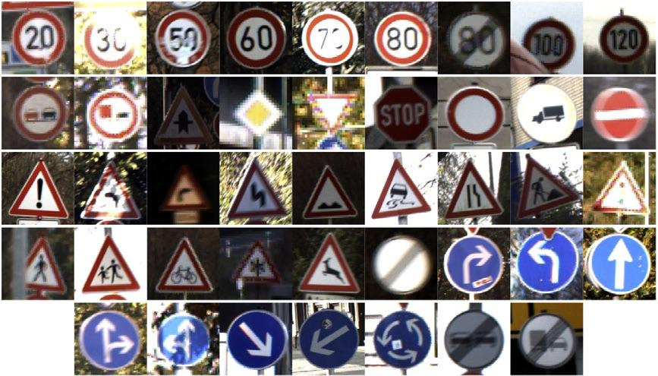
As we did with Assignment 0, it is recommended that you upload the dataset into your personal Google Drive to follow the Colab instructions as they are. Of course, if you prefer to use other than Colab, you will need a similar preprocessing.

Instruction for Colab (repeated from Assignment 0)
To get started with Google Colab, simply go to Google Colab, sign in with your Google account, and create a new notebook. You can write and execute Python code directly in the notebook. To access your dataset stored in your Google Drive (previous step), first run the following code to mount your Drive:
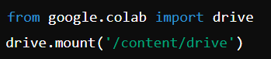
Follow the authorization steps, and your Drive will be accessible at /content/drive/My Drive/. You can then load your dataset into the notebook by providing the correct file path. This part of the code is provided for you in the .ipynb file of Assignment 0. You will need to setup the drive connection and run the code.
To use the free GPU provided by Colab, you can change the runtime to access a GPU by clicking on "Runtime" > "Change runtime type” and selecting "T4 GPU" from the Hardware accelerator dropdown menu. You can always use higher GPU powers at a cost (Colab Pro is $10 per month), but you should be fine with the free version, considering that you start the assignment early enough.
Colab comes with many pre-installed libraries, but if you need to install additional Python packages, you can do so with pip. For example:
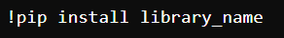
Remember to save your work frequently.
After you've completed your work in Google Colab, you can easily download your notebook from Google Colab, go to "File" > "Download" > "Download.ipynb".

Other than Colab
If you don’t prefer Colab or notebook, you always have the option to run it on your computer (especially if it has a GPU) or access HPCC resources at TTU (needs an account with my permission).

Additional resources
- TensorFlow resource https://www.tensorflow.org/
- PyTorch resources https://pytorch.org/get-started/pytorch-2.0/
- Deep learning with Python https://dl-with-python.readthedocs.io/en/latest/
- Get started with Colab https://colab.research.google.com/

Task 1-untargeted attacks (40 pts)
Let’s start with basic non-target white-box attacks. First, we will implement some non-target white-box attacks we studied in class. Your downloaded code from Blackboard will build a VGG16 model for you. You will attack that deep learning model throughout the assignment.
This task aims to implement the following attacks: Fast Gradient Sign Method (FGSM), Projected Gradient Descent (PGD), Deep Fool, and C&W with L2 norm. You don’t need to implement these attacks from scratch. Code for them can be in several libraries, including Adversarial Robustness Toolbox (ART), cleverhans, or scratchai (Just traditional libraries. Maybe there are better ones now). Using ART for this assignment is recommended, but using any other libraries of your choice is also acceptable. This notebook is a good start on how to use ART, and multiple other notebooks are available here.
Your task is to apply attacks to create non-target adversarial examples using the first 500 images of your test set (check imgs_adv and labels_adv in your code). For FSGM, PGD, and DeepFool, apply perturbations magnitudes: 𝜖= [0.05, 0.1, 0.2, 0.25, 0.3]. For C&W, use the L2 norm to perform the attack. You should provide us with the following results.
Note: [10 pts] will go to your code for attack implementation. The comparison code evaluation will be included in its respective questions.
- [4 pts] Plot the clean image vs adversarial image for three images of your choice. This should happen for all perturbation magnitudes (if any) and for all attacks. An example of FGSM is shown below. Do it for FGSM, PGD, DeepFool, and C&W (separate figure for each)
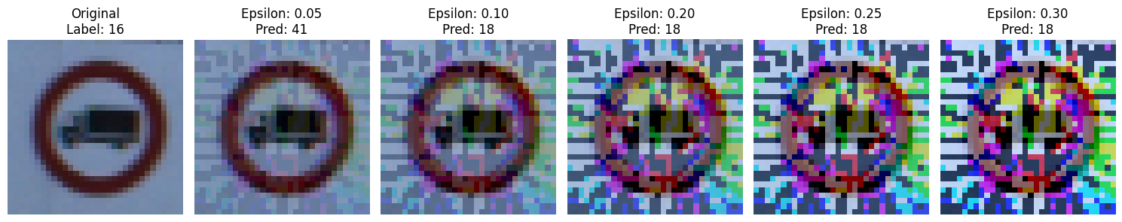
Clean Vs Adversarial images
FGSM:
Clean Image Adversarial images
Clean Image 0.05 0.10 0.20 0.25 0.3
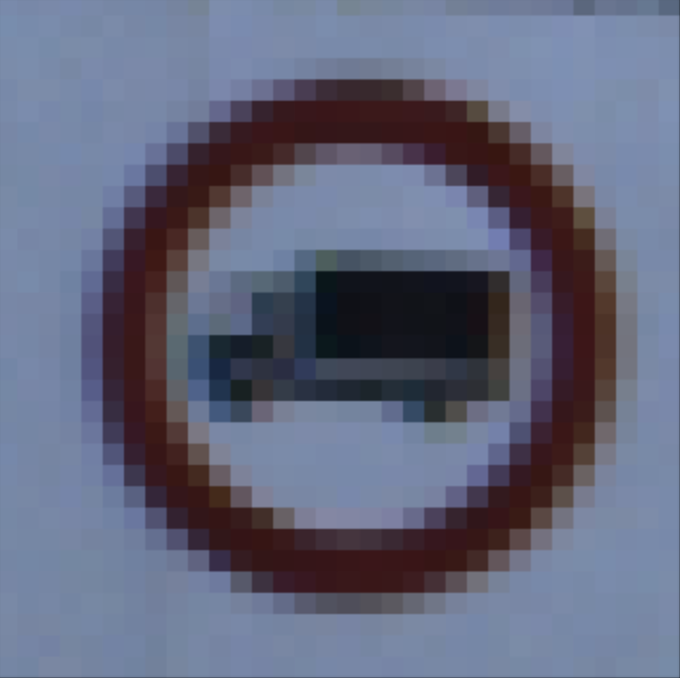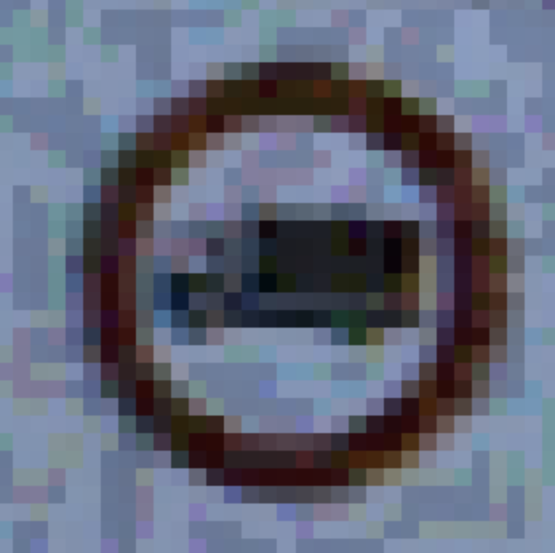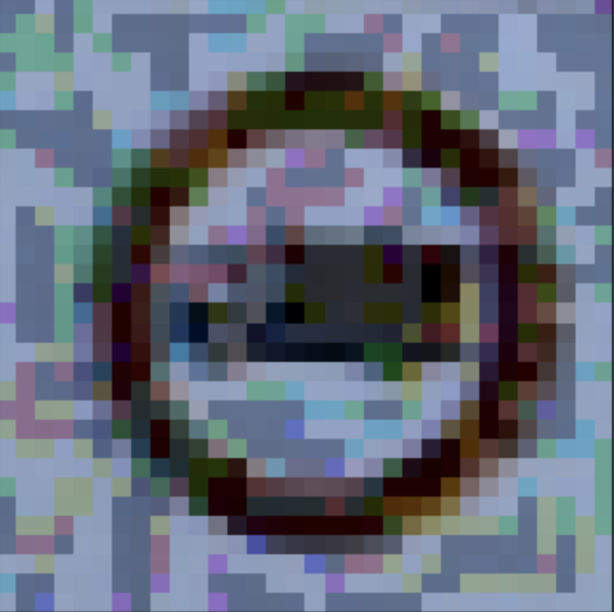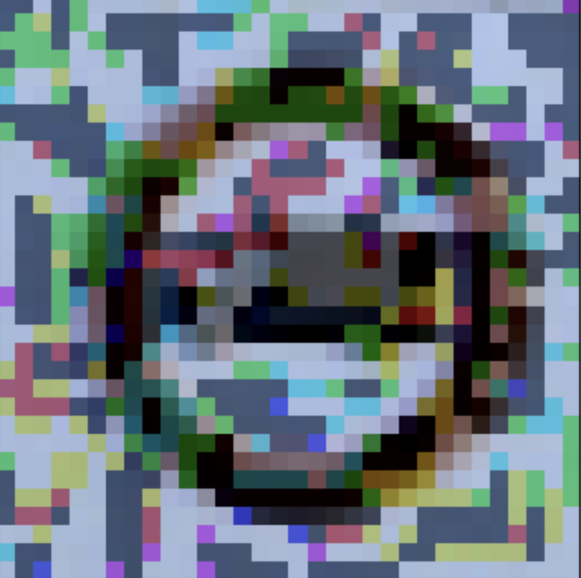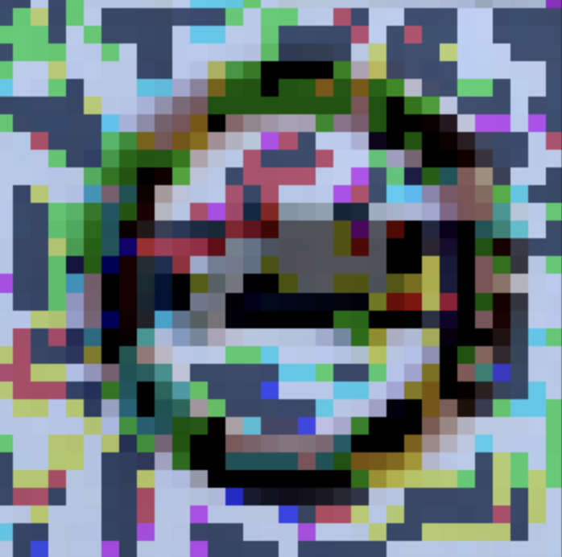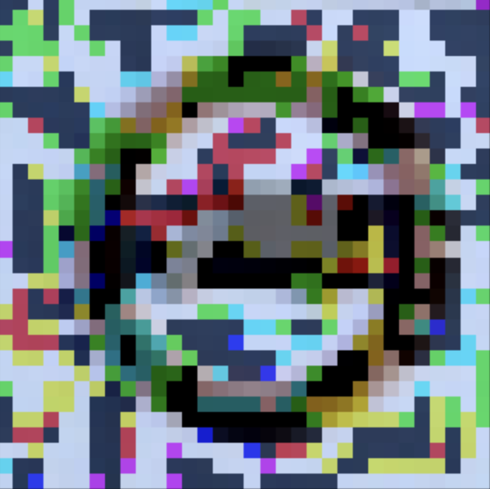
Clean Image
Clean Image 0.05 0.10 0.20 0.25 0.3
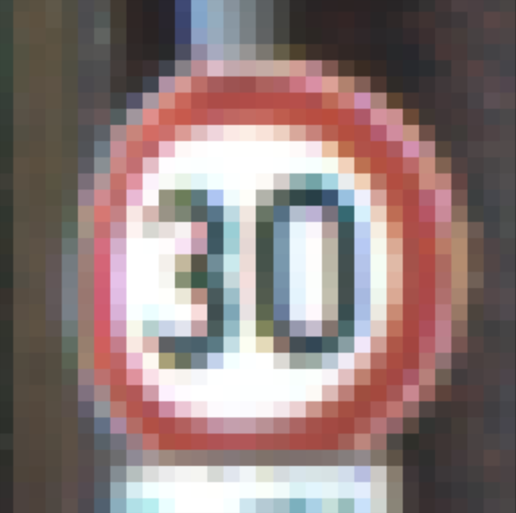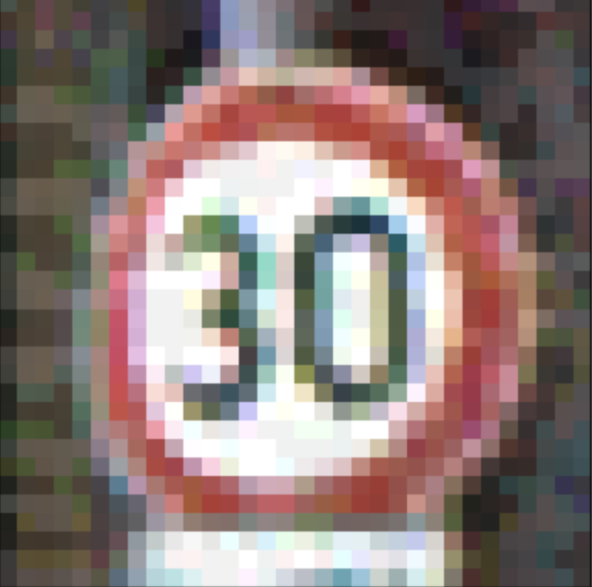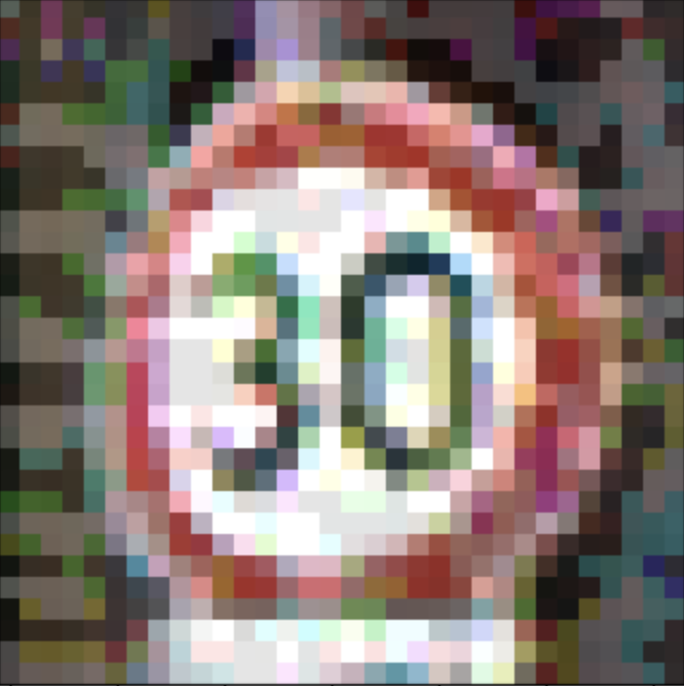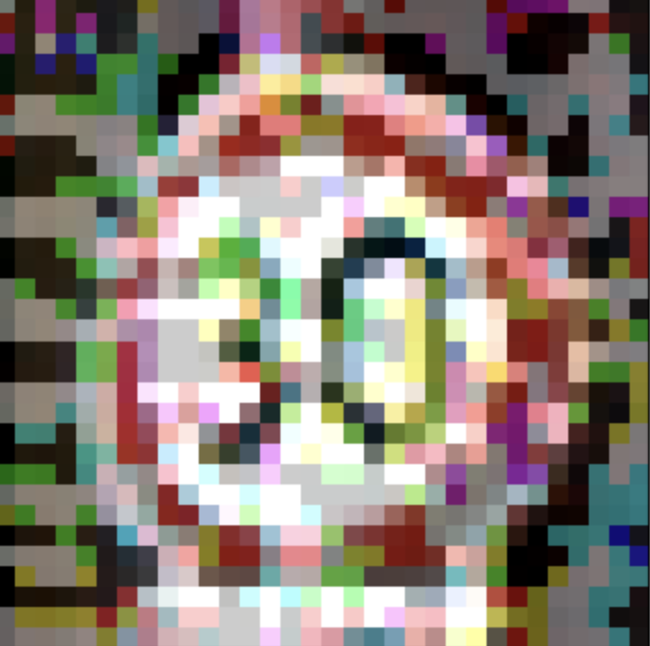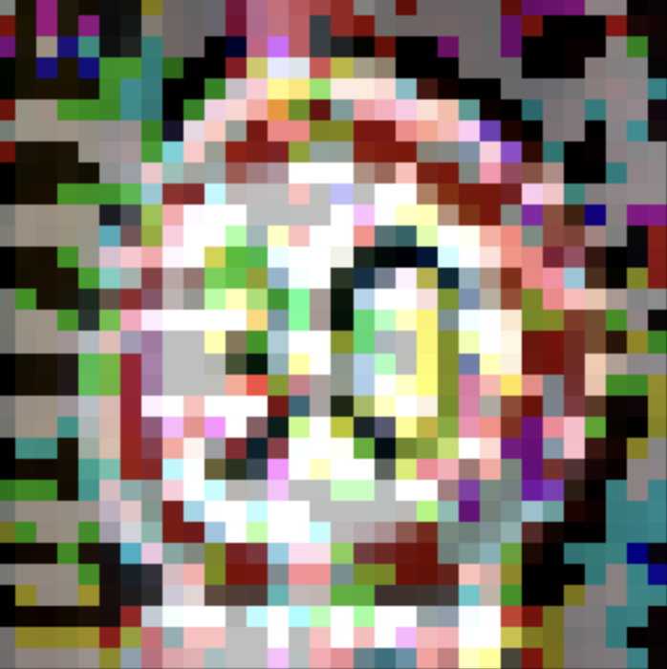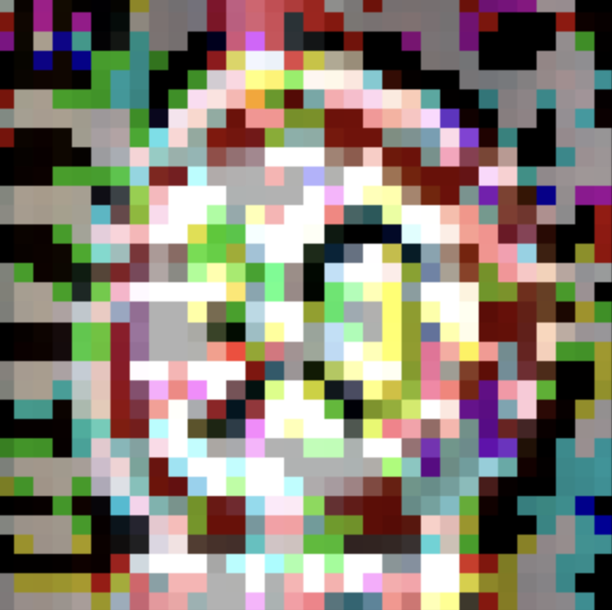

Clean Image 0.05 0.10 0.20 0.25 0.3
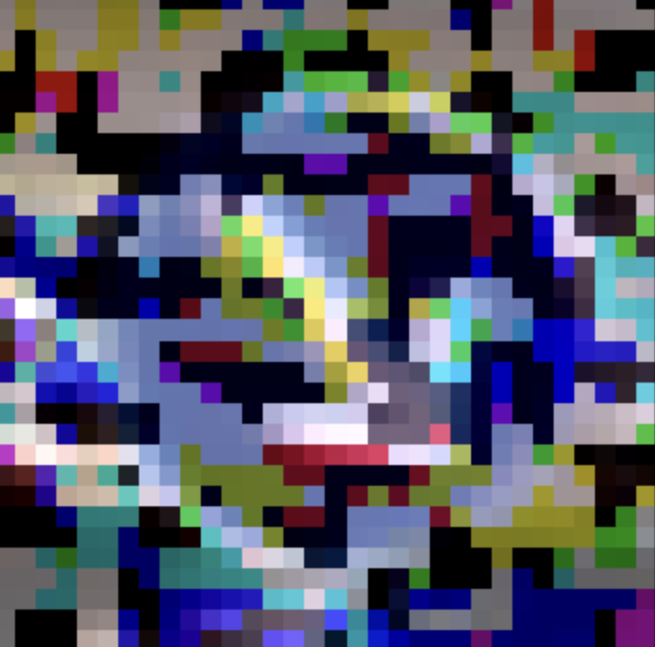

PGD:
Clean Image Adversarial Image
Clean Image 0.05 0.10 0.20 0.25 0.3
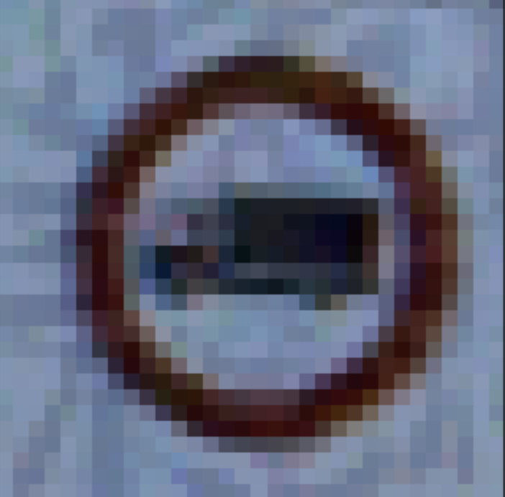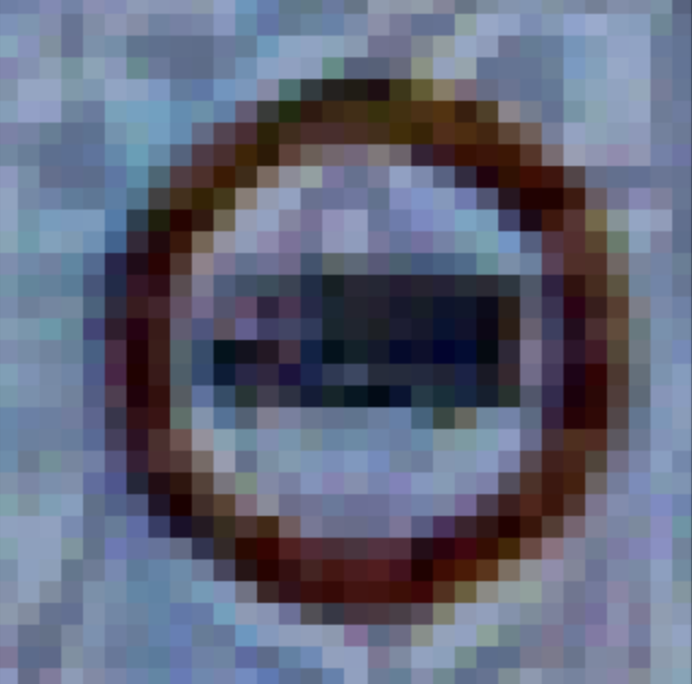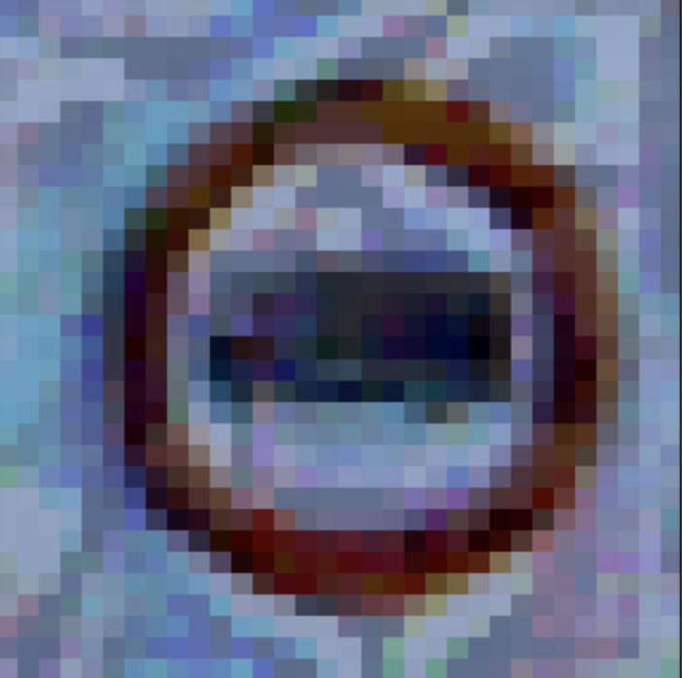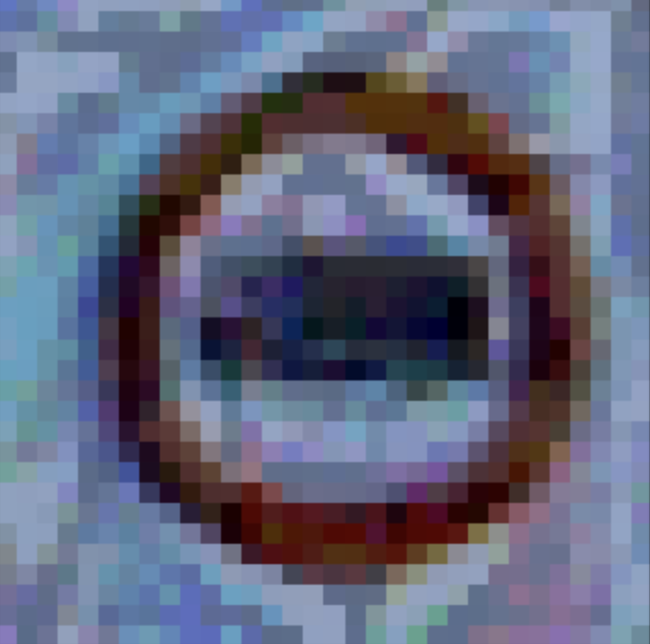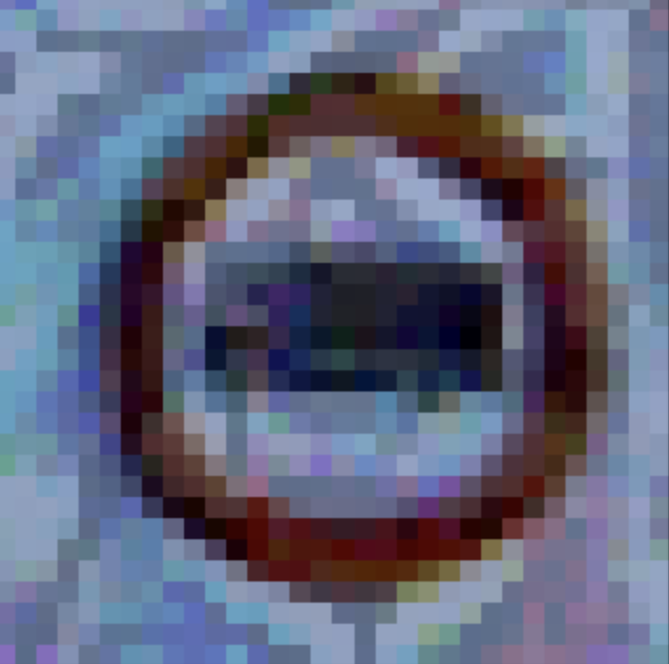
Clean Image 0.05 0.10 0.20 0.25 0.3
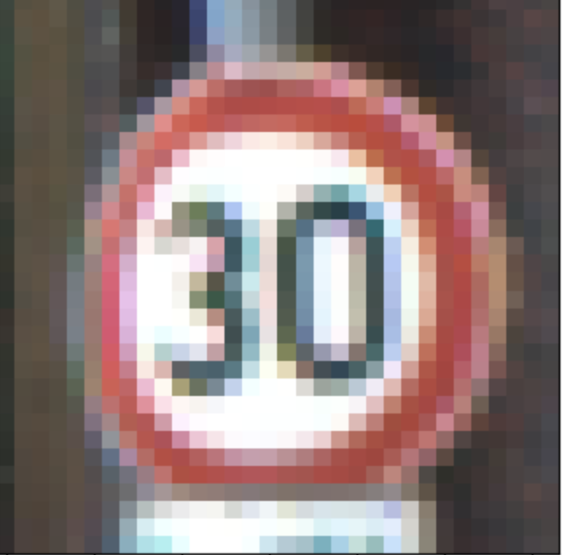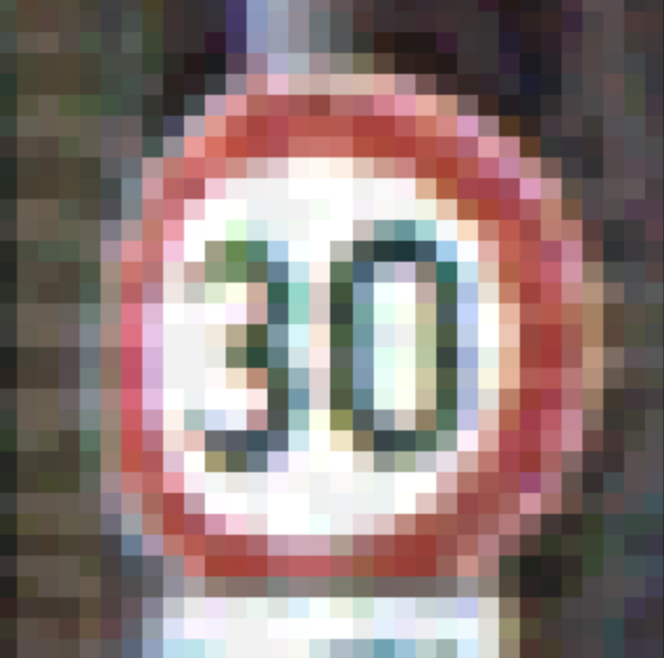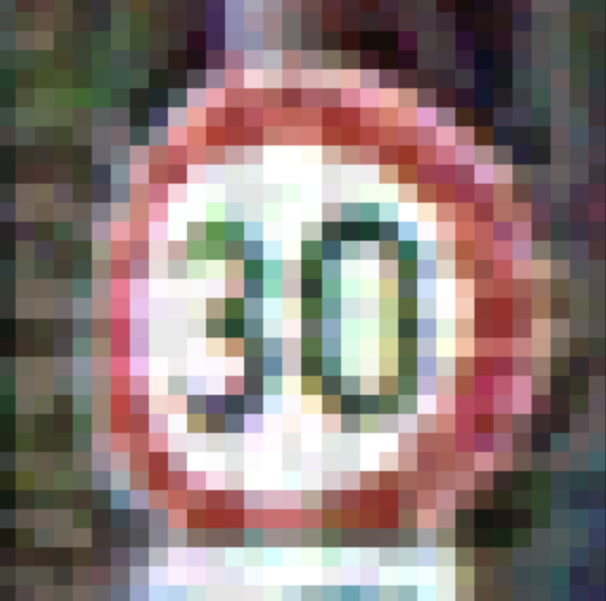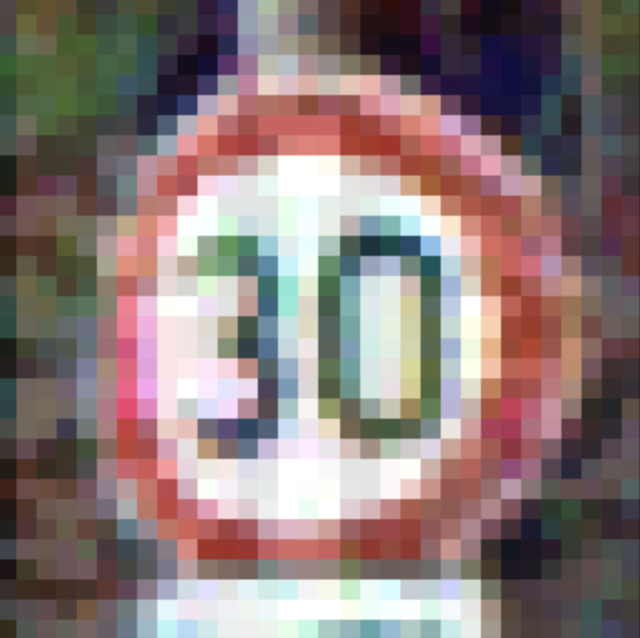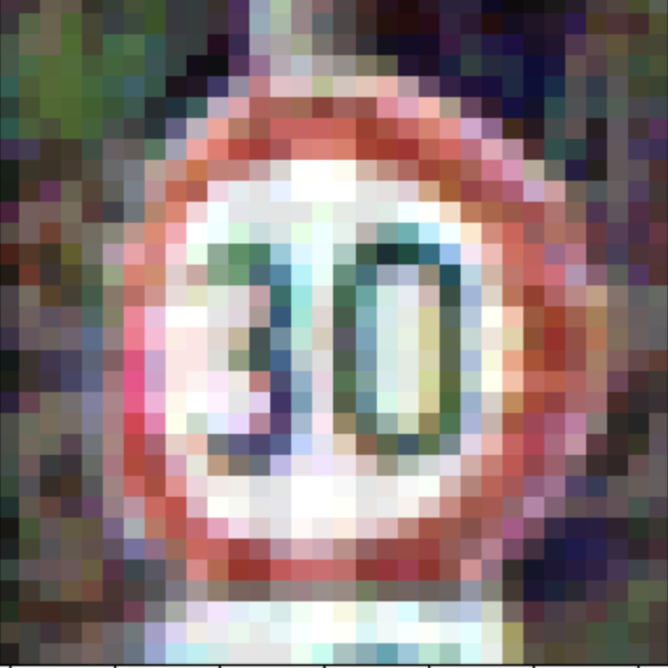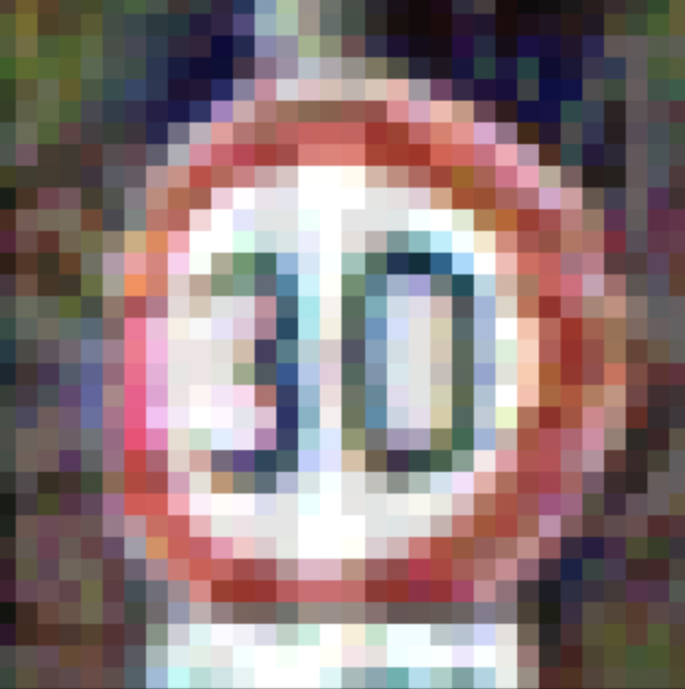
Clean Image 0.05 0.10 0.20 0.25 0.3
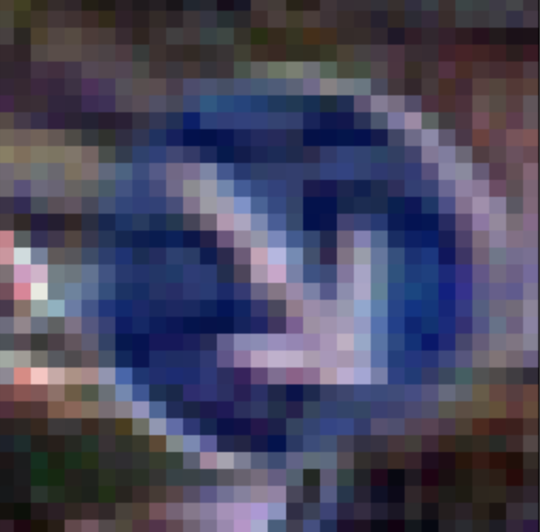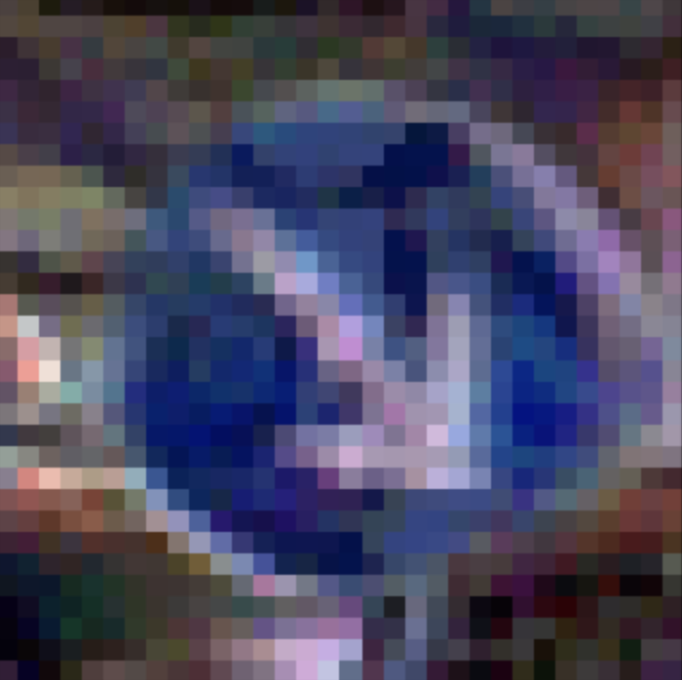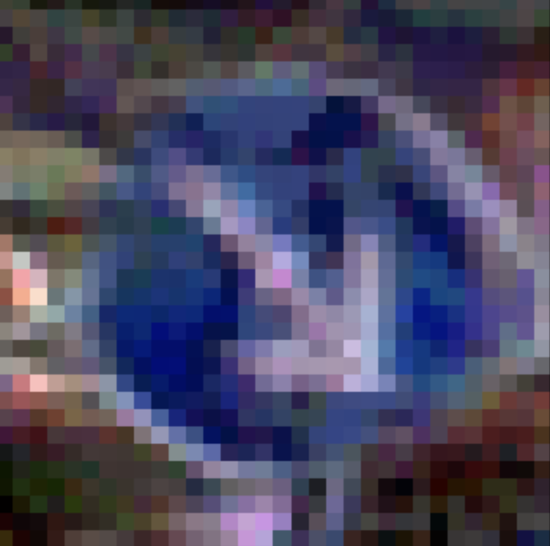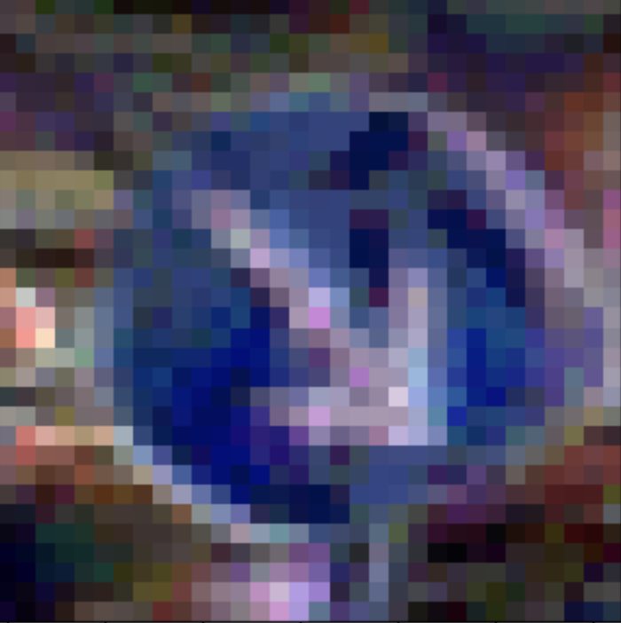

DeepFool :
Clean Image Adversarial Images
Clean Image 0.05 0.10 0.20 0.25 0.3
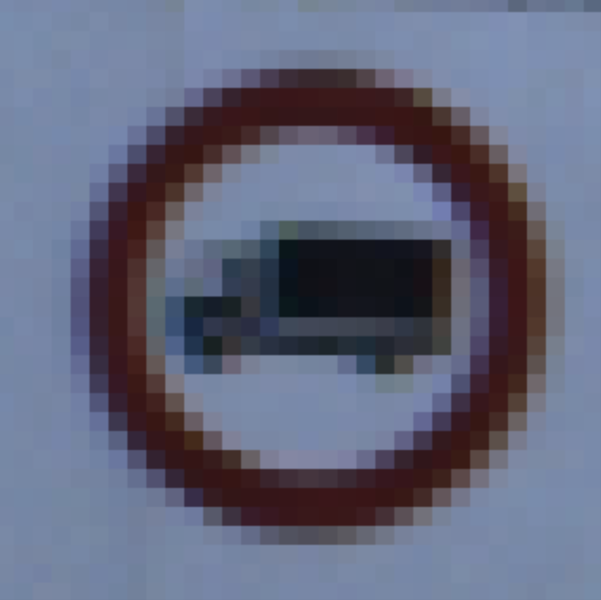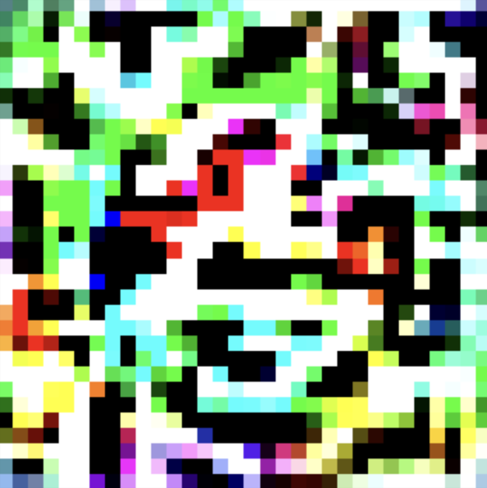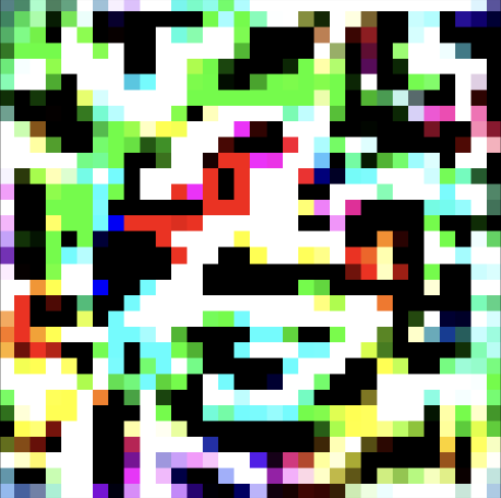
Clean Image 0.05 0.10 0.20 0.25 0.3
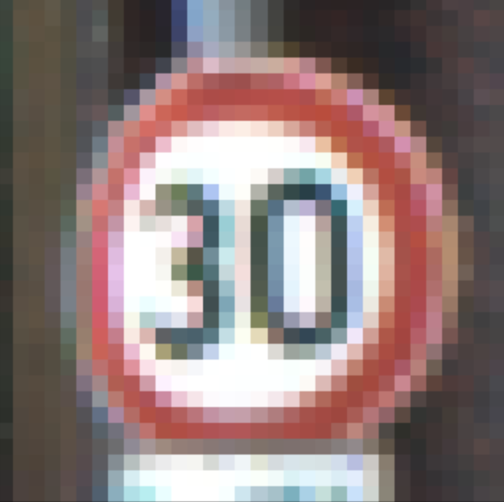
Clean Image 0.05 0.10 0.20 0.25 0.3

C&W:
Clean Image Adversarial Images
Clean Image 0.05 0.10 0.20 0.25 0.3
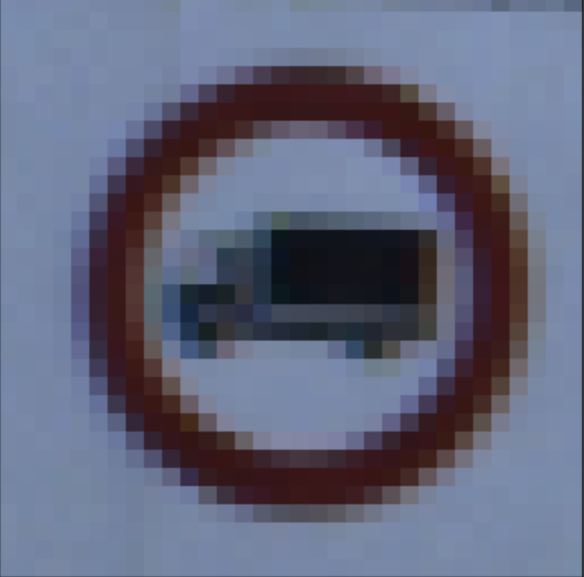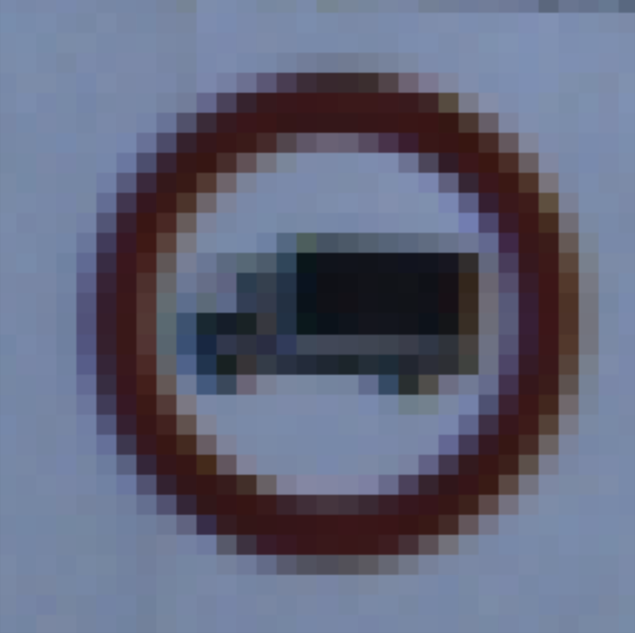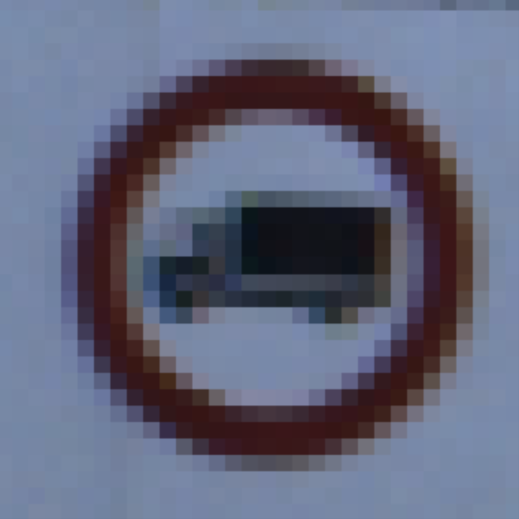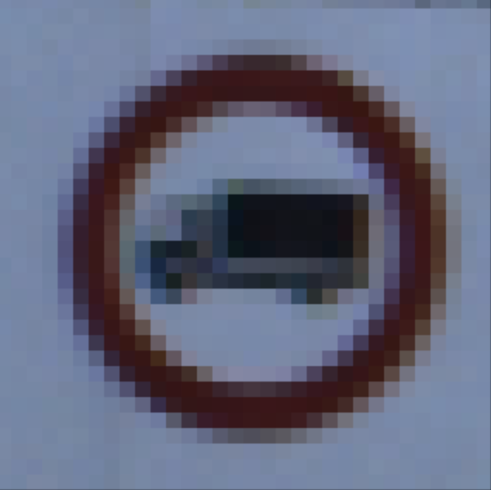
Clean Image 0.05 0.10 0.20 0.25 0.3
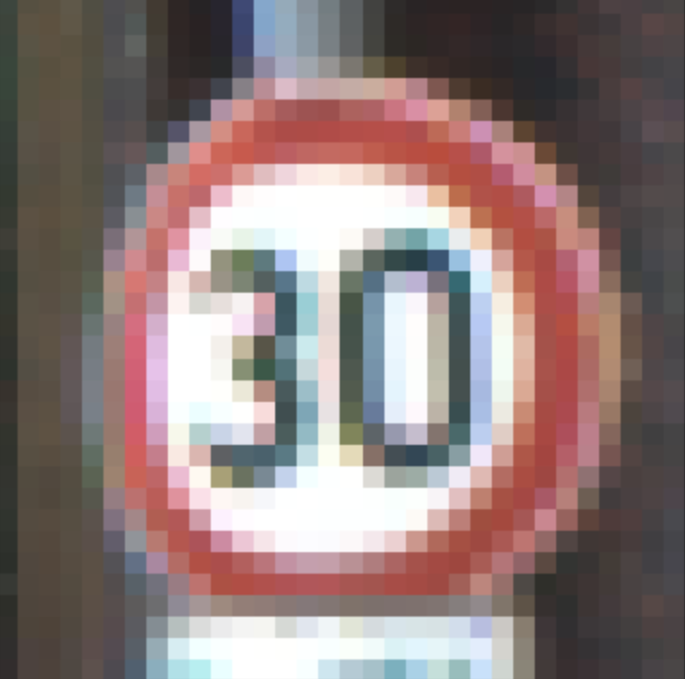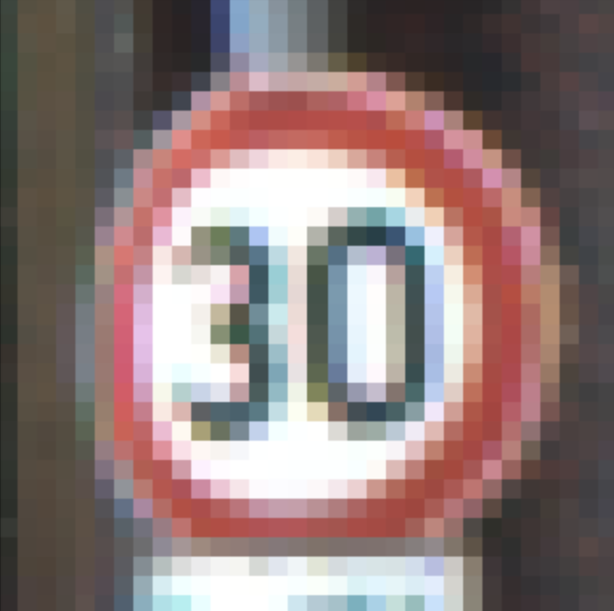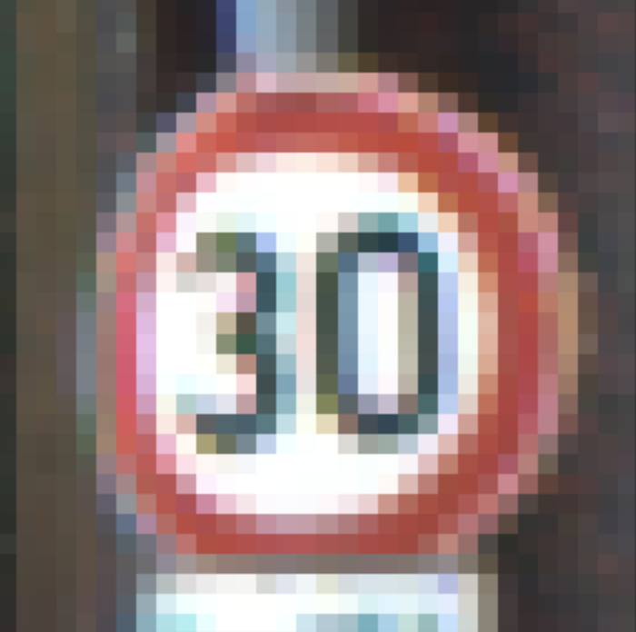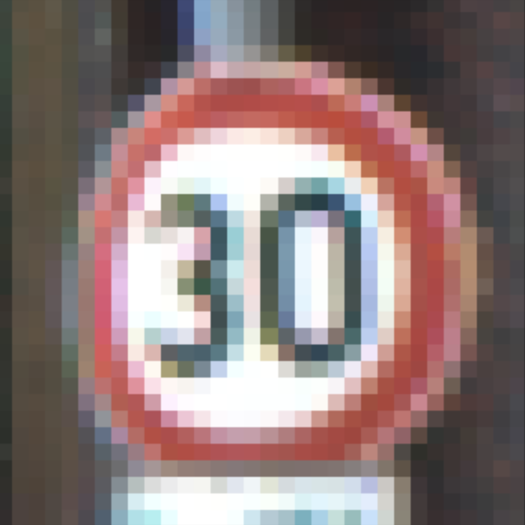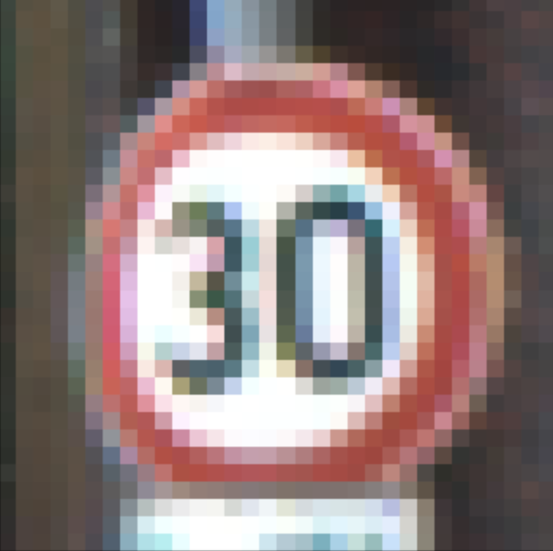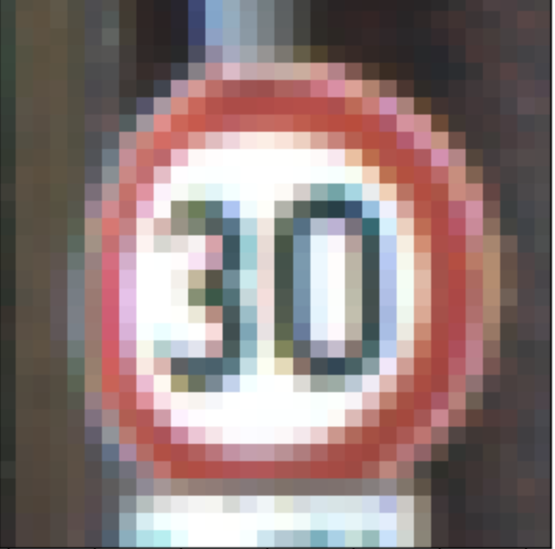

Clean Image 0.05 0.10 0.20 0.25 0.3


- [6 pts] For two images of choice, plot the clean image vs. adversarial images of all attacks (if the perturbation is needed, choose 𝜖= [0.1]). You should produce one similar figure but with the four attacks and the original.

FGSM:

Clean Image Adversarial Image




PGD:
Clean Image Adversarial Image




DeepFool:
Clean Image Adversarial Image




C& W:
Clean Image Adversarial Image




- [5 pts] Fill out Table 1 and Table 2 for accuracy and add the noise of each attack. Adversarial classification accuracy is the accuracy on adversarial samples only.
Table 1: Adversarial classification accuracy of the models
Model | Clean image | Adversarial images with 𝜖=0.05 | Adversarial images with 𝜖=0.2 | Adversarial images with 𝜖=0.3
VGG16-FGSM | 0.938 | 0.274 | 0.172 | 0.142
VGG16-PGD | 0.938 | 0.184 | 0.128 | 0.126
VGG16-DeepFool | 0.938 | 0.28 | 0.15 | 0.15
 | Clean image | Adversarial images
C&W L2 | 0.93 | 𝜖=0.05 0.826 𝜖=0.2 0.826 𝜖=0.3 0.84

Table 2: Noise of the models
Model | Adversarial images with 𝜖=0.05 | Adversarial images with 𝜖=0.2 | Adversarial images with 𝜖=0.3
VGG16-FGSM | 0.0486 | 0.1731 | 0.2406
VGG16-PGD | 0.0273 | 0.0577 | 0.0626
VGG16-DeepFool | 0.18 | 0.22 | 0.22
 | Adversarial images
C&W L2 | 𝜖=0.05 0.0001 𝜖=0.2 0.0002 𝜖=0.3 0.0001
- [5 pts] Plot accuracy versus perturbation 𝜖 for FSGM and PGD adversarial attacks (similar to the example in the following figure).
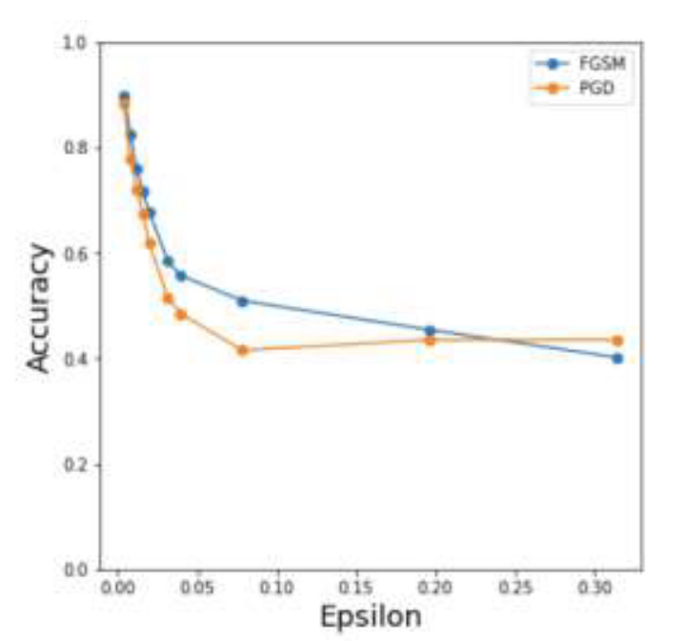

Below is the graph for accuracy versus perturbation 𝜖 for FSGM and PGD adversarial attacks

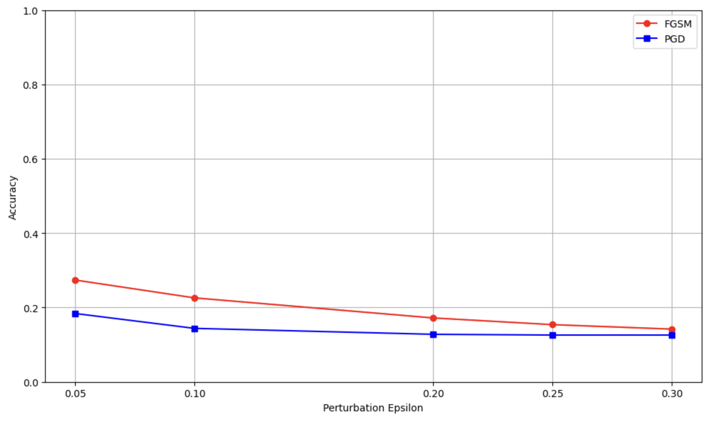

- [5 pts] Briefly provide insights on the model’s performance under attacks and any other observations regarding the results.

With Vgg and FGSM there is a significant drop in the accuracy with increasing in epsilon values indicates that vulnerability to adversarial perturbations. The accuracy is dropping straight away from 27.4% to 14.2%
Whereas with PGD also has considerable decline in its performance, but it is a bit more robust compared to that of fgsm, accuracy is low among all the values of epsilon perturbations.
Similar to fgsm , deep fool also experiences a notable drop in its accuracy especially at higher epsilons, suggesting that the deep fool is effective at generating adversarial images that deceive the model.
With C& W with L2 norm model it maintains high accuracy across all the perturbations and with a higher accuracy of 82.6%, which means that’s this attack is not that effective at compromising the model performance at these given levels of perturbations, this might be because of its targeted nature.

The noise with fgsm and has the highest noise at all epsilon levels which that it produces more visually noticeable perturbations whereas PGD show lesser noise which can be corelated to better accuracy under the attack.
Deepfool generated moderate noise but maintained similar noise level indicating that the consistency.
C&W L2 has really low noise across all the epsilon values , which means that the adversarial images are less visible to human eyes.

Task 2-targeted attacks (30 pts)
Now, let’s do some target attacks with white-box assumptions. Use the images with the Stop sign (label 14) from the overall test set for this task. There are around 270 images of that kind. Implement FGSM attacks on the Stop sign images to misclassify them as speed 30 sign images (label 1). Apply perturbations magnitudes: 𝜖= [0.05, 0.1, 0.2, 0.25, 0.3] for these attacks and report the classification accuracy on the Stop sign images and the Speed Limit 30 sign images.
Apply the same thing using PGD attacks and compare the results.
Apply the same thing using C&W L2 attacks (perturbations magnitudes) and compare the results.
Then, answer the following questions.
Note: [10 pts] will go to your code for attack implementation. The comparison code evaluation will be included in its respective questions.
- [5 pts] Plot the clean image vs adversarial image for a Stop sign image of your choice. This should happen for all perturbation magnitudes (if any) and all attacks.

FGSM:
Clean Image Adversarial images
Clean Image 0.05 0.10 0.20 0.25 0.3
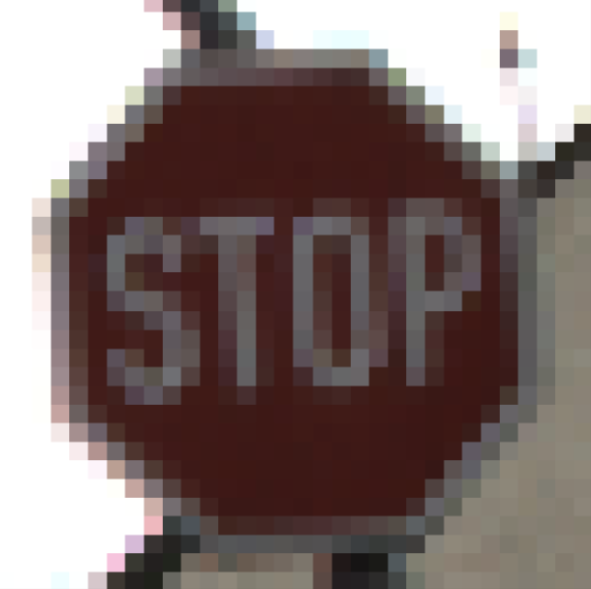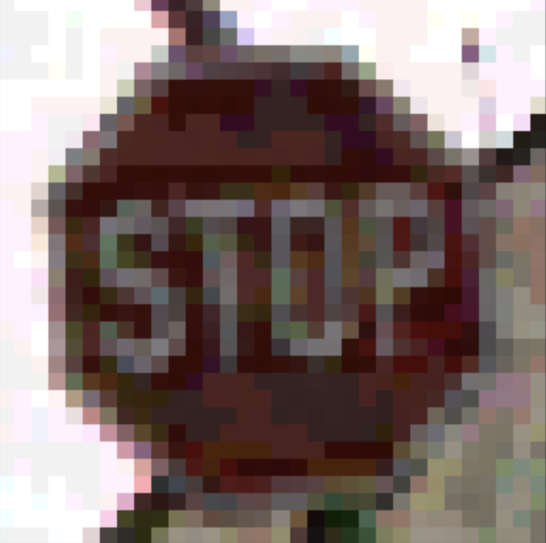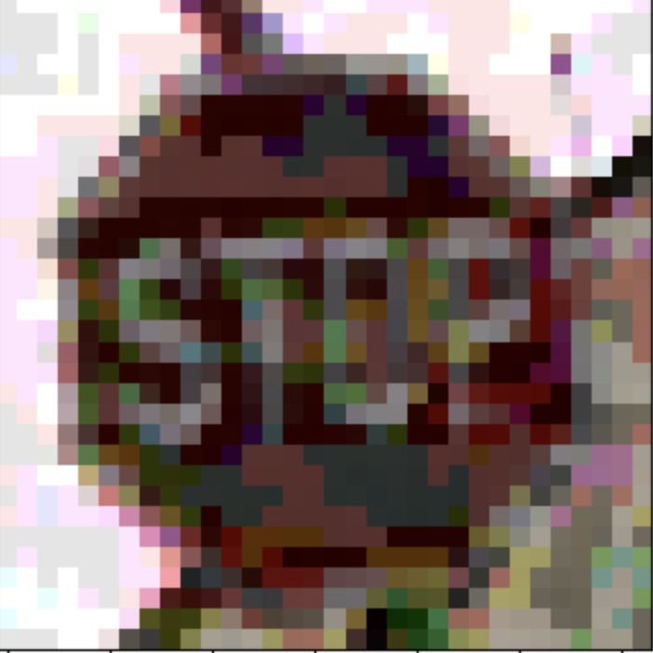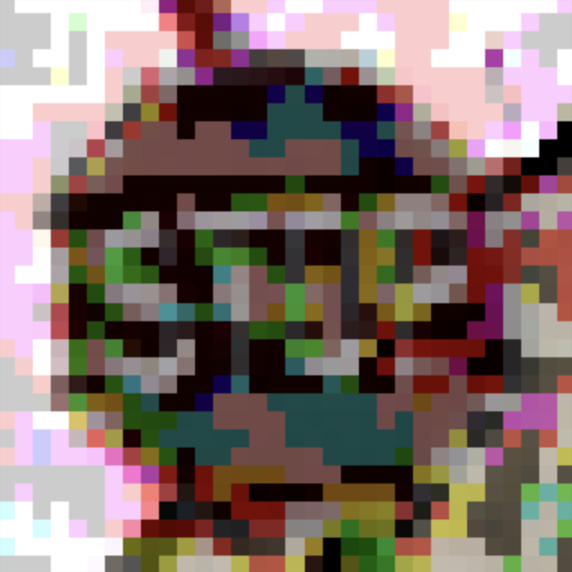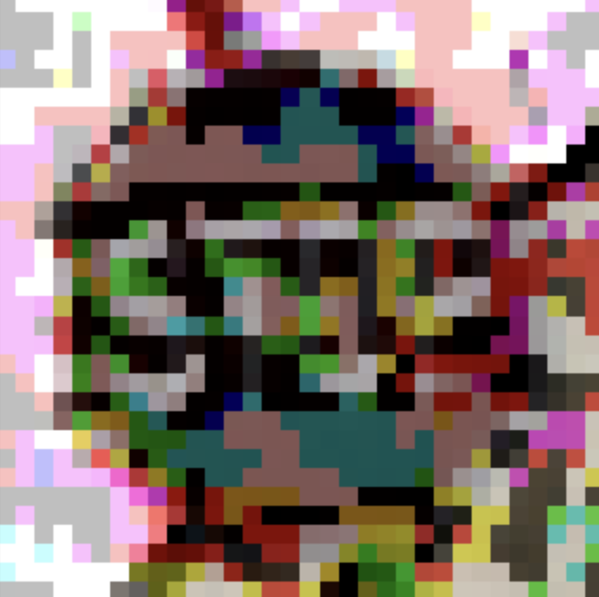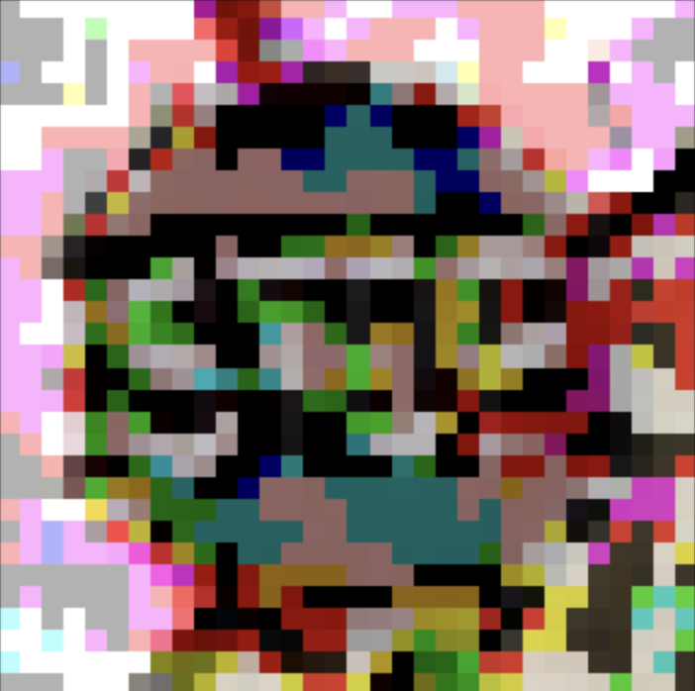

PGD:
Clean Image Adversarial Image
Clean Image 0.05 0.10 0.20 0.25 0.3
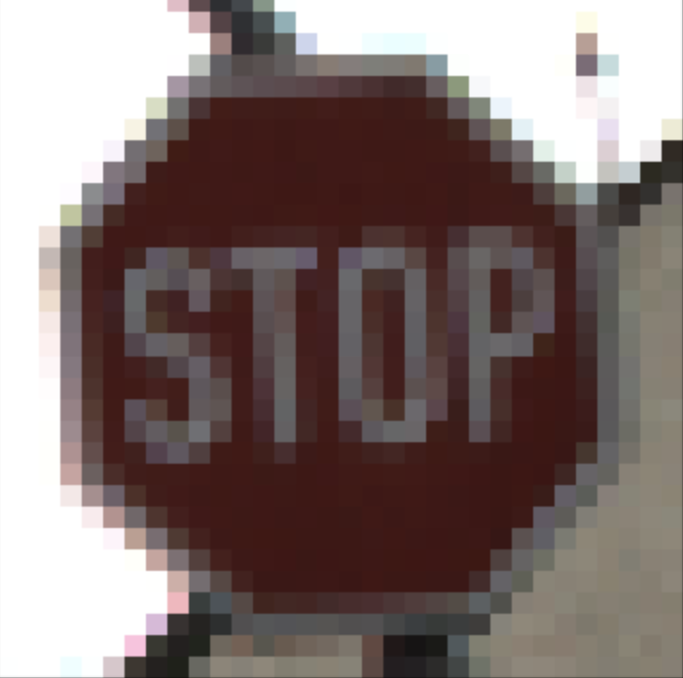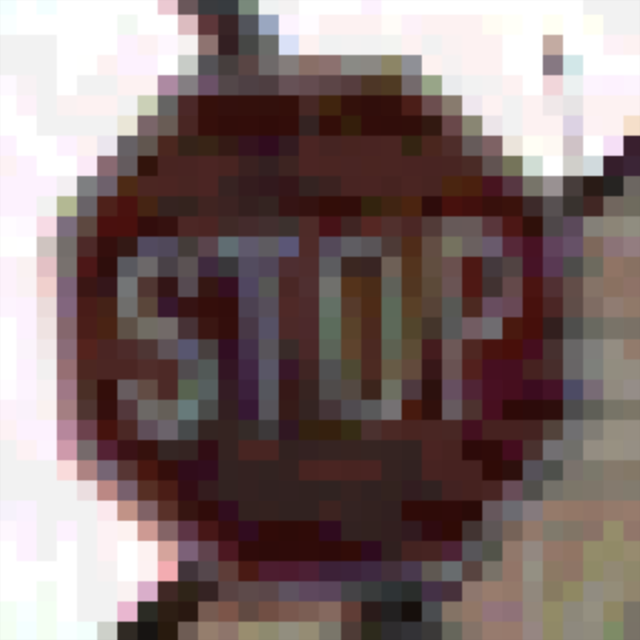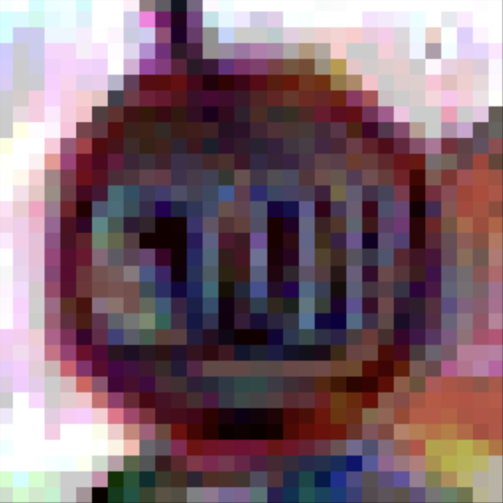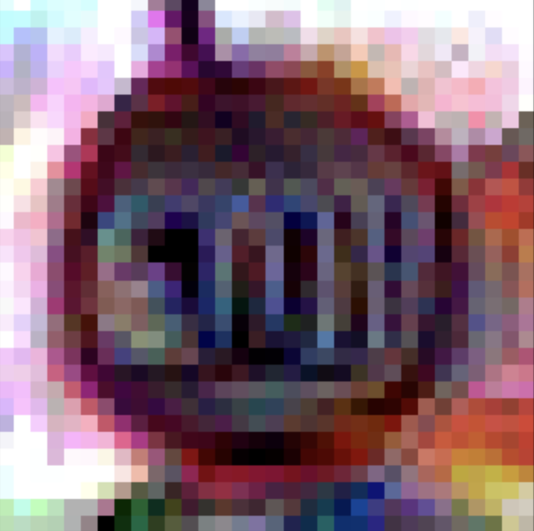

C&W:
Clean Image Adversarial Images
Clean Image 0.05 0.10 0.20 0.25 0.3


- [10 pts] Fill out Table 3 for accuracies.
Table 3: Classification accuracy of the model on adversarial original and target class images.
𝜖 | FGSM attack – Stop sign images | FGSM attack – Speed Limit 30 sign images | PGD attack – Stop sign images | PGD attack – Speed Limit 30 sign images
0.05 | 0.9778 | 0.03 | 1.000 | 0.15
0.1 | 0.9778 | 0.0519 | 1.000 | 0.15
0.2 | 0.9778 | 0.0185 | 1.000 | 0.081
0.25 | 0.9778 | 0.0111 | 1.000 | 0.08
0.3 | 0.9778 | 0.0037 | 1.000 | 0.09
 | C&W attack – Stop sign images |  | C&W attack – Speed Limit 30 sign images
0.05 | 1.000 |  | 0.24
0.1 | 1.000 |  | 0.24
0.2 | 1.000 |  | 0.24
0.25 | 1.000 |  | 0.25
0.3 | 1.000 |  | 0.25
- [5 pts] Briefly provide insights on the model’s performance under attacks and any other observations regarding the results.

There is a high consistency of accuracy in case of FGSM even at larger values and this is same for C&W and PGD. This might indicate that the model should have learnt features specific to stop signs that are resistant to the perturbations. The very low accuracies with speed limit 30 indicate that the model is effectively misclassifying these images as intended. This demonstrates the effectiveness of fgsm in targeted attacks as it is successfully altering the models’ predictions while maintaining the accuracy for stop signs.
Whereas with pgd attack the perfect accuracy on stop sign but very low accuracy on speed limit 30 signs. Due to its iterative nature pgd produces more challenging adversarial images.
C& W attack also achieves perfect accuracy with stop sign images, while there is moderate misclassification rates for speed limit 30 signs. This means that the model maintains its accuracy against stop signs, while the attack is still effective in causing the misclassifications in targeted scenarios like the above task.

Task 3-Adversarial Defense (20 pts)
Now, let’s defend against adversarial attacks. This notebook is a good start for adversarial training. Due to its complexity and the time taken to build an adversarial-trained model, we decided to give the model to you, and your only task will be to analyze it. The VGG classifier from earlier parts is used to build the adversarial model. New adversarial images were generated and used to build the new model. This model is provided in your assignment, and you will need to analyze it. Your tasks for this part will
- Analyze the code (commented) provided to build the adversarial model and answer question 1.
- Measure the performance of the trained robust model and compare it to the original VGG model used in earlier parts. For the attack part, we will use FGSM and PGD on the samples we reserved for adversarial generation in the earlier parts (use eps=0.1). You will probably need to implement your evaluation for things to work here. Record the classification accuracies that have been attacked.
- [5 pts] Answer the following questions about the provided model or code for it.
  - What attacks were used to build the model
ANS: the attack used to build the model is PGD (projected gradient descent)
ProjectedGradientDescent(estimator = robustClassifier,
eps=0.1,
max_iter=40,
batch_size=64)

  - What perturbation (if any) was used to build the attack samples?
ANS: the perbutation used to build the attack samples are 0.1 for the pgd attack
  - What percentage of training samples was used to generate the adversarial samples used in the built model?
ANS: 50% of the training samples were used to geanrate the adversarial examples as per the given code AdversarialTrainer(robustClassifier,attackFGSM,ratio=.5)

  - How many epochs were used?
ANS: The model was trained for 25 epochs
advTrainer.fit(imgs_train, labels_train_cat, nb_epochs=25, batch_size=16)

  - What needs to be changed in the code to generate an adversarial-trained model based on C&W attacks? Write the code for it as an answer.
ANS:
Keeping the code as same we can import the below statement
from art.attacks.evasion import CarliniL2
and update the below 2 statements so that the model is trained with C&W

advTrainer = AdversarialTrainer(robustClassifier, attackCw, ratio=0.5)
attackCw = CarliniL2(estimator=robustClassifier, eps=0.1, max_iter=100)

- [10 pts] Fill out Table 4 for accuracies.
Table 4: Classification accuracy of the traditional and adversarial trained model
Setup | VGG16 | Adversarial trained model
Clean train images | 0.93 | 0.96
Clean subset of test images | 0.88 | 0.9
FGSM attacked subset of test images | 0.22 | 0.45
PGD attacked subset of test images | 0.13 | 0.41
- [5 pts] Briefly provide insights on the model’s performance under attacks and any other observations regarding the results.
Both of the models were performing well on clean trained and test images, but adversarial model was performing a little better compared to that of vgg model. Which might mean that the adversarial training not only maintains performance but also improving generalization.
When the models are tested with adversarial examples the adversarial model has performed significantly well compared to that of vgg model when tested with FGSM and PGD methods generated adversarial samples.
For fgsm attack the adversarial model achieved a accuracy 0.45 compared to 0.22 for the original vgg method. Which indicates that a robust improvement in the model’s ability to simple adversarial perturbations similarly with PGD attack as well.

Overall, the adversarial training effective and the model is better at handling adversarial attacks, making a strategy in improving model’s robustness.
The increase in accuracy on adversarial images, we can say that the training process helped the model to learn and identify the adversarial modifications there by leading to a better performance

Submission Instruction (3 documents)
You are required to submit three documents:
- Report. Just fill out the above report and submit it as a Word or PDF document.
- Ipynb file. The code that you have written. Preferably in an ipynb document. You can submit it as a .py file as well.
- Txt file of the code. We need your code in the .txt file as well. Use whatever way you prefer. The fastest would be to download the file as a .py file and change the extension to .txt

