Fall 2024 | CS53331/4331 Adversarial Machine Learning | Assignment 2

Title | The Certification and privacy attack stuff
Due date | November 8th
First Name | Jhansi Lakshmi
Last Name | Kaligineedi
Student ID | R11896217
Marks | 100

Note: Please answer the following questions and submit them through Blackboard. Be sure to submit it to assignment 1. DO NOT write the report by hand and submit a scanned version. Just write the answers in a Word document and submit it. Both Word and PDF submissions are accepted.

Submission Instruction (3 documents)
You are required to submit three documents:
- Report. Just fill out the above report and submit it as a Word or PDF document.
- Ipynb file. The code that you have written. Preferably in an ipynb document. You can submit it as a .py file as well.
- Txt file of the code. We need your code in the .txt file as well. Use whatever way you prefer. The fastest would be to download the file as a .py file and change the extension to .txt

Objectives
This assignment has three main objectives:

Part 1
- Continuing on Assignment 1 objectives, the first objective in this assignment will be to certify the build VGG from the last assignment using Randomized smoothing.

Part 2
- Implement privacy attack (label one and shadow modeling)

Part 3
- Use DP as a defense

Get started
Download the assignment files from Blackboard. You will need the report (This file), the .ipynb file where you will put your code, the dataset, and the given model (if any). The GTSRB dataset will be used for both parts of this assignment.

Dataset
The German Traffic Sign Recognition Benchmark (GTSRB) dataset consists of almost 51K images of traffic signs. There are 43 classes, and the size of their images is 32×32 pixels. Some of the images are shown below. Please download the dataset from Blackboard or here. More information about the dataset can be found here.
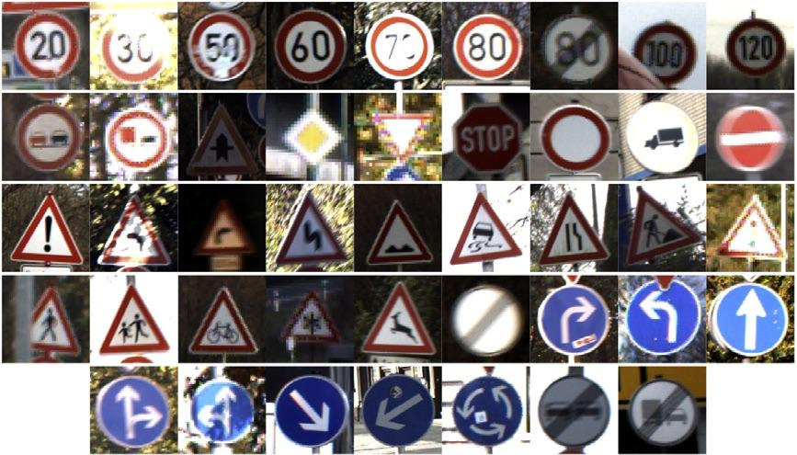
As we did with earlier assignments, it is recommended that you upload the dataset into your personal Google Drive to follow the Colab instructions as they are. Of course, if you prefer to use other than Colab, you will need a similar preprocessing.

Instruction for Colab (repeated from Assignment 0)
To get started with Google Colab, simply go to Google Colab, sign in with your Google account, and create a new notebook. You can write and execute Python code directly in the notebook. To access your dataset stored in your Google Drive (previous step), first run the following code to mount your Drive:
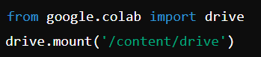
Follow the authorization steps, and your Drive will be accessible at /content/drive/My Drive/. You can then load your dataset into the notebook by providing the correct file path. This part of the code is provided for you in the .ipynb file of Assignment 0. You will need to setup the drive connection and run the code.
To use the free GPU provided by Colab, you can change the runtime to access a GPU by clicking on "Runtime" > "Change runtime type” and selecting "T4 GPU" from the Hardware accelerator dropdown menu. You can always use higher GPU powers at a cost (Colab Pro is $10 per month), but you should be fine with the free version, considering that you start the assignment early enough.
Colab comes with many pre-installed libraries, but if you need to install additional Python packages, you can do so with pip. For example:
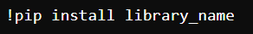
Remember to save your work frequently.
After you've completed your work in Google Colab, you can easily download your notebook from Google Colab, go to "File" > "Download" > "Download.ipynb".

Other than Colab
If you don’t prefer Colab or notebook, you always have the option to run it on your computer (especially if it has a GPU) or access HPCC resources at TTU (needs an account with my permission).

Additional resources
- TensorFlow resource https://www.tensorflow.org/
- PyTorch resources https://pytorch.org/get-started/pytorch-2.0/
- Deep learning with Python https://dl-with-python.readthedocs.io/en/latest/
- Get started with Colab https://colab.research.google.com/

Part1 Certified Training

Task 1: Randomized Smoothing (30 pts)
Our first task with implement randomized smoothing for the VGG model from last time. Your task is to download the model and use Adversarial Robustness Toolbox (ART) to implement randomized smoothing to certify the model. This notebook should be your guide to implementing the task. You will use $σ^{2}=[ 0.25, 0.5, 1]$ as Gaussian noise parameter. Once needed, use 100 as the number of samples to estimate the certifiable radius. You will find the standard and certified accuracy for different noises. You will also plot the L2 radius versus certified accuracy.
Notes: Training will take time to generate the results. Try it first with only 2 training rounds and then increase to 25. Certification for all the testing will take forever. Thus, whenever you need a testing set, use a subset of the testing samples, not all. We already provided that subset for you in a variable that you must look for .
- [10 pts] Implement what is required.

- [10 pts] Fill in Table 1 with the required values
Table 1: Standard and Certified Accuracies for different models
Model | L2 Radius | Standard accuracy | Standard coverage rate | Certified accuracy
VGG16 original | 0.0000 | 0.9380 | 1 | N/A
Smoothed $σ^{2}=0.25$ | 0.2500 | 0.2940 | 0.4280 | 0.1940
Smoothed $σ^{2}=0.5$ | 0.5000 | 0.0840 | 0.2660 | 0.0840
Smoothed $σ^{2}=1$ | 1.0000 | 0.0200 | 0.1340 | 0.0320
- [5 pts] Plot L2 radius (from 0 to 3) vs certified accuracy for the three models (original, smoothed 0.25, and smoothed 5) in one figure. An example of some smoothed certified accuracies is below.
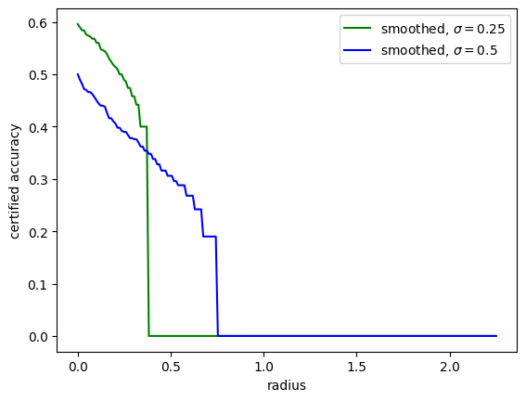

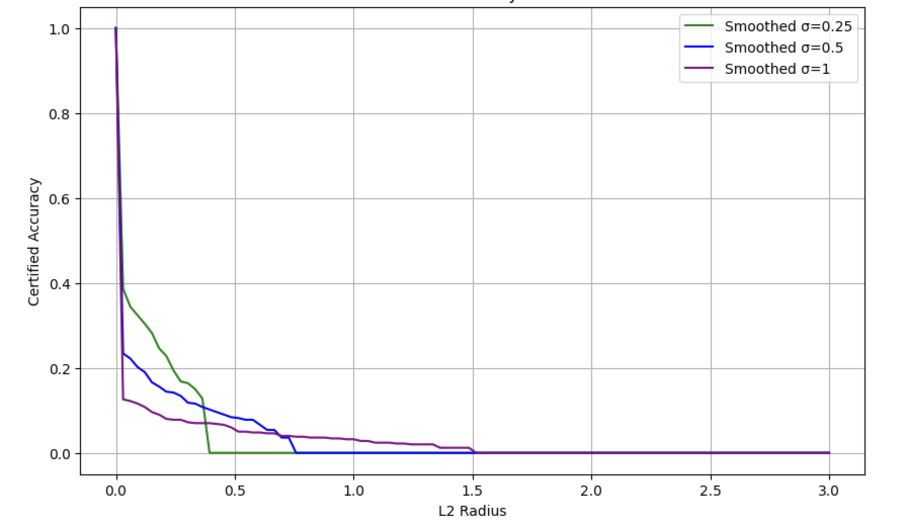
- [5 pts] Briefly provide insights on the results.

As there is no added noise the Original VGG16 model achieves high standard accuracy and its performance was unaffected by the gaussian perturbations, thereby making it most accurate but the least robust against adversarial perturbations. As per the results we can see that the adding the gaussian noise to perform randomized smoothing results in a trade off between accuracy and robustness. As we increase the noise parameter, both the standard accuracy and the certified accuracy decrease. When the noise parameter is 0.25, the standard accuracy is 0.294 and the certified accuracy is 0.194, this noise level has provided the moderate balance between accuracy and certification, thereby some robustness without compromising the accuracy.
When the noise parameter is 0.5, the standard accuracy has dropped to 0.084 and the certified accuracy is also 0.084, increasing the noise further reduces the model’s accuracy performance. When the parameter is 1, the accuracy has dropped to 0.020 but the robustness is high which is making it unsuitable for practical predictions. The plot demonstrates how increasing the noise value effects the certification radius at the cost of accuracy, the higher the noise provides more robustness over a large certification radius but with lowered certified accuracy.

Part 2 Privacy Attacks

Task 2-Label-only attack (25 pts)
Now, let’s do some privacy attacks. We will focus on Membership inference attacks. This task will implement label-only attacks, while the next will implement shadow modeling. As discussed in class, the label-only attack is developed based on the fact that it costs an attacker so much to generate a successful adversarial sample for a member sample. In contrast, the cost will be much less for a non-member sample. Thus, it uses HopSkipJump to generate a successful adversarial sample and then measure the perturbation using the L2 norm. If the perturbation is above a threshold, it will be classified as a member; if not, it will be classified as a non-member. Hence, we will follow the following steps to perform the attack (Your reference code is this notebook):
- Generate a dataset (already given): The training and testing datasets are merged into one, with the training classified as members and the testing as non-members. We picked 1500 samples from this dataset to build our attack model.
- Calculate the threshold (to be implemented by you): Your task here is to use existing implementations in ART to calculate/calibrate the threshold. All parameters are given to you in the code (in comments).
- Infer the data: Use the 1500 provided samples to predict whether they are members. Then, compare your performance to the ground truth and present the results.
One parameter you will need to set is the maximum number of queries (used in step 2). Set this parameter to 5 and 10. All that is needed is to answer the questions below.
Note on resources: It takes time to generate the adversarial examples. A good GPU computer will take you around 1-3 hours per round. Thus, plan your time accordingly.
- [10 pts] Implement what is required.

- [10 pts] Fill out Table 2.

Table 2: Attack accuracy with different number of queries.
Max number of queries | Members accuracy | Non-member accuracy | Overall accuracy
5 | 0.588 | 0.062 | 0.65
10 | 0.6006 | 0.0573 | 0.658

- [5 pts] Briefly provide insights on the results.

With the query limit as 5 the overall accuracy was 65%, indicating moderate success rate in differentiating between member and non-member samples, upon increasing the value to 10 has slightly improved the overall accuracy to 65.8% showing that more queries allow for slightly better membership inference.
Also, the accuracy difference between member samples is higher than that of the nonmember samples, this reflects the fast that the model is better at identifying members but is struggling with classifying nonmembers.
Increasing the queries slightly improves accuracy but doesn’t make much bigger difference. The threshold here helped in maximizing the attacks’ ability to correctly classify the samples, but this also depends on the perturbation distribution between member and non-member samples.

Task 3- Shadow Models attacks (25 pts)
Let’s do another privacy attack. This time, it is a “shadow models” attack, discussed in class. This notebook will be your guide. You are going to use ART again, and here are a few steps to follow:
- Build the shadow models based on the numbers provided below. Set the training ratio for them to 0.5.
- Measure the accuracies for them (use validation accuracy as a measure)
- Build the attack model. You can build any binary classifier. You are suggested to use a random forest classifier for simplicity.
- Evaluate your attack models for members and non-members (the evaluation data is already given to you).
- Calculate the precision and recall of your attack model.
Your changing parameter in this task is the number of shadow models. You will set it to 1,2 and 5. Please note the needed metrics so you can plan your code accordingly.
Note on the implementation: Our implementation will look strange. Shadow models will require lots and lots of data. Thus, in a general setup, researchers use 80% of the data for shadow models, and only 20% is for training/testing/validation. However, given that we are using a model already built from Assignment 1, we cannot use this general setup. Thus, our shadow models’ data will concatenate training and testing while the validation will be left out to test performance accuracy. To evaluate the attack, we generated a separate dataset that is taken from training and testing. You will need to locate and work with that data. In general, your attack results won’t be good due to the above design, but the idea is that you should analyze it.
- [10 pts] Implement what is required.

- [10 pts] Fill out Table 3.
Table 3: Shadow model performance and attack performance
Metric | 1 shadow model | 2 shadow models | 5 shadow models
Average Accuracy (using validation) | 0.9721 | 0.971 | 0.968
Members accuracy | 0.6973 | 0.698 | 0.68
Non-members accuracy | 0.5433 | 0.542 | 0.534
Overall accuracy | 0.6203 | 0.623 | 0.60
Attack precision | 0.6042 | 0.60 | 0.604
Attack recall | 0.6973 | 0.69 | 0.69
- [5 pts] Briefly provide insights on the results.
From the above table we can see that the average validation accuracy for each model is high at around 97% regardless of the different shadow models we take, this means that the shadow model is well trained and performing accurately on its validation data. Here, high validation accuracy means that the shadow model is generalizing reasonably. The attack model’s accuracy is higher for the members when compared to that of the non-members, this highlights the common pattern in membership inference attacks, where the attack model better identifies members due to its strong signals in the shadow model for training samples.
The overall accuracy indicates that there is a moderate success rate for the attack which means that it can infer the membership, there’s still some error rate especially with non- member prediction. The stability in the precision and recall implies that even though we are increasing the shadow models may add diversity to the training data for the attack model, which does not improve the attack’s ability to distinguish between the members and nonmembers.
The shadow model attack here demonstrates moderate success in differentiating between members and nonmembers, but the approach is facing issues in precision and non-member accuracy. Increasing the shadow model is not improving the attack performance significantly.

Part 3

Task 4- Deferentially private model performance (20 pts)
Now, let’s defend test defense with DP. We have built a DP-SGD model using the TensorFlow privacy library. The model is given to you, and you just need to analyze it. First, check the overall DP code and answer the below questions. Then, analyze the given DP model in terms of accuracy and resiliency to membership inference attacks. Use a label-only membership inference attack with 5 max-queries and the same setup as in Task 2.
- [5 pts] Answer the following questions about the provided model or code.
  - What is the value of the L2 norm used to build the model?
ANS: the value of the L2 norm used to build the model is 2

  - What is the value of the noise added?
ANS: the added noise value is 1.6

  - What is the batch size and the micro-batch size to build the model?
ANS: the batch size is set to 128
It is given that num_microbatches=128 which mean that the micro batch will contain 1 data point.

  - Modify the commented code to enhance your accuracy performance (you can accept less privacy in this case). You don’t need to run the code; just tell us about the changes and maybe paste your code here.
optimizer = tensorflow_privacy.DPKerasSGDOptimizer(
l2_norm_clip=4,
num_microbatches=256,
noise_multiplier=0.8,
learning_rate=LR
)
The changes are uincreasing the L2 norm and increasing the num of microbatches and reducing the noise multiplier.
- [5 pts] Measure the differential privacy guarantee of the given model.

The differential privacy guarantee can be computed with the function compute_dp_sgd_privacy() from the library tensorflow_privacy.
Here the delta value 2.88e~5, and n is 34688, batch size= 128, noise multiplier = 1.6, num of epochs=14. We can calculate the privacy level epsilon.

from tensorflow_privacy.privacy.analysis import compute_dp_sgd_privacy

epsilon, best_order = compute_dp_sgd_privacy(
n=len(imgs_train),
batch_size=BATCH_SIZE,
noise_multiplier=1.6,
epochs=NUM_EPOCH,
delta= 2.88e~5
)

print(f"Achieved privacy guarantee: epsilon = {epsilon}")

upon calculating based on the above values the epsilon value would be around closer to 2.

- [5 pts] Calculate the model’s performance under attacks and any other observations regarding the results.

Table 4: DP vs original performance
Model | Accuracy | Members accuracy | Non-member accuracy | Overall accuracy
VGG16 (Original) | 0.939 | 0.9653 | 0.9507 | 0.9580
DP | 0.5001 | 0.4933 | 0.5040 | 0.4987
From the results, we can say that the original model has achieved higher accuracy for both members and nonmembers indicating that the model has learned data distribution well and generalizes effectively on unseen samples.
The high accuracy differences between the members and non-members means that the original model is more vulnerable to membership inference attacks, and this is because the model might have retained specific information about its training samples.
The DP has lower accuracy across, this reduction is reflecting the trade-off made for privacy. The close values for members and nonmembers indicate that the do model doesn’t differentiate between the members and the non-members. This shows a reduced vulnerability to the membership inference attack.
- [5 pts] Briefly explain why DP accuracy is lower than VGG original. Provide insights on the results.

There is the privacy accuracy tradeoff, due to which the added noise to the gradients during the training limits the model’s ability to learn specific details about the individual samples. This limitation helps against the membership inference attack, but the model’s overall performance is reduced. Thus, protecting privacy but it has costed the models performance. Due to which dp has a lower accuracy compared to the original VGG model.
Though the vgg model has the high accuracy it is highly vulnerable to membership inference attack. The noise and the gradient have reduced the overfitting of training data in the DP, which is good for privacy. From the results, we can say that the original model has achieved higher accuracy for both members and nonmembers indicating that the model has learned data distribution well and generalizes effectively on unseen samples.
The high accuracy differences between the members and non-members means that the original model is more vulnerable to membership inference attacks, and this is because the model might have retained specific information about its training samples.
The DP has lower accuracy across, this reduction is reflecting the trade-off made for privacy. The close values for members and nonmembers indicate that the do model doesn’t differentiate between the members and the non-members. This shows a reduced vulnerability to the membership inference attack.

Submission Instruction (3 documents)
You are required to submit three documents:
- Report. Just fill out the above report and submit it as a Word or PDF document.
- Ipynb file. The code that you have written. Preferably in an ipynb document. You can submit it as a .py file as well.
- Txt file of the code. We need your code in the .txt file as well. Use whatever way you prefer. The fastest would be to download the file as a .py file and change the extension to .txt

