Introduction

My report is for those who are planning to start a new business. I'll try to provide as many suggestions on what all factors need to be considered while starting a new venture.

Business Problem

In my report I'm going to focus on problems one might face while opening a new business. Well there are many factors to be considered to open a small or big level business. For example, say I wants to open a boutique shop, first and foremost important point to decide is the location for the new shop. On what basis can I decide my shop’s location? Do I want to rent the place or can I afford to buy it? While selecting the place there are key points to consider like I need to check out how many boutique shops are there in that specific location? If incase there are already two boutique shop which have good ratings, will it be risky to open new one near these shops? What all factors will help me to run my business above average? (Out of scope for this project: Budget for tools, furniture and decorations, hire new employees, budget everybody's salary. Decide on product details, advertisement, publish discount coupons, website.)

Discussion

Let's discuss the above-mentioned problem statements. Firstly, I need to choose a suitable location for my shop. Let's say I wants to open a new boutique shop in Houston. Houston is a famous tourist place, and it is very good market place for Oil and Gas companies, because of that real estate is very costly. So, I must rent a place for my shop. And now I need to figure out how many shops are there in say neighborhood A, B, C,etc. If there are more than two shops in a neighborhood then that would be a great risk to open shops of same style in that neighborhood. Selecting a place where there is less or no shop would be of great choice, considering the rent of neighborhood too. Why I'm emphasizing that there should be less shops are, so that my business will face less competition with same products. I need to look for a place where many people frequently visit so that her business is above average. Places like Downtown, Movie theatre, Malls & Gas stations would help her business running. Shop ratings, checking of customers might help in deciding location crowd. So, I should check for opening and closing timings of other shops. I may try opening the shop place 30 mins before other shops open and close 30 mins or 1 hour later the other shops, and try opening in the weekends too, this might help to get more customers.

Data Description

As I am planning to open a boutique shop in Houston, and assuming that I am going to rent a place. So first I took the rent dataset from (https://www.zillow.com/research/data/) according to neighborhood wise, so that it's easy for us to check the rent data neighborhood wise. In this dataset I couldn't get all neighborhoods rent information. So, I managed to use only those information which I could get from the website. I have cleaned the dataset and I'm going to compare the rent data of year 2018. Because for this project we just need to analyze the current rent range. Since from the webpages I didn't get all neighborhood's rent data, I planned to test only for the data I have retrieved.

I'm going to use a formula to find which neighborhood is good to open a new Boutique. Before coming up with a formula, I was wondering what all attributes/factors can we consider because it's really unfair to compare data of 10 years old shop with 1 year old shop. Like for example, the checking count of 10 years old shop will be more compared to a 1 year old or 6 months old shop. And also after analyzing data I found that in many shops checking count is zero. I thought checking count would be really be helpful to figure out the number of crowd visiting a neighborhood, but because of data discrepancy I avoided it. Then I conclude that every restaurant would definitely have ratings. Even if 100 customers have visited a 1 year old shop, the likes will be out of 5 stars, and same goes for a 10year old shop too.

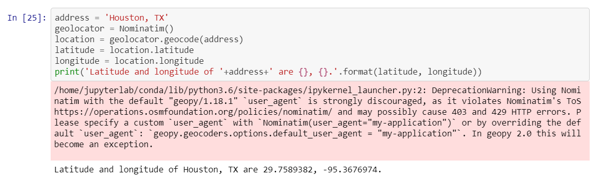

Below is the formula for the solution.

finalScore = (rentScore)0.6+(ratingScore)0.4

Closer the finalScore value to 1, better choice of neighborhood for the client to decide. I have given more weightage to rent than likes. Let's see what is rentScore and ratingScore means.

rentScore can be calculated by (maxrentofneighborhood-currentrentofneighborhood)/(maxrentofneighborhood-minrentofneighborhood). rentScore value for each neighborhood can be obtained from above rent dataset. ratingScore can be calculated by (maxgoodrest-currentrestratingofN)/(maxgoodrest-mingoodrest). ratingScore can be calculated after retrieving information from foursquare location.

**Methodology**

To calculate the formula first let's calucate the rentScore. From above rentScore formula we need maximum and minimum rent of neighborhood. Maximum and minimum values can be retrieved using max and min built in functions.

maxrentofN = max(dataframename['rentcolumn'])

minrentofN = min(dataframename['rentcolumn'])

I have uploaded my results on github to show examples in my report, Below I have shown few results of Neighborhood and Rent score .

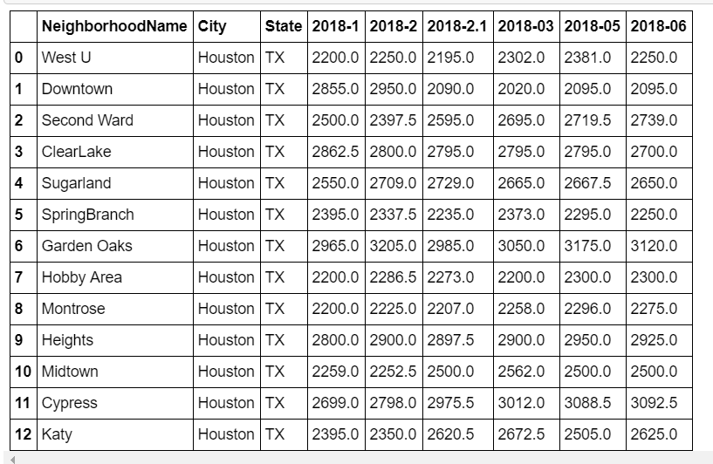

**Next in order to calculate ratingScore, we need to retrieve rating of each Boutique shop neighborhood-wise. So let's the analyse data. Firstly we need the co-ordinates of the neighborhood's, co-ordinates or latitude & longitude can be obtained by passing the Neighborhood name value through geocoding. The shop details can be retrieved using search endpoint of foursquare location. For our project we need only Boutique shop data, and in search endpoint there is an attribute called category id, i.e for each category foursquare has a defined categoryid which will help us to get the desired data. In this search response, we'll retrieve the venue id of all the shop venues. And then pass this venue id's through venue_id endpoint to get rating of each shop. Let's save the data in a dataframe, for further testing.**

**Now we need to select a neighborhood in which we have to reduce the competition for our new shop, hence we should test with only good rating shops. For this I'm going to consider shops which have rating greater than or equal to 7 in foursquare.**

After getting counts of good rating shops in each neighborhood, we can calculate our rentRating now. Max and min can be calculated using respective functions.

maxgoodrest = max(dataframename['ratingcountcolumn'])

mingoodrest = min(sf_Neighborhood['ratingcountcolumn'])

Thus now we can calculate ratingScore using the formula ratingScore = (maxgoodrest-currentrestratingofN)/(maxgoodrest-mingoodrest).

Once we have rentScore and ratingScore we can use our formula to calculate the finalScore. And below is the first 5 rows from the final results dataframe.

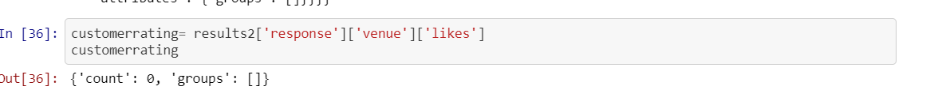

Above is the result of my formula which I used to analyze best neighborhood's for new Boutique shop. If you see carefully I have listed Neighborhood's which has Finalscore greater or equal to 0.8, so that I will have has more options to choose from. Downtown Neighborhood's in above results which are best suited for me as there is no competition, since there is no good rating Boutique shop and rent is also comparatively low according to our formula.