Step1: click on putty gen

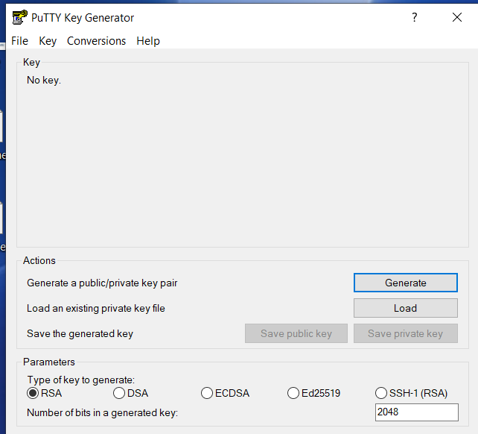

Step2 : click on load

And after check the path of the pem file like below image

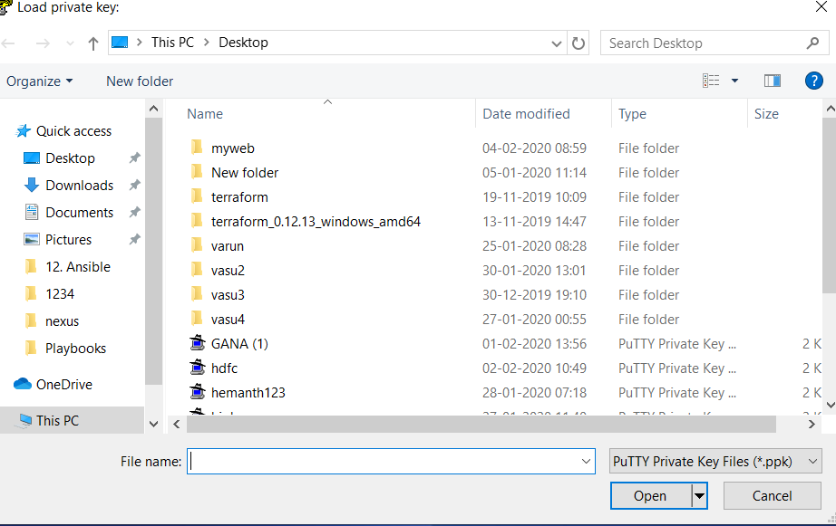

Step 3: select your pem file and

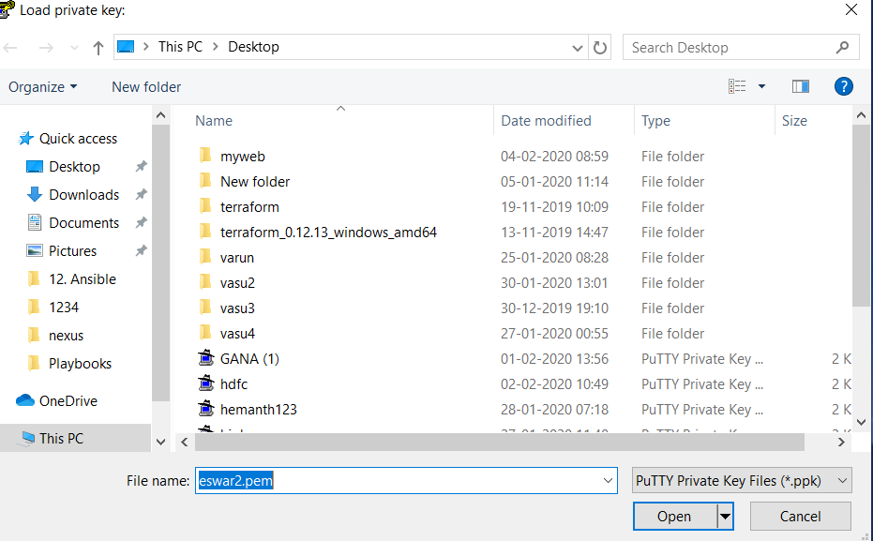

Step 4: after that click on open

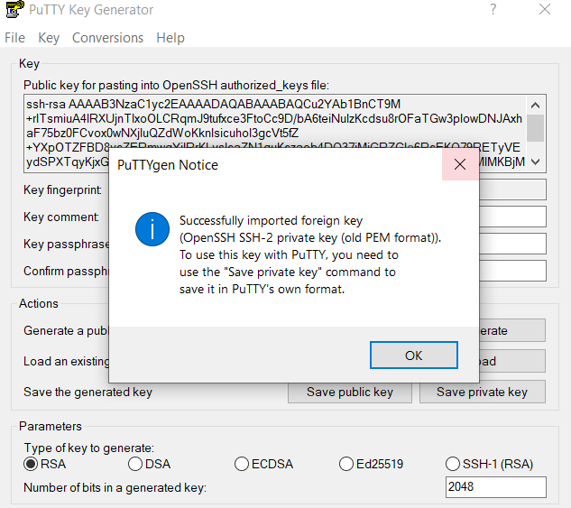

Step 5 : now click on ok.

Step 6: Now click on save private key

Step 7: click on yes

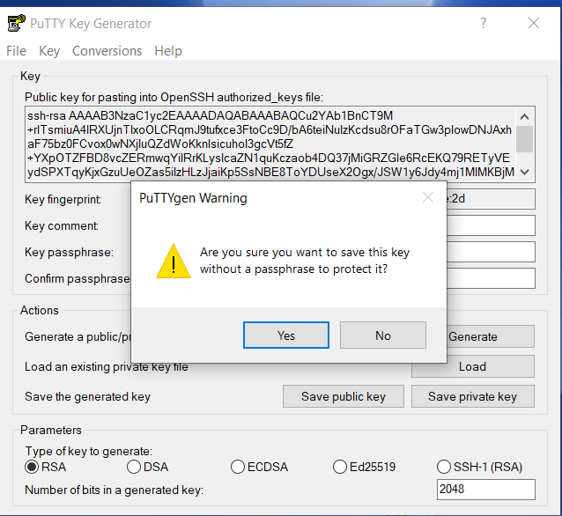

Step 8: Now select on yes

Step 9: select your pem file again

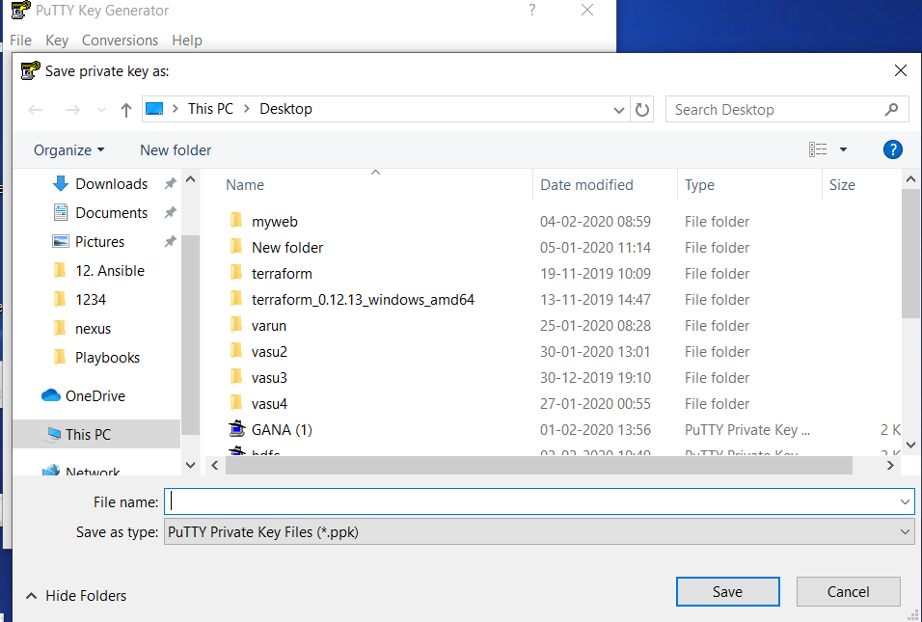

Step 9: after selecting your pem file and change your pem file to .ppk ( like eswar2.pem to eswar2.ppk )

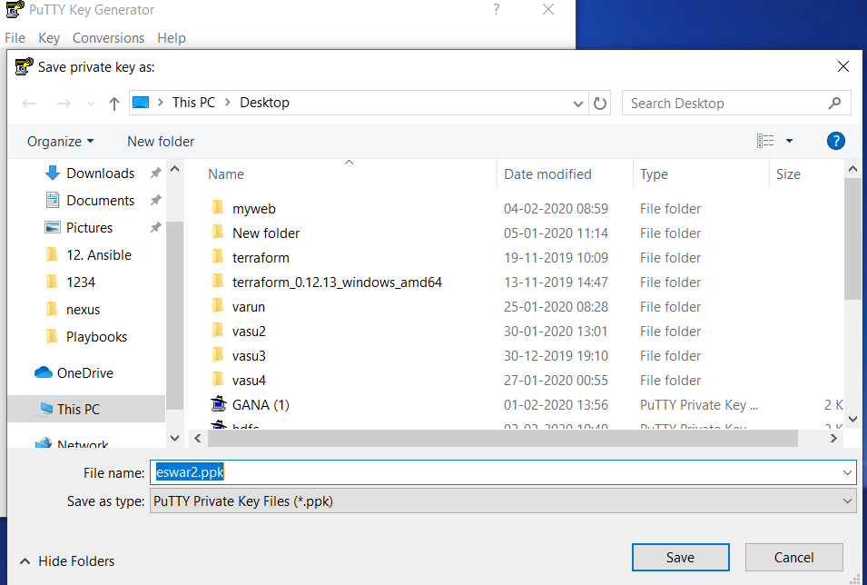

Step 10: finally save ( completed your pem file to ppk convertion )

Check ur desktop or your path

Ec2-instance connecting method:

Step 1: copy ec2-instance public ip and paste in putty tool.

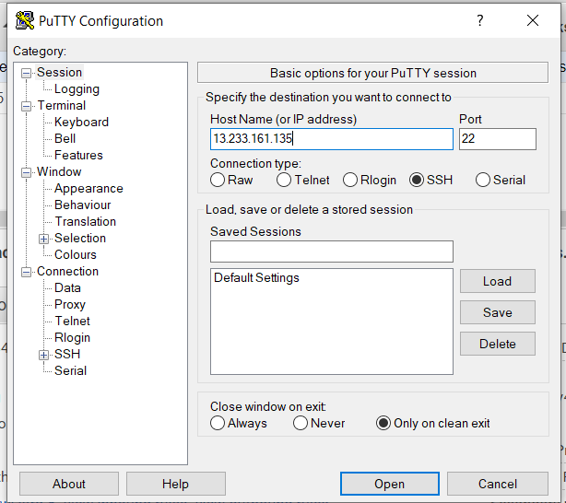

Step 2: select the ssh beside box :

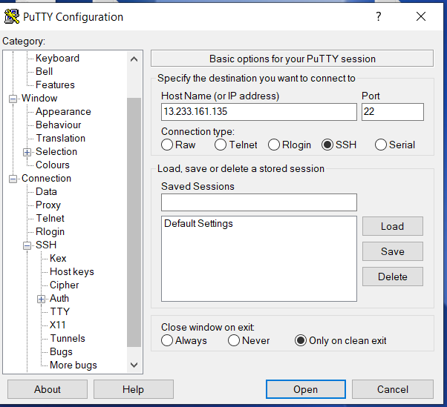

Step 3: Now select Auth

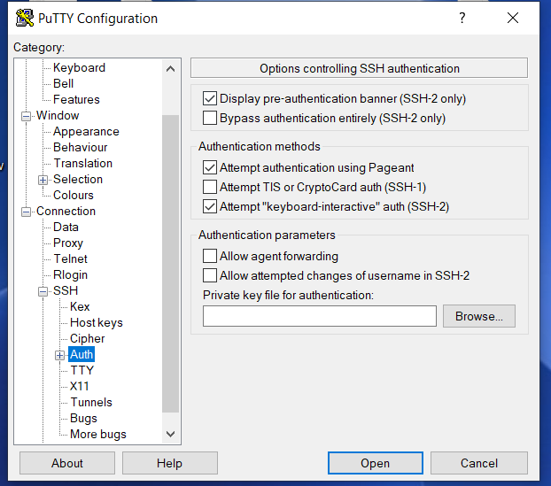

Step4: browse your ppk file

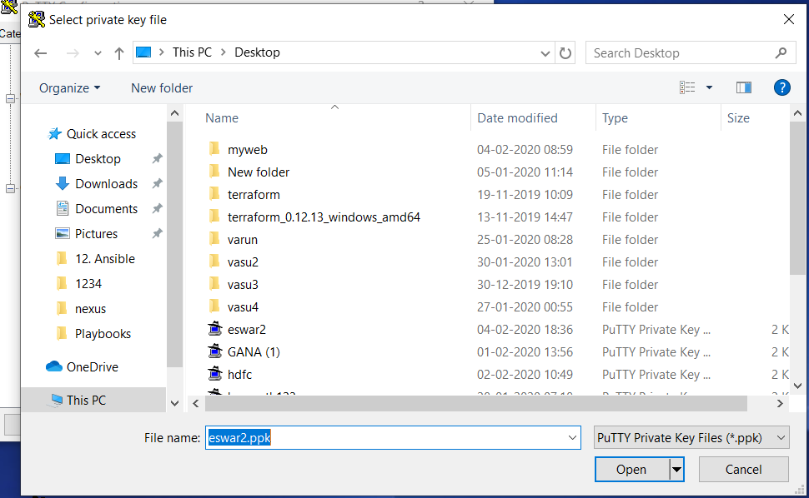

Step 5: now click on open

Step 6 : now also click on open

Step 7: Now click on yes

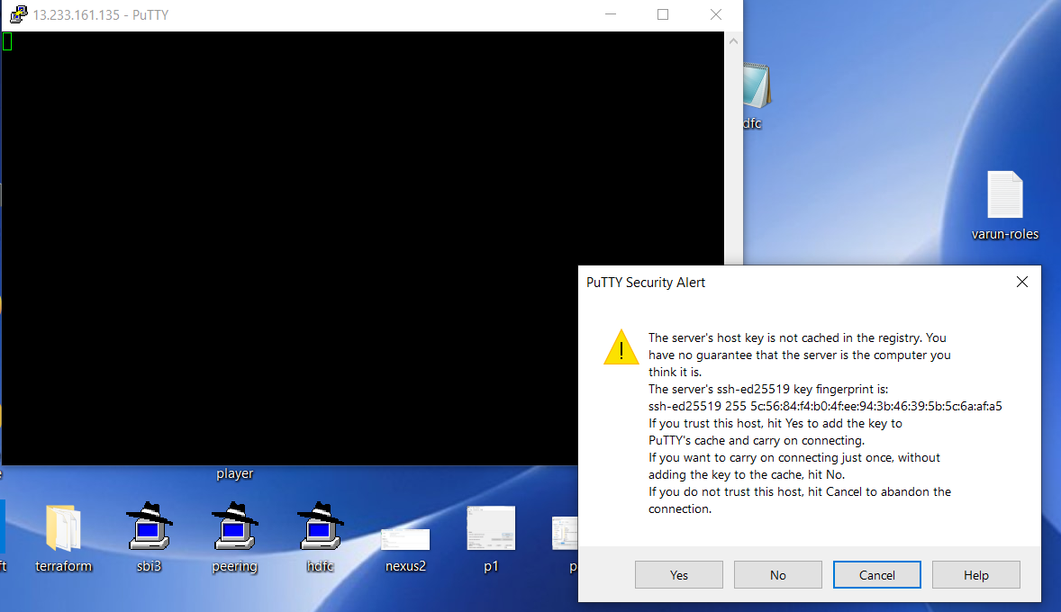

Step 8: Now login as ec2-user and then enter

And type command sudo su

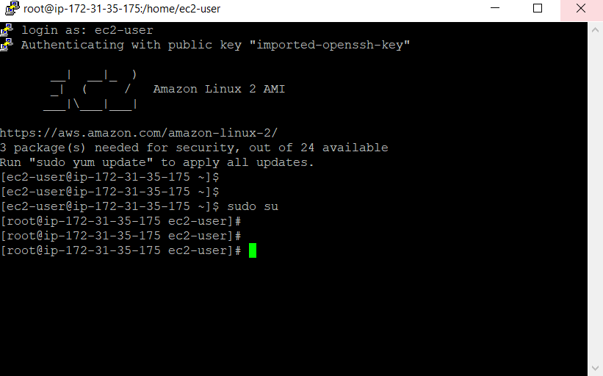

Now you are in ec2-instance.

Go with your Linux commands..