1. here is a small error in admin , plans & subscription page as it show you are currently on this plan

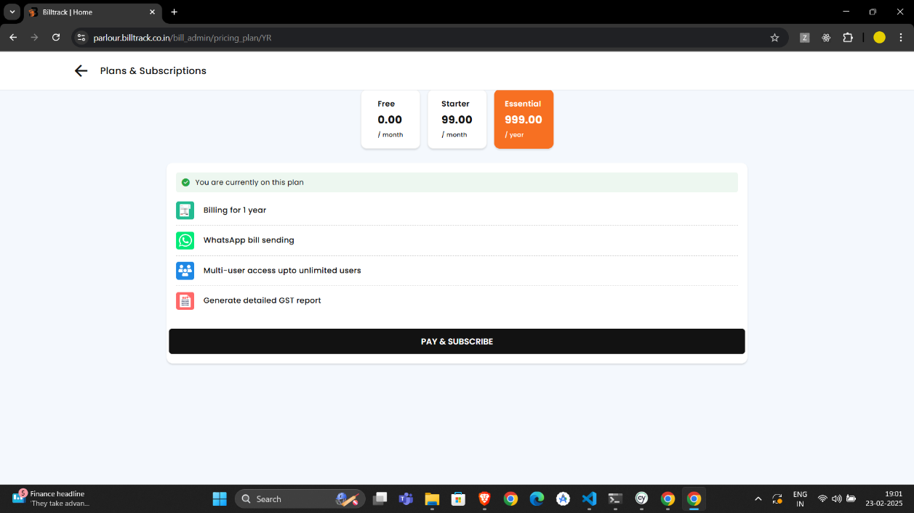

1. On the desktop admin page, selecting options like **Profile Settings, Service Category, or Invoice Tag Line** from the menu and then navigating back should return to the menu instead of redirecting directly to the admin dashboard.
2. In the login form, phone numbers cannot start with 1,2,3,4,5, but in the Add User section in admin panel, numbers starting with 1,2,3,4,5 are accepted.
3. Responsiveness issue in iPad Air menu button

