MEDITRACK
HOSPITAL PATIENT DATA ANALYSIS SYSTEM

A project report submitted as part of academic requirements for the python programming course.
2nd year | B. Tech | Computer Science and Engineering

PROJECT TEAM DETAILS

S. No. | Team member | Roll number | Role
1. | Ipparla Vaishnavi | 25102A040161 | Integration & Testing
2. | Golla Krishna Jhansi | 25102A040164 | Backend Development
3. | Bathalapalli Hasini | 25102A040184
  Frontend Development
4. | Mandhalapu Giridhar Naidu | 25102A040203
  Data Analysis & Visualization
5. | Dudekula Sujith Vali | 25102A040153 | Database Management

UNDER THE GUIDANCE OF
Mr. Mohammad Vali
Department of Computer Science and Engineering
MOHAN BABU UNIVERSITY
Tirupati, Andhra Pradesh
ACADEMIC YEAR: 2026–2027
TABLE OF CONTENTS
1. | Abstract
2. | Introduction
3. | Problem Statement
4. | Objectives
5. | Existing System
6. | Proposed System
7. | Software and Hardware Requirements
8. | Technologies Used
9. | System Architecture
10. | Database Design
11. | Module Description
12. | System Implementation
13. | Results and Screenshots
14. | Testing
15. | Conclusion
16. | Future Enhancements
17. | References

ABSTRACT
MediTrack is a Hospital Patient Data Analysis System developed to manage patient information and analyze hospital visit records efficiently. The system aims to simplify the organization of patient data and provide useful insights into hospital operations through data analysis and visualization.
The application is developed using Python and Flask for backend functionality, HTML, CSS, and JavaScript for the user interface, and MySQL for database management. It allows authorized users to register and log in, manage patient records, maintain hospital visit details, and view analytical reports.
The system uses Python libraries such as Pandas and NumPy for data processing and Matplotlib for generating graphical visualizations. It provides insights into daily and monthly patient visits, department-wise workload, and age-group distribution. These features help users understand patient visit patterns and observe the distribution of hospital workload.
MediTrack provides a simple and organized platform for handling hospital visit information and presenting meaningful analytical results. The project demonstrates the practical application of web development, database management, and data analysis techniques in a healthcare-related environment.

2. INTRODUCTION
The healthcare sector generates a large amount of information through patient registrations, hospital visits, appointments, and department activities. Managing this information in an organized manner is important for understanding hospital operations and maintaining accurate records.
MediTrack is a Hospital Patient Data Analysis System developed to organize patient information and analyze hospital visit records. The system provides a simple web-based platform where authorized users can manage patient details, maintain visit records, and view analytical reports.
The application combines web development, database management, and data analysis techniques. Flask is used to develop the backend, MySQL is used to store and manage data, and HTML, CSS, and JavaScript are used to create the user interface.
The system also uses Python libraries such as Pandas and NumPy for processing data and Matplotlib for generating visual representations. These visualizations provide insights into daily and monthly patient visits, department-wise workload, and age-group distribution.
MediTrack aims to make hospital data management more organized and present useful information through simple analytical reports and graphical visualizations.

2.1 Project overview
MediTrack is a web-based Hospital Patient Data Analysis System designed to maintain patient information and analyze hospital visit records. It provides a centralized platform for storing, accessing, and managing patient and visit details.
The system includes features such as user authentication, patient registration, visit management, demographic analysis, and report generation. Users can view patient records, maintain hospital visit information, and analyze data based on different categories.
The application processes stored information using Python libraries and presents analytical results through charts and visualizations. It helps in understanding patient visit trends, department-wise workload, and the distribution of patients across different age groups.
The project demonstrates how web technologies, database systems, and data analysis can be integrated to develop a simple and useful healthcare information management application.

3. PROBLEM STATEMENT
Managing hospital patient information and visit records can become difficult when data is maintained manually or stored in separate records. Such methods may lead to difficulties in organizing, retrieving, and analyzing information.
Without a proper system, understanding patient visit patterns, department-wise workload, and demographic distribution can require additional time and effort. The absence of graphical reports also makes it difficult to interpret stored information quickly.
Therefore, there is a need for a simple and centralized system that can manage patient details, maintain hospital visit records, and provide meaningful insights through data analysis and visualization.
MediTrack addresses these challenges by providing a web-based platform for patient data management and hospital visit analysis.

4. OBJECTIVES
The main objective of the MediTrack project is to develop a web-based system for managing hospital patient information and analyzing visit records efficiently.
The specific objectives are:
- To develop a user-friendly web application for hospital data management.
- To provide secure user registration and login functionality.
- To maintain patient information in a structured database.
- To record and manage hospital visit details.
- To analyze daily and monthly patient visits.
- To examine department-wise patient workload.
- To analyze patient distribution across different age groups.
- To generate graphical reports using data visualization techniques.
- To organize hospital information and make it easier to access and understand.

5. EXISTING SYSTEM
In traditional hospital data management systems, patient information and visit records may be maintained using manual registers, spreadsheets, or basic record-keeping applications. These methods are commonly used to store patient details and track hospital activities.
However, managing large amounts of information through such methods can be time-consuming and may make data retrieval and analysis difficult. Identifying patient visit trends, department-wise workload, and age-group distribution may require manual calculations.

Limitations of the Existing System
- Manual data management requires additional time and effort.
- Retrieving specific patient information can be difficult.
- Data analysis may require manual calculations.
- Generating graphical reports is not always convenient.
- Monitoring patient visit patterns can be challenging.
- Maintaining organized records becomes difficult as data increases.

6. PROPOSED SYSTEM
The proposed system, MediTrack, is a web-based Hospital Patient Data Analysis System developed to simplify patient information management and hospital visit analysis.
The application provides a centralized platform where authorized users can register, log in, manage patient records, and maintain hospital visit details. The information is stored in a MySQL database, making it easier to access and organize records.
MediTrack uses Python libraries such as Pandas and NumPy to process and analyze stored data. Matplotlib is used to generate graphical representations that help users understand patient visit trends, department-wise workload, and age-group distribution.
The system also provides a dashboard and analytical reports to present important information in an organized manner.

Advantages of the Proposed System
- Centralized management of patient information.
- Easy registration and retrieval of patient records.
- Organized maintenance of hospital visit details.
- Analysis of daily and monthly patient visits.
- Department-wise workload analysis.
- Age-group-based demographic analysis.
- Graphical representation of analytical results.
- Simple and user-friendly web interface.

7. SOFTWARE AND HARDWARE REQUIREMENTS
The development and execution of the MediTrack application require suitable hardware and software environments to ensure smooth operation.
7.1 Hardware requirements
The basic hardware requirements for the system are:
- Processor: Intel Core i3 or equivalent and above.
- RAM: Minimum 4 GB.
- Hard Disk: Minimum 10 GB of available storage.
- Display: Standard monitor or laptop display.
- Input Devices: Keyboard and mouse.

7.2 Software requirements
The software requirements for developing and running the application are:
- Operating System: Windows / Linux.
- Programming Language: Python.
- Frontend Technologies: HTML, CSS, JavaScript.
- Backend Framework: Flask.
- Database: MySQL.
- Database Management Tool: MySQL Workbench.
- Code Editor: Visual Studio Code.
- Data Analysis Libraries: Pandas and NumPy.
- Data Visualization Library: Matplotlib.
- Additional Libraries: Flask-WTF, Python-dotenv, MySQL Connector.
- Deployment Server: Gunicorn.
- Web Browser: Google Chrome or any modern web browser.

8. TECHNOLOGIES USED
The MediTrack application is developed using various programming languages, frameworks, libraries, and database technologies. Each technology plays an important role in building the application, managing data, and generating analytical reports.

8.1 Python
Python is the primary programming language used for backend development and data analysis. It handles application logic, database operations, and data processing.

8.2 Flask
Flask is a lightweight Python web framework used to develop the backend of the application. It manages routing, user authentication, session handling, and communication between the frontend and database.

8.3 HTML
HTML (HyperText Markup Language) is used to create the structure of web pages, including forms, tables, navigation menus, and other interface elements.

8.4 CSS
CSS (Cascading Style Sheets) is used to design and style the application. It improves the appearance of web pages through layouts, colors, spacing, and fonts.

8.5 JavaScript
JavaScript is used to add interactivity and dynamic functionality to the user interface, improving the overall user experience.

8.6 MySQL
MySQL is a relational database management system used to store and manage patient information, department details, and hospital visit records in a structured format.

8.7 Pandas
Pandas is a Python library used for data manipulation and analysis. It helps process hospital visit records and organize information for generating analytical reports.

8.8 NumPy
NumPy is a Python library used for numerical operations and efficient data processing. It supports calculations required during data analysis.

8.9 Matplotlib
Matplotlib is a Python data visualization library used to generate charts and graphs. It helps represent patient visit trends, department-wise workload, and age-group distribution visually.

8.10 Flask-WTF
Flask-WTF is used to integrate form handling and validation functionality into the Flask application.

8.11 MySQL connector
MySQL Connector is a Python library used to establish communication between the Flask application and the MySQL database.

8.12 Python-dotenv
Python-dotenv is used to load environment variables from a .env file. It helps manage database configuration details separately from the application code.

8.13 Gunicorn
Gunicorn is a Python WSGI HTTP server used to run the Flask application in the deployment environment.
9. SYSTEM ARCHITECTURE
System architecture describes the overall structure of the MediTrack application and explains how its different components interact with one another.
MediTrack follows a web-based architecture consisting of a frontend, backend, database, and data analysis components. Each component performs a specific function to ensure the proper functioning of the application.

9.1 Architecture components
1. User Interface (Frontend)
The frontend is developed using HTML, CSS, and JavaScript. It provides an interactive interface through which users can log in, register, manage patient details, view visit records, and access reports.
2. Application Layer (Backend)
The backend is developed using Python and Flask. It handles user requests, manages application routes, performs authentication, processes form submissions, and communicates with the database.
3. Database Layer
MySQL is used as the database management system. It stores patient information, department details, and hospital visit records in structured tables.
4. Data Analysis Layer
Pandas and NumPy are used to process and analyze the stored data. Matplotlib generates graphical representations of the analysis, helping users understand hospital visit patterns and other important information.

9.2 Working flow of the system
The overall working process of MediTrack is as follows:
- The user accesses the application through a web browser.
- The frontend displays the required pages and forms.
- User requests are handled by the Flask backend.
- The backend communicates with the MySQL database to store or retrieve information.
- Retrieved data is processed using Pandas and NumPy.
- Matplotlib generates charts and graphical visualizations.
- The processed information and reports are presented to the user through the web interface.

9.3 Architecture flow diagram
User → Frontend (HTML, CSS, JavaScript) → Flask Backend (Python) → MySQL Database

MySQL Database → Data Analysis (Pandas, NumPy) → Visualization (Matplotlib) → Reports and Dashboard

This architecture provides a structured approach to managing hospital information and presenting analytical results through a web-based application.

10. DATABASE DESIGN
Database design is an important part of the MediTrack application. MySQL is used to store and manage user credentials, patient information, department details, and hospital visit records in a structured manner.
The database used in this project is named hospital_db. It consists of four main tables: Users, Patients, Departments, and Visits.

10.1 Database tables
1. Users Table
The Users table stores the information required for user registration and authentication.
Attributes:
- user_id – Unique identifier for each user and Primary Key.
- username – Stores the user's name.
- email – Stores the user's email address.
- password_hash – Stores the hashed password for authentication.
- created_at – Records the account creation timestamp.
2. Patients Table
The Patients table stores basic information about registered patients.
Attributes:
- patient_id – Unique identifier for each patient and Primary Key.
- age_band – Represents the patient's age category.
- gender_optional – Stores optional gender information.
- blood_group – Stores the patient's blood group.
3. Departments Table
The Departments table maintains information about the different hospital departments.
Attributes:
- department_id – Unique identifier for each department and Primary Key.
- department_name – Stores the name of the department.
4. Visits Table
The Visits table maintains records of patient visits to different hospital departments.
Attributes:
- visit_id – Unique identifier for each visit and Primary Key.
- patient_id – References the patient in the Patients table and acts as a Foreign Key.
- department_id – References the department in the Departments table and acts as a Foreign Key.
- visit_date – Stores the date of the hospital visit.
- visit_type – Specifies the type of visit, such as Check-up, Consultation, or Follow-up.

10.2 Relationships between tables
The database contains the following relationships:
- Users Table: Maintains user account information independently for authentication.
- Patients and Visits: One patient can have multiple visit records. Each visit belongs to a particular patient. This represents a One-to-Many relationship.
- Departments and Visits: One department can have multiple visit records. Each visit is associated with a particular department. This also represents a One-to-Many relationship.

10.3 Database structure
The database follows a relational structure in which tables are organized using primary and foreign keys.
- patient_id connects the Patients and Visits tables.
- department_id connects the Departments and Visits tables.
- The Users table maintains account information for application authentication.

10.4 Database management
The database is managed using MySQL, and MySQL Workbench is used for database administration and query execution.
The application uses MySQL Connector to establish communication between Python and the MySQL database. This allows the system to insert, retrieve, and manage records efficiently.
The structured database design helps maintain organized hospital records and provides the necessary data for analysis and report generation.

11. MODULE DESCRIPTION
MediTrack is divided into different modules, with each module performing a specific function. These modules work together to provide an organized platform for managing patient information and analyzing hospital visit records.

11.1 Login and Registration module
This module provides user authentication functionality. New users can create an account through the registration page, while existing users can log in using their credentials.
The application uses Flask sessions to maintain user login status and restrict access to protected pages.

11.2 Dashboard module
The Dashboard module provides an overview of the hospital data. It presents important information in an organized manner, allowing users to access different sections of the application easily.
It acts as the main navigation point for patient management, visit records, demographic analysis, and reports.

11.3 Patient management module
The Patient Management module allows users to add and maintain patient information.
It stores details such as patient ID, age group, gender (optional), and blood group. Users can access organized patient records through this module.

11.4 Visit management module
The Visit Management module is used to maintain hospital visit records.
It records information such as patient ID, department ID, visit date, and visit type. The available visit types include Check-up, Consultation, and Follow-up.
These records are used for analyzing hospital visit patterns and department activities.

11.5 Demographics module
The Demographics module focuses on analyzing patient information based on demographic categories.
It provides an overview of patient distribution across different age groups and other available demographic categories. This helps users understand the composition of the registered patient population.

11.6 Reports module
The Reports module presents analytical information obtained from hospital visit records.
It uses Python data analysis and visualization libraries to generate graphical representations of hospital activities.
The reports provide insights into:
- Daily patient visits.
- Monthly patient visits.
- Department-wise workload.
- Age-group distribution.
These visualizations make the analytical information easier to understand and interpret.

12. SYSTEM IMPLEMENTATION
The MediTrack application is implemented using Python, Flask, MySQL, and frontend web technologies. The implementation involves developing the user interface, handling application logic, connecting the database, managing user authentication, and performing data analysis.

12.1 Frontend implementation
The frontend is developed using HTML, CSS, and JavaScript.
- HTML is used to structure the application pages.
- CSS is used to design the layout, colors, navigation menus, and overall appearance.
- JavaScript is used to provide interactive functionality.
The frontend consists of pages such as Login, Registration, Dashboard, Patients, Visits, Demographics, and Reports.

12.2 Backend implementation
Python and Flask are used to implement the backend functionality.
Flask handles application routing and processes user requests. It connects the frontend with the database and manages operations such as user authentication, patient record management, and visit record management.
The application uses Flask sessions to maintain login status and a login-required mechanism to protect restricted pages.

12.3 Database connectivity
MySQL is used to store application data in the hospital_db database.
MySQL Connector is used to establish a connection between the Flask application and the database.
The database operations include:
- Registering and authenticating users.
- Adding patient information.
- Retrieving patient records.
- Maintaining hospital visit details.
- Accessing department information.

12.4 Data analysis implementation
The data analysis component is developed using Python libraries such as Pandas and NumPy.
Pandas is used to organize and process hospital visit records, while NumPy supports numerical operations.
The system analyzes the available data to identify:
- Daily patient visit counts.
- Monthly patient visit trends.
- Department-wise workload.
- Patient age-group distribution.

12.5 Data visualization implementation
Matplotlib is used to generate graphical representations of the analyzed data.
The generated charts help present patient visit trends, department-wise workload, and demographic information in an understandable format.
These visualizations are made available through the application's analytical sections.

12.6 Application deployment
The application is configured for deployment using Gunicorn as the WSGI HTTP server.
The required Python packages and environment configurations are maintained to support application execution in the deployment environment.
The deployment process makes the web application accessible through a web browser.

13. RESULTS AND SCREENSHOTS
The MediTrack application was successfully developed to manage hospital patient information and analyze hospital visit records. The system provides a user-friendly interface for managing records and viewing analytical information.
The application includes user authentication, patient management, visit management, demographic analysis, and report generation functionalities.
The system processes the stored information and presents analytical results through graphical visualizations, helping users understand patient visit patterns and department-wise workload.

13.1 Application screenshots
The following screenshots illustrate the different functionalities and outputs of the MediTrack application.

1. Login Page
Displays the login interface through which registered users can access the application.
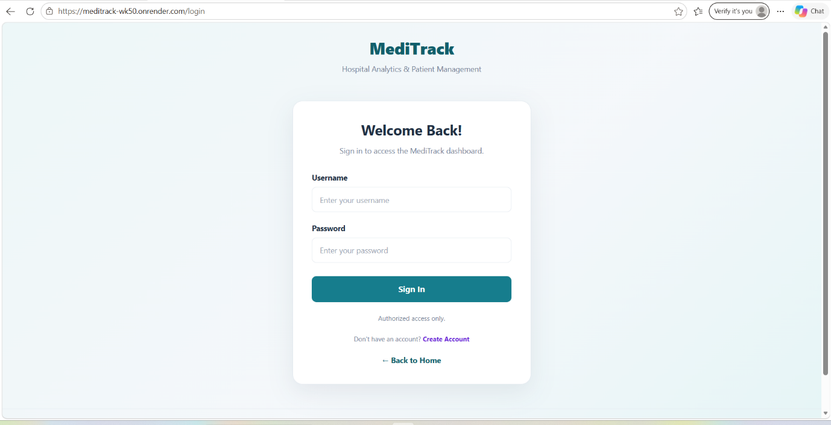
Fig 13.1.1: Login page

2. Registration Page
Allows new users to create an account to access the application.
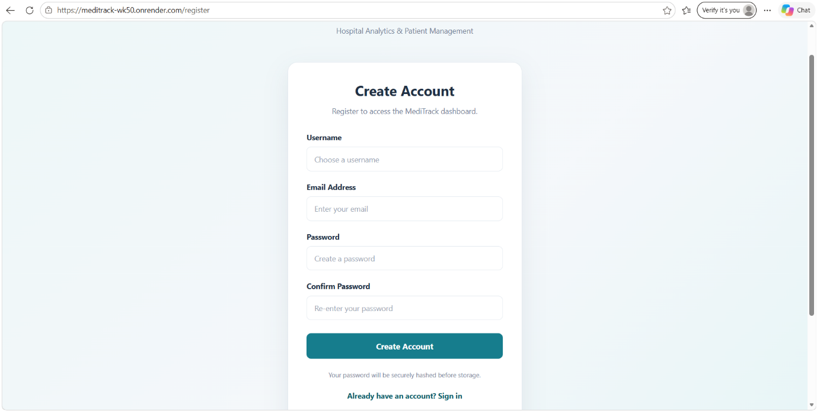
Fig 13.2.1: Account registration page

3. Home Page
Displays an overview of the application and provides navigation to different modules.
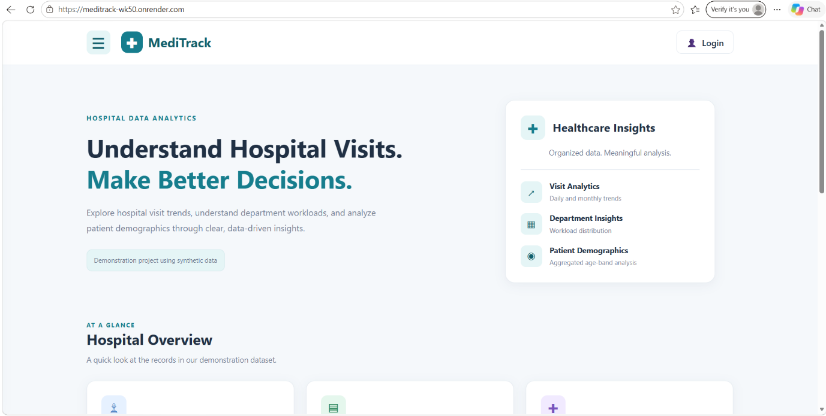
Fig 13.3.1: Home page
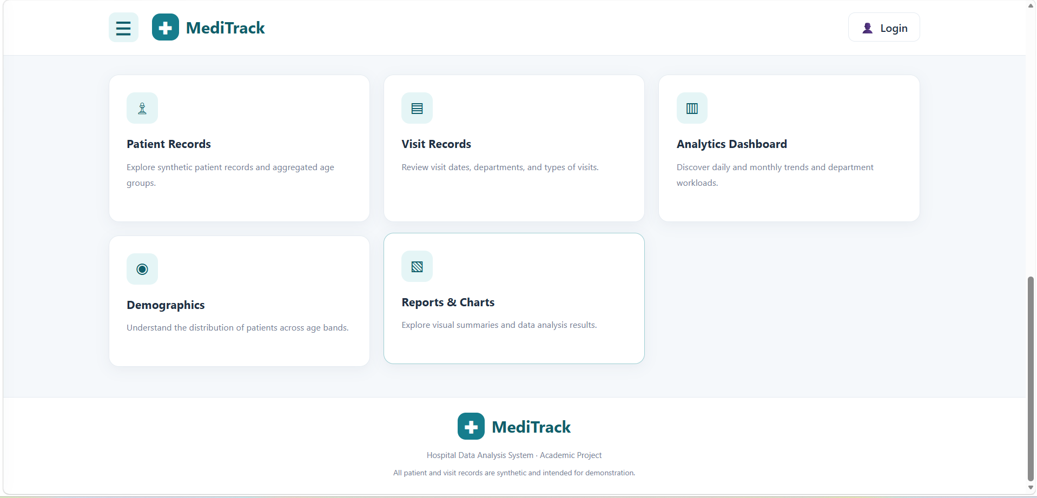
Fig 13.3.2: Feature cards display on home page

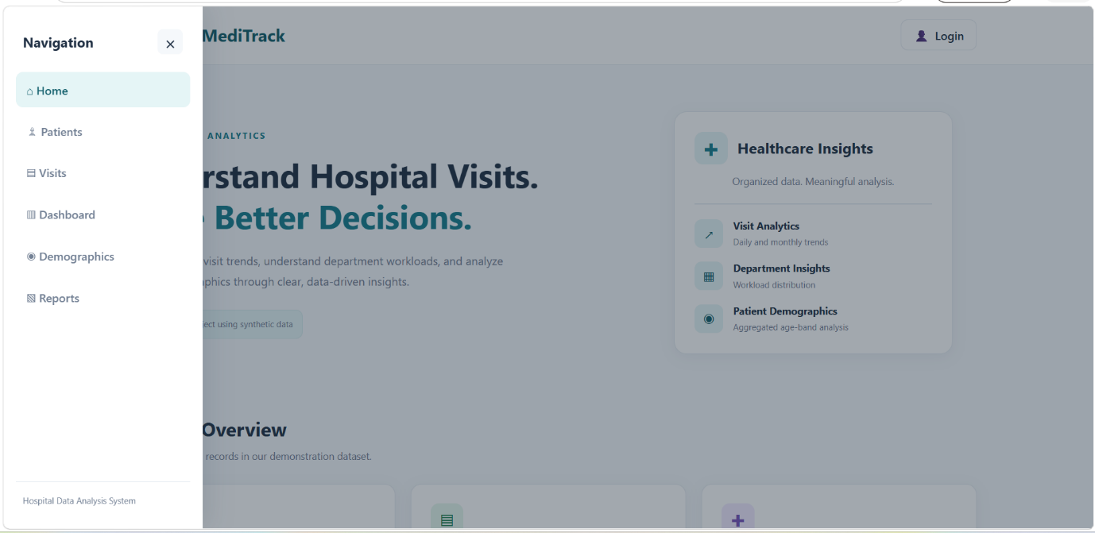
Fig 13.3.3: Navigation bar

4. Patient Management Page
Displays patient records and provides functionality to add patient information.
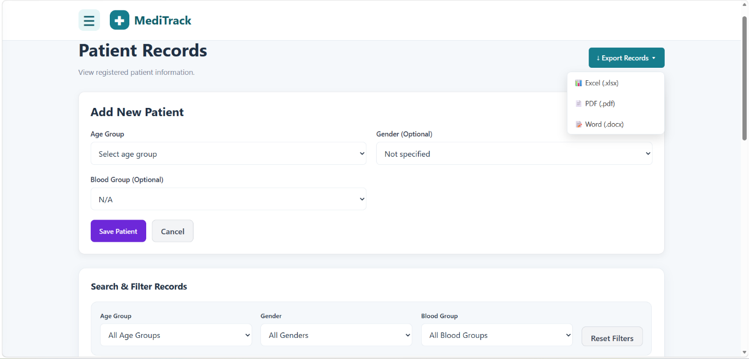
Fig 13.4.1: Add patient form

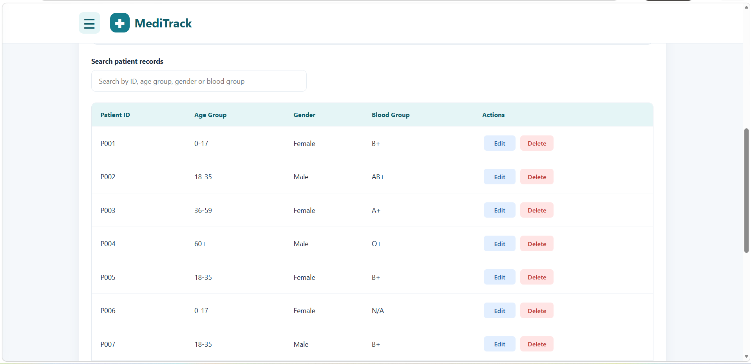
Fig 13.4.2: Patient records

5. Visit Management Page
Displays hospital visit records, including patient details, departments, visit dates, and visit types.
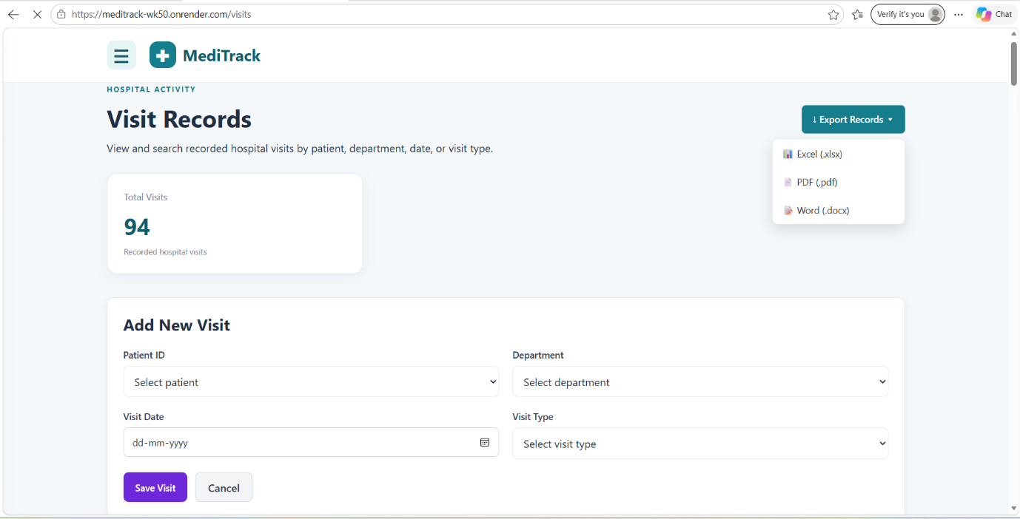
Fig 13.5.1: Add visit form

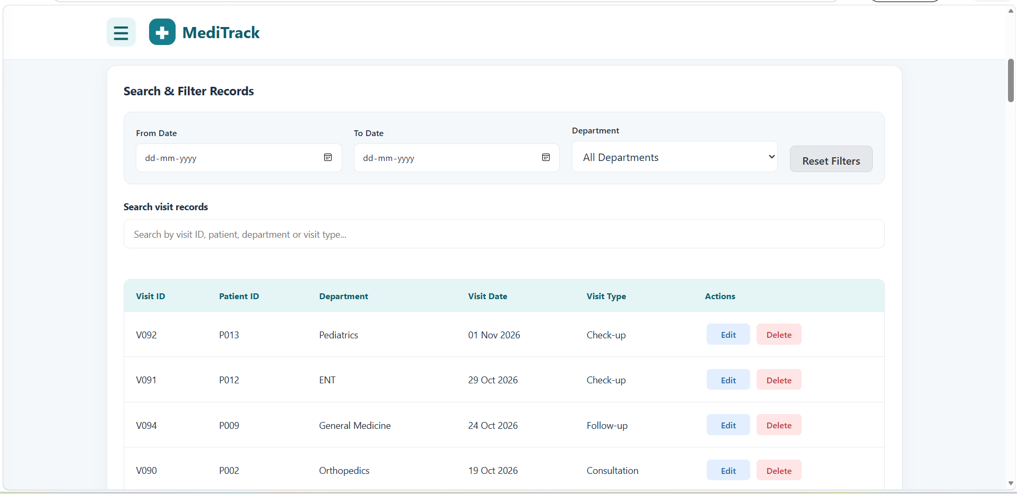
Fig 13.5.2: Visit records

6. Dashboard Analytics page
Displays an overview of hospital statistics and analytical information.
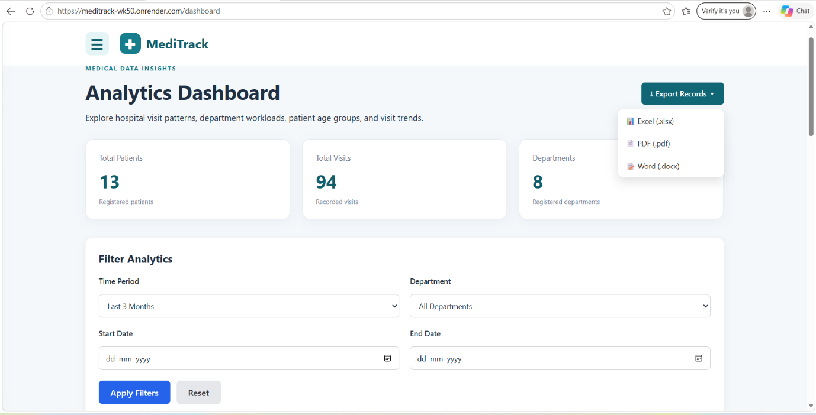
Fig 13.6.1: Overview

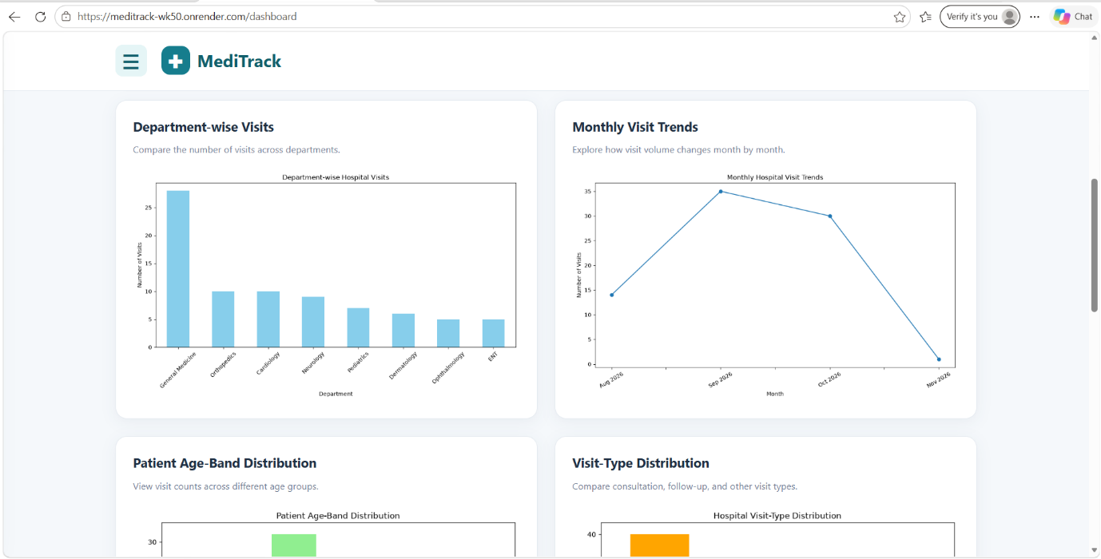
Fig 13.6.2: Analytical charts

7. Demographics Page
Presents demographic information and age-group distribution through analytical visualizations.

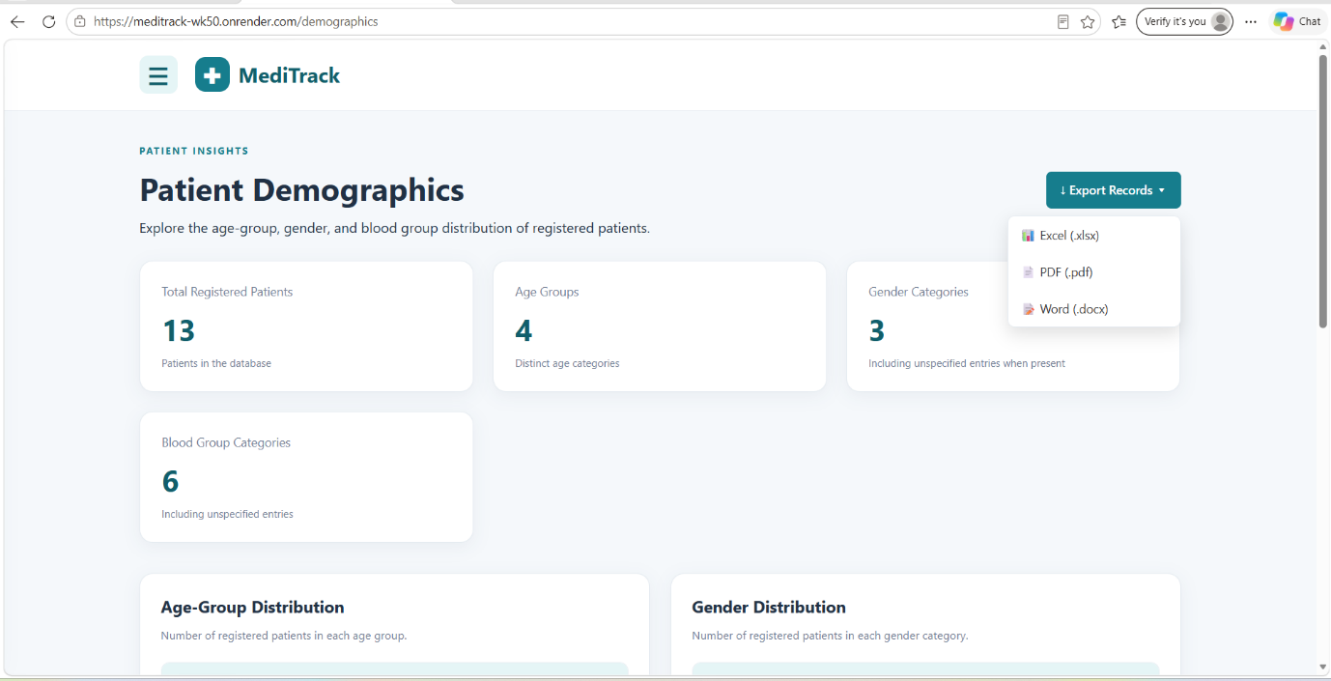
Fig 13.7.1: Overview

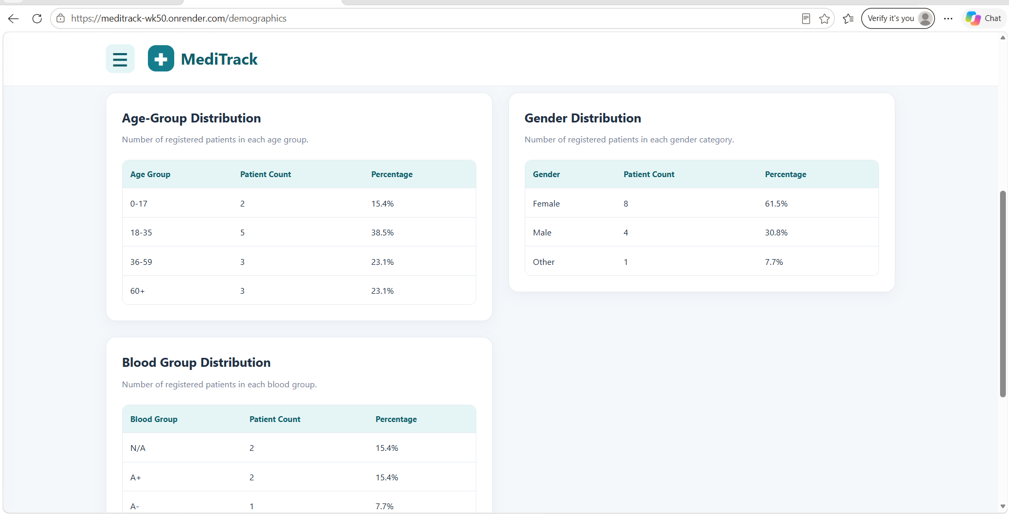
Fig 13.7.2: Age group, Gender and Blood group distribution

8. Reports Page
Displays analytical reports, including daily and monthly patient visits and department-wise workload.
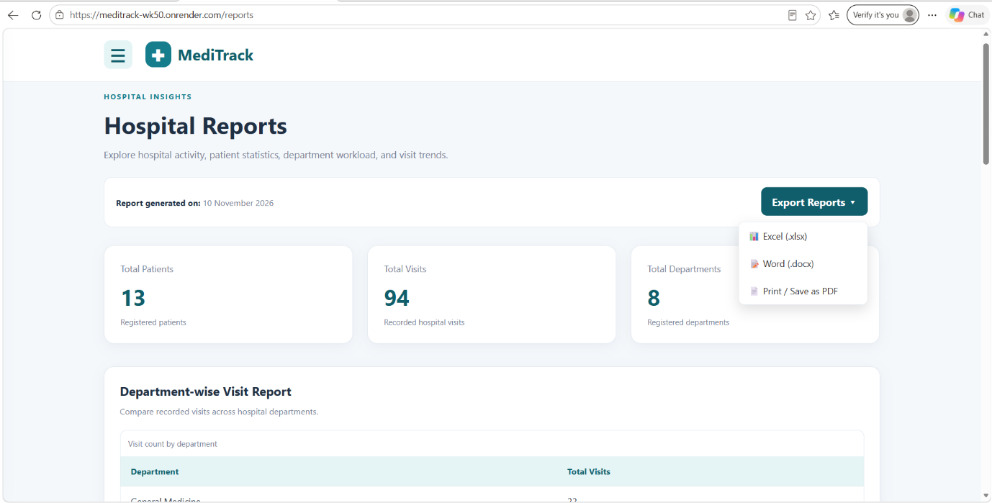
Fig 13.8.1: Department-wise visit report
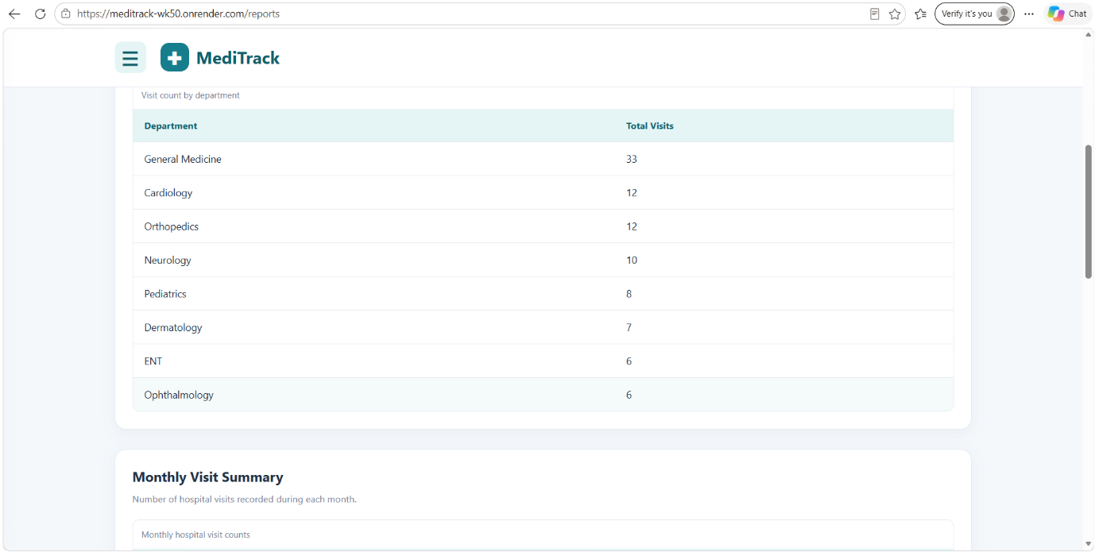
Fig 13.8.2: Monthly visit summary
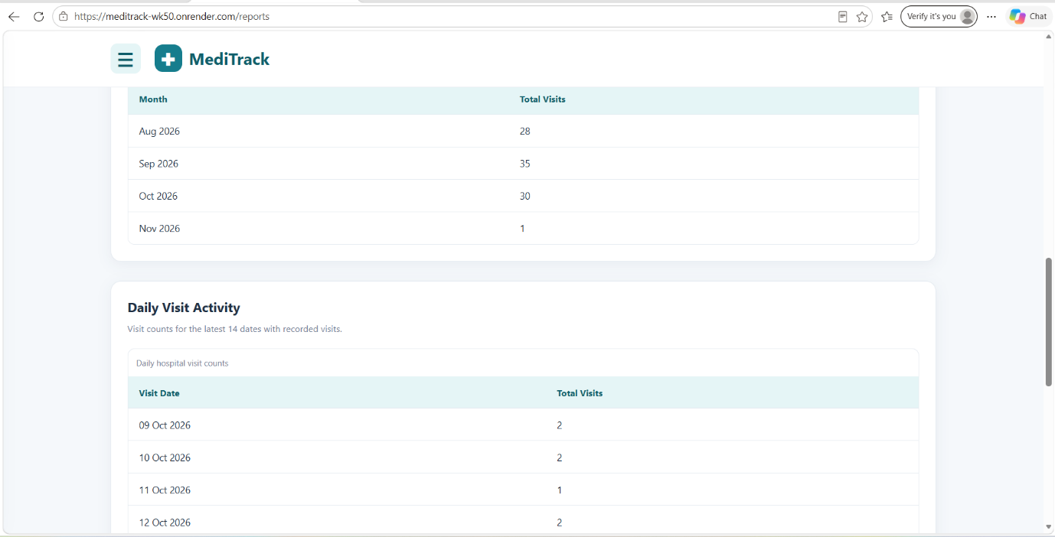
Fig 13.8.3: Daily visit activity

Project output
The developed application successfully demonstrates the integration of web development, database management, and data analysis.
The system provides an organized method of maintaining patient records and generates graphical reports that make hospital data easier to understand.

14. TESTING
Software testing is an important phase of application development. It is performed to verify that the application functions correctly and meets its intended requirements.
The MediTrack application was tested to check the functionality of its different modules, database operations, user authentication, and data analysis features.

14.1 Types of testing
1. Functional Testing
Functional testing was performed to verify the working of different application features, including user registration, login, patient management, visit management, and report generation.
2. Database Testing
Database testing was performed to verify the connection between the Flask application and MySQL database. It also checked the storage and retrieval of patient, department, and visit records.
3. User Interface Testing
The application pages were checked to ensure that navigation, forms, buttons, tables, and other interface elements function properly.
4. Data Analysis Testing
The data analysis functionality was checked to verify that patient visit records were processed correctly and that the generated charts represented the available data.

14.2 Test cases
The following test cases were considered during application testing.
S. No. | Test Case | Expected Result
1 | User Registration | New user account should be created.
2 | User Login | Valid credentials should allow access.
3 | Invalid Login | Access should be denied.
4 | Add Patient | Patient information should be stored.
5 | View Patients | Registered patient records should be displayed.
6 | Add Visit | Visit information should be stored.
7 | View Visits | Available visit records should be displayed.
8 | Demographic Analysis | Patient distribution should be displayed.
9 | Report Generation | Analytical charts should be generated.
10 | Database Connectivity | Application should communicate with MySQL successfully.
14.3 Testing outcome
Testing helped verify the major functionalities of the MediTrack application. The application was checked for proper navigation, database connectivity, record management, authentication, and data visualization.
The testing process helped identify and correct issues during development and improved the overall reliability of the application.

15. CONCLUSION
MediTrack, a Hospital Patient Data Analysis System, was successfully developed to organize patient information and analyze hospital visit records through a web-based application.
The project integrates Python, Flask, MySQL, HTML, CSS, and JavaScript to provide an organized platform for patient and visit record management. It also uses Pandas, NumPy, and Matplotlib to process data and generate graphical visualizations.
The application provides features such as user authentication, patient registration, visit management, demographic analysis, and report generation. It helps users understand daily and monthly patient visits, department-wise workload, and age-group distribution through analytical reports.
Through this project, practical knowledge of web application development, database management, Python programming, and data visualization was gained. MediTrack demonstrates how these technologies can be combined to develop a simple and useful hospital data management and analysis system.

16. FUTURE ENHANCEMENTS
The MediTrack application provides basic functionalities for managing patient information and analyzing hospital visit records. However, several additional features can be introduced in the future to improve its functionality, efficiency, and usability.
The possible future enhancements include:
- Appointment Scheduling: Introducing an appointment booking feature to help manage patient appointments efficiently.
- Advanced Analytics: Adding more analytical features to identify patient visit patterns and hospital activity trends.
- Data Export: Providing options to download analytical reports in formats such as PDF and Excel.
- Enhanced Security: Implementing additional security measures to improve user authentication and protect stored information.
- Search and Filtering: Introducing advanced search and filtering options to retrieve patient and visit records easily.
- Notification System: Adding notifications for upcoming appointments and important updates.
- Improved Dashboard: Introducing additional charts and statistical summaries to provide a more detailed overview of hospital activities.
These enhancements can make MediTrack more comprehensive and improve its usefulness for hospital information management and analysis.

17. REFERENCES
The following resources and documentation were referred to during the development of the MediTrack application.
- Python Official Documentation – https://docs.python.org/3/
- Flask Documentation – https://flask.palletsprojects.com/
- MySQL Official Documentation – https://dev.mysql.com/doc/
- Pandas Documentation – https://pandas.pydata.org/docs/
- NumPy Documentation – https://numpy.org/doc/
- Matplotlib Documentation – https://matplotlib.org/stable/
- Flask-WTF Documentation – https://flask-wtf.readthedocs.io/
- MySQL Connector/Python Documentation – https://dev.mysql.com/doc/connector-python/en/
- Gunicorn Documentation – https://docs.gunicorn.org/
- MDN Web Docs – HTML, CSS, and JavaScript References – https://developer.mozilla.org/

