1. Select * from customers;

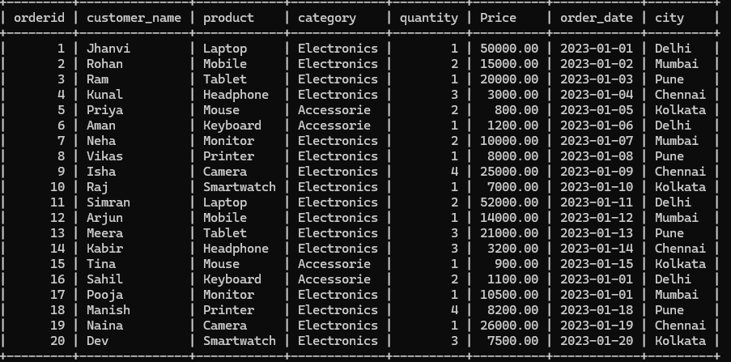

2) select orderid,customer_name,product,Price

from customers;

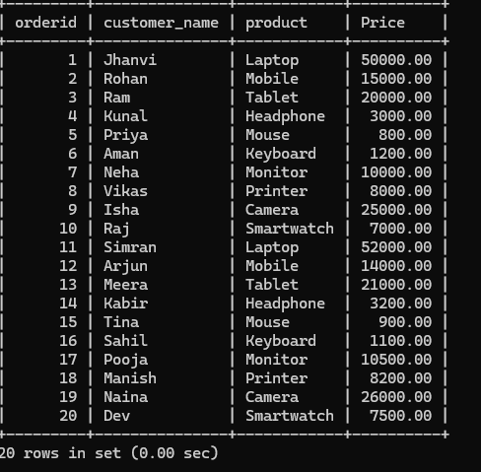

3) select orderid,customer_name,product,Price

from customers

WHERE Price>20000;

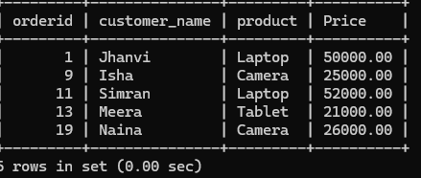

4) select orderid,customer_name,product,quantity,city

from customers

WHERE quantity>=2;

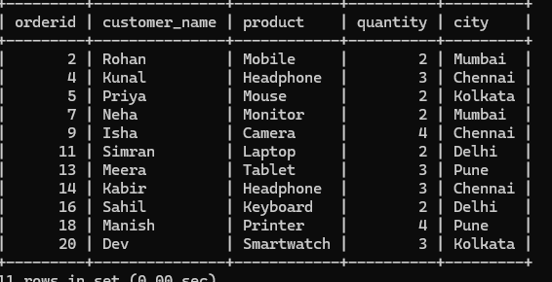

5) select orderid,customer_name,product,quantity,city

from customers

WHERE quantity>2 ORDER BY quantity ;

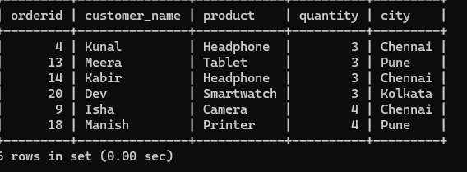

6) select customer_name,SUM(Price)

from customers

GROUP BY customer_name;

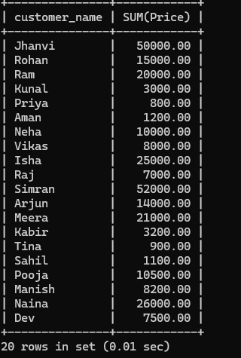

7) SELECT orders.order_id, customer.customer_name, customer.City, orders.Product, orders.Price

FROM orders

INNER JOIN customer

ON orders.customer_id = customer.customer_id;

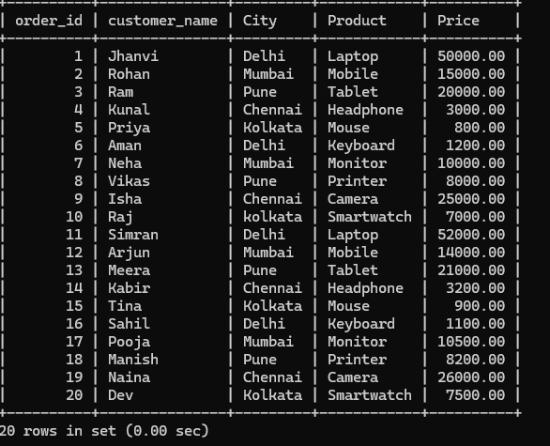

8) SELECT orders.order_id, customer.customer_name, customer.City, orders.Product, orders.Price

FROM orders

LEFT JOIN customer

ON orders.customer_id = customer.customer_id;



9) SELECT orders.order_id, customer.customer_name, customer.City, orders.Product, orders.Price

FROM customer

RIGHT JOIN orders

ON orders.customer_id = customer.customer_id;



10) SELECT customer_id, product, price

FROM orders

WHERE price > (SELECT AVG(price) FROM orders);

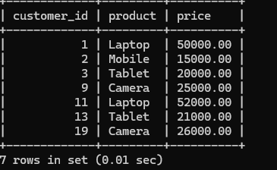

11) SELECT customer_id, AVG(price) AS avg_spent

FROM orders

GROUP BY customer_id

HAVING AVG(price) > (

SELECT AVG(price) FROM orders);

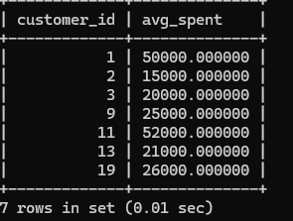

12) CREATE VIEW customer_total_spent AS

-> SELECT

-> customer.customer_id,

-> customer.customer_name,

-> SUM(orders.Price * orders.quantity) AS total_spent

-> FROM customer

-> JOIN orders ON customer.customer_id = orders.customer_id

-> GROUP BY customer.customer_id, customer.customer_name;

SELECT * FROM customer_total_spent;

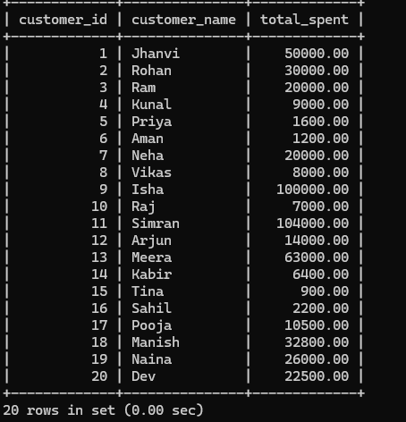

13)

