**Fruit salad with oats & berry yoghurt**

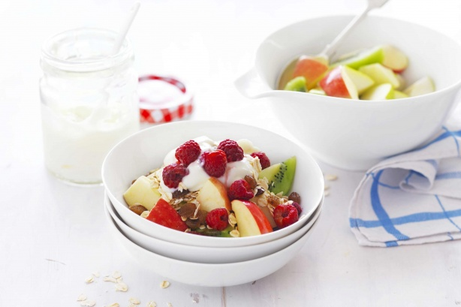

Energy:1504kJ

**Ingredients:**

* 2 Williams pears, sliced
* 2 Jazz apples, sliced
* 2 kiwifruit, sliced
* 1/2 cup rolled oats
* 1/3 cup sultanas
* 2 cups vanilla yoghurt

2/3 cup frozen raspberries, thawed.

**Steps:**

* 1. Divide pears, apple and kiwifruit evenly between 4 bowls.

2.  Top fruit salad with rolled oats and sultanas followed by vanilla yoghurt and thawed raspberries.

**Steamed Asian greens with honey soy sauce**

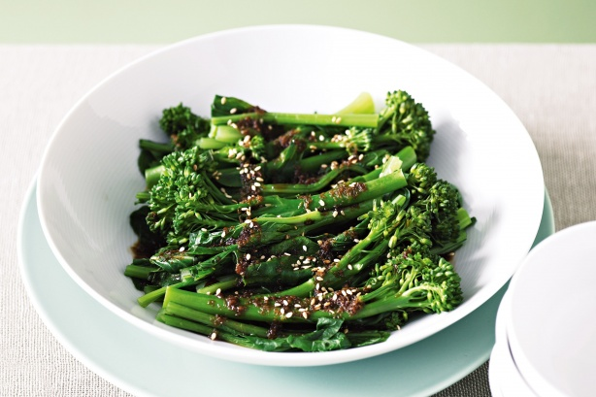

Energy:250kJ

**Ingredients:**

* 2 tablespoons salt-reduced soy sauce
* 1 tablespoon honey
* 2cm piece fresh ginger, peeled, finely grated
* 1 bunch baby choy sum, trimmed
* 1 bunch broccolini, trimmed

1/2 teaspoon sesame seeds, toasted

**Steps:**

* 1. Combine soy sauce, honey and ginger in a jug. Separate leaves from choy sum
* stems.

2. Place a large steamer over a wok or large saucepan of simmering water. Place choy sum stems and broccolini in steamer. Cook, covered, for 3 to 4 minutes or until just tender. Add choy sum leaves. Cook, covered, for 1 to 2 minutes or until wilted. Transfer to a bowl. Add sauce mixture. Toss to combine. Sprinkle with sesame seeds. Serve.

**Vegetable and tomato pasta soup**

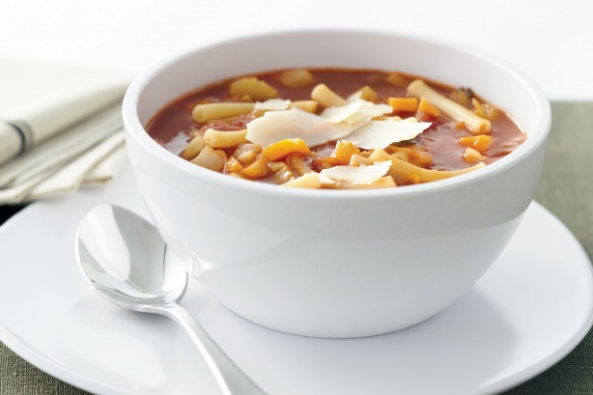

Energy:997kJ

**Ingredients:**

* 1 tablespoon olive oil
* 1 x 400g pkt Fresh Veggie Mix
* 1 x 800g can diced Italian tomatoes
* 1.25L (5 cups) water
* 145g (1 cup) dried macaroni pasta

Shaved parmesan, to serve

**Steps:**

* 1. Heat the oil in a large saucepan over medium heat. Add the vegetable mixture
* and cook, stirring, for 3 minutes or until the leek softens slightly.
* 2.  Add the tomato and water, and bring to the boil. Stir in the pasta and bring
* back to the boil. Reduce heat to medium. Simmer for 15 minutes or until the
* pasta is al dente. Season with salt and pepper.

3.  Ladle the soup among serving bowls and top with shaved parmesan to serve.

**Beef and cucumber salad**

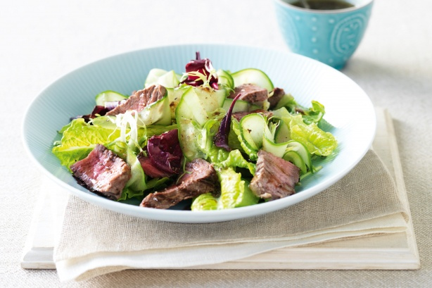

Energy: 1287kJ

**Ingredients:**

* 500g beef scotch fillet steaks
* Olive oil spray
* 200g pkt Italian-Style Salad
* 2 Lebanese cucumbers, peeled into ribbons

60ml (1/4 cup) bought balsamic dressing (see note)

**Steps:**

* 1. Preheat a chargrill on medium-high. Spray both sides of the steaks with oil.
* Season with salt and pepper.
* 2.  Reduce heat to medium. Cook the steaks for 2-3 minutes each side for medium
* or until cooked to your liking. Transfer to a plate and cover loosely with foil. Set
* aside for 3 minutes to rest.
* 3.  Combine the salad, cucumber and dressing in a large bowl.

4. Thickly slice the steaks diagonally across the grain. Add to the salad. Toss to combine.

**Warm roasted eggplant salad**

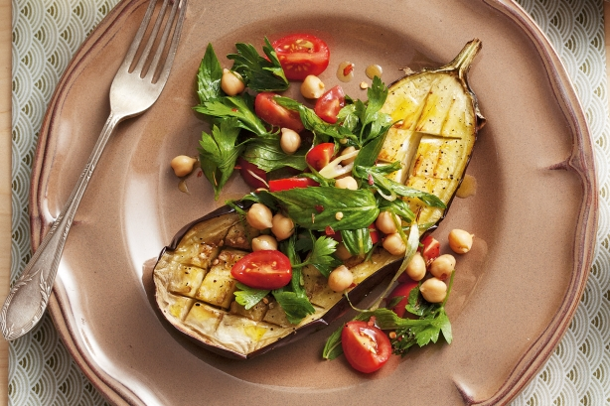

Energy: 1165kJ

**Ingredients:**

* 2x 350g eggplants, halved lengthwise
* 1 clove garlic, finely chopped
* 60ml (1/4 cup) olive oil
* 250g cherry tomatoes, quartered
* 400g can chickpeas, rinsed, drained
* 1 cup mint leaves
* 1 cup flat-leaf parsley
* 2 spring onions, thinly sliced on the diagonal
* 1/2 teaspoon dried chilli flakes
* 95g (1/3 cup) Greek-style yoghurt

1/2 lemon, juiced

**Steps:**

* 1. Preheat oven to 200C fan-forced. Line a large oven tray with foil and lightly
* grease. Using a small knife, cut a crosshatch pattern three-quarters of the way
* into flesh of each eggplant half, then place, flesh-side up, on tray. Combine garlic
* and 2 tablespoons oil in a small bowl, then brush over eggplant flesh. Season
* with salt and pepper. Roast for 20 minutes or until top is golden and flesh is
* tender.
* 2.  Meanwhile, to make dressing, whisk yoghurt, lemon juice and 2 tablespoons
* water in a bowl. Season. Makes 100ml.
* 3.  Combine tomatoes, chickpeas, herbs and onions in a bowl. Drizzle over
* remaining 1 tablespoon oil, season, then gently toss to combine.

4. Divide eggplant halves among plates and top with tomato and chickpea salad. Drizzle with yoghurt dressing and scatter with chilli flakes to serve.