**Broccoli with waldorf salad**

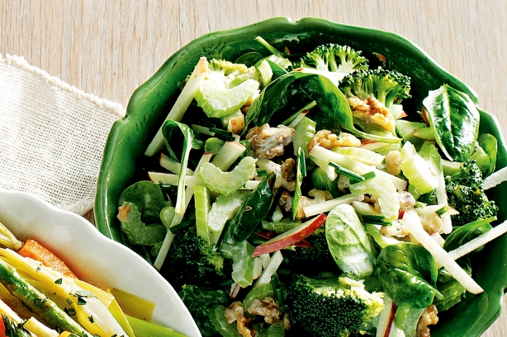

Energy: 1119kJ

**Ingredients:**

* 1 large head broccoli, cut into florets
* 1 red delicious apple, cored, cut into thin matchsticks
* 2 stalks celery, trimmed, thinly sliced
* 1/2 cup walnuts, toasted, roughly chopped
* 50g baby spinach leaves
* 1 tablespoon chopped fresh chives
* 1/4 cup whole egg mayonnaise
* 2 tablespoons lemon juice

**Steps:**

* 1. Cook broccoli in a saucepan of boiling water for 3 minutes or until bright green
* and just tender. Rinse under cold water. Drain well. Set aside to cool.
* 2. Place apple, celery, walnuts, spinach, chives and broccoli in a large bowl.
* Combine mayonnaise and lemon juice in a small jug. Season with salt and pepper.

3. Drizzle mayonnaise mixture over salad. Toss gently to combine. Serve.

**Chargrilled tomato & bean salad with spicy dressing**

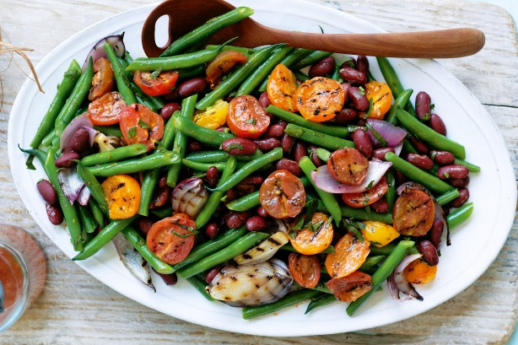

Energy: 395kJ

* **Ingredients:**
* 60ml (1/4 cup) extra virgin olive oil
* 1 tablespoon red wine vinegar
* 1/2 teaspoon ground cumin
* 1/2 teaspoon paprika
* 250g tomato Medley Mix, halved olive oil spray
* 1 large red onion, cut into wedges
* 500g green round beans, trimmed, halved diagonally
* 400g can red kidney beans, rinsed, drained

2 tablespoons chopped fresh continental parsley

**Steps:**

* 1. Combine the oil, vinegar, cumin and paprika in a small jug. season with salt
* and pepper. Cover and set aside until required.
* 2. Preheat a chargrill or barbecue grill on high. spray the tomato with oil. Cook
* for 1-2 minutes each side or until lightly charred. transfer to a bowl. Cook the
* onion, turning, for 6-8 minutes or until charred and soft.

3. Cook the green beans in a saucepan of boiling water for 2-3 minutes or until bright green and tender crisp. drain and refresh under cold running water. Transfer to a large bowl. Add the tomato, onion, kidney beans and parsley. Drizzle the dressing over the salad and toss to combine.

**Cajun lamb with healthy coleslaw**

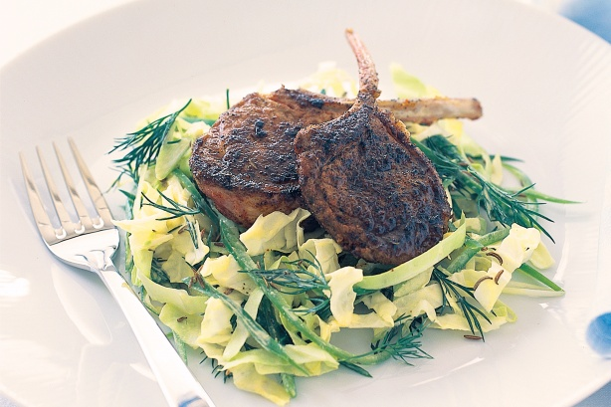

Energy: 1419kJ

**Ingredients:**

* 2 tablespoons Dijon mustard
* 2 tablespoons reduced-fat Greek-style yoghurt
* 1 tablespoon white wine vinegar
* 6 cups thinly sliced savoy cabbage (about 1/4 cabbage)
* 1 green capsicum, thinly sliced
* 2 spring onions, thinly sliced on the diagonal
* 2 teaspoons caraway seeds, toasted
* 1/3 cup dill sprigs
* 2 teaspoons Cajun spice mix*
* 2 teaspoons olive oil, plus extra to cook

8 lamb cutlets, trimmed of excess fat

* **Steps:**
* 1. Combine mustard, yoghurt and vinegar in a small bowl. Place the cabbage,
* capsicum, spring onion, caraway seeds and dill in a large bowl, then add the
* dressing and toss to combine.

2. Place the spice and oil in a bowl and stir well to combine. Add cutlets and rub all over with the mixture. Lightly oil a large frypan and place over medium heat. When hot, add cutlets in batches, and cook for 3 minutes, turning once for medium-rare, or until cooked to your liking. Serve with coleslaw.

**Spicy sausages with bean salad**

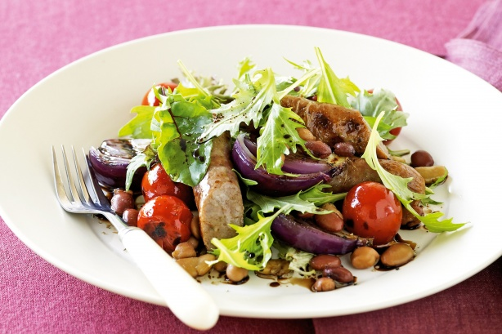

Energy: 1303kJ

**Ingredients:**

* 1 red onion, cut into 8 wedges
* 250g cherry tomatoes
* 8 (560g) thin beef and chilli sausages, halved
* 420g can four bean mix, drained, rinsed
* 120g packet baby leaf salad with herbs

1 tablespoon balsamic salad dressing

**Steps:**

* 1. Heat a lightly greased barbecue plate or chargrill on medium-high heat. Cook
* onion and tomatoes for 5 minutes, turning occasionally, or until browned and
* softened. Transfer to a large bowl. Cool for 10 minutes.
* 2. Cook sausages on barbecue or chargrill for 12 minutes, turning occasionally, or
* until browned and cooked through.

3. Add beans, salad leaves and dressing to tomato mixture. Toss to combine. Divide between plates. Top with sausages. Serve.