

My Computer:

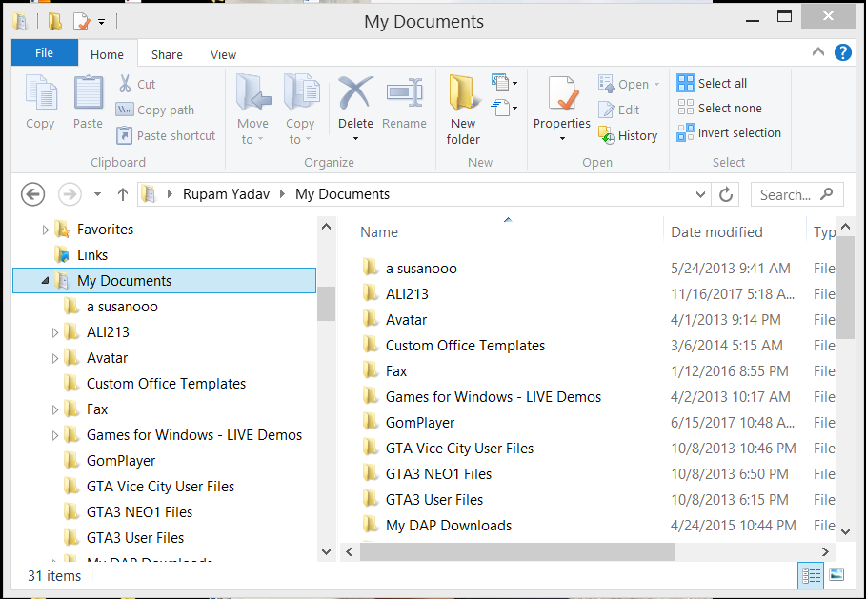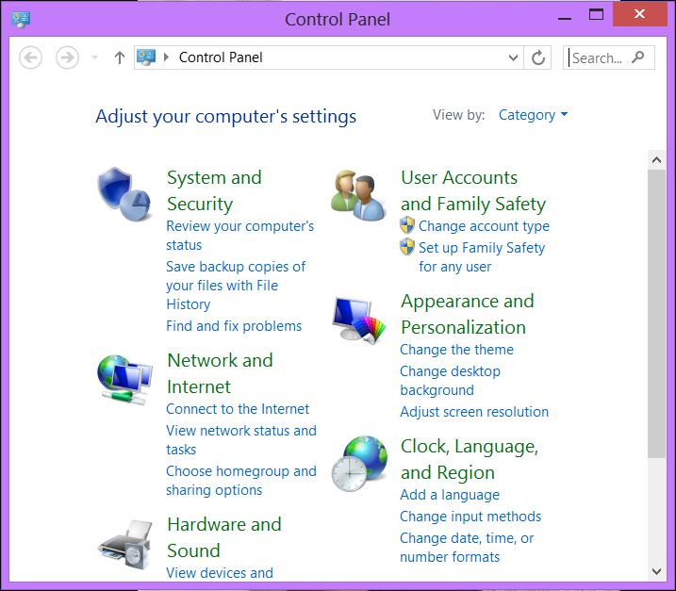

Recycle bin :

Control panel:

My documents:

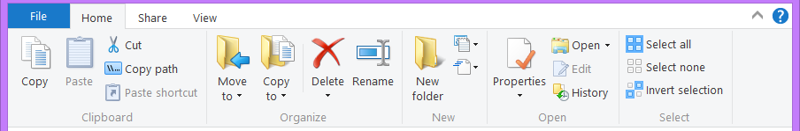

Taskbar: