Weather Data Analysis

# Weather Variables Data Analysis

## temperature Data Analysis

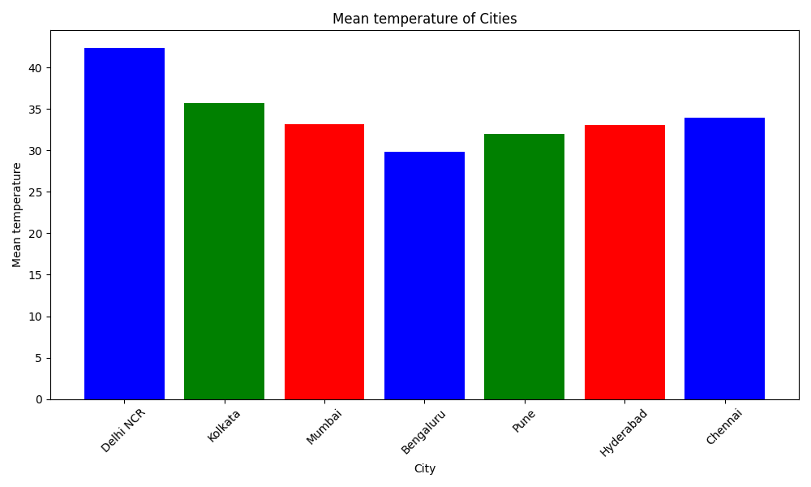

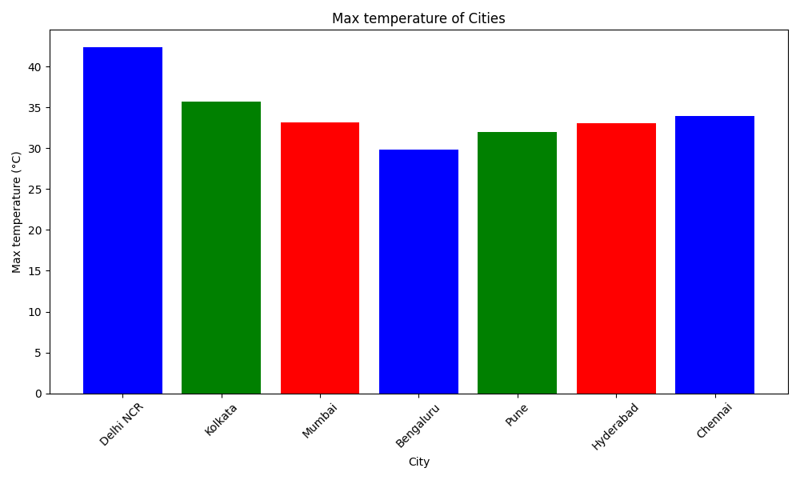

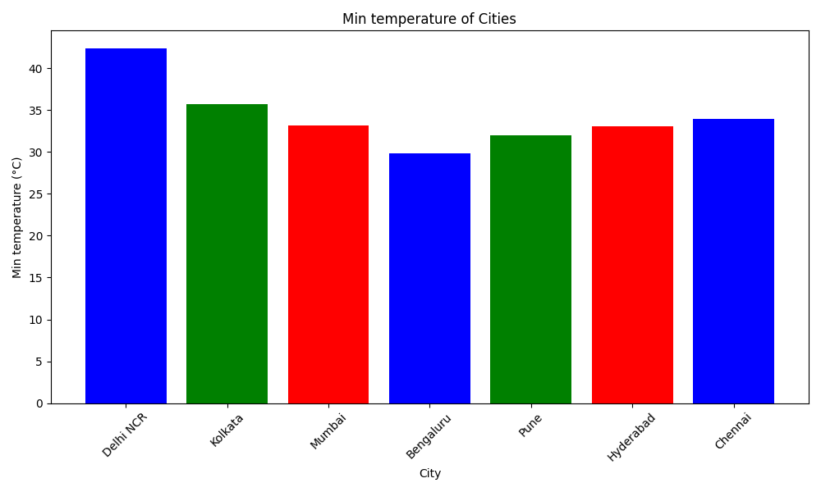

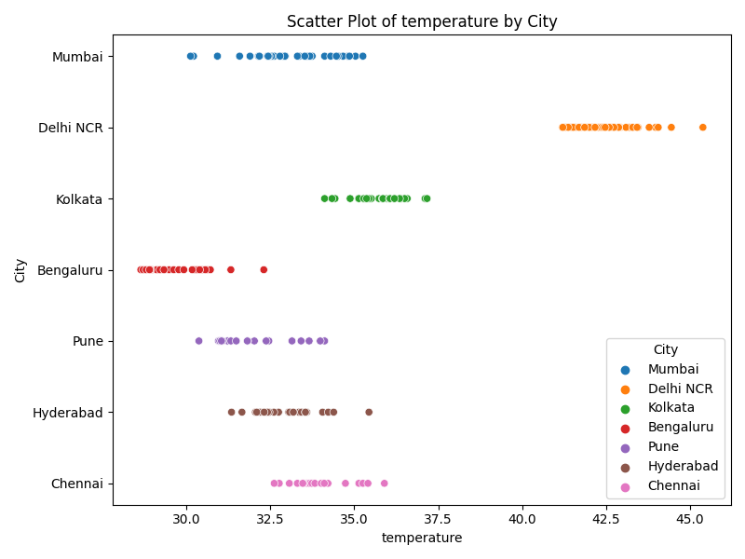

For temperature, Delhi NCR has the highest average (42.39), while Bengaluru has the lowest average (29.81). The common range across cities is from 29.81 to 42.39.

## humidity Data Analysis

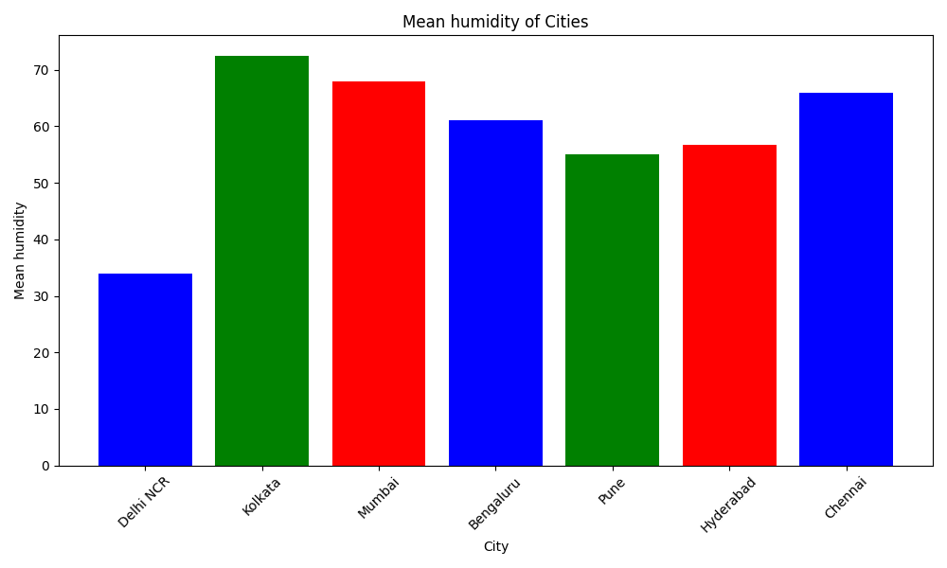

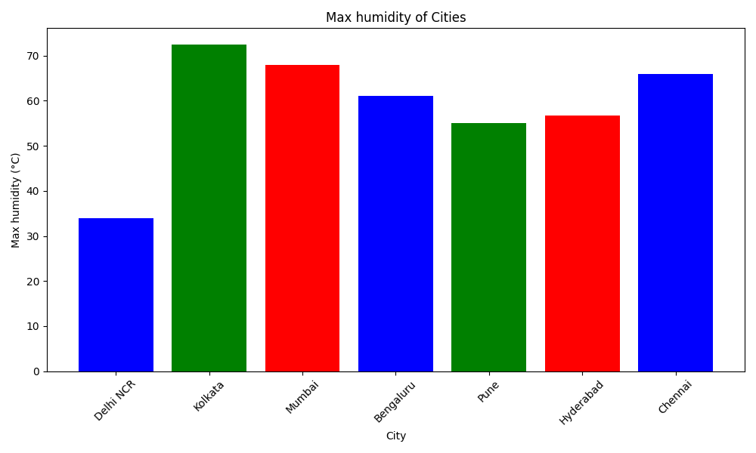

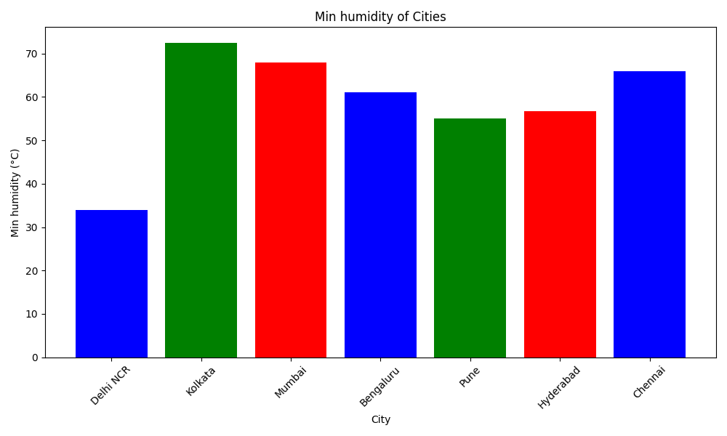

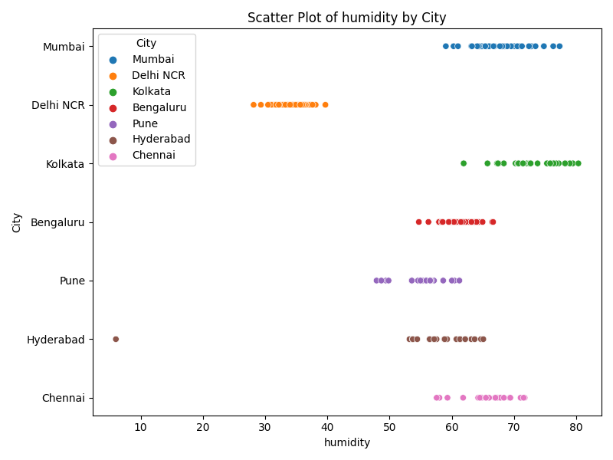

For humidity, Kolkata has the highest average (72.48), while Delhi NCR has the lowest average (33.97). The common range across cities is from 33.97 to 72.48.

## wind_speed Data Analysis

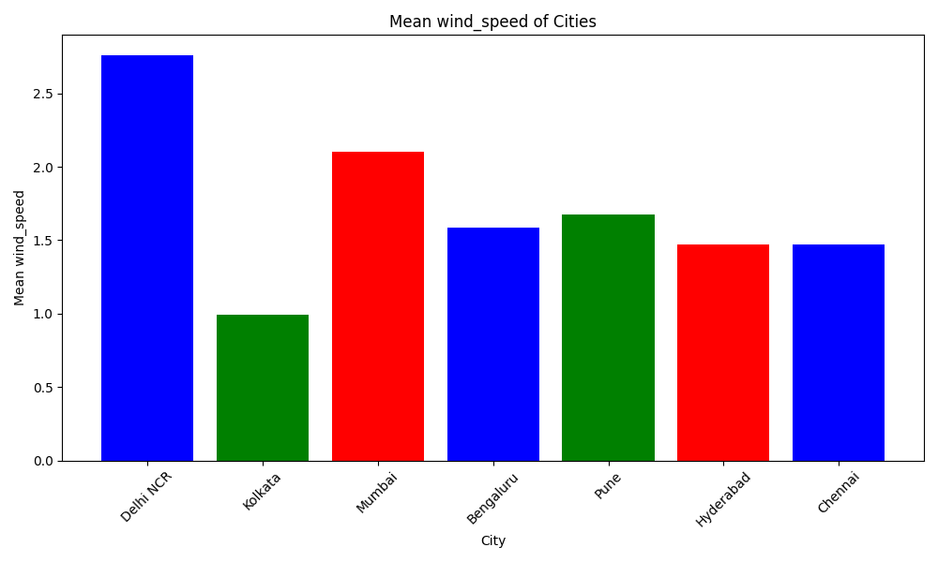

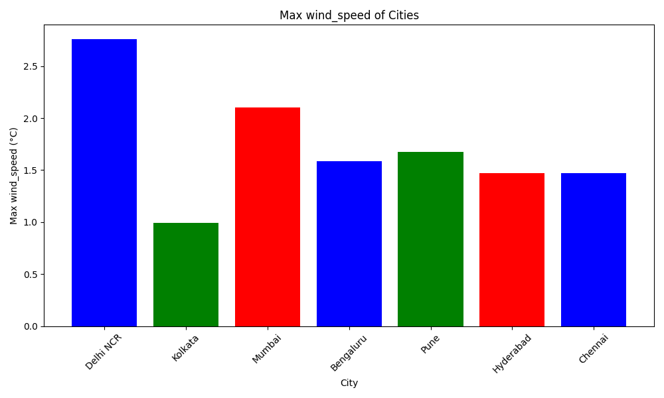

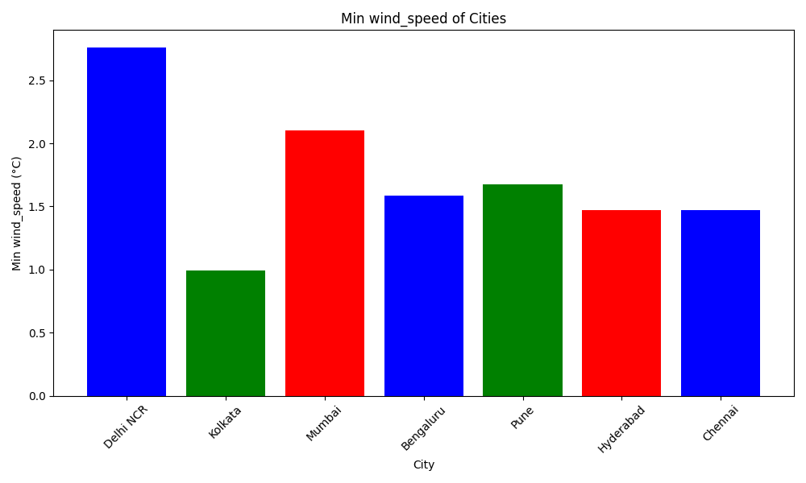

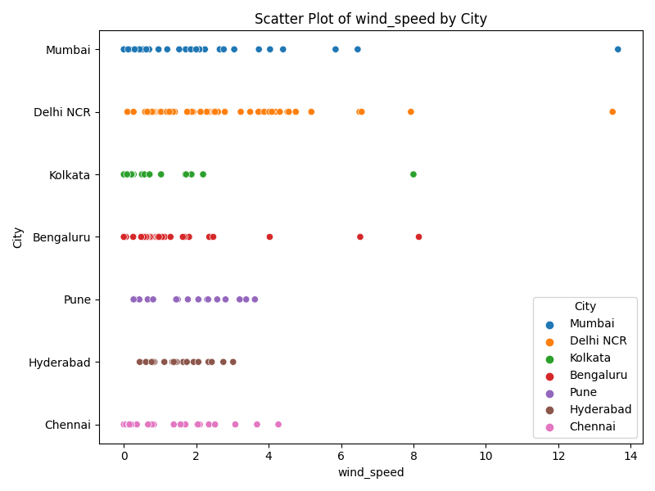

For wind_speed, Delhi NCR has the highest average (2.76), while Kolkata has the lowest average (0.99). The common range across cities is from 0.99 to 2.76.

## wind_direction Data Analysis

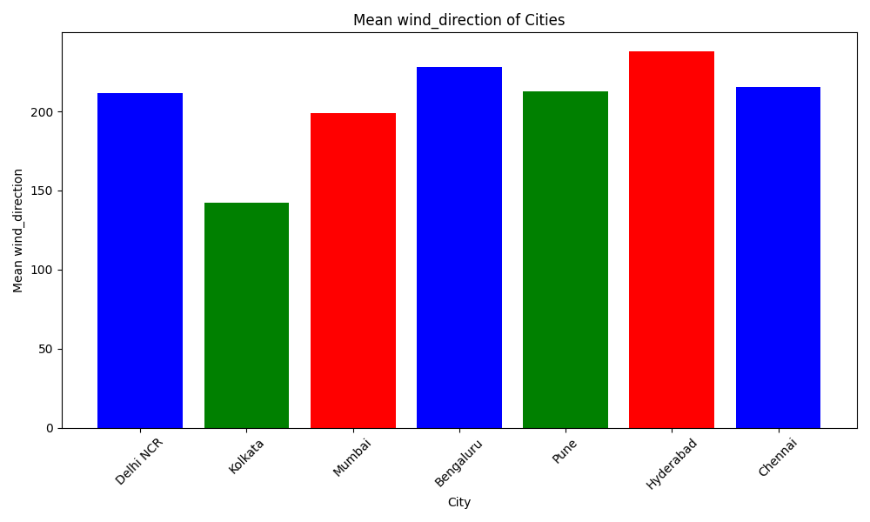

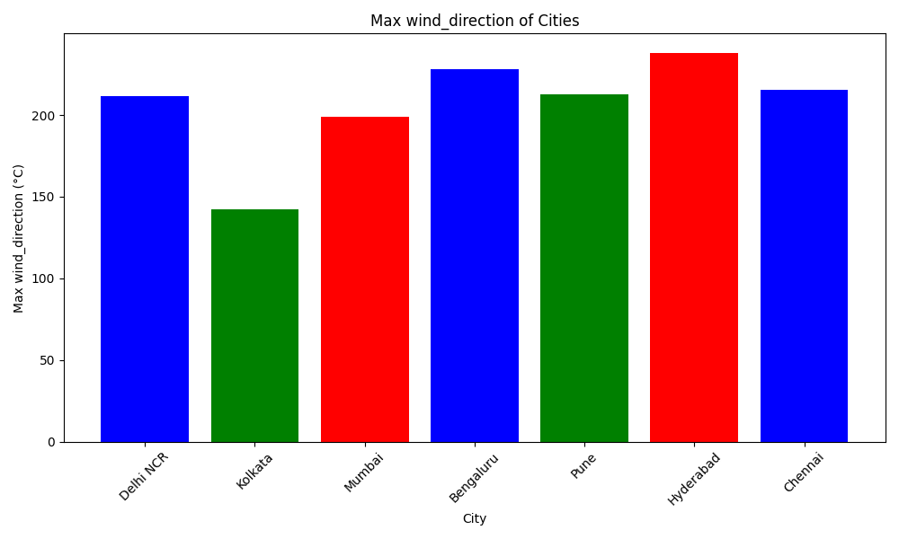

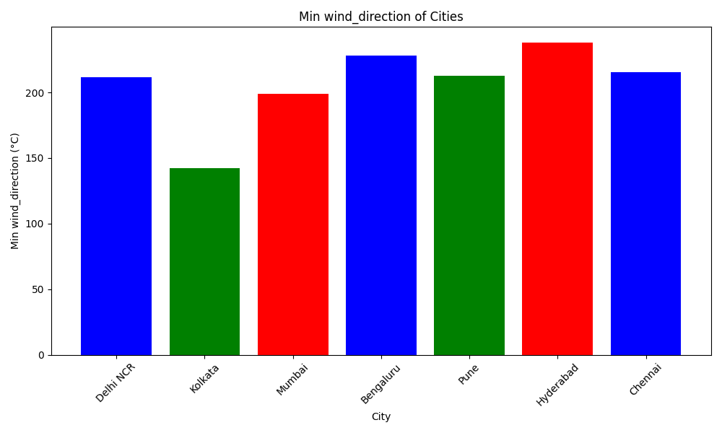

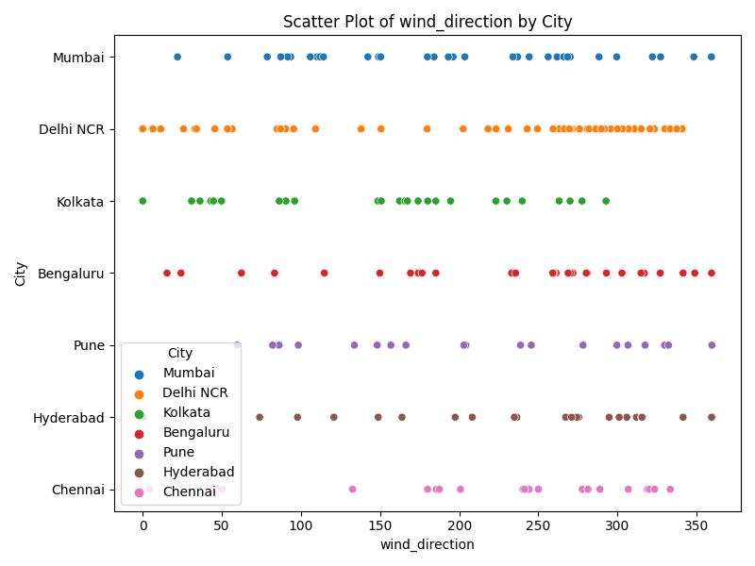

For wind_direction, Hyderabad has the highest average (238.03), while Kolkata has the lowest average (142.27). The common range across cities is from 142.27 to 238.03.

## rain_intensity Data Analysis

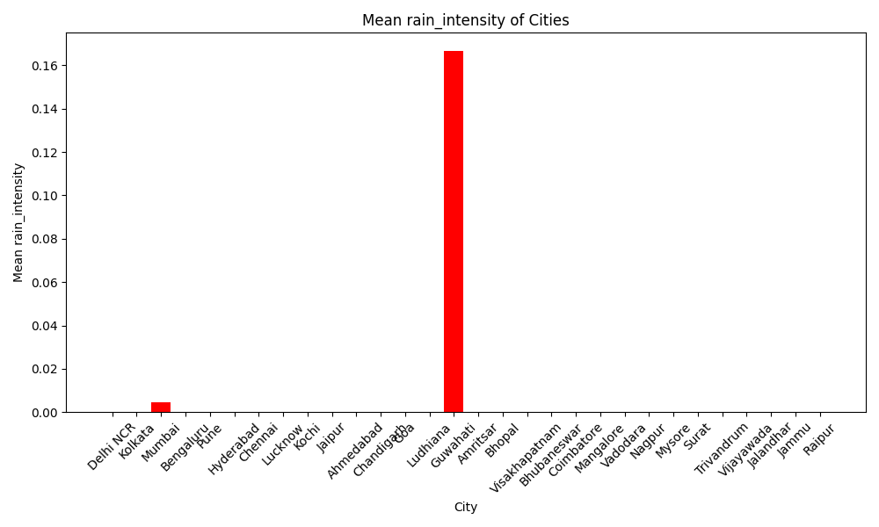

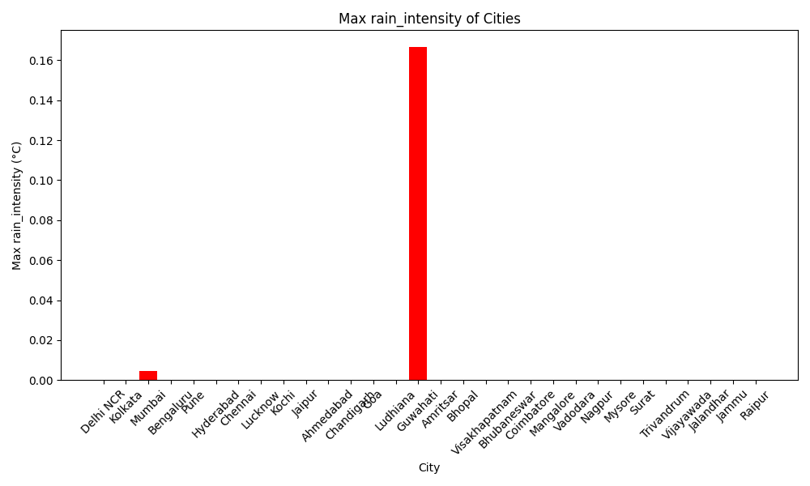

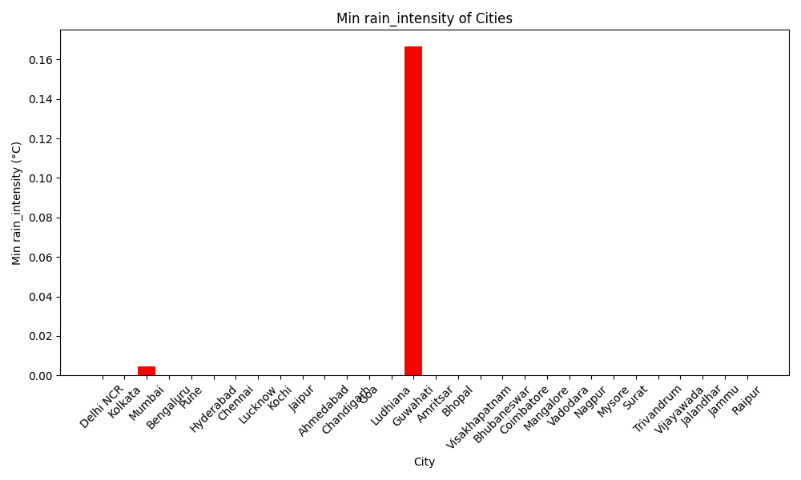

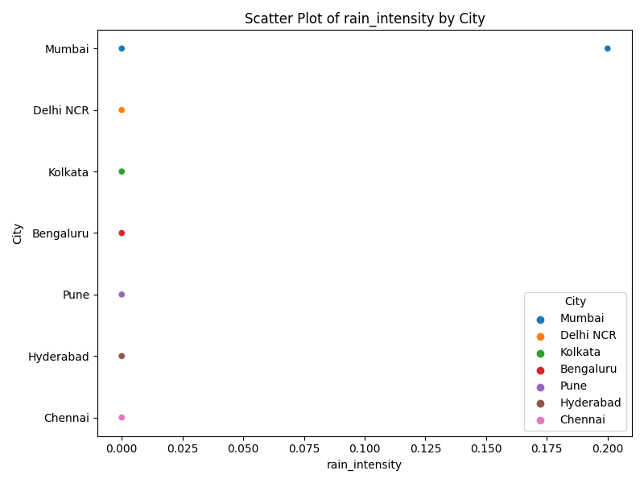

For rain_intensity, Mumbai has the highest average (0.00), while Bengaluru has the lowest average (0.00). The common range across cities is from 0.00 to 0.00.

## rain_accumulation Data Analysis

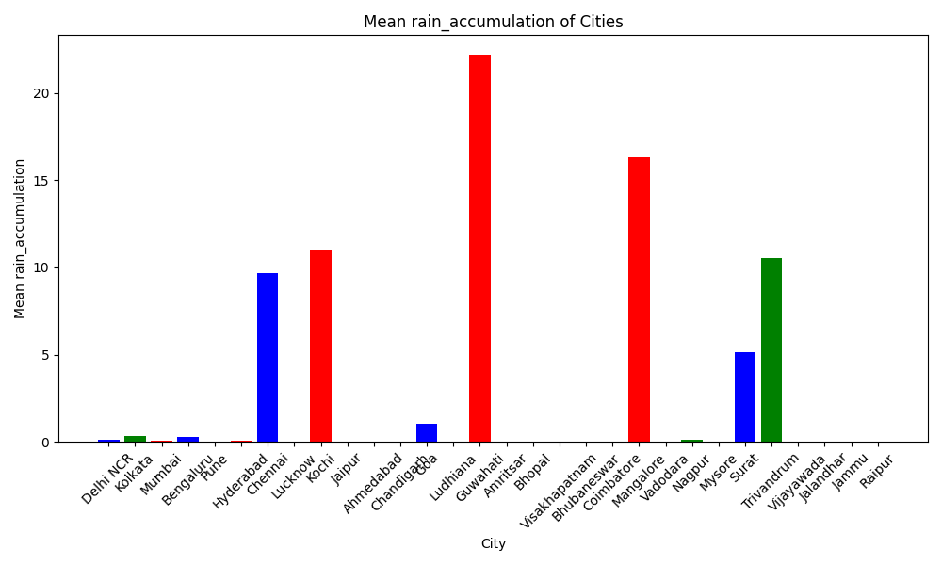

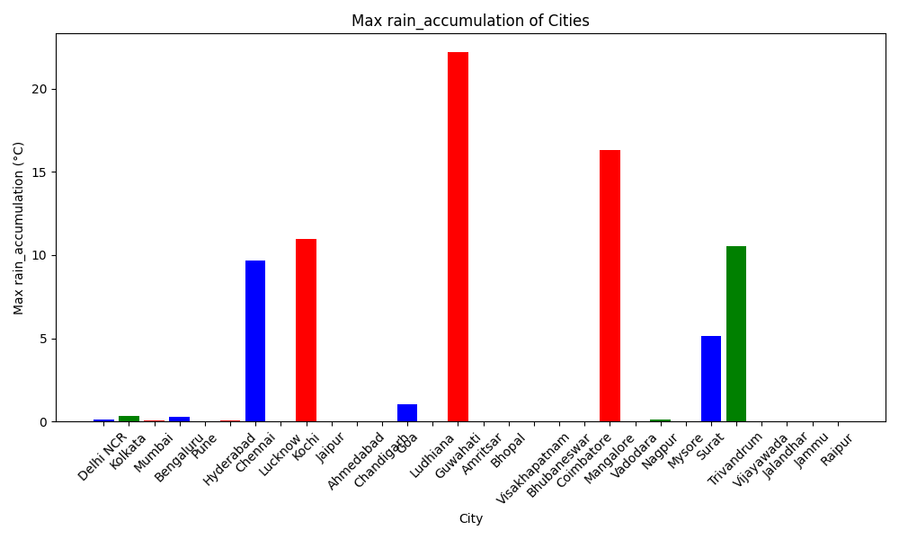

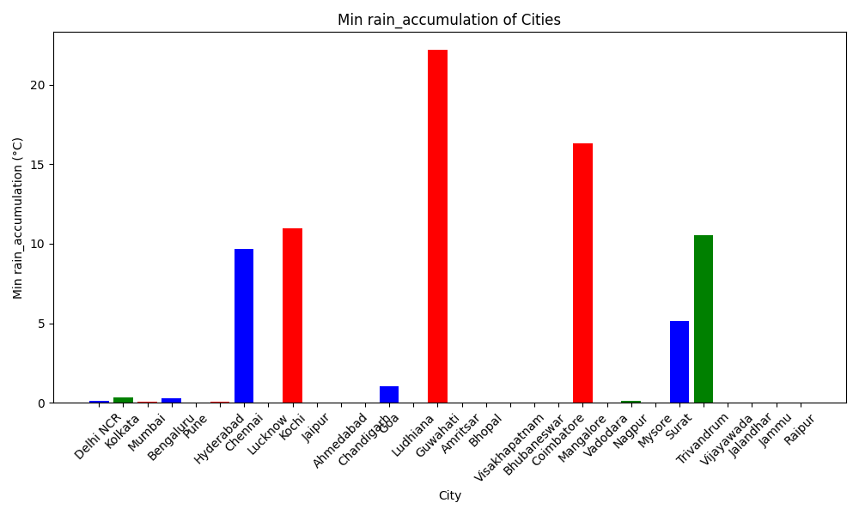

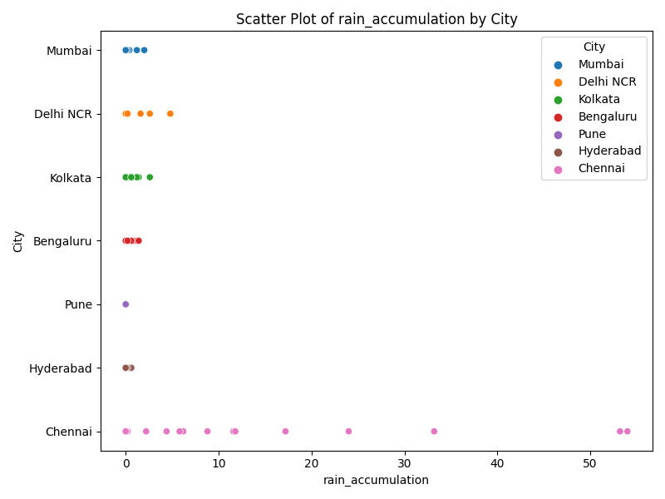

For rain_accumulation, Chennai has the highest average (9.70), while Pune has the lowest average (0.00). The common range across cities is from 0.00 to 9.70.

# Correlation Analysis of Weather Variables

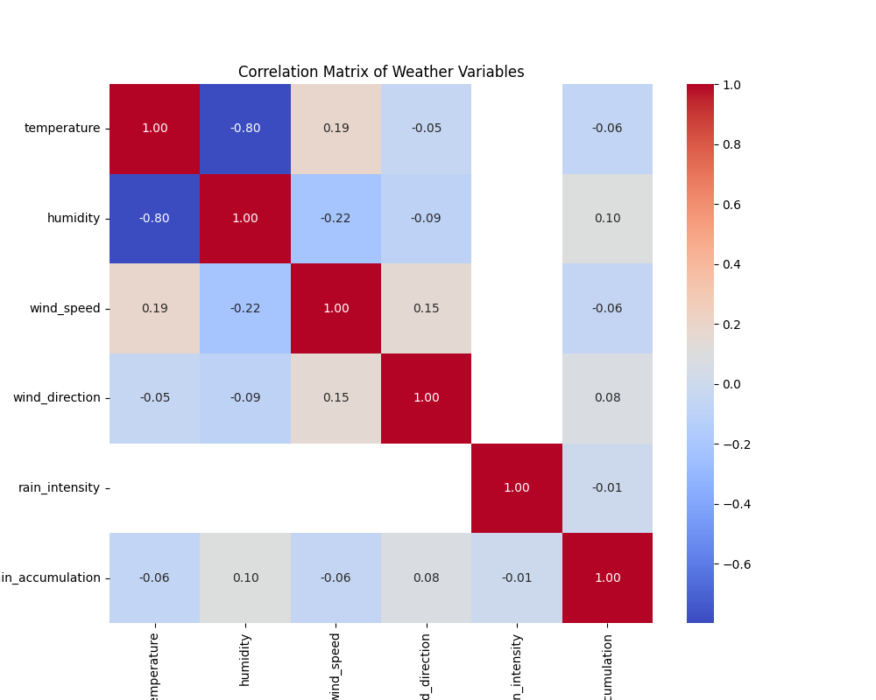

High correlations:  
- humidity and temperature have a correlation of 0.80  
  
Low correlations:  
- rain_intensity and rain_accumulation have a correlation of 0.01  
- temperature and wind_direction have a correlation of 0.05  
- rain_accumulation and wind_speed have a correlation of 0.06  
- temperature and rain_accumulation have a correlation of 0.06  
- wind_direction and rain_accumulation have a correlation of 0.08  
- wind_direction and humidity have a correlation of 0.09  
- rain_accumulation and humidity have a correlation of 0.10  
- wind_direction and wind_speed have a correlation of 0.15  
- temperature and wind_speed have a correlation of 0.19  
- humidity and wind_speed have a correlation of 0.22

# Wind Direction Analysis

## Wind Rose Diagram for Delhi NCR

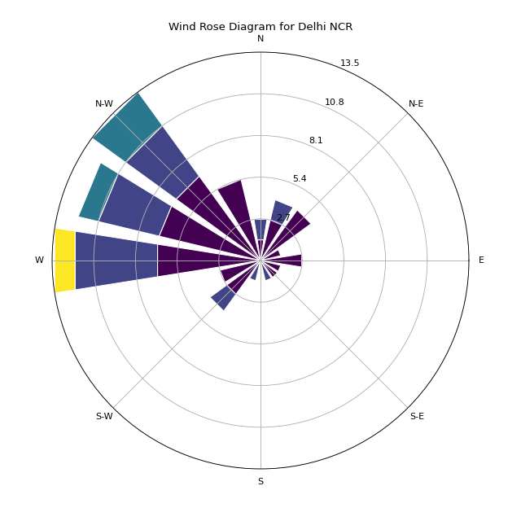

## Wind Rose Diagram for Kolkata

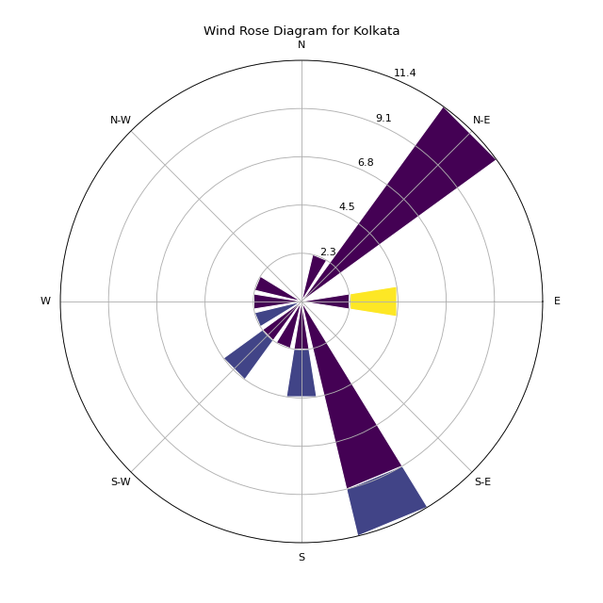

## Wind Rose Diagram for Mumbai

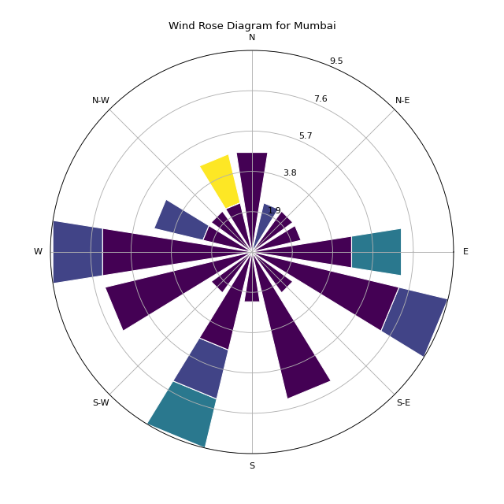

## Wind Rose Diagram for Bengaluru

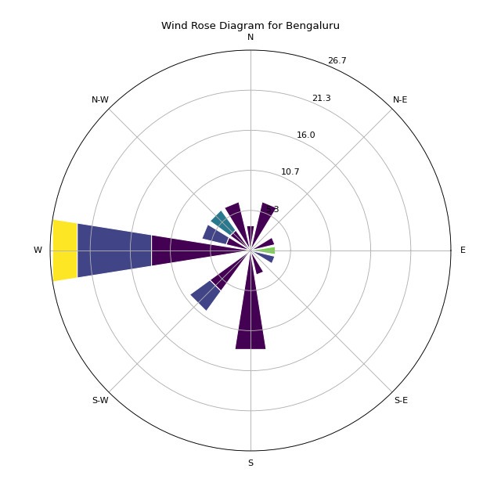

## Wind Rose Diagram for Pune

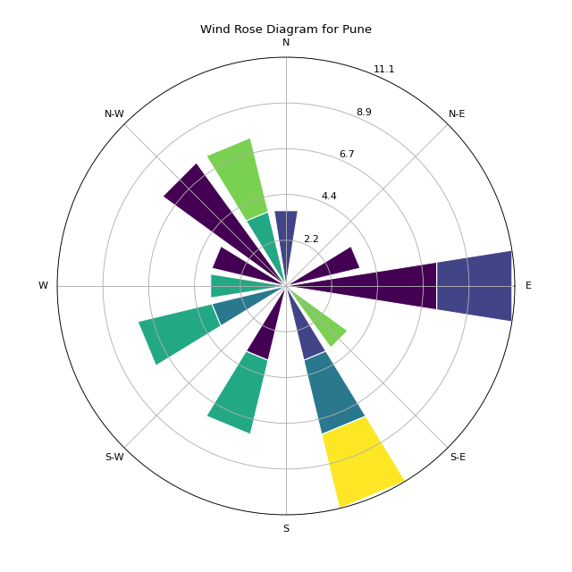

## Wind Rose Diagram for Hyderabad

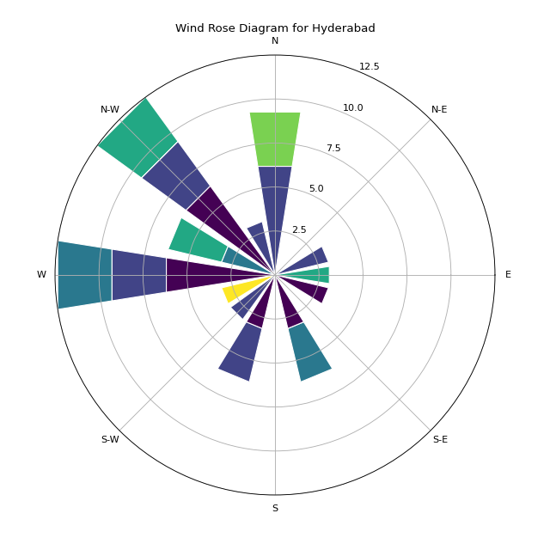

## Wind Rose Diagram for Chennai

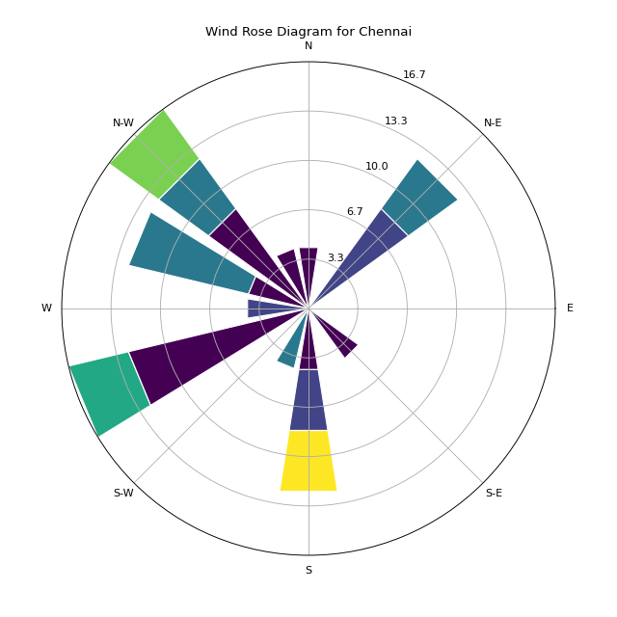

Bengaluru: Dominant wind direction is South-West (228.08 degrees).  
Chennai: Dominant wind direction is South-West (215.58 degrees).  
Delhi NCR: Dominant wind direction is South-West (211.47 degrees).  
Hyderabad: Dominant wind direction is South-West (238.03 degrees).  
Kolkata: Dominant wind direction is South-East (142.27 degrees).  
Mumbai: Dominant wind direction is South (198.68 degrees).  
Pune: Dominant wind direction is South-West (212.94 degrees).