ARE THE TONYS STILL RELEVANT?
Nielsen viewership analysis updated through 2026 — findings, charts, and data

Charts
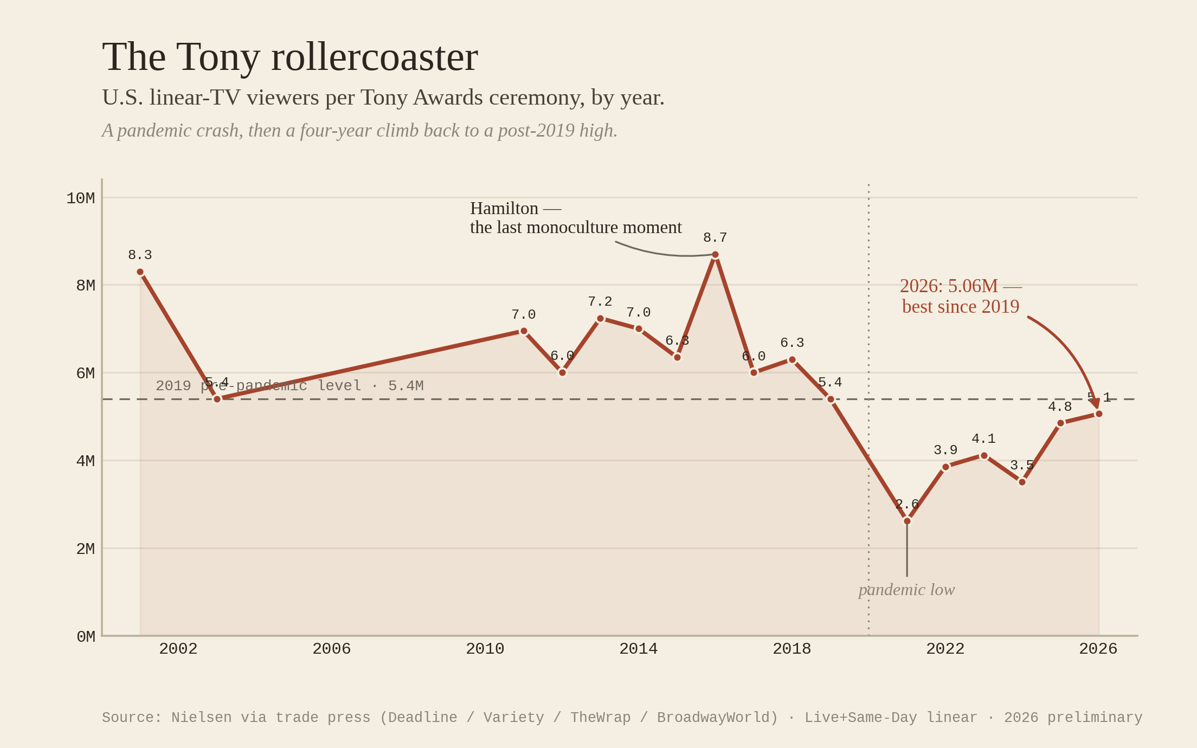
Striking 1 Rollercoaster
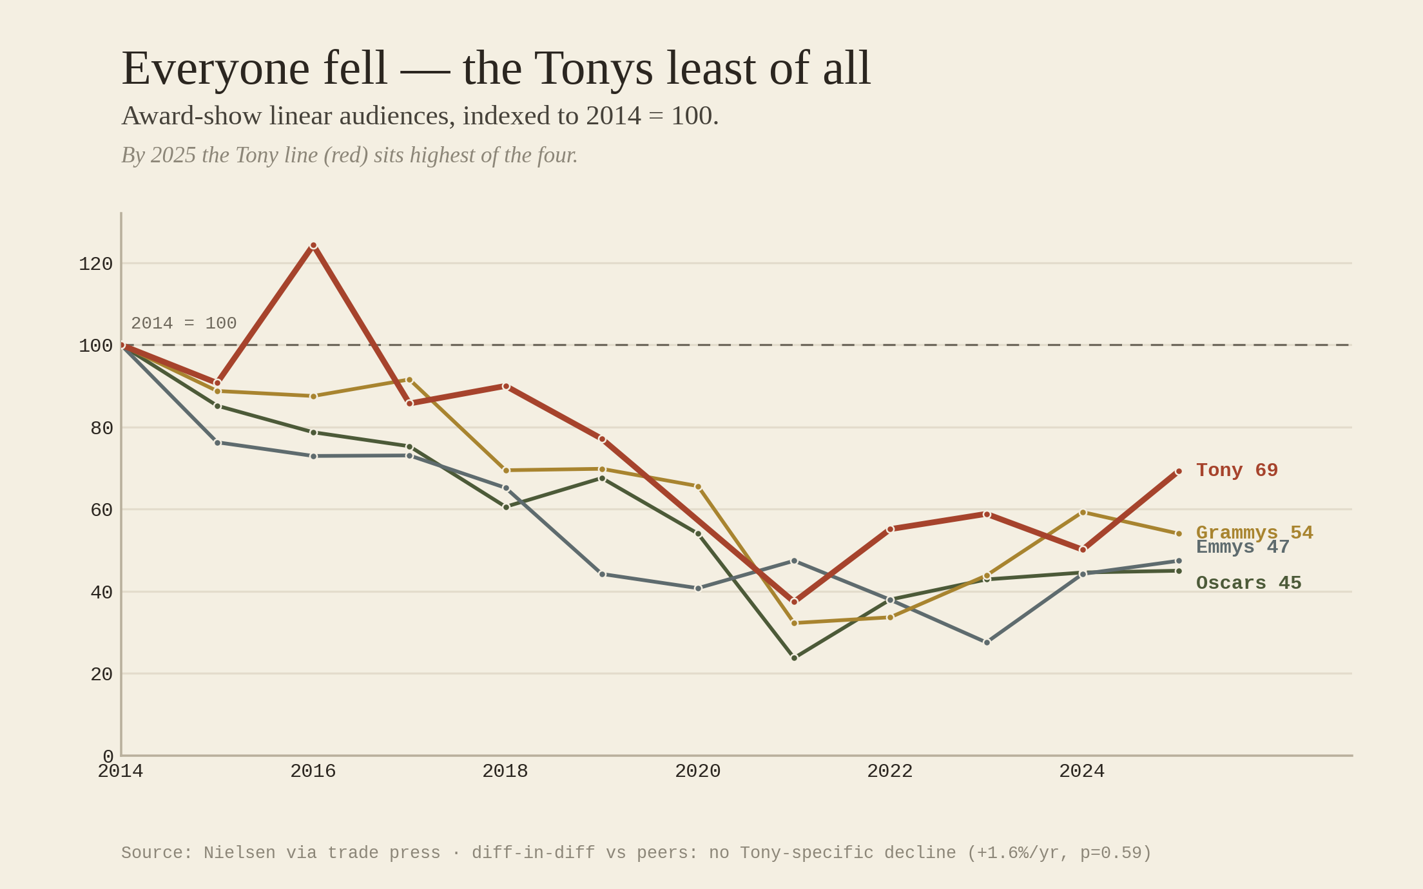
Striking 2 Everyone Fell
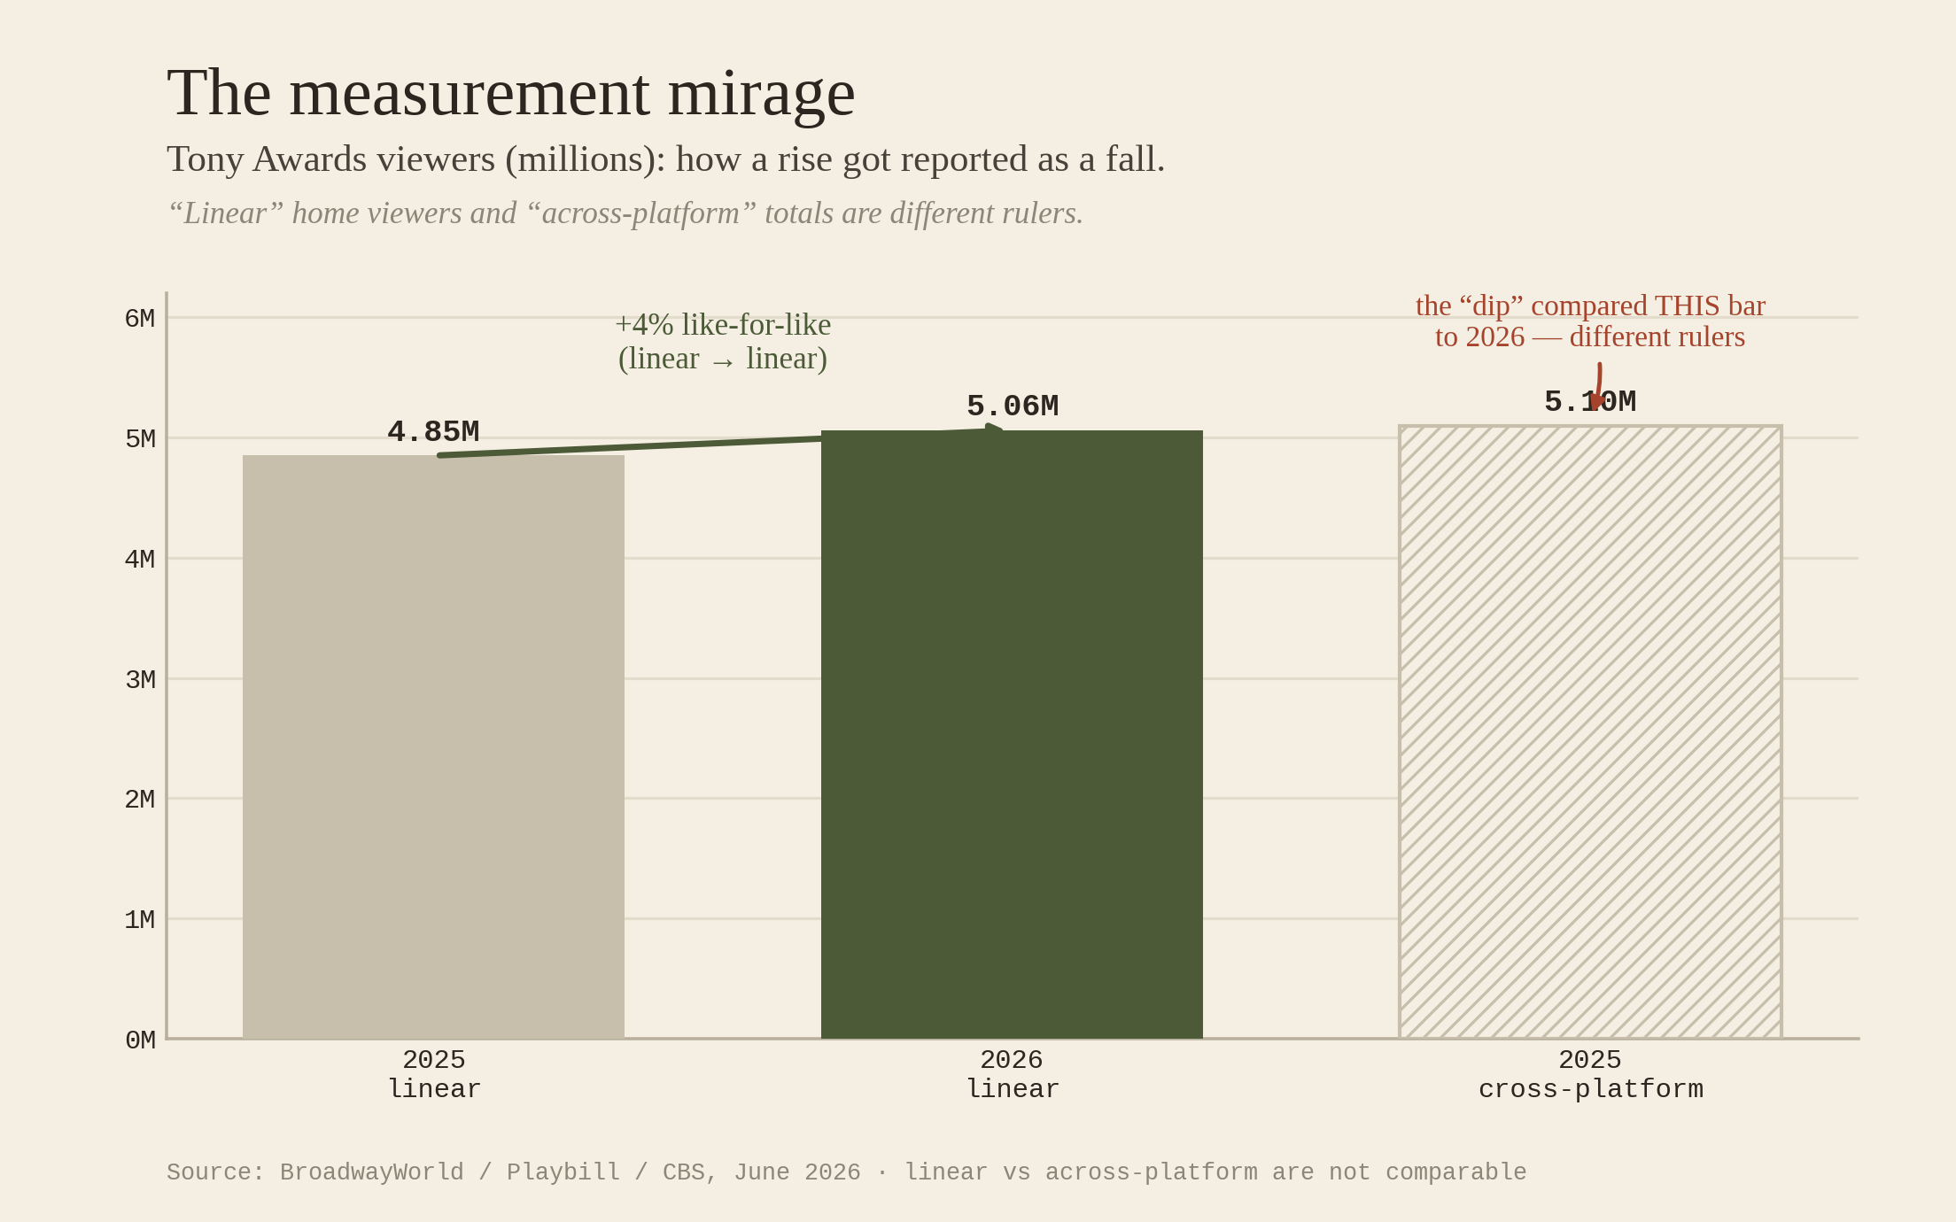
Striking 3 Measurement Mirage
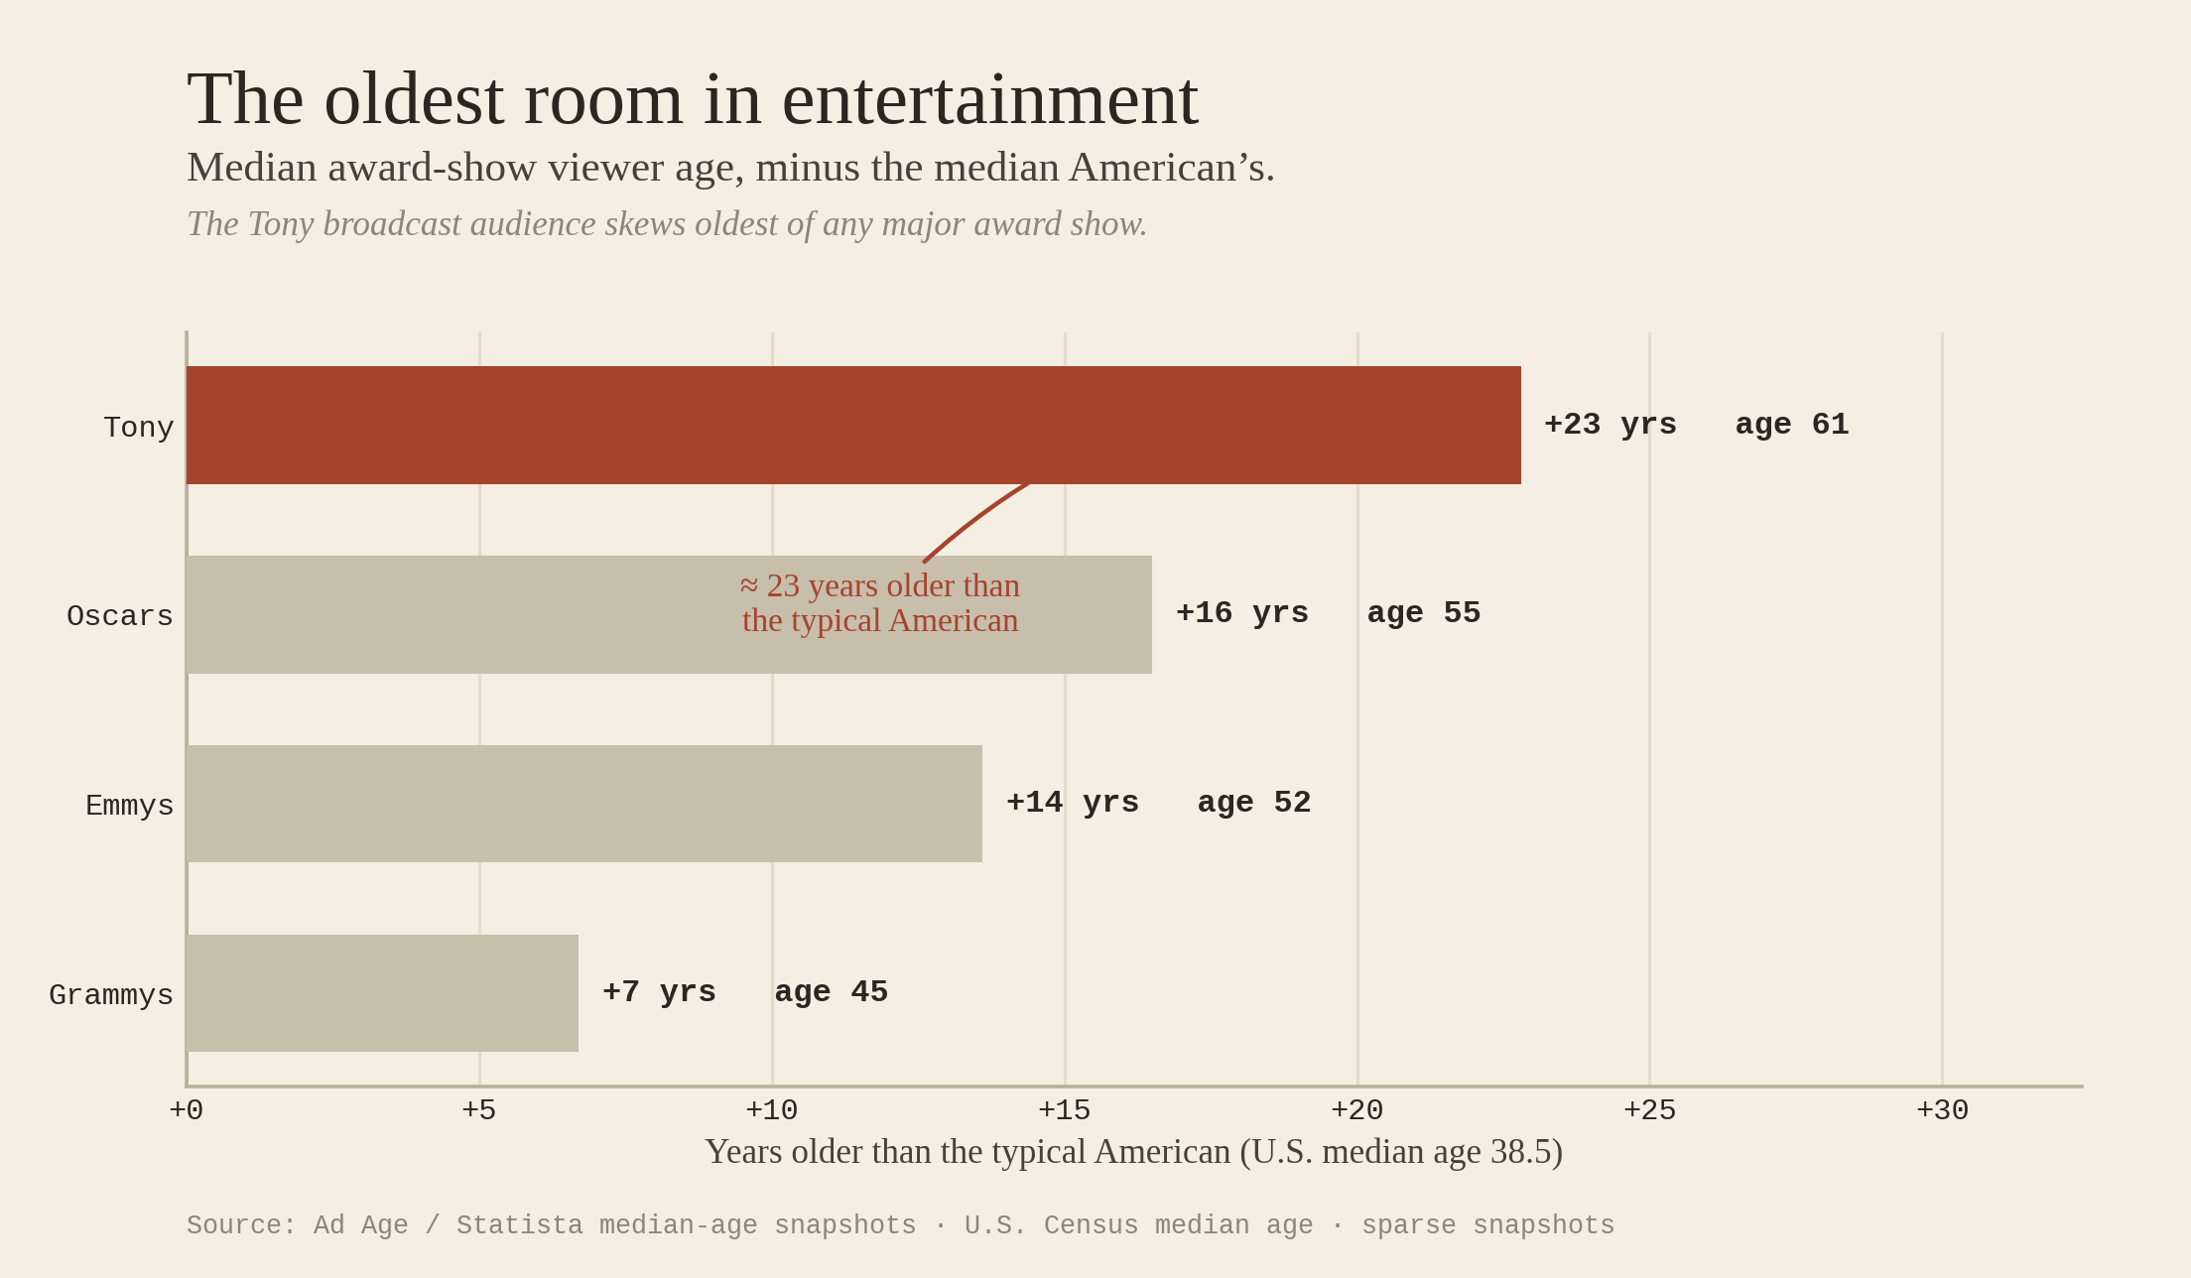
Striking 4 Oldest Room
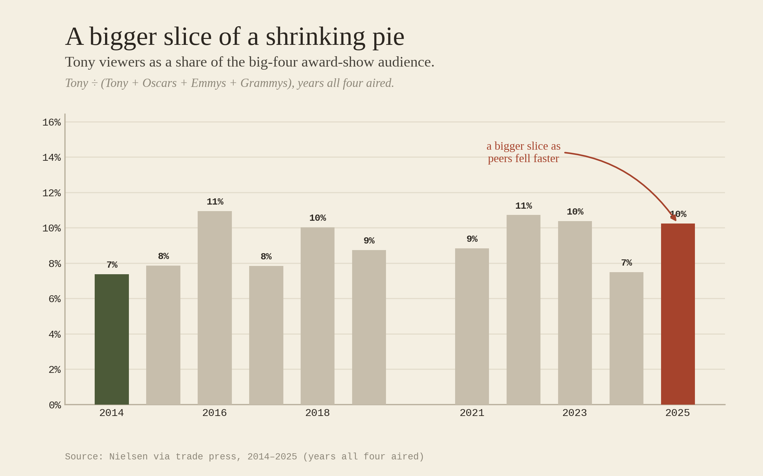
Striking 5 Shrinking Pie

The Tony Awards Nielsen story, updated through 2026 — in-depth findings

*Refresh of the Phase-1 ratings analysis with the 79th Tony Awards (June 7,
2026), a full data-verification pass, and a new chart set in a bold
media-economics style. Bottom line: the popular "the Tonys are dying on TV"
narrative is now even harder to defend on the numbers — and the most-repeated
2026 headline is a measurement artifact.*

────────────────────────────────────────────────────────────

0. The headline findings

- 2026 was the Tonys' best broadcast since 2019 — and the "dip" was a mirage.
The 79th Tonys drew 5.06M linear viewers on CBS (preliminary). That is the
highest Tony broadcast number since 2019 and +4% over 2025's linear 4.85M.
Outlets reported a "slight (−0.78%) dip" — but only by comparing the 2026
linear number to 2025's 5.10M across-platform number (linear +
Paramount+). That is two different rulers. Like-for-like, the Tonys rose.
- The Tonys have now recovered for four straight years, from the 2021
pandemic trough (2.62M) to 5.06M in 2026 — climbing right through the period
everyone was calling them culturally dead.
- The decline that did happen is not Tony-specific. A difference-in-
differences test against the Oscars, Emmys and Grammys still finds **no
Tony-specific trend** (+1.6%/yr, p=0.59). Whatever fell, fell across all of
linear TV — not on Broadway's award show in particular.
- The real Tony-specific signals are structural, not cyclical: the Tonys
remain the smallest of the big-four award broadcasts and have the **oldest
audience of any award show (~61, i.e. ~23 years older than the typical
American)**. Those — not the ratings line — are the relevance story.

────────────────────────────────────────────────────────────

1. What the 2026 number actually is (the data-integrity catch)

Year | Linear (CBS, L+SD) | Across-platform | What outlets compared
2023 | 4.12M | n/a | —
2024 | 3.51M (CBS: 3.53M) | n/a | —
2025 | **4.85M** | **5.10M** | —
2026 | **5.06M** | *not yet released* | 5.06M **vs. 2025's 5.10M** → "−0.78% dip"

The "dip" headline compares a linear figure (2026) to a cross-platform
figure (2025). On a consistent linear basis the sequence is
3.51 → 4.85 → 5.06, a clean two-year climb to a post-2019 high. CBS's own
release confirms the basis: "+44% vs. 2024 (3.53M)" and "+23% vs. 2023 (4.12M)"
only work if 5.06M is the linear number. **The honest read: 2026 linear
viewership rose ~4%; the Paramount+ add (which would push the across-platform
total above 5.10M) had not been published at the time of writing.**

This is the single most important reason to keep `measurement = 'linear' |
'xplat'` strictly separated — see chart 3, "The measurement mirage."

────────────────────────────────────────────────────────────

2. Verification pass (what changed and why)

- 2026 added: 5.06M linear, confidence = med (preliminary home viewers).
- 2023 reconciled to 4.12M (Live+Same-Day), the basis CBS uses for its own
year-over-year math and consistent with how 2024–2026 are measured here. The
Variety "final" 4.30M is recorded as an alternative. The DiD result is
unchanged in substance (+1.7%→+1.6%/yr; still null).
- Peers re-confirmed against second sources earlier in the project (Oscars,
Emmys full series; Grammys compiled series). See VERIFICATION.md for the
cell-by-cell log and residual risks (some mid-decade SAG and med/low Tony
cells still merit primary-source validation before any single figure is
published).

────────────────────────────────────────────────────────────

3. The trend, re-run

Metric | Value
Tony linear, 2014 → 2026 | 7.0M → **5.06M (−28%)**
Tony off its 2016 (Hamilton) peak | 8.7M → 5.06M (−42%)
Tony 2021 trough → 2026 | 2.62M → 5.06M (**+93%**)
Peer-average change, 2014 → 2025 | **−52%**
**DiD: Tony-specific annual trend vs peers** | **+1.6%/yr, p=0.59 (null)**
Tony rank by rate of decline (1 = fastest) | **slowest of the four**
Tony share of the big-four audience | 7.4% (2014) → **10.2% (2025)**
Tony median viewer age | **~61 — oldest of any award show**

Interpretation. The "ratings collapse" was a *linear-TV* event with a
*pandemic* trough, now substantially recovered, and never Tony-specific. The
Tonys even gained share of the (shrinking) award-show audience because their
peers fell faster. The genuine vulnerabilities are size and age, plus the
off-TV "cultural export" question taken up in the Phase-2 work (DEEPER_ANALYSIS.md,
IP_SHARE.md).

────────────────────────────────────────────────────────────

4. The charts (bold "media-economics" set)

Rendered by analysis/06_striking_charts.py into charts/striking_*.png:

- `striking_1_rollercoaster.png` — Tony broadcast audience 2001–2026,
annotated: Hamilton peak, pandemic low, 2026 best-since-2019.
- `striking_2_everyone_fell.png` — indexed vs. peers; the Tony line ends
highest of the four. The "it's all of TV, not the Tonys" chart.
- `striking_3_measurement_mirage.png` — how a +4% linear rise got reported
as a "dip."
- `striking_4_oldest_room.png` — median viewer age vs. the typical American;
the Tonys ~23 years older.
- `striking_5_shrinking_pie.png` — Tony share of the big-four audience.

*(Theme note: these mirror the dark, neon-on-black, annotation-forward house
style of data-forward media newsletters; the exact palette/typography is a few
constants at the top of the script and can be matched to any reference.)*

────────────────────────────────────────────────────────────

5. What you can write

- Lead (the myth-buster): *"The 2026 Tonys didn't dip — they hit a six-year
high. The 'dip' was a footnote about which Nielsen number you read."* Use it to
teach the linear-vs-cross-platform trap, then pivot to the real story.
- The structural piece: *"The Tonys aren't losing the ratings race — they're
losing the age race."* Smallest room, oldest audience (~61), even as the
broadcast recovers.
- The honest frame to keep: ratings recovered and the decline was never
Tony-specific; the relevance question lives off the Nielsen chart (search,
social, cast-album crossover — the export layer still to be built).
- Avoid: "Tony ratings prove the show is dying" (the line recovered four
straight years) and "2026 fell" (a measurement artifact).

────────────────────────────────────────────────────────────

6. Reproduce

python3 tony_relevance/build_db.py
python3 tony_relevance/analysis/01_relevance_trends.py
python3 tony_relevance/analysis/02_causal_did.py
python3 tony_relevance/analysis/06_striking_charts.py

