|  |  |
| --- | --- |
| *Owner’s Manual and Safety Instructions* | |
|  | |
| *PN: OGRTC-001* | |
|  | |
|  | *WARNING* |
| *Failure to read and follow this manual may result in serious injury. Open GarageRTC is a user community supported project and the owner/operator of this product is responsible for ensuring safe installation and operation.* | |

*Table of Contents*

Contents

Safety 3

Specifications 3

Installation 4

Included Equipment 4

Mounting the GarageRTC 4

Connecting to Door Opener 5

Software Setup 5

Building the Project 5

Installing the Web Server Software 6

Operation 8

Using the Local Interface 8

Using the Web Interface 9

Maintenance 10

Warranty 10

# Safety

|  |  |
| --- | --- |
|  | **WARNING**: This equipment is NOT a toy. Read this manual before installing or operating. Do not allow children to play in or around the door or GarageRTC project. This product should only be operated by adults. |

The GarageRTC Project hardware and software is provided without warranty. The owner and installer of this product should read this manual completely and retain for future use. As this device is intended to operate a garage door, care should be taken to ensure that the components supplied with this product and those originally equipped with the garage door are in proper operating condition.

Immediately stop using this product or the garage door if any problems are suspected and call a qualified repair serviceman before retiring the equipment to use.

# Specifications

|  |  |  |
| --- | --- | --- |
| Control Module | Power:  Wireless:  Mains Switching: | 5V DC 0.5A  802.11abn  250 VAC 5A |
| Obstacle Sensor | Power:  Range: | 3.3 V DC to 5.5 V DC  16 ft |
| Power Supply | Power Input:  Input Connector:  Power Output:  Output Connector: | 120 VAC 0.25A  NEMA 5-15  5V DC 1A  Mini-USB |
| Light Control | Switched Power: | 120 VAC 10A |

This device has not been subjected to Part 15 testing of the FCC rules. The operator is responsible to ensure the device accepts interference and does not generate interference that interferes with other devices operation in accordance with FCC regulations.

# Installation

## Included Equipment

Inspect all components before installation and consult the project website for replacement part substitutions. The GarageRTC is shipped with the following items:

|  |  |  |  |
| --- | --- | --- | --- |
|  | **Item** | **Part Number** | **Qty** |
| 1 | GarageRTC Main Controller Kit | OGRTC-001 | 1 |
| 2 | Limit Switch assembly and harness | OGRTC-001-10 | 2 |
| 3 | Laser Break-Beam and Harness | OGRTC-001-30 | 1 |
| 4 | Power Adapter | OGRTC-001-50 | 1 |
| 5 | Mounting Screws | OGRTC-001-70 | 12 |
| 6 | Mounting Anchors | OGRTC-001-80 | 12 |
| 7 | Limit Switch Brackets | OGRTC-001-90 | 2 |
| 8 | Limit Switch Trigger Block | OGRTC-001-110 | 1 |
| 9 | Break-Beam Bracket | OGRTC-001-130 | 2 |
| 10 | Self-Adhesive Wire Guides | OGRTC-001-150 | 10 |

## Mounting the GarageRTC

Mount the GarageRTC at a convent height near an entry way or door. Install in a location were the mounting wire harnesses supplied with the kit will be able to reach the Main controller with excess. Consider locations with convenient access to a power plug for the power adaptor. Mount the controller out of reach of small children.

**Installation Steps:**

1. Use the supplied template mount hardware to install the screws (4x #5) for anchoring the main unit.
2. Open the door all the way.
3. Install the self adhesive limit switch trigger block (#8) in a convenient place along the door travel where the door is still in line with the vertical tracks.
4. Mark the position in the center of the trigger block on the garage door tracks.
5. Close the door and mark the center position on the door track.
6. Using the screws (2x #5) and anchors (2x #6) mount the limit switch bracket (#7) and limit switch (#2) at the positions marked on the door assembly.
7. Mark a position no higher than 6” from the base of the door on both sides of the opening. Using the screws (2x #5) and anchors (2x #6) mount the laser break beam transmitter and receiver (#3). Make sure the transmitter and receiver align.
8. Route the wires to the main uint. Use wire guides (#10) to route the wires along the way. Ensure they are free from all moving parts of the door and cannot be caught, dragged, or chaffed by operation of the door.

## Connecting to Door Opener

**Connection Steps:**

1. Remove the cover to the main assembly.
2. Connect the upper limit switch to the screw terminals marked UP on the side of the case.
3. Connect the lower limit switch to the screw terminals marked DOWN on the side of the case.
4. Connect the laser receiver pins to the lines marked LASER RCVR on the side of the case. Connect the Black wire to the – post, the White wire to the + post and green wire to the SIG post.
5. Connect the laser transmitter to the screw terminals marked LASER XMTR. Connect the Black wire to the – post, and the White wire to the + post.
6. Connect the power adapter to the main power connector.
7. The unit should illuminate and then start reporting the temperature. The fidget indicator on the left bottom side of the screen should rotate indicating the system is up and running.

# Software Setup

## Building the Project

Prerequisites:

* Development Computer running Windows 10 or MacOS Sierra or newer
* MicroUSB cable
* Install the Arduino studio from the Arduino studio website: <https://www.arduino.cc/en/Main/Software>

Install the requisite libraries:

1. Open the Arudino Studio
2. From the Tools menu, select board > Board Manager
3. Search for “esp32” and install “esp32 by Espressif Systems version 1.0.1”
4. This will install a variety of necessary libraries including:
   1. WiFi by Hristo Gochkov
   2. Wire by Hristo Gochkov
   3. ESP32 Async UDP by Me-No-Dev
   4. FreeRTOS V8.2.0 by Real Time Engineers Ltd.
5. Close the dialog.
6. From the Tools menu, select “Manage Libraries…”
7. Search “LiquidCrystal” and install “LiquidCrystal_PCF874 by Matthias Hertel 1.1.0”

Configure the board:

1. Connect a MicroUSB cable to the development computer.
2. Connect the MicroUSB connector to power port on the side of the main controller
3. The unit should power on.
4. In the Arduino IDE, from the tools menu select Board: and select “NodeMCU-32S” from the available boards
5. The properties should auto populate as shown in the figure below:

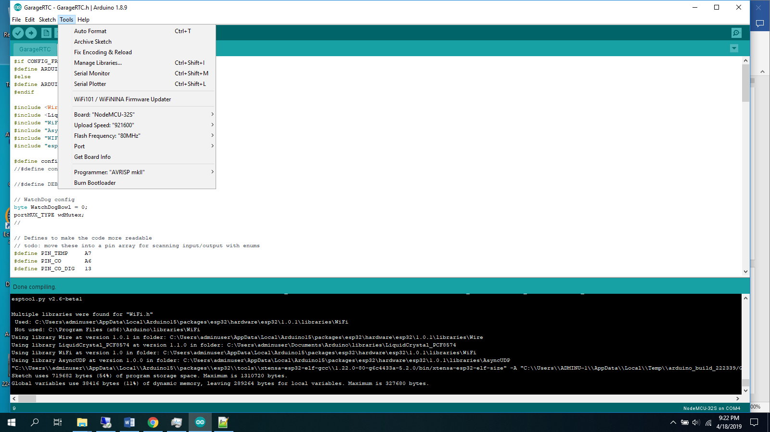

Figure 1. Board Configuration

Follow the steps below to build the software and program the unit:

1. Go to the project site and clone the project folder: <https://github.com/jharmer95/Garage-RTC>
2. Open the ESPRuntime folder and open GarageRTC.
3. Double click on the GarageRTC.ino file to open the project
4. Click on the Wifi_AP.h tab at the top of the display.
5. Enter the SSID and Password for the wifi access point the system will be connecting to.
6. Click on the Compile and program button in the upper left corner of the Arduino IDE.
7. Observe the programming window for a successful compile and upload:



Figure 2. Completed Compile

## Installing the Web Server Software

Prerequisites:

* Host computer running Debian compatible Linux
* MicroUSB cable

Install the requisite libraries:

1. Connect to the machine
2. Copy the Web_Server folder from the project site.
3. Run the command: “pip install flask”
4. Run the command: “pip install socketio”
5. Run the command: “pip install flask_socketio”
6. Run the command: “pip install eventlet”

Start the server:

1. From the command line
2. Enter the Web_Server folder
3. Run the command “python main.py”
4. Point a web browser at the address of the computer on port 5555.:

Ex: <http://192.168.1.105:5555/>

# Operation

## Using the Local Interface

**Local Display**

The local display provides information about the system and door status.

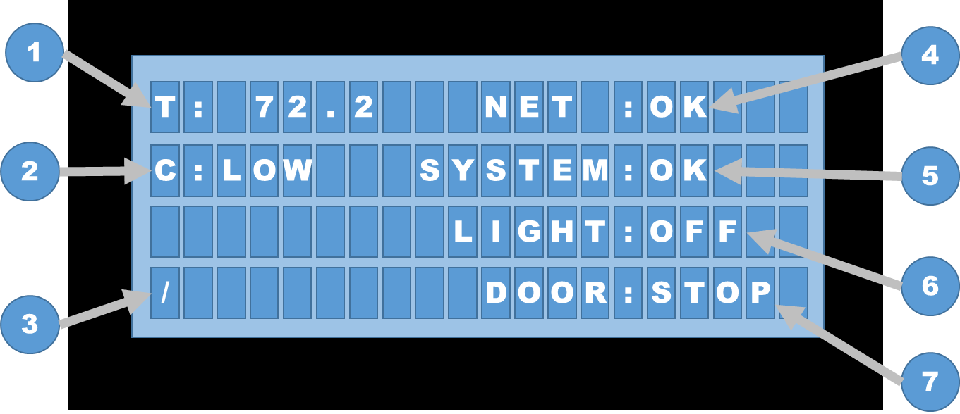

Figure 3. Local Display

The functions for each of the display elements are described in the table below:

|  | **Display Feature** |
| --- | --- |
| **1** | **Temperature (T) –** Displays the temperature in degrees F inside the garage. |
| **2** | **Carbon Monoxide (C) –** Displays the level of carbon monoxide detected in the garage. Displayed in the ranges:   * Low – Levels < 70 ppm * Warn – Levels > 70 ppm but < 150 ppm * High – Levels > 150 ppm |
| **3** | **Activity Indicator (/) –** Moves with each update to the display. |
| **4** | **Network Indicator (NET)** – Indicates networks state as follows:   * None – No connection * Conn – Connecting * OK – Connected |
| **5** | **System Status (SYSTEM)** – Indicates system status as follows:   * OK – System functioning normal * ALARM – CO too high or Temp too High or Low in the garage * Fault – Error detected with the system |
| **6** | **Light Status (LIGHT)** – Indicates the state of the light control   * ON – Light On * OFF – Light Off |
| **7** | **Door Status (DOOR)** – Indicates the state of the door   * STOP – Door is stopped in between. * MOVE – Light Off * OPEN – Door is open. * CLOSE – Door is closed. |

**Interface Button Functions and Use**

The interface buttons mounted on the front of the GarageRTC are used to provide local operation of the controller features. The buttons can be used anytime the GarageRTC is up and functioning.

|  |  |  |  |
| --- | --- | --- | --- |
|  |  |  |  |
| **Alarm** | **Door** | **Stop** | **Light** |

Figure 4. Manual Interface Buttons

**Alarm** – When an alarm has been set, use this button to silence the alarm. The system will remain in an alarm state but the audio will be silenced. Once the alarm condition clears and another alarm occurs, the alarm will resound.

**Door** – When pressed, this will trigger the next movement to the door. Movement will stop when a limit is reached, an obstacle detected, or the stop button pressed.

**Stop –** When pressed, this button will trigger the moving door to stop.

**Light** – When pressed, this will toggle on or off the externally connected light.

## Using the Web Interface

Using a web browser open the address of the system that is running the server setup earlier (ex: <http://192.168.1.120:5555> ). From the main page, shown in Figure 5, select the  button from the upper right corner and select settings.

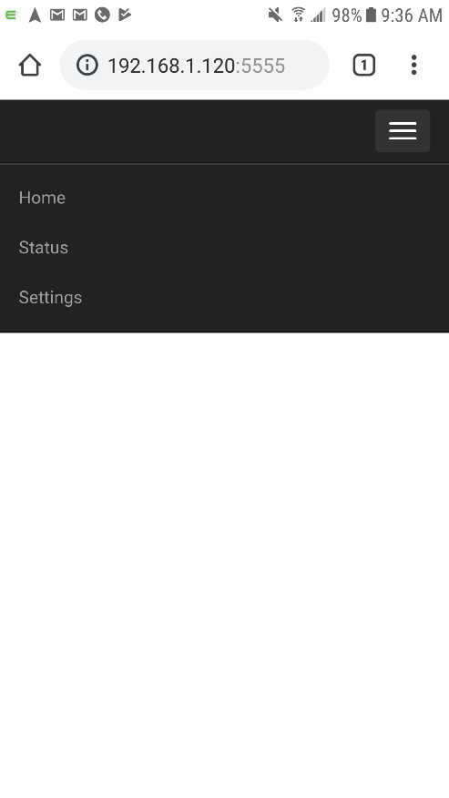

Figure 5. GarageRTC Main Page

From the settings page, Figure 6, type in the address the GarageRTC has been assigned. This can be found out by logging into your Wi-Fi router and looking for the ESP32 device in the DHCP list, or by using the serial monitor with the Arduino IDE and the GarageRTC will display the network address at startup or connection.

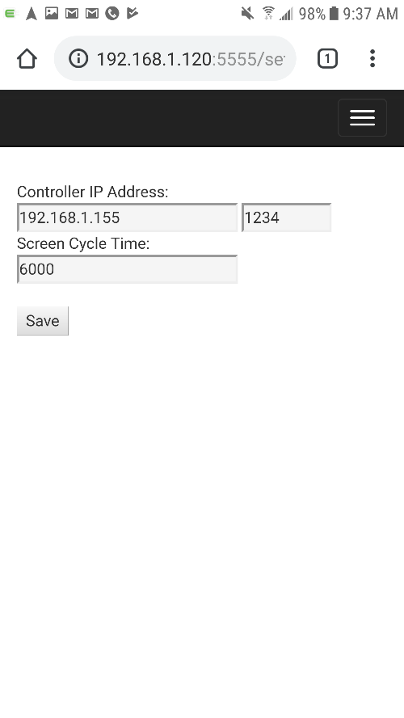

Figure 6. GarageRTC Settings Page

Finally, select the  again from the top right corner. Select Status from the list, and the status of the GarageRTC will be shown, Figure 7. Use the door button to trigger the door operation for open, close, start, and stop. Press the light button to control the light settings. If an alarm is set, the system status button will turn red and the alarm can be silenced by pressing the ALARM button.

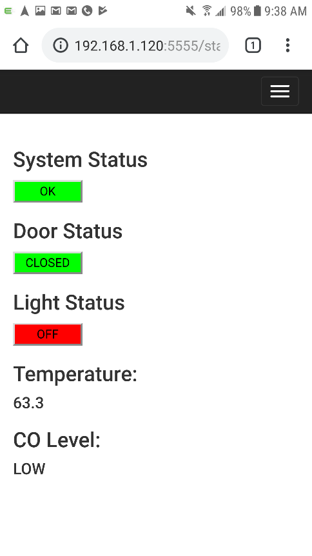

Figure 7. GarageRTC Status Page

# Maintenance

On a monthly basis, inspect the following components and replace as necessary:

| **Component** | **Inspect For:** | **** |
| --- | --- | --- |
| Limit Switch Wires | * Fraying of wires at the screw terminals. * Abrasion of the wire jacket * Moisture build-up or corrosion at terminals |  |
| Laser Transmitter/Receiver wires | * Fraying of wires at the screw terminals. * Abrasion of the wire jacket * Moisture build-up or corrosion at terminals |  |
| Door Control Wires | * Fraying of wires at the screw terminals. * Abrasion of the wire jacket * Moisture build-up or corrosion at terminals |  |
| Power Supply | * Fraying of wires at the screw terminals. * Discoloration of housing * Arcing or pitting of mains contacts |  |
| Laser Transmitter | * Mounting screws loose or missing * Dirt of webbing inside transmitter housing * Alignment with receiver |  |
| Laser Receiver | * Fraying of wires at the screw terminals. * Abrasion of the wire jacket * Moisture build-up or corrosion at terminals |  |
| Main Module | * Housing firmly mounted to wall * Damage to LCD or buttons |  |

If any of the components listed above reveal damage or show excessive wear immediately discontinue using the GarageRTC. Repair or replace the item with an equivalent or newer part before returning the Garage RTC to service.

# Warranty

This product is part of a graduate level project and is provided free of charge and without any warranty. All responsibility for repair, maintenance, installation, materials and risk are the responsibility of the owner/builder. By using any part of this project, the user agrees the authors of this project shall not be held liable for any damages incurred. Warranty replacement of parts should be obtained from the suppliers of the purchased parts. Labor to repair or recondition is the responsibility of the user.