During the time since the last milestone:

* I’ve managed to fix some of my stored procedures so they can convert to xml
* Working towards utilizing the xml file so the user can search for the item they require
* Css styling for the pages is nearly complete still need to insert images properly
* Need to finish up some functions to figure out how to change information properly (possibly change how its being displayed)

Previous Timeline: 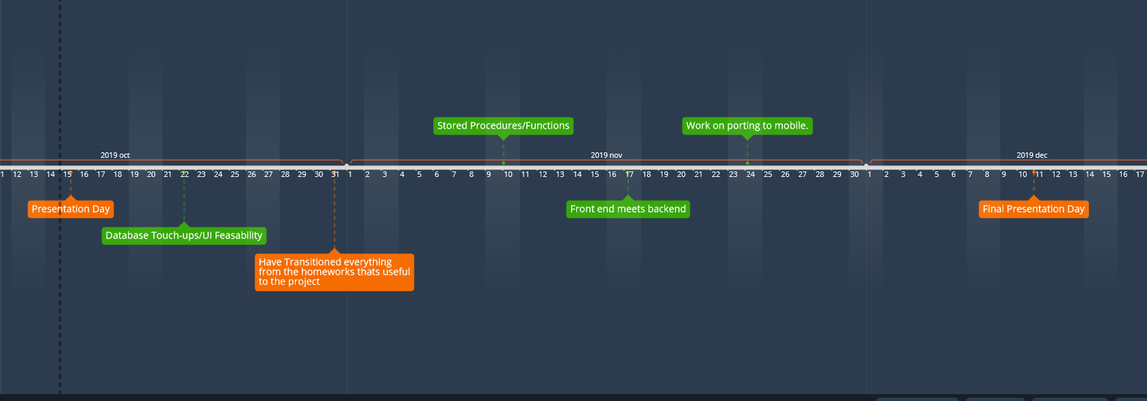

Current changes to timeline:

* Everything getting connected frontend to backend might take longer than expected due to other classwork load being higher than expected.
* Stored procedures are almost done should be finished this weekend.\
* Worried about getting everything done so i can port it to mobile asap but most stuff is on time.

Optimization:

So I decided to make my database calls on the page load and store everything into an xml file to help speed things up overall for searching through all of the items. Most(if not all) of items should be accessible through the main page by using modal popups to save on overall page space and to make more use of one page.

I decided on this to have the interface be more like an application to help make it easier to transfer stuff onto mobile. Since players will be going through various searches for equipment in their builds having everything more easily accessible without having to make calls to the database as often.

I plan on testing the initial load times and how quickly you can change between items/searching for items.